Dear Applicant

Teacher of science

Thank you for your interest in the position of science teacher at Carlton le Willows.

Please complete the application form, and send it with a letter of application to the school by the closing date of Monday 5 March 2018, 12 noon. In your letter please indicate how you think you are suited to the post.

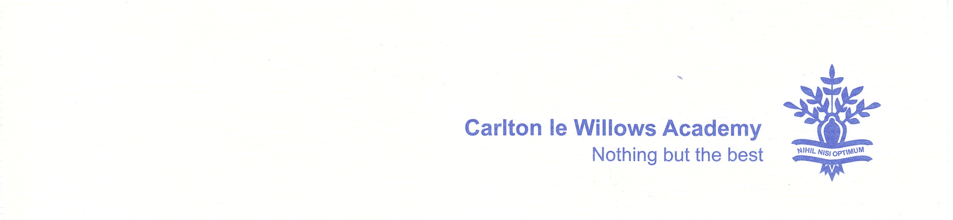
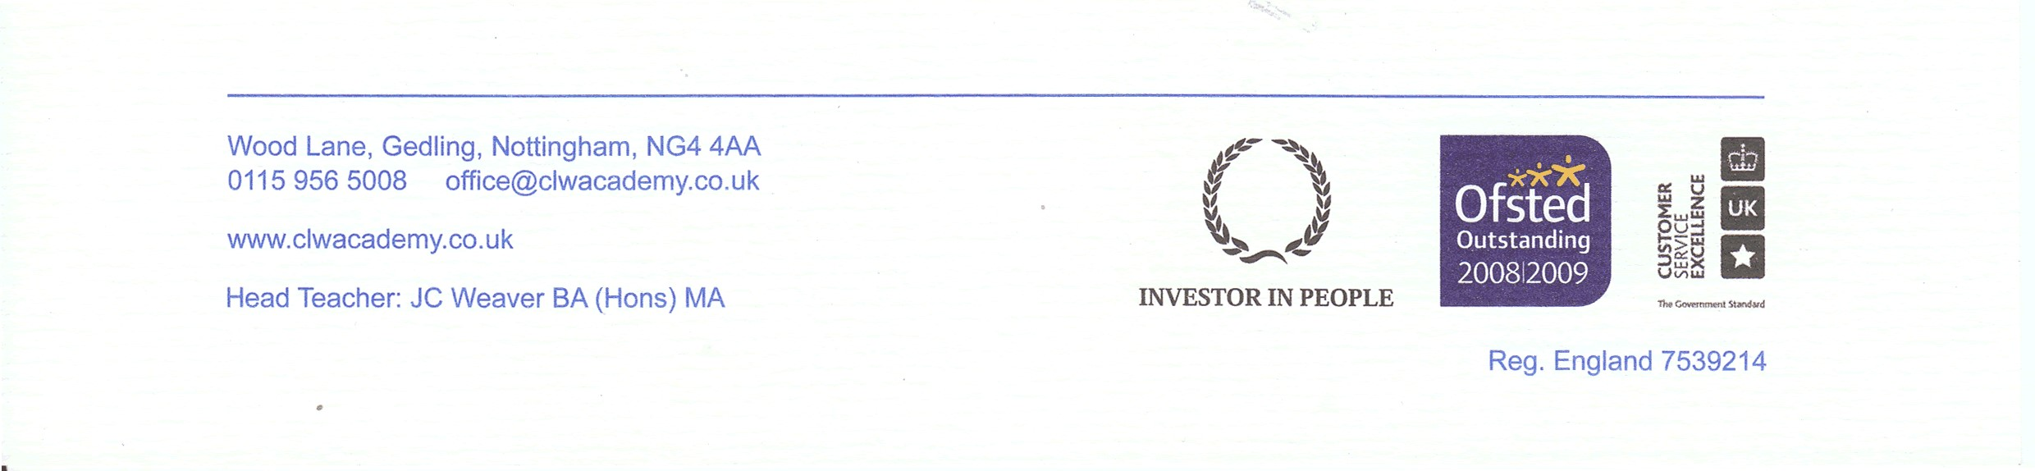
I look forward to receiving your application.

Yours sincerely

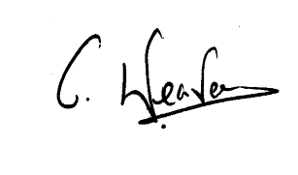
JC WEAVER (Mr)
Head Teacher

