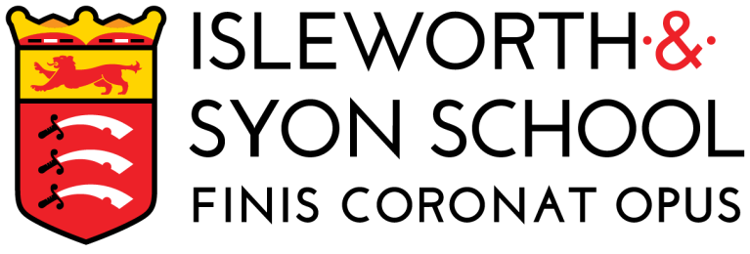 | ADVERT

Teacher of Physical Education
Closing date: 09:00 – 20th May 2019

Date posted: 3rd May 2019 Salary: MPS/UPS (Outer London)
Start date: 1 September 2019 Contract term: Permanent
Contract type: Full Time or Part Time Suitable for NQTs: Yes (can be employed in July 2019)

“Staff are proud of the work they do. Building on the long-standing traditions of the school, staff support the development of ‘courteous, respectful and calm’ young men, reflecting the school’s well-established values.”
[Ofsted Report – February 2017]

“The bespoke support and offer which Sport Impact provides to primary schools is inspirational.”
[Headteacher – 2016]

This is a fantastic opportunity for an enthusiastic and well-organised colleague with a passion for physical education, sport and health to join our high performing school sport partnership (SSP). The partnership is overseen by Isleworth and Syon School.

The SSP bucks the national trend for, first, our engaging work with primary schools in relation to Physical Education (PE), second, the participation rates of young people in physical activity and, third, competition success. We have an extensive calendar of events with over 120 level two competitions and growing participation numbers in KS1-2 (approximately 10,000 participants).

We wish to appoint a colleague who understands the importance of physical activity for children and young people, The successful candidate must has specialist PE knowledge across an array of physical activities and, crucially, across all key stages. They must also have the desire to work in a supportive and invigorating environment in which staff are passionate about delivering creative and engaging sporting competitions as well as festivals. You will be joining an already outstanding team of expert practitioners and strong mentors. The successful candidate can be safe in the knowledge that your subject is highly valued and supported.

Across the local authority students from the early years and foundation stage (EYFS) to KS5 benefit from opportunities created by the SSP to improve both hard and soft educational outcomes.

Isleworth & Syon is an over-subscribed and popular boys’ school with a mixed Sixth Form. We are situated in a tree-lined neighbourhood of the London Borough of Hounslow, a vibrant area of West London. We are close to Osterley Park, a short hop from central London by tube or rail, and have easy access to the M3, M4 and Heathrow Airport. Sport Impact is a sub-company of the school and based at Norwood Green Infant and Nursery.

Amongst other benefits, we offer:
- A full, bespoke induction programme
- On-going professional development with an individual CPD allowance
- State of the art touchscreen classroom technology and a laptop
- The opportunity to work with dynamic, innovative and supportive colleagues
- The opportunity to work with students that exhibit “outstanding” student behaviour
- The opportunity to work with a range of leading external partnerships
- A chef-led canteen service
- Access to schemes such as: childcare vouchers; cycle to work and free flu jabs.

Application details
Please click on ‘Quick Apply’ to submit your application. Further recruitment details are on our website www.isleworthsyon.org under ‘Staff Recruitment’.

Early application is encouraged, as we will undertake selection processes on receipt of completed forms.

We are committed to safeguarding and promoting the welfare of children and young people and expect all staff and volunteers to share this commitment. The successful applicant will be subject to an Enhanced DBS check, references and other pre and post-employment checks.
More about Isleworth & Syon School
Type: Mainstream School Address: Ridgeway Road, Isleworth, Middlesex, TW7 5LJ
Phase: Secondary with Sixth Form Telephone: +44 20 8568 5791
Funding status: State – Academy http://www.isleworthsyon.org
Gender: Boys and mixed Sixth Form email: school@islewothsyon.org
Age range: 11-18 years

Placement : TES Package / Teacher’s Register / DfE Teaching Vacancies

Banner for school and / or Sport Impact web site :
We have an exciting opportunity for a teacher of Physical Education to join our innovative Sport Impact team and to work in a highly supportive environment across all key stages.

