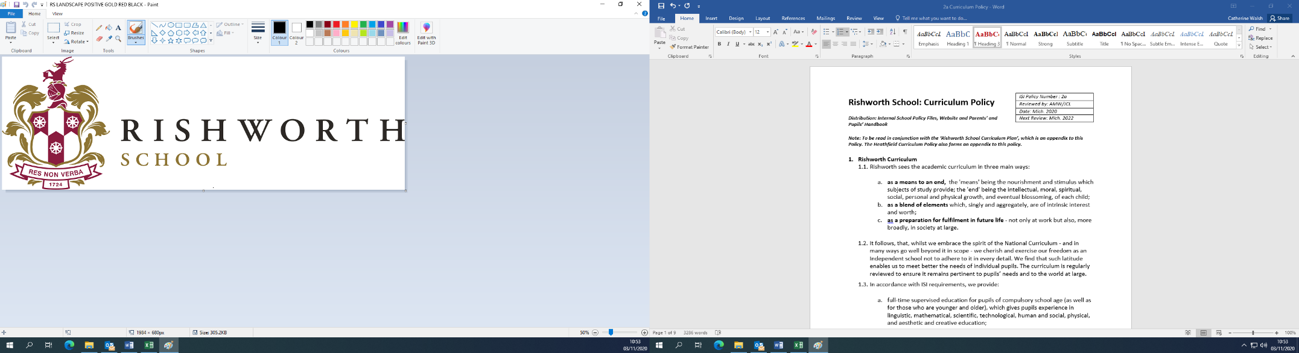

**MARKETING LEAD (6 MONTHS FIXED TERM CONTRACT)**

Rishworth School is a co-educational UK day and boarding School for students aged 3 to 18. Celebrating our Tri-Centenary in 2024, Rishworth School has occupied magnificent buildings in 140 acres of Yorkshire countryside located in the heart of the Ryburn Valley for the past 300 years. Rishworth School joins traditional values with innovative Teaching and Learning encapsulating our Res Non Verba motto.

We are looking to recruit an experienced Marketing Lead who will have overall responsibility for consistent marketing communications to existing and potential stakeholder audiences i.e. parents, pupils, teachers, alumni, governors and community. This will include acquisition strategies to bring in new customers as well as retention strategies to existing customers. The role oversees the Marketing Co-ordinator (MC) and together will ensure effective multi-channel marketing to promote Rishworth School, including Nursery, Rishworth Prep, Rishworth School, Sixth Form, Rishworth International Football Academy (RIFA) and boarding. This role involves working closely with the senior leadership team (SLT) in the annual business planning process and executing strategic marketing initiatives to attract, recruit and engage students, parents, alumni, and external partners globally.   
The Marketing Lead will focus principally (but not exclusively) on implementation and execution of acquisition strategies and the MC will focus principally (but not exclusively) on retention. Both roles need to have an understanding of the other, in order to facilitate cover when the other is on annual leave.

Previous independent school experience is not essential, although an understanding of the sector would be desirable.

**Closing date**: **Monday 7th April 2025 at 9am**

**Salary:** £37,710 to £44,179, final salary dependant on experience.

Contact Phone: 01422 822217

Contact Email: lnewman@rishworth-school.co.uk

*Rishworth is committed to safeguarding and promoting the welfare of children and applicants must be willing to undergo child protection screening appropriate to the post, including checks with past employers and the DBS.*

*Rishworth School, Rishworth, Halifax, HX6 4QA*

*Tel:* ***01422 822 217*** *Fax: 01422 820 911* ***Charity no. 1115562***