Applicant Information Pack
Subject Leader of Engineering (Full Time)

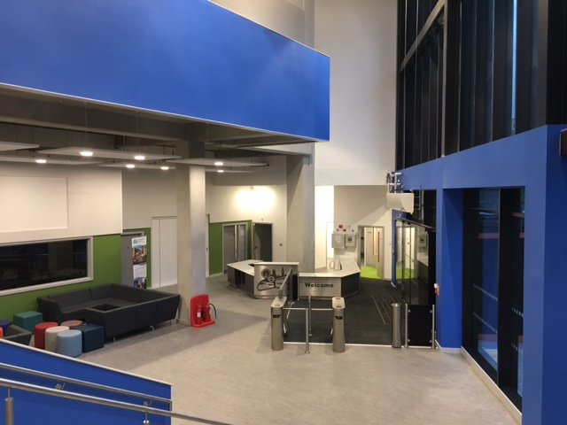

Sir Simon Milton Westminster UTC is committed to safeguarding and promoting the welfare of children and young people and expects all staff and volunteers to share this commitment. Appointed staff will be subject to Disclosure and Barring Service (DBS) checks. The UTC is committed to equal opportunities.

Letter from the Principal

Thank you for your interest in working for Sir Simon Milton Westminster University Technical College.

We are a new University Technical College that educates the young women and men that will become the next generation of professional engineers, technicians and innovators.
Sir Simon Milton Westminster University Technical College delivers academic excellence, alongside problem solving and valuable technical skills, for London’s 14 to 19 year olds.
Our students are inspired by solving real life community and industry problems, working alongside professionals from our sponsors in the transport engineering and construction industries. These industries are rapidly transforming London and there is an enormous need for the ambitious, high achieving, young women and men that will come through our UTC with their innovative thinking, team working and project management skills, all standing on a bedrock of excellent academic qualifications.

Students work on the employers’ business challenge projects, benefitting from University of Westminster student mentors, and learning how to apply their English, Maths, Science and Engineering to London’s real-life industry projects.

The flagship UTC building is a short walk from the transport hub of London Victoria railway station. This location enables unparalleled access to our high profile industry partners: Network Rail, Landsec, Sir Robert McAlpine, Alstom, BT Fleet, Colas Rail and Transport for London.
We have a strong, passionate and committed senior leadership team, and with the support of outstanding staff across all areas, we look forward to the continued evolution of the UTC. We are looking for an engaging and passionate Engineering teacher to join us in facilitating continued and ever more success.

Sir Simon Milton Westminster UTC’s staff are team players, prepared to do the extra things that really make a difference for students and colleagues and are excited about learning and student success. This is an exciting opportunity. As a new UTC, our staff will have the ability to influence and shape their area of work.

We do hope that you will apply for a position with us. You are very welcome to book an appointment to visit us; our staff and students will make you feel very welcome.

Antonia Evans

Principal

Benefits of Working at the UTC

Letter from the Joint Headteachers

- Generous leave and holiday entitlement
- Conveniently situated within walking distance of London Victoria, Pimlico and Sloane Square stations.
- Exciting and innovative educational institution, allowing you to influence and shape your area of work
- Work alongside top employers
- Unrivalled opportunities for career development
- Work within a brand new building designed for modern technical education
- Outstanding resources to support learning, including an exceptionally high IT/ student ratio and industry standard specialist equipment
- Outstanding internal and external professional development opportunities to help you excel in your role and shape your skills and future potential.
- Opportunities to gain funding for additional leadership qualifications, such as the NPQML/ SL/H.
For Teachers:
- Class sizes and student numbers that will allow you to personalise your approach to the students
- Benefits are aligned with the Teachers’ main scale pay and conditions, including a generous inner London allowance
- An additional UTC allowance of £2000 per annum on top of pay scale

Job Description and Person Specification:
Teacher of Engineering

JOB DESCRIPTION: SUBJECT LEADER OF ENGINEERING

Responsible to Senior Leadership Team

Job Purpose Management, teaching and development of Engineering in the UTC

Sir Simon Milton Westminster UTC is committed to safeguarding and promoting the welfare of children and young people and expects all staff and volunteers to share this commitment. Appointed staff will be subject to Disclosure and Barring Service (DBS) checks.

Job Responsibilities

- To effectively line manage the Engineering Department and develop apace the UTC’s Engineering provision.

- To fulfil one's own responsibilities as a teacher within the UTC, in accordance with the quality standards of the institution.

- Plan and deliver inspiring lessons, incorporating a range of techniques and differentiation strategies.

4 To attend regularly meetings of the UTC, and be willing to share best practice with other staff.

5 To assist in the provision of appropriate courses and the promotion of activities to provide for and support the learning needs of students within Engineering.

6 To attend open evenings, parental events, progress review meetings and other dedicated activities as required.
7 To assist with, and promote,

i) the contribution of Engineering to the cross-curricular work in the College;

- the use of ICT in classroom teaching and learning;

- additional subject workshops to support learning.

8 To work to improve one's professional performance by taking advantage of opportunities to develop skills and broaden experience and participating in the UTC’s performance management arrangements.

9 To assist in managing effectively and efficiently the physical resources of the subject. In particular, to

i) consider the use of accommodation and to make recommendations to the senior leadership team for its continued and improved use;

ii) suggest suitable items for resource expenditure;

iii) observe the UTC’s health and safety policies and encourage safe working practices.

- To assist in the arrangements within the College for the induction of students and monitoring progress, offering guidance to students where necessary and liaising with UTC managers, and parents/ carers, where appropriate.

- To assist with the organisation of work experience if required.

- To assist in the arrangements made for students to receive advice on courses in Higher Education and career opportunities related to, or progressing from those in the subject.

- Ensure that references and reports are produced when requested.

- To assist in the setting up and organisation of UTC examinations in the courses covered by the subject and assisting, where necessary, in the supervision of public examinations.

- To assist with organisation and accompany students on, educational visits which may include overseas, residential trips.

- To ensure that departmental records are kept up to date. To share in the recording and analysis of internal examinations, value added and external examination results and, with the senior leadership team, take whatever action is necessary to sustain and improve performance by students.

- When necessary and appropriate, to represent the subject at meetings and to publicise the work of the subject at the various events in the UTC and partner schools.

- Act as a Learning Coach (pastoral tutor) and, subject to timetabling, to meet the responsibilities defined by the UTC for this role.

- When necessary, to attend for duty at places other than the UTC’s sites, for example at partner schools or training conferences/ events.

- To undertake any other particular duties which may be reasonably assigned to you by the Joint Headteachers or wider Senior Leadership Team from time to time.

- General

- To develop and maintain professional, productive relationships with all members of staff within the UTC.

- To be aware of your entitlement to professional development.

- To be aware of equal opportunities and to demonstrate these principles in all aspects of work.

- To understand the UTC Health and Safety Policy and to work within its guidelines.

- To work in the interests of students and in accordance with the UTC’s policies and values.

- To be aware of your responsibility for promoting and safeguarding the welfare of young persons whom you have contact with during the course of your duties, and follow the guidance issued in the staff code.

The College may be able to offer appropriately qualified and experienced candidates the opportunity to undertake various leadership responsibilities. Please ensure you refer to any specialist skills or leadership experiences you have had or developed in the past in your supporting statement.

For staff new to teaching, but who are interested in progressing into leadership, please make it known on your supporting statement. We are committed to supporting those who wish to develop their careers.

PERSON SPECIFICATION: TEACHER OF ENGINEERING

The person appointed will be expected to have:

CRITERIA | Essential | Desirable
- A degree or equivalent qualification. | E
- Appropriate teaching qualifications, or a commitment to gain an appropriate teaching qualification within three years of appointment. | E
- Appropriate qualifications in engineering, teaching and some leadership / management experience in the subject field. | E
- The ability and willingness to teach engineering to students at both KS4 (GCSE) and KS5 (A Level). | E
- The ability, and willingness, to offer a second subject that is offered at the UTC if required. |  | D
- Willingness to embrace working in a UTC, and an understanding of the UTC concept. | E
- Good interpersonal, organisational and IT skills. | E
- A proven track record of success as a teacher, as exemplified by good examination results; for NQT’s evidence should consist of an outstanding placement reference particularly with regard to the standard of learning and teaching. | E
- The ability, and willingness, to participate in curriculum planning, coursework design and moderation. In addition, the ability to deliver well planned, carefully differentiated lessons is critical. | E
- Commitment, enthusiasm and flexibility in their approach to the subject and the ability to work well as part of a team. | E
- Willingness to act as an engineering champion for the College. | E
- The ability to use positive rewards and sanctions to promote effective engagement for learning. | E
- An awareness of the need for personal development, both as a member of a team and as an individual. | E
- Commitment to the UTC’s programme of 30 hours Continuing Professional Development (or pro-rata equivalent for hourly paid and part time Teachers). | E
- Evidence of a commitment to equality of rights and opportunities together with practical ideas for its implementation in the post. | E

Disabled candidates meeting the essential criteria are guaranteed an interview.

Note to applicants: You should ensure that your supporting statement addresses each of the points contained in the person specification in turn.

