

**JOB DESCRIPTION**

**JOB TITLE: Part time Lecturer**

**REPORTS TO: Head of School**

**AREA: Specified teaching area**

**DBS: Enhanced Disclosure with children’s barred list __________________________________________________________________**

**PURPOSE:**

To teach on and contribute to identified programmes in the specified area. To work closely with other members of staff both within the area and across other College areas.

**PRINCIPAL DUTIES:**

1. To teach on identified programmes within the specified area.
2. To undertake any associated marking and preparation as required by the needs of the programme.
3. To attend meetings as required which are specifically related to the specific delivery area.
4. To demonstrate commitment to his/her professional development.
5. To be proactive in maintaining and developing quality standards on all programmes and demonstrate a commitment to quality improvement.
6. To produce any statistical returns, registers etc as required by the Head of School.
7. To adhere to policies, procedures and values of Solihull College & University Centre.
8. To embed sustainability within the curriculum.
9. To adhere to policies, procedures and values of Solihull College & University Centre.
10. To undertake all mandatory training in a timely manner as required e.g. Safeguarding, Prevent.
11. To actively promote [equality, diversity & inclusion](https://www.solihull.ac.uk/about-us/equality-diversity/) and to champion [anti-racist](https://www.bbc.co.uk/bitesize/articles/zs9n2v4) practice.
12. To support the college to become a Sustainable Net Zero organisation by 2030 and support the delivery of its [Sustainability Strategy](https://www.solihull.ac.uk/sustainability/).
13. To undertake necessary Health and Safety responsibilities, duties and training as required by this post.
14. To undertake any necessary Data Protection responsibilities, duties and training as required by the post.
15. Such other duties as required which are broadly consistent with the general functions and grading of this position.

**EQUAL OPPORTUNITIES:**

Solihull College & University Centre is committed to a comprehensive [policy of Equality](https://www.solihull.ac.uk/wp-content/uploads/2024/03/equality-policy.pdf). All employees are required to abide by this policy and ensure its compliance throughout the College.

**SAFEGUARDING:**

Solihull College & University Centre is committed to ensuring a safe environment for all students and expects all staff to engage fully to this commitment.

**CORE VALUES:**

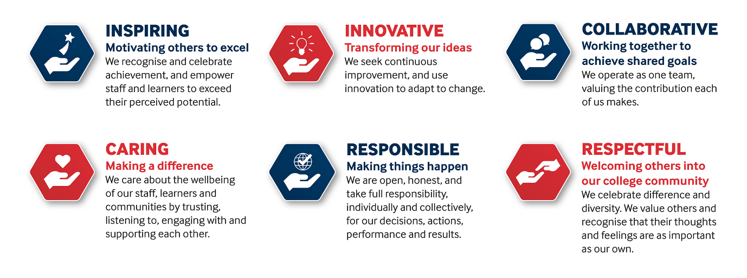



SOLIHULL COLLEGE & UNIVERSITY CENTRE

PERSON SPECIFICATION

**JOB TITLE: Part time Lecturer**

|  |  |  |
| --- | --- | --- |
| SPECIFICATION | **ESSENTIAL** | **DESIRABLE** |
| **EDUCATION/**  **TRAINING** | Hold an appropriate subject or professional qualification  Level 5 Teaching qualification (or committed to work towards in line with contractual requirements)  Minimum Level 2 in English and Maths | Assessor Award |
| **RELEVANT**  **EXPERIENCE** | Proven knowledge of subject area  Proven ability to teach to appropriate level | Curriculum development experience  Teaching experience on related programmes  Industry related work experience |
| **SKILLS/APTITUDES** | Good administrator – well organised  IT literate  Ability to work as part of a team  Ability to embed English and Maths into vocational teaching  Flexible and well motivated  Able to work on own initiative  Enthusiastic, flexible & dynamic  An awareness of sustainability and climate change and how it applies to FE and can be embedded into the curriculum |  |
| **OTHER**  **REQUIREMENTS** | Strong commitment to Equal Opportunities  An understanding of the needs and challenges of teaching a range of students  Commitment to continuous professional development  A commitment to the Safeguarding of Young People and Vulnerable Adults and an awareness of the Government ‘Prevent’ strategy  Commitment to the College’s Values | General awareness of cultural diversity |