 | 
Autism Lead Practitioner
Thames Valley School, Reading
Leadership scale L1 - L6 (circa £45 - 51k), dependent on experience

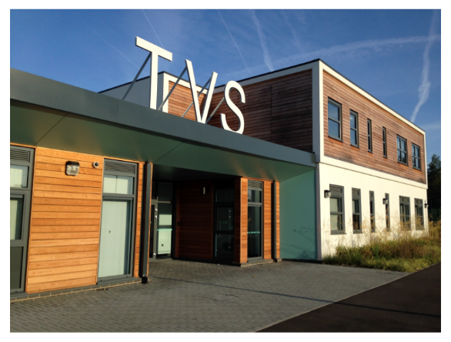 | About Us  The Liberty Academy Trust is an education charity established in 2022. Our vision is to create a world that works for autistic children and young people, by providing an exceptional educational offer so that they achieve success now and are well-prepared for adulthood. We work towards this vision through our core values of courage, determination and teamwork.  We are currently a small Trust of three academies, but we have plans to grow so that our reach and impact can extend further. Committed to providing an excellent education for autistic children and young people, our approach is to support the whole child, offering a balance of personalised teaching and therapeutic support as standard.  Thames Valley School in Reading is an Autism Specific Specialist Free School, providing education to 54 children and young people aged 4 to 16. The school helps autistic students build on their strengths, learning, confidence and enjoyment. Our aim is to respond to the needs of each of our students, helping them to grow in confidence and achieve.


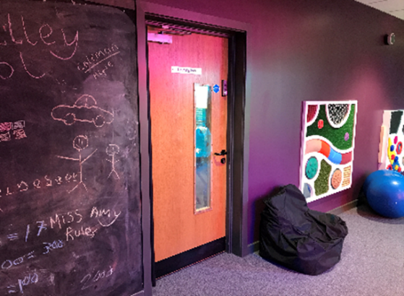

Thank you for your interest in this role at Thames Valley School. As part of a newly established Trust, we want to challenge any sense that, as a special school, children’s aspirations are limited. Our values of courage, determination and teamwork are the key drivers to bring about positive change, so that all of our children and young people can be successful now and in their future lives.
The school was opened in 2013, with inclusion and community engagement at its core. Ofsted assessed the school as Requires Improvement in 2021, but a monitoring visit in 2022 endorsed the progress which had been made, finding Leadership and Safeguarding to be effective. We need to continue to improve and embed practice to move the school.
A school is nothing without a skilled and dedicated staff team. This is a wonderful opportunity to be part of our school’s journey in establishing excellence in the education of autistic pupils.
Jo Galloway, Director of Education

The Opportunity
As Autism Lead Practitioner, you will be responsible for leadership of autism practice and pedagogy within the school. You will support staff in all roles to provide highly specialist support. You will use your experience to advise, negotiate, advocate and champion the needs of our pupils. You will liaise with the SENCO and school therapists to ensure individual support for pupils ensures progress against EHC plans.
You will also work with Autism Lead Practitioners in other schools, and build partnerships and networks outside of the Trust. In this way, the post offers career progression and personal growth.
You will be an experienced, skilled and suitably qualified educationalist, who can demonstrate strong leadership qualities, including those of innovation and vision. You will be passionate about developing best practice in your school, and be self-motivated to continually update your knowledge and ensure practice in the school is informed by evidence and research.
We offer a competitive salary and pension, as well as a range of benefits and a focus on staff well-being. More importantly, we offer the opportunity to play a part in highly rewarding work, as part of an ambitious and supportive team.
We are an equal opportunities employer. Applications for this job are sought from anyone who is suitably qualified and experienced for the role, but particularly welcome from those with a diagnosis of autism or Asperger syndrome.
Liberty Academy Trust is committed to safeguarding and promoting the welfare of all children and adults who use our services and as such expects all staff and volunteers to share this commitment. Successful applicants will be required to complete the relevant safeguarding checks.

Job Description
Support for pupils
- Adapt classroom activities and / or resources to engage pupils
- Work with the school SENCO and clinical team colleagues to ensure effectiveness of EHCP provision through research, quality assurance, and implementation plans;
- Fulfil a teaching role, leading planned lessons demonstrating best practice;
- Ensure the educational environment is appropriate for autistic pupils
- Contributing to the development of individual plans / pupil profiles through the identification of appropriate social communication targets, teaching strategies and resources
- Liaise with parents (and provide training when appropriate) in order to keep them informed of their child’s progress and to provide advice and support
- Attending relevant meetings, including multi-agency meetings, regarding individual pupils and maintain appropriate records
- Support students consistently whilst recognising and responding to their individual needs
- Encourage students to interact and work co-operatively with others and engage all students in activities
- Promote independence and employ strategies to recognise and reward achievement of self-reliance
- Provide feedback to students in relation to progress and achievement
- To promote and model the highest standards for safeguarding pupils and young people in our education and care providing outstanding leadership and support
- Actively promote diversity, equality of opportunity and anti-discriminatory practices
Support for staff
- Lead on the provision of specialist advice and guidance on autism, including specific strategies for individuals, to teaching and support staff across the Trust
- Draw on current research and evidence-based practice and model and cascade best practice in relation to autism practice and pedagogy
- Coach and mentor colleagues to support pupils effectively
- Consult on the appropriateness of learning environments and resources for autistic pupils
- Be responsible for providing training and development for colleagues in school and for local governing bodies so that they can provide appropriate support
- To ensure staff within the school are kept up to date with developments within the field of Autism
Support for the School
- Lead on implementation of Autism Education Trust frameworks, under the direction of the Director of Education
- Develop and maintain professional relationships with pupils, parent, staff and external professionals
- To contribute to the development plan / self-evaluation framework (SEF) with particular focus on the area of Autism;
- Be the main point of contact for Autism Accreditation, liaising with the link advisor to book reviews and interim visits and lead on the completion of the school’s Autism Accreditation audit and action plan
- Take responsibility, on a rota basis for class assembly, lunchtime clubs, playground duty and other general school commitments
- Willingness to provide reasonable classroom cover and use this as an opportunity to model pest practice
Support for the wider trust
- Maintain and develop the ethos, values and expectations of the Academy and support agreed Academy policy in all areas
- To comply with all Trust policies and procedures at all times, including, but not limited to, safeguarding, health and safety and employment policies
- To contribute to the development of Trust-wide and local policies, ensuring co-production and understanding
- To participate in Autism Lead Practitioner network meetings across the trust
- Work within an extended range of networks and partnerships across and outside of the Trust to provide advice and guidance, broker support and learning opportunities and improve the quality of services to children and young people
Job descriptions only reflect 80% of a role, and are not an exhaustive list of duties. You are expected to carry out other activities that are within the scope of the role.

Person Specification
Qualifications and knowledge
- Qualified teacher status
- Secure knowledge and understanding of autism and how it impacts on learning
- Sound understanding of Current research in the field of autism; widely read and able to describe how research has influenced practice
- Sound knowledge of Keeping Children Safe in Education (2022) and the schools safeguarding and welfare policies and processes
- Sound knowledge of the SEND Code of Practice (2015) including knowledge about the EHCP process
- The required professional standards including confidentiality and following data protection guidance
- Knowledge of what constitutes an effective learning environment for SEND pupils, but particularly those who are autistic
- Knowledge of key autism specific approaches
Skills and experience
- Proven track record of consistently delivering highly specialist education to SEND pupils, including those who are autistic.
- Ability to prepare and model differentiated lessons and activities that are drawn from a school’s schemes of work and the National Curriculum, but incorporate interests and motivations of autistic children.
- Experience of developing curriculum documentation and subject policies incorporating autism specific strategies to ensure autistic learners have full access to a broad and balanced curriculum
- Excellent written and verbal communication and presentation skills; articulate and able to advocate for autistic pupils and their parents
- Excellent ICT skills, which enhance the presentation of data, as well as support the adaptation of teaching and intervention resources.
- Proven ability to deliver training, coaching and mentoring to colleagues.
- Confident in cascading knowledge to others.
Personal attributes
- Creative, innovative and adaptable, able to share and embed innovative solutions to supporting all pupils with SEND, but particularly those who are autistic.
- A strong team player with excellent interpersonal skills.
- Skilled in engaging people and building rapport and confidence in order that staff are keen to work with you and implement your ideas
- Energy, stamina and resilience.
- Empathy and understanding when supporting pupils, families and staff.
- Self-discipline and self-motivation. Highly responsive and able to work under pressure and to tight deadlines.
- Able to act as a positive role model for other members of staff.
- An understanding and commitment to the vision and aims of Liberty Academy Trust
Other
- Recent relevant training on SEND at leadership level, and / or a post-graduate qualification relating to SEND or autism would be an advantage

The Trust pays full regard to ‘Keeping Children Safe in Education’ guidance 2022. We ensure that all appropriate measures are applied in relation to everyone who works for the Trust who is likely to be perceived by the children as a safe and trustworthy adult including e.g., volunteers and staff employed by contractors.
Safer recruitment practice includes scrutinising applicants, verifying identity and academic or vocational qualifications, obtaining professional and character references, checking previous employment history, and ensuring that a candidate has the health and physical capacity for the job. It also includes undertaking online checks and an Enhanced DBS checks
We are an equal opportunities employer. Applications for this job are sought from anyone who is suitably qualified and experienced for the role, but particularly welcome from those with a diagnosis of autism or Asperger syndrome. Please note that we can only consider applicants who are legally entitled to work in the UK.

