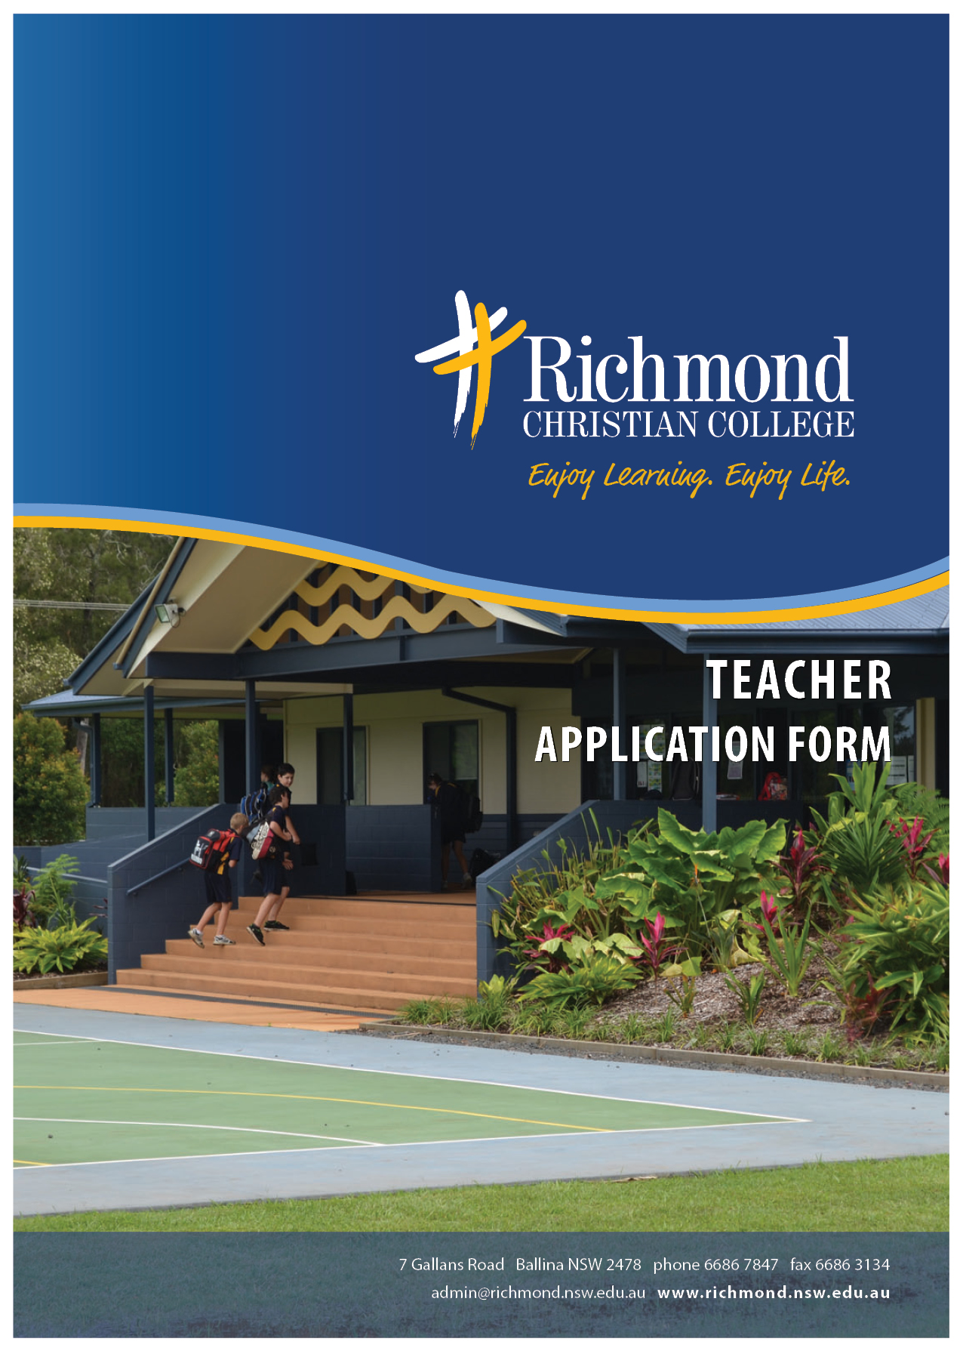

Name
Address

Phone
 |  |  |  | Postcode
 | (h) (m) |  | Birth date
Email |  |  | Nationality
NESA Teacher Number |  |  | Working with Children  Check No

POSITION APPLIED FOR

1. PERSONAL DETAILS:
a. Family

Marital Status |  | Name of Spouse

b. Health
Are there any health issues that may impact adversely on your ability to undertake the duties of the advertised teaching position? Yes/No

If yes, can you please explain

c. Church
The church you belong to:

The gifts you exercise/positions you hold within present congregation:

Your Pastor’s name |  | Phone No.
Address

The names of two other persons to whom reference might be made:

Name |  | Phone No.
Address
Name |  | Phone No.
Address

What were the factors that brought you to Christ?

What you would say as a summary of the Gospel?

What do you judge to be the challenges (new demands, difficulties, etc) that face you at present, and
what are the strategies you are planning to adopt to deal with them?

What biblical truths do you believe are most neglected by Christians today?

2. EDUCATIONAL BACKGROUND AND EXPERIENCE

Details of secondary and tertiary education

Name/Location of Institution | Qualifications Gained | Years (from/to)

3. EMPLOYMENT DETAILS

Current position and length of service:

Current salary/rate/scale or award:

(i) Details of professional experience, noting reason for change (request, promotion etc).
Dates Organisation Position Reason for Change

Dates | School | Subjects | Position | Reason for Change

(ii) Please list any extra areas in which you have special interest, ability or training, or where you have had past responsibility

4. CHRISTIAN EDUCATION

What do you believe a Christian school provides that state school education does not?

What do you believe state schools provide that Christian schools normally do not?

Outline your teaching philosophy (include reference to any scriptures that have influenced your approach):

5. SELECTION CRITERIA – Please address in a separate Cover Letter

6. ADDITIONAL INFORMATION

Are there particular reasons why you are interested in working at Richmond Christian College?

From what date would you be available to commence duties, if appointed?

Are there any other details relevant to your application, you wish to state?

I declare the information supplied in this application to be true and accurate, to my knowledge.
Signed |  | Dated
Please read the school’s Statement of Faith (on following page)
and sign if you are in full agreement with it.

PLEASE INCLUDE WITH THIS APPLICATION

- A cover letter explaining your suitability for the position and addressing the criteria for the position

- Full resume
- At least two (2) telephone numbers of professional referees.
**Please note that we will also contact previous employers.
- A written reference from your current Pastor or Minister
- A copy of your tertiary qualifications and/or academic transcript

Thank you for making an application to work at Richmond Christian College. You will receive written acknowledgement of receipt of your completed application within 2 working days.

Ballina Christian Education Association Ltd
A.B.N. 22 056 537 065
T/as Richmond Christian College
Return by email to the Principal’s Assistant: janelleclarke@richmond.nsw.edu.au

STATEMENT OF FAITH

The basis of the company is the divinely inspired, inerrant word of God, the Holy Bible, as it is acknowledged and defined by the Reformed Confessions. The Company is not a church body nor is it subject to any denominational organisations, but it is governed autonomously in relation to all other institutions and organisations.

The Company is based on the following principles: (a) Holy Scripture and Education
By faith we confess the books of the Old and New Testament to be the divinely inspired, inerrant Word of God, the only absolute rule for all faith and conduct and also for the education of our children at home and at school.

(b) Christian Parents and Education

As believing parents we have Christ’s comforting assurance for our children that he will bless them when we bring them to Him.

Expecting the fulfillment of his promise and obeying his command, we endeavour to bring our children up

in the discipline and instruction of the Lord”.

Since the responsibility for this task has been placed on our shoulders as parents we gladly accept responsibility for that part of the education which takes place outside our homes in the school. We consider our involvement in Christian Schooling to be our duty and God-given privilege.

(c) Christian Schools

As Christ is the Saviour and King of the whole of human life we understand a Christian school to be an educational institution in which Christ is not only honoured by prayer and study of the Bible, but all subjects are taught by the light of God’s revelation in Jesus Christ contained in the Old and New Testaments.

For such a Christian school, we, as parents, claim freedom in the field of education as long as this education takes place

in obedience to the requirements of God’s Word and in adherence to legitimate governmental standards and provision. (d) Some Doctrines Fundamental to Christian Education
Believing all the truth revealed in the Word of God, we wish to emphasise some doctrines which are of special
importance to Christian education. They are:

(i) God and creation.

All things were created by God. God created them in, through and for Christ by his Word and Spirit for His glory. It is also by God’s direction, power and care that all created things are sustained. In order to understand the world, man and history, they must be seen in their relationship to God as the Bible speaks of it.

(ii)The Bible and Sciences

Creation as well as Scripture has been brought forth by the same God of Truth. Therefore, any seeming discrepancy between the Bible and science can only be due to human error either in science or in the interpretation of Scripture.

(iii) Man

Man was created in the image of God to enjoy true communion with his creator. Man was instructed to exercise dominion over the world in strict and loving obedience to God.

(iv) Sin

By disobeying God’s law, man estranged himself from God and brought God’s curse upon himself and all creation. (v) Regeneration
The call of God to salvation is by his grace alone through faith in which we receive new life. (vi) Christ
Jesus Christ, the second person of the Holy Trinity, is God incarnate, the Word become flesh. Laying down his life for his people, he paid the price of sin for them, being a ransom for all who truly believe in him. Risen from the dead in his physical body, and having ascended to the throne of heaven, he is the king of the universe.

(vii) The Holy Spirit.

The Holy Spirit, the third person of the Holy Trinity, the divine source of all created life is also the source of faith in Christ, true spiritual knowledge. As the fruit of Christian education depends on the work of the Holy Spirit, both parents and teachers pray that God may bless their work that the children come to know the Lord Jesus Christ as their personal Saviour and Lord.

I (Full Name) agree with this Statement of Faith

Signature: Date:

