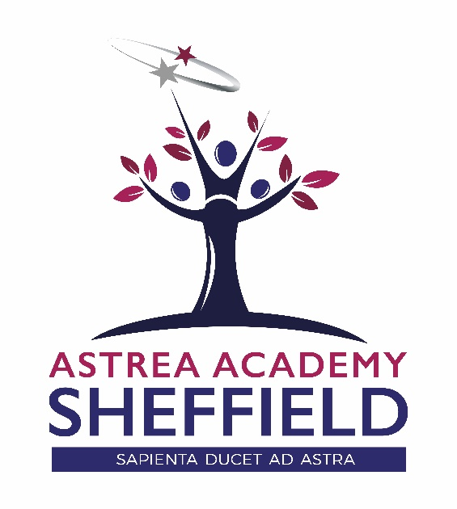
Applicant Information Pack

A BEACON OF EXCELLENCE FOR THE NORTH OF SHEFFIELD

Contents

ASTREA ACADEMY SHEFFIELD

- Welcome Letter – Libby Nicholas, CEO
- Welcome Letter – Kim Walton, Executive Principal
- Astrea Academy Sheffield – The Vision
- Astrea Academy Sheffield Floorplan
- Astrea Academy Trust
- Astrea Academy Trust Ethos
- Astrea Academy Trust Family
- Child Safeguarding Policy
- Explanatory Notes
- How do I apply?

"The staff are amazing, a true team with a shared vision who have the pupils best interests at heart.

The expectations of pupils are high, everyone is so supportive and we always work together to achieve the high standards expected at Astrea Academy Sheffield"

Sarah Naylor | Head of PE

Welcome Letter from Libby Nicholas

CEO – Astrea Academy Trust

Thank you for your interest in this role with Astrea Academy Sheffield. At Astrea, we are passionate about education that inspires beyond measure. The Astrea Academy Sheffield, Astreas first purpose built all-through academy, will be a beacon for the area – both literally and metaphorically: looking out over the city, it will provide an absolutely exceptional education for 2-18 year olds.

Astrea was established in 2015. Our schools – primary, secondary and all-through – do not subscribe to the typical notion of “schooling” where everything is driven by results. Our pupils achieve to the very highest levels, but we believe that education is about so much more than just attainment. To deliver this, we focus on encouraging and nurturing Resilience, Empathy, Aspiration, Contribution and Happiness in all of our children and young people. We also have the highest expectations of the staff in our family: responsibility and leadership; aspiration and development; honesty and integrity; enjoyment and innovation; and collaboration and inclusion. These values are used as a measure of progress with individuals, academies and overall as a trust. We have the highest expectations of pupil behaviour, so that our teachers are able to focus on teaching to the ‘Astrea Teacher Standards’.

This is a hugely exciting time for our family of academies. The Trust has been recognised by the Department for Education as being well placed to raise standards and achieve excellence for pupils in a growing number of academies. We are presented with a rare opportunity to make a real difference to the lives and life chances of so many primary and secondary school children – many of whom haven’t previously received the educational opportunities they deserve. The Trust currently has over 20 academies based across South Yorkshire and Cambridgeshire, including academies at various stages of development. As a Trust, we are clear about the importance of achieving long term sustainability for our academies. Our vision is to enable individual academies to flourish with real autonomy, whilst also ensuring a strong ethos of support and collaboration across our Academies.

Those we recruit need to demonstrate that they share our values, are highly motivated to work with colleagues within and beyond their academy to continuously develop their skills and pursue professional excellence, and are committed to providing the highest standards of teaching for all children. If that is you then we would be delighted to receive your application. At Astrea, we are all dedicated to providing an education with no boundaries so that every pupil can fly, and I hope you will join us on this exciting journey.

Libby Nicholas
Chief Executive, Astrea Academy Trust
A Warm Welcome from Kim Walton

Executive Principal – Astrea Academy Sheffield

‘Sapienta ducet ad astra – Wisdom leads to the stars’
We are delighted that you are interested in applying for this role at Astrea Academy Sheffield.
Astrea Academy Trust is thrilled to have the opportunity to cultivate a brand new academy that compliments the existing provision in the area and meets the basic need for additional school places in the area. This is a rare and unique opportunity to join us on our journey from day one - where ambition has no limits!
It is key to understand the context of our academy. Pupils in our current Year 7 arrived from 31 different feeder schools and represent 21 different ethnicities – 98.4% of our current cohort are from Ethnic Minority Groups. 65% of our pupils are disadvantaged, with 38% currently receiving Free School Meals (national is 13.3%). The catchment area of the academy is within the 10% most deprived areas within the country.
The Academy opened its doors for the first time in September 2018 and will in time be a 3 – 18 provision for children in the Burngreave area. This September has seen the first children in nursery, reception and year 7 arrive, as well as our new compliment of staff. From September 2019 we welcome our new Year 7’s and reception and nursery classes. We are delighted to say we are the school of choice in the area and are currently oversubscribed for 2019/20.
With the combination of a Grade II listed building and a brand new building, there is a real physical heritage to our new school. With an investment in excess of £25M, the facilities will be cutting edge, including science and technology laboratories, modern classrooms, a 300 seated hall, 4G pitch, an underground sports hall, outside amphitheater and forest school learning area. This ground breaking campus is truly breathtaking and will be occupied from April 2019.
It is a rare opportunity and an exciting time to join the Academy. Key work at this moment in time includes collaborating with the Trust, architects, designers and local community to create a legacy for the future. Our location will be at the heart of a new learning community which will continue to grow as we forge these ever essential relationships with families and businesses in the area.
We work within a supportive learning community of staff, parents and students, enabling a world of learning opportunities which will inspire and motivate students of Astrea Academy Sheffield to achieve excellence and create the successful path for their future. We are creating an academy where each day will be a journey of discovery to fire their imagination, establish their sense of worth, and to gain the confidence and courage to take a full part in the wider world.
This is a truly unique and once in a life time opportunity and we are seeking distinctive and exceptional individuals who are able to offer the absolute best they can to enhance the life chances of children at Astrea Academy Sheffield.

This is an exciting and challenging role which offers:
- The opportunity to be part of something truly special – to be part of our family from its infancy.
- The opportunity to make a significant impact and ensure a lasting legacy in an academy that will grow with you as an individual.
- The unwavering support of an experienced Principal and dedicated teams within the academy.
- Significant investment in your professional development.
- The chance to work with a vibrant and enthusiastic cohorts of students aged 3 – 18.
- The opportunity to be part of a true all – through education provision.
- The opportunity to contribute to the development of our curriculum, professional development and quality teaching networks across the entire Astrea Academy Trust.
Ideal candidates will:
- have a true passion for excellence in education
- be a great teacher - we are looking for someone who really knows what great learning looks like in the classroom and how to achieve it
- be dedicated to the creation of an education with no boundaries
- be committed to community cohesion and developing the whole child, not just academically
- have a very clear understanding of what makes a great school and the skills and character to be part of this (rigorous planning, high expectations, great CPD, honesty, kindness, passion, commitment and resilience) day in, day out
- be excited by, and committed to, supporting practices that will drive great progress at Astrea Academy Sheffield
- be fully aligned with Astrea’s Value Partners
Everything we achieve is underpinned by all, in these Value Partners;
- Responsibility and Leadership (#4equity)
- Enjoyment and Innovation (#go4it)
- Aspiration and Development (#Reach4thestars)
- Collaboration and Inclusion (#all4one)
- Honesty and Integrity (#4good)

If you think you have what it takes to further unleash Astrea Academy Sheffield’s incredible potential, and be part of this amazing journey - we want to hear from you!

Miss Kim Walton
Executive Principal, Astrea Academy Sheffield

The Vision

Astrea Academy Sheffield

Our Mission
A broad and balanced curriculum based on knowledge, skills and experiences will enrich pupils’ lives, build cultural capital and instil a love of learning. They will be able to apply their learning to real world contexts and problems, creating solutions in collaboration with others. Pupils will learn to value family, community and the environment. They will make a positive contribution to the life of the school and those around them. Pupils will become resilient learners who are motivated to take responsibility for their learning, health, well-being and happiness. Pupils will have high expectations of themselves, a culture of craftsmanship and a drive for excellence. They will understand the scope of possibilities that lie ahead of them and what is required to achieve their ambitions with the confidence and belief to make them a reality.
A Unique Education
At Astrea Academy Sheffield, our curriculum is the purpose of our school. The curriculum is everything that we want our pupils to know and to understand. It includes learning about discrete subject disciplines such as the sciences, humanities and the arts, and also how these disciplines relate to one another. Our curriculum is also what we want pupils to achieve, the opportunities we offer them and the experiences we believe all pupils are entitled to.
The unique offer of our enriched curriculum enables pupil’s attitudes to learning flourish. The Year 7 pupils undertake a range of electives on a Wednesday afternoon which include circus skills; Football; Dodgeball; Netball; Creative Writing; Taekwondo; Cheerleading; Art; Fun Science and Dance.
In addition to elective and subject curriculum, the role of the form tutor is pivotal in pupil and pastoral development and wellbeing. Tutors meet with their group twice per day and through this time build exceptional relationships with pupils and also with parents.
Our Affirmation
Pupils and colleagues all live by our affirmation;
- I am Strong
- I am Successful
- I am Astrea
Astrea Academy Sheffield Campus
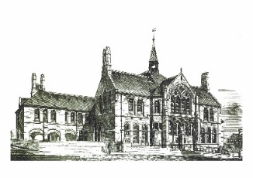
Academy Sheffield encompasses two contrasting facilities that bring together the traditions and history of education in Sheffield and the latest technology and facilities to provide pupils and the community with an outstanding environment for learning. Overlooking Sheffield city centre, the new state of the art building will feature a full complement of highly equipped classrooms providing a bright and colourful learning environment for all pupils with additional open learning spaces for independent and small group study.

New Build – Floor Plans

Astrea Academy Sheffield

First Floor
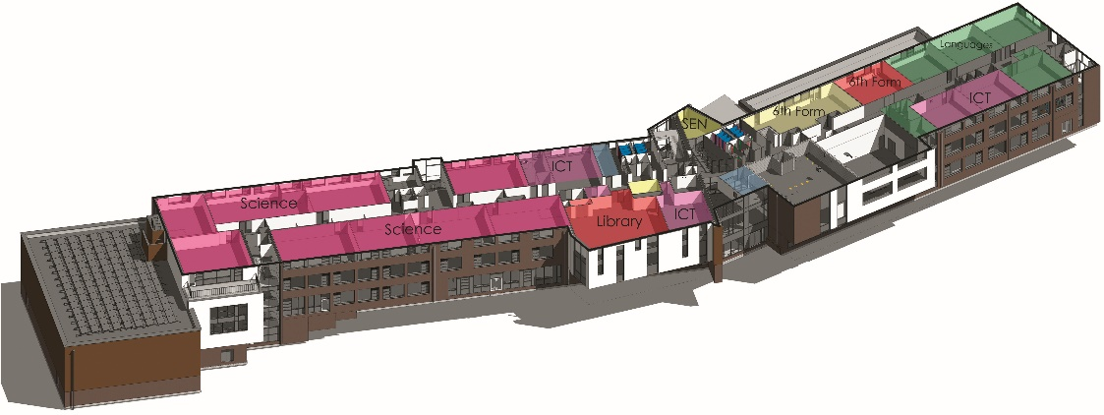
Upper Ground Floor
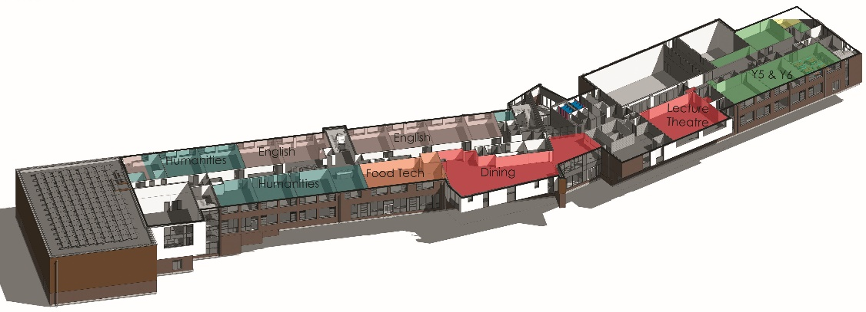
Ground Floor
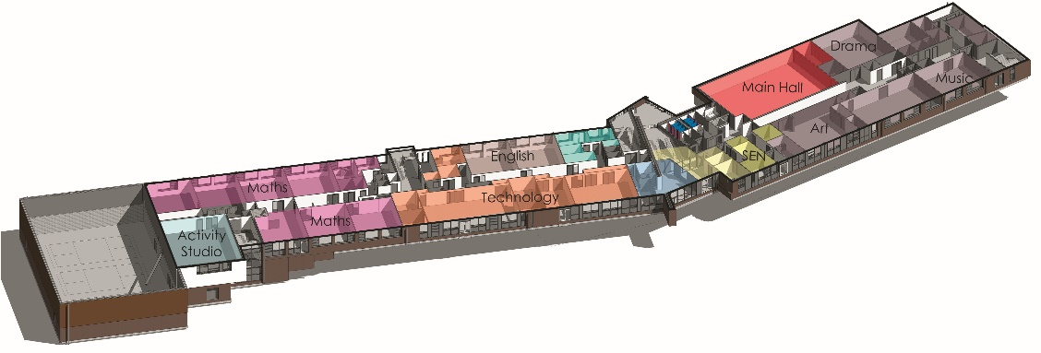
Lower Ground Floor
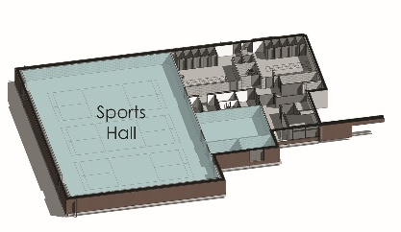

About

Astrea Academy Trust
We value all-round development of the individual, through arts, sports, leadership opportunities, enrichment and community. This is encapsulated in the skills, qualities and personalities we foster in our pupils.
The Astrea Academy Trust logo communicates the values collaboration, development and aspiration. The three figures are coming together in the shape of a tree, which represents growth, whilst the tallest figure reaches upwards, towards a star, which is above and beyond the highest branch of the tree.
Academies, staff and children within the Trust benefit from a strong ethos of support and collaboration across the Astrea family. Teachers within Astrea belong to a national community of professionals, and benefit from a wide range of networks and development opportunities across the Trust.
Astrea benefits from the involvement of leading educationalists, including our Professional Adviser Professor John West-Burnham, and strong links to prestigious institutions such as the Institute of Education.
Ethos

Astrea Academy Trust

The work of the Astrea Academy Trust is underpinned by five core Value Partners, which are equally applicable to pupils, staff and the work of the Trust itself.

Each pair of Value Partners is accompanied by a call for action in the form of a hashtag, which is used in verbal, digital and hard copy communications.

The Value Partners can be used as a measure of individual, Academy and Trust progress and as a guide to inform the direction of change.

Responsibility and Leadership
Individuals in the Astrea community are accountable for their own decisions and actions and are supported by strong leaders, while trailblazers are encouraged to develop skills and talents in others. The Trust has a strong commitment to developing and nurturing our own leaders. #4equity

Enjoyment and Innovation
We know that everyone learns best when they enjoy what they do and can follow their innate desire to achieve. Astrea pushes boundaries so that pioneering ideas are tried and tested so that our academies remain leaders in the advancement of teaching and learning methods. #go4it

Aspiration and Development
Every member of the Astrea community, from the youngest pupil to the oldest member of staff, is encouraged to cultivate opportunities to grow. We achieve excellence by being inspired to become the best we can be. The progress and well-being of pupils is our top priority, at the centre of every decision. #Astreastars

Collaboration and Inclusion
Astrea honours and applauds the differences that make us unique whilst actively seeking and celebrating the common ground that binds us together as a strong community. We work together in a productive environment where dynamic ideas are shared in partnership, so that every member of the community may thrive #all4one

Honesty and Integrity
We are honest and open. Astrea decisions and responses are grounded in time-honoured moral principles that remain constant in the face of challenges and change #4good
You can learn more about the Values, and hear from staff and pupils across Astrea Academies, at our website: https://astreaacademytrust.org/

The Family of Academies within

Astrea Academy Trust

Academies currently within Astrea Academy Trust:

Primary | Website
- Atlas Primary Academy, Doncaster | http://www.stirling.doncaster.sch.uk/
- Byron Wood Academy, Sheffield | https://astreabyronwood.org/
- Carrfield Primary Academy, Rotherham | https://www.astreacarrfield.org/
- Castle Academy, Doncaster | https://www.astreacastle.org/
- Denaby Main Primary Academy, Doncaster | https://www.astreadenabymain.org/
- Edenthorpe Hall Academy, Doncaster | https://astreaedenthorpehall.org/
- Gooseacre Primary Academy, Rotherham | https://www.astreagooseacre.org/
- Greengate Lane Academy, Sheffield | https://www.astreagreengatelane.org/
- Hartley Brook Primary Academy, Sheffield | https://www.astreahartleybrook.org/
- Hatfield Primary Academy, Sheffield | https://www.astreahatfield.org/
- Hexthorpe Primary Academy, Doncaster | https://www.astreahexthorpe.org/
- Highgate Primary Academy, Rotherham | https://www.astreahighgate.org/
- Hillside Academy, Doncaster | https://astreahillside.org/
- Intake Primary Academy, Doncaster | https://www.astreaintake.org/
- Kingfisher Primary Academy, Doncaster | https://www.astrea-kingfisher.org/
- Lower Meadow Primary Academy, Sheffield | https://www.astrealowermeadow.org/
- The Hill Primary Academy, Rotherham | https://www.astreathehill.org/
- Waverley Primary Academy, Doncaster | https://www.astreawaverley.org/
Secondary
- Astrea Academy Woodfields, Doncaster | http://astreawoodfields.uk/
- Cottenham Village College, Cambridgeshire | https://www.astreacottenham.org/
- Ernulf Academy, Cambridgeshire | http://www.ernulf.cambs.sch.uk/
- Longsands Academy, Cambridgeshire | http://www.longsands.cambs.sch.uk/
- Netherwood Academy, Barnsley | https://astreanetherwood.org/
Special School
- The Centre School, Cambridgeshire | https://www.astreacentreschool.org/
All-through
- Astrea Academy Sheffield, Sheffield | https://astreasheffield.org/

Job Description

Astrea Academy Trust

Position: Early Years Foundation Stage Reception teacher
Salary: Competitive
Contract: Permanent
Reporting to: Head of Pre-Prep
Purpose of this role: The role is to teach a class of Reception aged children in Pre-Prep. The post holder will take responsibility for teaching, planning and assessing children’s learning and taking a key role in continuing to develop an outstanding learning environment. The role will involve working closely with other members of the Pre-Prep team and working closely with parents and families.
We would also expect the post holder to drive forward the development of a particular part of the Early Years curriculum.
The post holder must at all times carry out his/her responsibilities within the spirit of Academy policies and within the framework of the Education Act 2002, and School Standards and Framework Act 1998 with particular regard to statutory responsibilities of the Governing Bodies of Schools.

Employment duties

To be performed in accordance with the provisions of the School Teachers’ Pay and Conditions document and within the range of teachers’ duties set out in that document (Part XII of the ‘Teachers Pay and Conditions Document’).

General responsibilities
- To pursue the aims of the academy in a positive manner and promote the agreed ethos
- To work co-operatively within a whole staff team, and throughout the academy to achieve continuous improvement with constant regard to quality in both learning and teaching
- To teach pupils according to their individual needs, including the planning and assessment of work in line with agreed policies of the academy and to ensure work is differentiated and supports the needs of all learners
- To monitor and assess children’s progress and report to parents
- To implement and maintain the academy’s policy on discipline and behaviour
- To support the academy’s endeavours to meet the needs of its community
- Participate in the academy’s performance management process
- To contribute towards curriculum development within the academy

Particular responsibilities
- To promote and monitor the organisation of the learning and teaching of children in the Early Years Foundation Stage, including end of year assessment, where appropriate, and transition to next Key Stage

Key tasks
- To plan programmes of work for pupils in co-operation with teaching colleagues within the team in order to ensure that all children are taught by members of that team experience similar learning opportunities
- To plan work matched to the individual needs of children and within the academy’s agreed policy and schemes of work, including organisation and display of the classroom
- To produce written records of planning, evaluations and assessments in accordance with academy policy and within agreed timescales
- To assess and record pupil’s achievements and progress within the statutory requirements and academy’s assessment policy and report to parents
- To contribute to meetings, discussions and management systems necessary to ensure the co-ordination of the work of the academy as a whole
- To ensure that the learning environment is kept tidy and attractive, with children’s resources readily available for them to find independently
- To contribute to the ideas within and the implementation of the Academy Development Plan
- To supervise the use of support staff relevant to the class
- To contribute to the provision of a safe and secure learning environment
- To liaise with other teachers regarding pastoral, curriculum and other academy matters in order to maintain the smooth running of the academy and the well being of all children and adults
- To liaise with parents as required on pastoral and curriculum matters
- To actively support the implementation of academy policies e.g. behaviour, dress code, ethos of continuous improvement etc
- To promote the good name of the academy with colleagues in and out of the academy and in the wider community
- Demonstrate a commitment to excellence every day
- Be familiar with all emergency and security procedures
- To relate confidently and politely to colleagues, volunteers, parents and members of the public
- To report any Child Protection incidents or concerns in accordance with the Child in Need procedures, Sheffield child protection procedures and education directorate guidance
- Flexible approach required to work
- Comply with the Academy and Trust no smoking policy
- Demonstrate a commitment to their own development, to take advantage of education
and training opportunities and develop their own competence
- Support and encourage harmonious internal and external working relationships
- Make a positive contribution to raising the profile of the academy

The Academy Trust is committed to safeguarding and promoting the welfare of children and young people and expects all staff and volunteers to share in this commitment.

The above duties are not exhaustive and the post holder may be required to undertake tasks, roles and responsibilities as may be reasonably assigned to them by the Principal.
Person Specification

Astrea Academy Trust

This part will allow you to understand who we are looking for within this role and the skills knowledge or experience that we would expect.
Knowledge, Qualifications and Experience | Essential | Desirable
Qualified Teacher Status, UK | *
Certificate of Education or First degree or equivalent | *
Evidence of further study |  | *
Proven record of success as a teacher in Early Years Foundation Stage | *

Skills, abilities and professional attributes | Essential | Desirable
Understanding of pupils’ complex learning needs including EAL and SEN | *
Ability to lead and manage teaching and learning within a team |  | *
Ability to teach to a high standard | *
Knowledge and understanding of the Early Years Foundation Stage | *
Knowledge and understanding of what motivates and supports pupils to perform to a high standard | *
Ability to understand and consistently apply aspects of educational legislation, Safeguarding Procedures etc. | *
Knowledge of a range of teaching strategies | *
Knowledge and understanding of assessment for learning and of learning in the Early Years Foundation Stage | *
Ability to demonstrate understanding of differentiation and inclusion | *
Have a commitment to young children, their families and the community | *
Knowledge of child development and implementing next steps in learning | *

Personal qualities | Essential | Desirable
Ability to reflect on professional practice personally and with colleagues in order to develop individually and as a team for the benefit of learners | *
Flexibility with a positive outlook | *
Good organisational skills | *
Commitment to providing high quality education within in the academy | *
A co-operative team member | *
Self-motivated with the ability to motivate others by support, challenge and example | *
Commitment to developing the academy within the community | *
Commitment to continuing professional development | *
High expectations of the academy’s ability to achieve good standards and outstanding achievements | *
Ability to self-reflect on own practice | *

Child Safeguarding Policy

The Trust is committed to Safeguarding and Promoting the Welfare of all its students. Each student’s welfare is of paramount importance. We recognise that some children may be especially vulnerable to abuse e.g. those with Special Educational Needs, those living in adverse circumstances.

We recognise that children who are abused or neglected may find it difficult to develop a sense of self-worth and to view the world in a positive way. Whilst at the Academies, their behaviour may be challenging. We will always take a considered and sensitive approach in order that we can support all our students.

The Trust’s Child Safeguarding Policy applies to all adults, including volunteers, working in or on behalf of the Trust.

Everyone in the education service shares an objective to help keep children and young people safe by contributing to:
- Providing a safe environment for children and young people to learn in education settings; and
- Identifying children and young people who are suffering or likely to suffer significant harm, and taking appropriate action with the aim of making sure they are kept safe both at home and in the education setting’
Keeping Children Safe in Education 2016

The Trust pays full regard to ‘Keeping Children Safe in Education’ guidance 2016. We ensure that all appropriate measures are applied in relation to everyone who works for the Trust who is likely to be perceived by the children as a safe and trustworthy adult including e.g. volunteers and staff employed by contractors. Safer recruitment practice includes scrutinising applicants, verifying identity and academic or vocational qualifications, obtaining professional and character references, checking previous employment history and ensuring that a candidate has the health and physical capacity for the job. It also includes undertaking interviews and an Enhanced DBS check.
Please visit https://astreaacademytrust.org/about-us/statutory-documents/ for the full policy.

Explanatory Notes

Applications will only be accepted from candidates completing the Trust’s Application Form. Please complete ALL sections of the Application Form which are relevant to you as clearly and fully as possible. CVs will not be accepted in place of a completed Application Form.

Safeguarding Children and Young People
We are committed to safeguarding and promoting the welfare of children and young people. We expect all staff to share this commitment and to undergo appropriate checks, including an enhanced DBS check.

- Candidates should be aware that all posts in Astrea Academy Trust involve some degree of responsibility for safeguarding children and young people, although the extent of that responsibility will vary depending on the nature of the post. Please see the job description enclosed in this Application Pack for further details.
- Accordingly, this post is exempt from the Rehabilitation of Offenders Act 1974 and therefore all convictions, cautions and bind-overs, including those regarded as “spent” must be declared.
- If you are currently working with children, on either a paid or voluntary basis, your current employer will be asked about disciplinary offence, including those related to children or young people (whether disciplinary sanction is current or time-expired), and whether you have been the subject of any child protection allegations or concerns and if so the outcome of any investigation or disciplinary proceedings. If you are not currently working with children, but have done in the past, that previous employer will be asked about these issues.
- Where neither your current or previous employment has involved working with children, your current employer will be asked about your suitability to work with children, although it may be answered not applicable where it is appropriate; if your duties have not brought you into contact with children or young people for instance.

Interview Process
After the closing date, short listing will be conducted by a Panel. You will be selected for interview entirely on the contents of your application form, so please read the Job Description and Person Specification carefully before you complete your form.

All candidates invited to interview must bring the following documents:

- Documentary evidence of right to work in the UK
- Documentary evidence of identity that will satisfy DBS requirements
- Documentary proof of current name and address
- Where appropriate any documentation evidencing change of name
- Documents confirming any educational or professional qualifications that are necessary or relevant for the post

Please note that originals of the above are necessary, photocopies or certified copies are not sufficient.

We will seek references on shortlisted candidates for Trust based positions and may approach previous employers for information to verify experience or qualifications before interview. Any relevant issues arising from references will be taken up at interview.

In addition to candidate’s ability to perform the duties of the post, the interview will also explore issues relating to safeguarding and promoting the welfare of children, including:

- Motivation to work with children and young people
- Ability to form and maintain appropriate relationships and personal boundaries with children and young people
- Emotional resilience in working with challenging behaviours
- Attitudes to use of authority and maintaining discipline

Conditional Offer: Pre-Employment Checks
Any offer to a successful candidate will be conditional upon:

- Verification of right to work in the UK
- Receipt of at least two satisfactory references (if these have not already been received)
- Verification of identity checks and qualifications
- Satisfactory Enhanced DBS Check
- Verification of professional status such as QTS Status, NPQH (where required)
- Satisfactory completion of a Health Assessment
- Satisfactory completion of the probationary period (where relevant)
- Where the successful candidate has worked, or been resident overseas in the previous five years, such checks and confirmations as may be required in accordance with statutory guidance

How can I apply?

Astrea Academy Sheffield

This is an exciting and very rewarding role and we look forward to receiving your application.

Please complete and send the Astrea Application Form and Equal Opportunities Monitoring Form which are available together with this document to the below contact;

Name: Charlotte Reed
Position: Academy Support Manager & PA to Executive Principal
Contact: Charlotte.Reed@astreasheffield.org

The Application Process
The candidates selected for interview will be informed after shortlisting and full details of the interview programme will be provided. If you do not hear from us within 14 days of the closing date of this position, unfortunately you have been unsuccessful on this occasion. The information supplied in your application, as well as any supporting documents provided at the application or interview stage, will be used as part of the Astrea Academy Trusts Recruitment and Selection Process. All information is stored securely and all data submitted by unsuccessful candidates will be destroyed responsibly after 6 months from the date of interview.

Astrea Academy Trust pays full regard to ‘Keeping Children Safe in Education’ guidance 2016. We ensure that all appropriate measures are applied in relation to everyone who works for the Trust. Safer recruitment practice includes scrutinising applicants, verifying identity and academic or vocational qualifications, obtaining professional and character references, checking previous employment history and ensuring that a candidate has the health and physical capacity for the job. It also includes undertaking interviews and an Enhanced DBS check. Please visit https://astreaacademytrust.org/about-us/statutory-documents/ for the full policy.

