



Job Application Pack
Level 1 Teaching Assistant

Permanent, Full Time, Term Time Only
Salary: Grade 5, Points 5 - 7, £24,790 - £25,584 Full Time Equivalent
Actual salary: £21,322 - £22,005 per annum

Welcome from the CEO

Archway Learning Trust is a vibrant learning community where students are cared for, receive a high quality education and experience every opportunity to be successful.

School years are amongst the most important in our lives, helping us to develop the knowledge, skills and characteristics we need to succeed. At Archway Learning Trust, we are committed to giving every child the very best start that we can. We offer outstanding teaching and learning and exceptional personal support in an inclusive, faith based environment. I became a teacher because I believe in equal opportunities for everyone.

I also believe that every child has the right to an excellent education. Learning is at the heart of any good society and the opportunity to learn from teachers who are committed, enthusiastic and innovative is a right that all children should have.

Our mission is to help children to understand and believe in themselves, respect and care for others and to develop a wide understanding of faith, the world around them and their place within it. The determination of our youngsters to succeed, and the passion of our teachers to make a difference, makes me proud to be Chief Executive Officer of this diverse and dynamic family of academies.


About the Trust

Archway Learning Trust, previously Bluecoat Academies Trust was formed in April 2014 as a result of the very long and successful history of Bluecoat Academy.
The Trust comprises of Bluecoat Aspley Academy, Bluecoat Sixth Form, Bluecoat Wollaton Academy, Bluecoat Beechdale Academy, Bluecoat Primary Academy, Bluecoat Bentinck Primary Academy, The Nottingham Emmanuel School and Sixth Form, The Long Eaton School, Lees Brook Academy, Alvaston Moor Academy, Bluecoat Trent Academy and the Bluecoat SCITT Alliance (School Centred Initial Teacher Training).
Our aim as a Trust is to shine a spotlight nationally and internationally on our inclusive ethos so that more schools and academies can be encouraged to take up our approach to inclusive, enriching, knowledge based teaching, preparing young people for lifelong learning based firmly on our Christian principles.

The growth of the Trust is a truly exciting time for prospective candidates who are looking to further their careers in a dynamic learning community that has opportunity at every point to share and learn from each other in order to become the best that we can be.

We are proud of our diverse student population and passionate to create a staff team reflective of this diversity. We actively welcome applications from all backgrounds and you can be assured of a warm welcome at Archway.

Our Schools

Bluecoat Aspley Academy
Bluecoat Academy Aspley is the largest school in the Trust and was the founder of Archway Learning Trust (previously known as Bluecoat Academies Trust). The Academy is both distinctively Christian and inclusive with all students being part of a large, diverse and multi-ethnic family that we are very proud to be a part of. Bluecoat Aspley Academy is a School of Sanctuary, welcoming students and families from all backgrounds.

Bluecoat Wollaton Academy
Bluecoat Wollaton Academy has 800 learners and is both distinctively Christian and inclusive, with a relentless ambition to enable every member of our Academy ‘family’ to be the best they can be. Bluecoat Wollaton was graded as ‘Outstanding’ in all categories in its Ofsted inspection in 2018. The school’s outcomes place it consistently in the top 10% in the country and it was also awarded the highly coveted World Class Schools Quality Mark, which is awarded to the top schools in the country.

Bluecoat Beechdale Academy
Bluecoat Beechdale Academy is a growing school, with over 800 students on roll. The numbers have increased each year since our sponsorship began and we are delighted with the growing confidence that local families are expressing by making Beechdale their first choice school in increasing numbers. Bluecoat Beechdale Academy is not formally designated as a Church of England Academy, but shares the ethos and many of the Archway values.

Bluecoat Primary Academy
Bluecoat Primary Academy opened in January 2015. The primary school is located near our Bluecoat Beechdale Academy in a brand new state of the art building on Harvey Road and is home to 420 primary aged children, 26 Nursery pupils and a small focus provision for children with ASD. Like Bluecoat Aspley and Bluecoat Wollaton Academy is both distinctively Christian and inclusive.


The Nottingham Emmanuel School
The Nottingham Emmanuel School is a Church of England secondary and Sixth Form, with 1,000 students, including over 140 in the Sixth Form. The £25 million site is located near the banks of the River Trent in West Bridgford. The School is a diverse community, serving families and students from every academic, social, faith and ethnic background. Emmanuel has been praised nationally for its outstanding work as an effective, inclusive Church school.

Bluecoat SCITT

Based at Bluecoat Aspley Academy, the Bluecoat SCITT offers school based Teacher training in a range of schools and subjects. As an accredited provider of school based teacher training, we are committed to training outstanding teachers to work within the East Midlands region. Our comprehensive one year School Direct Training Programme is offered for both Primary and Secondary trainees, as well as a salaried option in certain subjects.
Bluecoat Trent Academy

The Bluecoat Trent Academy opened its doors in September 2021 with the founding cohort of Year 7 pupils. BTA is an 11-16, non-faith school. The new build for the academy will be built on the former site of Clarendon College, on the edge of Forest Fields, close to Mapperley Park. Whilst the new academy is being constructed BTA will, for the first two years, be based in its own building on the site of Bluecoat Aspley Academy on Aspley Lane. The school will be underpinned by the ethos of all the Archway academies whilst establishing its own unique vision and values.

Bluecoat Bentinck Primary Academy

Bluecoat Bentick Primary Academy officially joined of Archway Learning Trust in September 2023, becoming our second primary academy. The school has a proud and rich history of serving the children and community of Nottingham since 1880; we are delighted to be part of its next chapter! Bluecoat Bentinck is a popular, diverse and multi-cultural Academy in the heart of Nottingham City. The Academy’s vision of ‘Together We Make a Difference’ underpins our commitment to work together to achieve our common purpose of transforming lives of the children we serve. Staff at Bentinck are committed to supporting and teaching the diverse cohort of learners, creating the conditions to enable all children to thrive in their education. Bentinck is a happy, calm and welcoming place to be where children are kind, respectful and are proud to represent Bluecoat Bentinck.

Lees Brook Academy
Lees Brook Academy based in Derby has 1,120 students and is a school that puts its students at the heart of everything it does. The school’s motto ‘Lead, Believe, Create, Succeed’ was chosen by its students and is at the core of everything that the school does. Lees Brook is passionate about its extra-curricular provision in particular the thriving Duke of Edinburgh scheme. Lees Brook is a school that cares for the people within it.

Alvaston Moor Academy
Our Academy vision is at the heart of everything we do, ‘Ambition, Manners and Achievement’. We also recognise the importance of positive relationships, equality and respect. Situated in the heart of the City of Derby, it serves a diverse local community and serves families from many different backgrounds. The curriculum offered is broad and specifically designed to engage and challenge its students.

The Long Eaton School

The Long Eaton School with 1,078 students is built on a long tradition of academic success, dating back to 1910. The school has gained an excellent reputation for the quality of its educational provision and its developments in Literacy and Numeracy have earned the school the prestigious Quality Mark and our approaches have been shared nationally as a model of good practice.

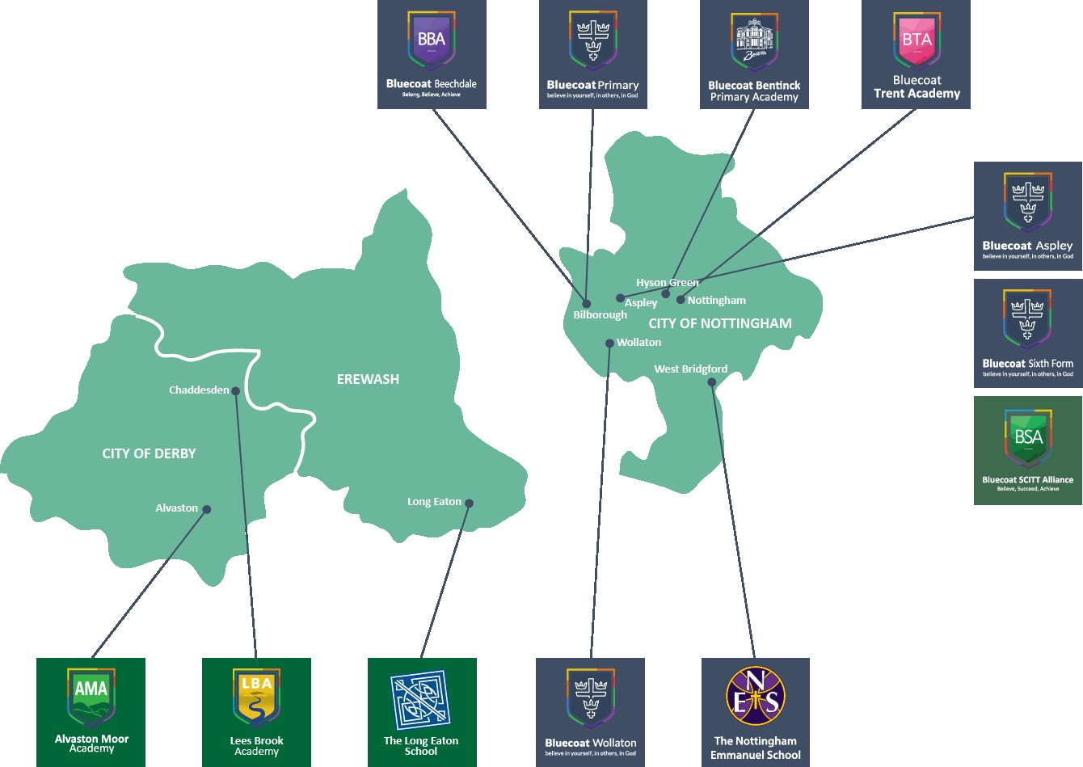
School Locations

Welcome from the Principal

It is with great pride that I introduce you to Lees Brook Academy.

We believe that every young person should have the chance to be successful, regardless of their ability or background and have access to a high quality broad and balanced curriculum. Our aim is that all students should leave the school as highly qualified, confident and well-rounded young people who will go on to be successful in the world of work. We ensure we equip students with the skills, knowledge and confidence for the future, and our dedicated body of staff here work tirelessly to support this success for all.

We are passionate about our students and are deeply committed to ensuring that they have a rich and successful experience at Lees Brook Academy. We set high standards and have high expectations in every aspect of school life. We are so proud of the many opportunities we provide for our students. There are a wide range of extra-curricular activities that students are encouraged to take part in, including trips, visits and activities, all organised to develop the whole person.

We really hope you choose to come on this journey with us and look forward to welcoming you to Lees Brook Academy. Do not hesitate to contact us for further information if you would like to visit us and learn more.



Clare Watson
Principal
The Vacancy

We are inviting applications for the above post of Level 1 Teaching Assistant based at Lees Brook Academy. This is an exciting opportunity to work within a team committed to improving attainment levels for students within the school. Applicants will have a passion for teaching and learning and an inclusive approach to education for all students. We are looking forward to welcoming new members of staff who can help fulfil our vision for supporting students with a varied range of additional educational needs across the school.

The successful applicants will be professional, adaptable and dedicated to delivering high quality teaching and educational support, ideally with experience of working students and young people. They will have strong communication skills with a range of stakeholders, including colleagues, leaders, parents / carers and students, and will be able to work cooperatively and effectively within a team of teaching assistants. They will be motivated and resilient, able to demonstrate the skills required to engage students in their learning.

Candidates should pay attention to the job description/person specification and explain within their application how they meet the criteria, whilst also describing what they will bring to the post from their own knowledge and experience.

The role will be based at Lees Brook Academy but the post holder may at any time be required to support or work at any of the sites within Archway Learning Trust.


Applications
For more information about Lees Brook Academy and the vacancy, please visit http://leesbrook.co.uk/index.php To apply for the role click apply which will take you to the application form for the post. We would encourage you to refer to the job description and person specification, demonstrating your suitability for the role.

Closing Date: **
Interview Date: **

Due to the number of applications we receive, it is with regret that we cannot respond to every application, if you do not hear from us within two weeks of the closing date, please assume that on this occasion your application has unfortunately not been successful.

Trust Ethos, Mission, Vision and Values


The Trust believes in the transformational power of education for each individual and that this is enhanced through collaborative working between the academies.

Safeguarding Children and Young People
Archway Learning Trust is committed to safeguarding and promoting the welfare of children and young people. All staff and volunteers are therefore expected to behave in such a way that supports this commitment. Appointment to this post will be subject to the following satisfactory pre-employment checks:

- Health
- Identity
- Relevant work qualifications
- Right to work in the UK
- Barred List Check (previously List 99)
- Disclosure & Barring Service Check (for all staff and volunteers)
- References
- Childcare Disqualification Declaration Check (relevant Primary School posts only)
- Online Searches

Job Description
POST TITLE: TEACHING ASSISTANT – LEVEL 1

GRADE: GRADE 5, Point 5-7

WORKING PATTERN: 37 Hours per week, Term Time Only

RESPONSIBLE TO: SENDCo

JOB PURPOSE
To work with students within the Academy as part of a team under the direction of the line manager in order to:
- Improve the quality of learning and foster the participation of students in the social and academic processes of the Academy;
- Seek to enable students to become more independent learners;
- Help raise the standards of achievement for all students.

GENERAL RESPONSIBILITIES
- Support the overall Christian ethos of the Trust.
- Be aware of and comply with Trust policies and procedures including but not exhaustive of:
- Acceptable Use of IT Policy
- Code of Conduct
- Extremism & Radicalisation Policy
- Health, Safety and Security Policy & Guidance
- Keeping Children Safe in Education (Part 1) Guidance
- Safeguarding Policy and Training Slides
- Whistleblowing Policy
- IT Pack including Acceptable Use Statement
- Health, Wellbeing and Benefits Policy
- Finance Policy
- Be aware of and support difference and ensure equal opportunities for all.
- Contribute to the overall aims of the Trust and Academy Improvement Plans
- To develop and implement own professional development and skills
- To behave in a manner that is professional, friendly, fair with students and colleagues demonstrating and role modelling politeness and respectfulness
- To demonstrate an excellent record of attendance and punctuality.
- Work cooperatively as part of the Trust wide staff team
- Undertaking any other duties which may reasonably be regarded as within the nature of the duties and responsibilities/grade of the post as defined.

SPECIFIC RESPONSIBILITIES
SUPPORT FOR THE STUDENTS
- To help students develop independent learning skills and manage their own learning
- Support and direct activities with either individuals or groups of students to ensure their safety and facilitate their physical, emotional and cognitive development.
- Help with care, personal hygiene and medical needs of students.
- Contribute to the health and well-being of students.
- Promote and reinforce the students’ self-esteem and independence.
- Establish and maintain good working relationships with individual students and groups.
- Encourage acceptance and inclusion for all students.
- To support groups of students as directed during formal, public or internal academy assessments.
- To assist students on educational visits, residential trips, transition, off site placements and recreational activities as appropriate.
- By following advice and guidance around individual needs, develop an understanding of the specific needs of the students within the Academy community.
- To liaise effectively with teachers/ parents/ carers as appropriate.
- Promote and reinforce the students’ self-esteem and independence.
- Support the transition process and with individualised programmes for targeted students.

SUPPORT THE TEACHER
- Liaise with classroom teachers and complete Teacher/TA contracts
- To work with staff to improve learning outcomes and ensure raised aspirations for those with SEND
- Create appropriate resources reflecting the various needs of students in lessons.
- Support student/s across the class as agreed by the teacher.
- Support with the collection of data for targeted students.
- To implement learning programmes as directed by the teacher – with individuals and groups.
- To monitor individual students and groups of students needs and provide feedback to the teacher.
- Support the management of student behaviour under the direction of the teacher.

SUPPORT FOR THE ACADEMY
- To assist in designing and maintaining an effective learning environment.
- Maintain effective working relationships with colleagues and parents.
- Maintain and safeguard the confidential nature of student/ teacher/ home issues.
- Contribute to the maintenance of student safety and security, including break and lunch time duties.
- Attend meetings as appropriate.
- Willingness to keep up to date with professional practice by maintaining an up-to-date understanding of the requirements of the role and individual responsibilities.

SUPPORT FOR THE CURRICULUM
- Support the teaching in delivering literacy and numeracy tasks to improve access across the curriculum in a planned manner
- Co-ordinate and organise students attending extra-curricular activities.
- Support the teaching in delivering learning activities including enrichment activities during and after the school day.
- Support the use and development of ICT within the classroom.
- Assist in the development and delivery of individual/small group intervention sessions under the direction of the Senior TA/Class Teachers/Subject leader.
- To liaise with and report to, as necessary, during visits by external support agencies who might be involved in the support of key areas of the curriculum. [Educational Psychologist, Speech Therapist, Inclusive Education Service, Academy Doctor etc.]
- To assess, record and report back on student achievement through Academy assessment procedures.

STAFF CONDUCT
- All employees are expected to familiarise themselves and follow the Trust vision and ethos during their working lives with Archway Learning Trust.
- We are professional people and expect professional conduct (behaviour and language) based on mutual respect, good manners, politeness and common courtesies for all members of our community. We expect that at all times employees behave in a manner that role models positive behaviours for our students to follow.
- Physical violence, verbal abuse and swearing are unacceptable and not tolerated.
- Employees are expected to maintain a professional relationship with students.
- Staff will be fully supported by the Trust at all times in carrying out the behaviour policy.

DRESS CODE
- The Trust expect staff to wear professional business dress mirroring our high expectations of our student dress code.
- Some functions within the Trust are required to wear uniform that will be supplied by the Trust.
- When working in the kitchens or any food outlet at the Trust, staff are expected to wear full protective clothing at all times.

PERSON SPECIFICATION – LEVEL 1 TEACHING ASSISTANT

 | ESSENTIAL | DESIRABLE
EDUCATION & TRAINING
Further or Higher Education | *
NVQ3 in Early Years Care and Education; BTEC National in Learning Support; The Council for Awards in Children’s Care and Education [CACHE] Diploma or relevant experience |  | *
Take responsibility for own professional development and be willing to partake in further in-service or external staff development and training | *
EXPERIENCE
Previous experience of working within an educational setting |  | *
Ability to use resources and materials including ICT software and equipment | *
Experience of working with children with special educational needs |  | *
Working knowledge or be willing to build knowledge of safeguarding procedures, behaviour management practices, health and safety legislation for working with students and other regulatory body’s legislation and policy relating to education |  | *
PROFESSIONAL SKILLS
Excellent written and oral communication skills | *
Excellent organisational and administrative skills | *
Ability to establish positive relationships  with students, families and colleagues | *
Ability to provide support for planning and delivery of learning activities. | *
Ability to organise classroom resources and assist with the maintenance of pupil records. | *
Willingness to identify and develop own IT skills | *
PERSONAL QUALITIES
Confidence and independence | *
Ability to work unsupervised and independently understanding school roles and responsibilities and your own position within these | *
Builds and maintains effective relationships with colleagues and stakeholders in a fair and equitable manner | *
Good time management skills | *
Commitment to Equal Opportunities | *
Willingness to work within the Christian framework of the Trust | *
Suitability to work with children. Enhanced DBS check to be undertaken on appointment | *

