**Caretaker**

**37 hours per week / Full year**

**\*Part time hours would be considered\***

**Actual salary £21,575 - £21,968**

**(26 days holiday which rises to 31 days after 5 years’ service)**

Role information

Closing date for applications: Monday 4th September 2023 at 9am

Interviews will take place soon after.

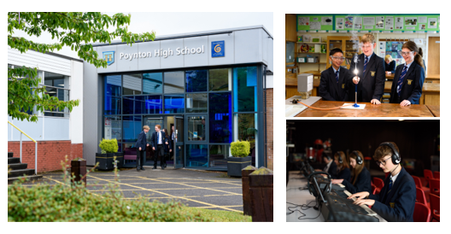

**Dear applicant**

Thank you for your interest in working at our school.  Poynton High is a great school, full of inspirational young people and exceptionally talented staff.  As Headteacher I am proud to have such a supportive, expert and engaged staff team and I hope that you will wish to move forward on your application and look to join us in due course.

We require an enthusiastic and flexible individual to assist in the efficient management of the buildings and site. Experience of work in a trade or DIY skills and/or ground keeping will be advantageous. The post holder will be part of a team of five who presently form a very efficient Site Team. There will be a full induction programme into the post with full training.

We offer a generous 26 days holiday per year, in addition to Public Holidays, that rises to 31 days holiday after 5 years’ service.

Our school has served the families of Poynton, Disley, Adlington and surrounding areas since 1972 and we lie at the heart of this community’s learning needs.  We pride ourselves on our vision as a school which serves our whole community and which works in partnership with our colleagues in other schools.  We have approximately 1450 students in Years 7 to 13 and offer a wide range of A levels in our successful Sixth Form.

Our staff support our students in an extraordinary range of ways and at the heart of this lies our House System.  Every member of staff and every student is in one of our four Houses and we have an extensive programme of House Activities on offer; from House Water Polo to House Fishing, from House General Knowledge to House Dragons’ Den; as well as the traditional football, rugby, lacrosse, athletics, basketball, etc.

The school motto is INSPIRE ACHIEVE CELEBRATE and we apply that to every element of school life.  Our role as staff is to ensure that we inspire every student to achieve the best they possibly can in everything they do, whether that be academic, sporting, cultural or in the community and at the heart of our culture is a celebration of that achievement.  We hope that as a prospective member of staff you will share our mission to “inspire and empower all within our learning community to fulfil their individual potential and ambitions so that all are able to be active and successful citizens in our global society”.

I would encourage you to visit our website ([www.phs.cheshire.sch.uk](http://www.phs.cheshire.sch.uk)) to get a better understanding of life here at Poynton High and if you have any questions that you would like to ask please do not hesitate to contact me directly on [mdean@phs.cheshire.sch.uk](mailto:mdean@phs.cheshire.sch.uk).  I very much hope that you want to join our team and I look forward to receiving an application from you in due course.  Good luck!

Matthew Dean

Headteacher

# Job Description

We are seeking an individual to be responsible for the security of the premises and its contents; including being the registered key holder. To ensure that the lighting and heating systems are in good working condition and to carry out cleaning of designated areas. Undertaking minor repairs and porterage duties will also be required.

|  |
| --- |
| Work alongside the site team to maintain the school building, including effecting repairs and improvements in order to fulfil the school’s specific responsibilities. |
| Monitor and operate the engineering system (i.e., heating, etc.) and advise management of any faults in order to ensure the most economical use of fuel and water. |
| Discuss with and monitor the work of contractors engaged by the school to ensure specified standards are achieved. |
| Monitor, operate and maintain appropriate site security systems, including opening and closing the building at the beginning and end of the school day, lettings outside school hours and responding to call outs as necessary in order to provide satisfactory security arrangements. |
| Maintain the appearance of the school through light cleaning duties including emptying outside bins and litter picking. |
| Maintain and monitor Health and Safety standards, reporting any failures to comply with the school’s statutory obligations in this area and ensure that contractor’s work meets Health and Safety Regulations. |
| Carry out DIY, portering and cleaning duties (including the moving of heavy furniture) which will secure the most efficient use of resources. |
| Order supplies in order to maintain the necessary stock of appropriate resources. Receive delivery of supplies, furniture and parcels and ensure their correct distribution. |
| Carry out general grounds maintenance duties in and around the school including:-   * grass cutting using tractor or sit-on mower; * maintenance of school lawned areas, planted beds and shrubbery; * line marking on the school sports pitches;   maintain the school site free of litter and debris at all times. |

Notwithstanding the detail in this job description, in accordance with the Trust’s Flexibility Policy the job holder will undertake such work as may be determined by the Trust Senior Team from time to time, up to or at a level consistent with the Main Responsibilities of the job.

**CORE RESPONSIBILITIES FOR ALL TRUST EMPLOYEES**

**Safeguarding & Child Protection**

The TRUE Learning Partnership is committed to safeguarding and promoting the welfare of children and young people and expects all staff to share this commitment and adhere to, and comply with, the Trust’s Safeguarding and Child Protection policy and procedures at all times.

**Health & Safety**

All staff within The TRUE Learning Partnership are required to remain vigilant, observe all relevant Health and Safety policies and procedures, take reasonable care of their own and others’ Health and Safety, report all accidents and incidents, and raise concerns through their line manager, the site management team or another member of SLT as appropriate.

**Equality & Diversity**

Staff employed by The TRUE Learning Partnership are expected to promote equality of opportunity for all students and staff, both current and prospective, and to support an environment that values diversity and respect. The TRUE Learning Partnership believes that all individuals are of equal value and we are committed to equal opportunities for all.

**Data Protection**

All staff within The TRUE Learning Partnership have a responsibility to ensure that data they are responsible for is accurate and appropriate to the needs of the organisation, and that they are responsible for ensuring any personal data processed for any purpose or purposes in connection with their role in the Trust shall not be kept for longer than is necessary for that purpose or those purposes, in accordance with GDPR 2018.

**Person Specification**

|  |  |
| --- | --- |
| **QUALIFICATIONS AND TRAINING** | |
| **Essential** | **Evidence** |
| 1. To have basic levels of literacy and numeracy | **AF** |
| 2. To have excellent communication skills | **AF** |
| **Desirable** |  |
| 1. To have experience of working in the secondary sector of education. | **AF** |
| **PROFESSIONAL SKILLS AND EXPERIENCE** | |
| **Essential** |  |
| 1. To have DIY skills or skills in a specific trade, such as carpentry | **AF** |
| 2. To be able to work with a range of staff, students and outside agencies | **AF** |
| 3. To be able to contribute to the grounds’ maintenance programme | **I** |
| 4. To be able to remain calm under pressure | **I** |
| **Desirable**. |  |
| 1. To have knowledge of Microsoft Office and other computer packages | **I** |
| 2. To have knowledge of Health & Safety | **I** |
| **KNOWLEDGE AND UNDERSTANDING** |  |
| **Essential** | |
| 2. To be aware of the unique demands of working in a school environment. | **I** |
| 3.To be willing to be flexible and adapt as priorities change throughout the year | **I** |
| **ABILITIES** |  |
| **Essential** | |
| 1. To display good quality interpersonal and communication skills | **I** |
| 2. To be able to prioritise, plan and organise workload. | **I + R** |
| 3. To be able to work as a member of a team | **I + R** |
| 4. To be able to operate a range of equipment. | **I** |
| **COMMITMENT** |  |
| **Essential** | |
| 1. To display commitment to the protection and safeguarding of children and young people | **I + R** |
| 2. To be committed to promoting equal opportunities in the widest context. | **I** |
| **PERSONAL ATTRIBUTES** |  |
| **Essential** | |
| 1. To be adaptable to the needs of the School | **I + R** |
| 2. To have energy, enthusiasm and determination. | **I + R** |
| 3. To have commitment, reliability and integrity. | **I + R** |
| 4. To be sensitive to the demands on other people in school | **I** |
| 5. To be able to manage time effectively. | **I** |
| 6. To be aware of the School’s position in the wider community and of its wide range of stakeholders | **I** |

Key to evidence source: AF = Application Form

LO = Lesson Observation

I = Interview

R = Reference

**Key information regarding the application process**

**Further details**

For further details, please contact the HR team via [recruitment@truelearning.org.uk](mailto:recruitment@truelearning.org.uk)

**To apply**

Applicants are required to submit a completed Teacher application form which is available from the school website [www.phs.cheshire.sch.uk](http://www.phs.cheshire.sch.uk)

Applications should be sent to [recruitment@truelearning.org.uk](mailto:recruitment@truelearning.org.uk)

**Closing date**

Closing date for applications: Monday 4th September 2023 at 9am

Interviews will take place soon after the closing date.

*The TRUE Learning Partnership is an inclusive Equal Employment Opportunity employer that considers applicants without regard to gender, gender identity, sexual orientation, race, ethnicity, disabled or veteran status, or any other characteristic protected by law. We welcome applications from all individuals regardless of individual background or circumstance.*

*The TRUE Learning Partnership is committed to safeguarding and promoting the welfare of all children* *and young people and preventing extremism; all staff must ensure that the highest priority is given to following the guidance and regulations to safeguard children and young people.*

*The successful candidate will be required to undergo an Enhanced Disclosure from the Disclosure and Barring Service (DBS) and obtain any other statutorily required clearance including an online check. Employment will also be conditional on the receipt of at least two acceptable references (one of which must be from the current/latest employer) and evidence of the formal qualifications required for the role.*



**Trust vision and ethos**

TRUE Learning Partnership’s vision, as a community-based Trust, is that all its students will benefit from an outstandingly rich and broad education within its ethos and values.

Vision

A community focussed, values based, learning organisation that meets the needs of all its stakeholders so that all will achieve.

Values

Serve our communities with 'An unswerving commitment to ensure every young person achieves their potential, whatever their circumstances'.

Every child, every chance



**Information regarding the constitution of the Trust Board**

The constitution of the Trust Board is set out in the Articles of Association. Trustees are appointed / elected or co-opted for a period of four years. The Chair of Trustees is elected every four years. Trustees appoint the Chief Executive Officer to assure the strategic intentions of the Multi Academy Trust.

The Chief Executive is also a trustee director of the Multi Academy Trust. As per the scheme of delegation, the CEO and Trustees work in partnership with the local governing bodies to appoint Headteacher’s to take responsibility for the day-to-day management of the individual schools.

The regular meeting of Trust management and local Headteachers will be facilitated through the Trust Executive Strategic Group to help facilitate the sharing information and expertise, to aid efficient working and to help provide creative solutions to the many challenges in the current educational landscape.

**Why work for the Trust?**

TRUE Learning is a community based, values focused, cross phased multi academy trust based across Cheshire and Derbyshire. All five academies in the Trust are closely located to one another which lends itself to many opportunities to work closely and collaboratively. Our vision is a community based, values focused, learning organisation that meets the needs of all its members so that all will achieve. By working within our community clusters, we will ensure that every child that is presented to us at the age of 3 is the best they possibly can be by the time they leave us at 18.

All our schools have excellent road links from the M56, M60, M67, A6, A34 and A57 and nearby railway stations of Poynton, Hadfield, Disley, and New Mills Central. For those travelling from further afield, both Stockport railway station on the West Coast mainline and Manchester Airport are both nearby.

We are exceptionally proud of our staff and the dedication they display every day to support our students to reach their potential. Whether a member of our Leadership Team, Teaching Staff or Support Team – all have a vital role to play in providing an environment where we can provide world class education where all can achieve.

We offer highly competitive salaries, pension scheme membership, free on-site parking and regular social events. All staff are able to access discounted gym memberships and other negotiated benefits across the Trust.

The Trust provides an Employee Assistance Programme through Health Assured which offers a wide range of services including legal and wellbeing support for employees and their families.

The Trust places at the heart of its development a commitment to high quality professional development for all staff who join the Trust. The CPD@TTLP programme enables all of our staff to access development opportunities across the Trust. Future goals and aspirations are supported through this programme to ensure that all staff are able to develop and achieve their own personal goals.

Staff wellbeing and providing a positive and healthy working environment is a key priority for us, as supporting all of our staff enables them to support all of our students. Our Director of Health and Wellbeing leads this key area working with senior staff across the multi academy trust. We are very pleased that our commitment to staff wellbeing has been recognised by the Valued Worker scheme which offers accreditation to workplaces where staff feel valued.

We are also committed to supporting mental health in the workplace by training a number of teaching and support staff across our Trust to be Mental Health First Aiders and through our work with the Time to Change programme which aims to end mental health discrimination in the workplace.

**Information about our academy schools**

**Poynton High School**

We are a very special school where the whole school team passionately believe in creating a school that truly meets the needs of all in our learning community. This is embodied in our mission statement which serves to guide us in the long-term planning for our school.

“We will inspire and empower all in our learning community to fulfil their individual potential and ambitions so that all are able to be active and successful citizens in our global society”

This can be summed up in three words, INSPIRE ACHIEVE CELEBRATE and is applied to every aspect of our work. We aim to inspire our young people in all of our work so that they may achieve their full potential and at the heart of this lies a truly celebratory culture; we aim to inspire our team, so that you can achieve, and we celebrate every achievement for everyone - staff and student. (Matthew Dean, Head Teacher)

**Lostock Hall Primary School**

We are a growing (205 students) Primary School, serving children from the age of 3 to 11. We are a safe, stimulating and friendly school which provides an inclusive, calm, caring and productive learning environment. Our aim is to challenge and support each other and every child to help them realise their potential and to make a positive difference to their lives. Children leave Lostock Hall Primary school very well prepared for their future learning at secondary school and beyond.

Through our guiding principles of Be Ready, Be Respectful and Be Safe we deliver a carefully designed curriculum which progressively meets the needs of our children through fun learning and leads to excellent outcomes. (Graham Hamilton, Head Teacher)



**Disley Primary School**

Our school is a very special place to be. We pride ourselves on being a happy, caring school where each child is valued as an individual. We aim to provide a stimulating learning environment which allows every individual to fulfil his/her potential.

We constantly seek exciting ways of delivering both the Foundation Stage and National Curriculum requirements, along with opportunities for social and moral development. Our children are at the heart of everything we do. (Jake Nicklin, Headteacher)

**Glossopdale School**

Our School is a warm and caring community for all of our 1244 students, from when they join us in Year 7 to when they leave us in Year 13. We are a school that has the highest expectations of students and ourselves, where every student is expected to work hard, behave well and contribute positively to the school community.

Our core purpose is to support students of all abilities and backgrounds to develop high aspirations and achieve their potential. We do this by nurturing and building ambition for our students, we open opportunities, broaden horizons and introduce challenges ensuring everyone can thrive, both academically and personally, to be the best that they can be.

We are in the very fortunate position to work within a new purpose-built school which opened in September 2018. This has benefitted staff and students in so many ways. Our students learn in a modern, open and inclusive environment which has been designed to reflect and compliment the local landscape. (Debbie McGloin, Executive Head Teacher)

**Hague Bar Primary School**

Here at Hague Bar Primary School, we have worked hard to develop a school which provides an excellent education by helping each child to achieve her or his full potential. Our skilled staff foster a happy and caring atmosphere, where children can succeed through our personalised learning process, ensuring no child is left behind.

The origins of Hague Bar Primary School stretch all the way back to 1854, with a school which was in existence at the Strines Print Works. Hague Bar Primary School is just inside the Derbyshire border. It lies between the town of New Mills in Derbyshire and Strines in Cheshire. The school is situated on the edge of the countryside and enjoys stunning views of fields and distant hills.

We are proud of, and celebrate, the achievements of our children, both in and out of the classroom, and we are here to help your child make the most of their potential. (Karen McCurdy, Head of School)

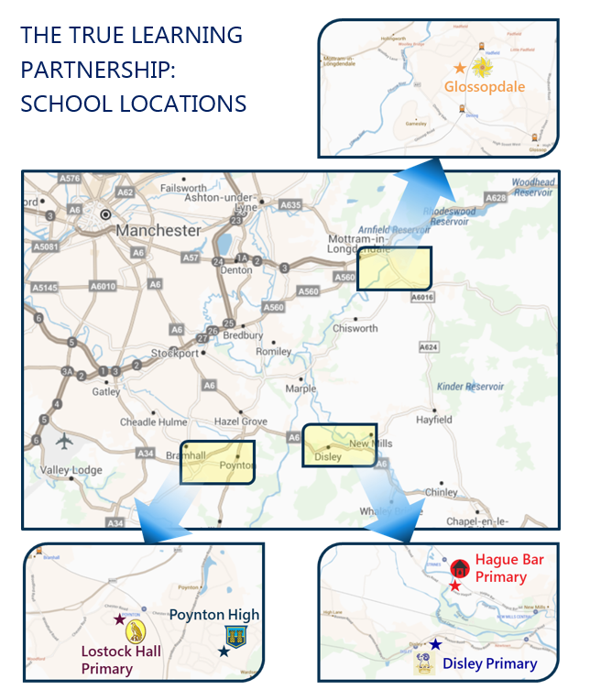

**TRUE LEARNING PARTNERSHIP:  
SCHOOL LOCATIONS**

Our partnership of primary and secondary schools is located to the south-east of Manchester, close to the natural beauty of the Peak District National Park.

All our schools have excellent road links from the M56, M60, M67, A6, A34 and A57 and nearby railway stations of Poynton, Hadfield, Disley, and New Mills Central.

For those travelling from further afield, both Stockport railway station on the West Coast mainline and Manchester Airport are both nearby.

**Trust Safeguarding Statement**

TRUE Learning (TL) recognises the important role that our schools and their staff have in the wider safeguarding system for children. **ALL** staff have a responsibility to provide a safe environment in which children can learn. The Trust fully adopts statutory guidance “Keeping Children Safe in Education” (September 2022).

TRUE Learning is committed to safeguarding and promoting the welfare of children and young people and expects all staff and volunteers to share this commitment. Our schools are a safe place for children, where our responsibilities for safeguarding children are taken seriously. As a Trust, we are responsible for ensuring that all our schools have thorough and robust child protection and safeguarding policies and procedures.

Should you have safeguarding concerns regarding any pupil at any of our schools, please speak to one of the Designated Safeguarding Leads at that school. Full details of key contacts for safeguarding in each of our schools is listed below.

The Trust’s Designated Safeguarding Officer is Catherine Holyland, Safeguarding Lead and Deputy Head Teacher at Poynton High School. If you wish to contact her directly please e mail [cholyland@truelearning.org.uk](mailto:cholyland@truelearning.org.uk)

The Trust Board safeguarding representative is Lucy Monk. If you wish to contact her, please email [info@truelearning.org.uk](mailto:info@truelearning.org.uk) stating that the email relates to a safeguarding issue.

Our schools’ Local Governing Bodies are regularly updated about child protection, bullying and safeguarding policies and practices by the relevant school Head Teachers, and other members of the Senior Leadership Team. This information is reported to the Trust Board.

For further details on roles and responsibilities, and recording information regarding Safeguarding, please see the Safeguarding Policy and Procedures documents held by each school in our Trust.

