
JOB DESCRIPTION

JOB TITLE: Programme Manager – Engineering

REPORTS TO: Head of School – Engineering

AREA: Engineering

REMISSION: Up to 400 hours

GRADE/SALARY: Salary up to £43,077 per annum

POST NO: LC009

CLOSING DATE: Sunday 24th September 2023

DBS: Enhanced DBS check with children’s barred list check required

PURPOSE:

The programme manager will have responsibility for the Engineering curriculum across all levels from Level 1 to Level 6. They will also be involved in the continuous development of the provision within the wider school in which Engineering sits. The post holder will ensure that agreed targets are met and that provision is consistent across all areas of the school.

PRINCIPAL DUTIES:

- To support the Head of School (HOS) in recruitment, retention, achievement and to ensure quality assurance within this area.

- To support the HOS with effective induction, guidance, admissions, registration, and exam procedures.

- To support the HOS with behaviour management issues including attendance, punctuality, and adherence to the code of conduct.

- To support business planning and timetabling of the curriculum within the school under the direction of the HOS.

- To support the HOS in the implementation of the cover plan.

- To participate in the self-assessment and quality improvement process.

- To champion Equality and Diversity.

- To teach/assess a specified number of hours on a range of programmes and act as course tutor for designated groups within the specified area.

- To line manage a group of staff, including, teachers, assessors, technicians as well as support staff.

- To conduct the appraisal/check ins of designated staff.

- To be course co-ordinator for engineering programmes.

- To contribute to curriculum intent and development.

- To contribute to the marketing of programmes, recruitment, and interviewing.

- To play an active part in the development of the flexible curriculum and the learning materials to support this including the college’s virtual offer.

- To develop external contacts and promote industry-based work including work experience placements where applicable.

- To demonstrate commitment to professional development.

- To be proactive in maintaining and developing quality standards on all programmes and demonstrate a commitment to quality improvement.

- To adhere to policies, procedures, and values of Solihull College & University Centre.

- To actively promote equality, diversity & inclusion and to champion anti-racist practice.

- To undertake all mandatory training in a timely manner as required e.g. Safeguarding, Prevent.

- To undertake necessary Health and Safety responsibilities, duties and training as required by this post.

- To undertake any necessary Data Protection responsibilities, duties and training as required by the post.

- Such other duties as required which are broadly consistent with the general functions and grading of this position.

EQUAL OPPORTUNITIES:

Solihull College & University Centre is committed to a comprehensive policy of Equal Opportunities. All employees are required to abide by this policy and ensure its compliance throughout the College.

SAFEGUARDING:

Solihull College & University Centre is committed to ensuring a safe environment for all students and expects all staff to engage fully with this commitment.

CORE VALUES:
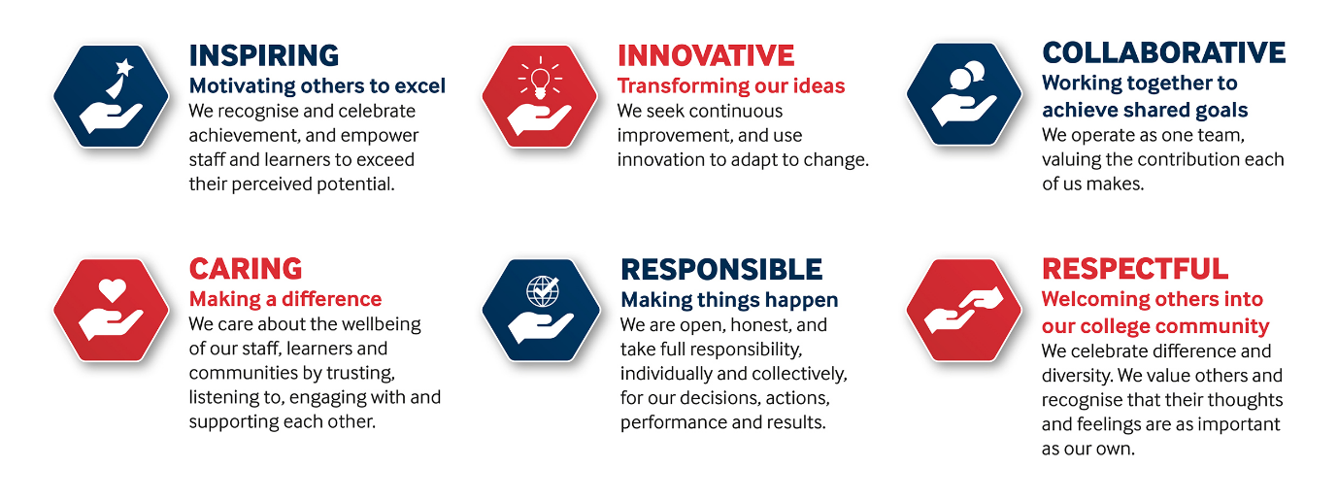

SOLIHULL COLLEGE & UNIVERSITY CENTRE
PERSON SPECIFICATION

JOB TITLE: Programme Manager – Engineering

SALARY: Salary up to £43,077 per annum

POST NO: LC009

SPECIFICATION | ESSENTIAL | DESIRABLE
EDUCATION/  TRAINING | Appropriate Degree or significant industry experience in a relevant subject area.  Level 5 teaching qualification or working towards.
RELEVANT EXPERIENCE | Experience teaching in the FE sector.  Significant experience of coordinating programmes.  Curriculum development and innovation experience.  Sound and current knowledge of built environment curriculum within the FE sector.
SKILLS/  APTITUDES | Excellent communication and IT skills.  Ability to network effectively  Ability to motivate others and lead and work effectively as part of a team  Sound understanding of one or more areas of provision within the school  Able to manage change and conflict
OTHER  REQUIREMENTS | Dedication to the development and maintenance of quality  Flexible approach to work  Energy and Enthusiasm  Strong commitment to Equal Opportunities  General awareness of cultural diversity  A commitment to the Safeguarding of Young People and Vulnerable Adults and an awareness of the Government ‘Prevent’ strategy  Commitment to the College’s Values

