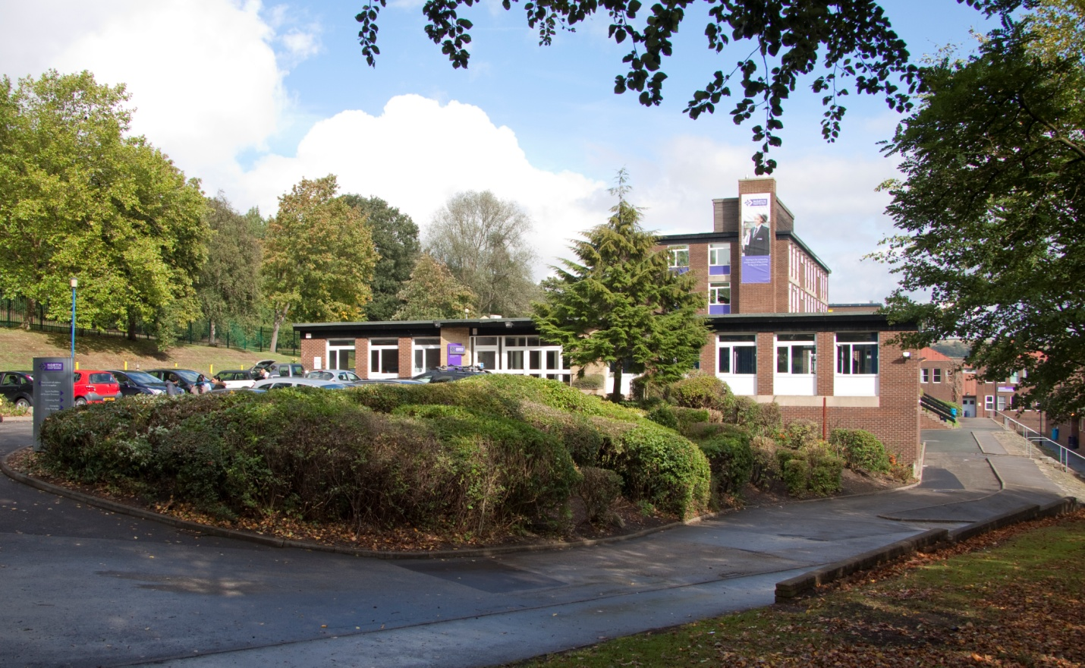

Vacancy: Head of Geography
Applicant Information Pack

Welcome

Thank you for your interest in the currently advertised position of Head of Geography at North Huddersfield Trust School.
The school opened in 2011 and has more than doubled in size. We currently have 750 students on role and expect this to continue to grow. Judged as ‘good’ during the most recent Ofsted inspection and with a level of pastoral care recognised to be excellent, there is a confidence in the effectiveness of approach and the impact made across all areas. A values focused ethos has been firmly established; this is reflected in the extremely strong relationships which are evident across the school.
As Headteacher since May 2019, I am in the privileged position of leading the school in its quest to provide a safe and happy environment in which our students thrive. Recruiting staff with the potential to make a significant contribution to this is crucial. As a subject lead, you will play an important role in developing the curriculum so that all students fulfil their potential and in ensuring standards of teaching and learning are of excellent quality. It is a high profile and potentially very rewarding role.
You will undoubtedly conduct research on our school and will see that the most recent KS4 outcomes were disappointing. Please do not allow this to stop you applying for the position. We are at an extremely exciting phase of our development with a largely new senior leadership team and strong middle leadership which includes staff who are new to post. We fully expect outcomes for the current academic year to show significant improvement but are also focused on developing a curriculum that meets our long term mission in creating engaged, critical and resilient learners equipped to become the people who define, shape and transform society.
Please take the time to read the contents of this pack carefully and to look at our website which provides lots of information about the school, its values, links and identity.
I hope that, having read through all the available information, you are keen to submit an application and look forward to receiving it. If you would like to visit the school, information on how to arrange this is included in the ‘Vacancy Details’ section.
Thank you again for your interest in the position and, should you choose to make an application, I wish you the best of luck.
Andrew Fell
Headteacher

Vacancy Details
Head of Geography
MPS/UPS + TLR 2b
Closing date: Tuesday 19th November (9am)
Start date: April 2020 or before if possible

North Huddersfield Trust School is recognised by Ofsted as a 'Good' school which is outstanding in its work around students' personal development, well-being, safety and security. We continually drive forward standards and are passionate about maximising the potential in all. Our caring and nurturing approach to education within and beyond the classroom contribute to what makes our school a special place both to work and to learn.

We place great value on the fulfilment and well-being of our colleagues; our successes to date are in no small part down to their hard work, commitment and determination and as a relatively new school, our growing student roll enables us to provide opportunities for both personal and career development.

We are seeking to appoint a talented individual with a flair for leadership and innovation, as well as a clear commitment to driving progress and raising attainment in geography. The successful candidate will demonstrate exemplary subject knowledge and curriculum awareness, a robust understanding of data and its application to bridge gaps in performance as well as a passion for geography and a desire to make it accessible to all students. It is essential that you are an outstanding classroom practitioner and an enthusiastic educationalist capable of providing aspirational leadership

If you would like further information please contact the Headteacher, Andrew Fell

Applicants are welcome to visit our school.
If you would like to arrange such an opportunity, please email nbrown@nhtschool.co.uk.

If you wish to apply for this post please apply through the TES website www.tes.com or North Huddersfield Trust School’s website www.nhtschool.co.uk. Applications should be returned to Mrs Nora Brown, Operations Manager, by email to nbrown@nhtschool.co.uk
by 9am on Tuesday 19th November 2019.
Interviews are planned for the week commencing 25th November.

We are committed to safeguarding and promoting the welfare of children and young people and expect all staff and volunteers to share this commitment. All staff are subject to an enhanced DBS check. A conviction may not exclude candidates from appointment but will be considered as part of the recruitment process.
Woodhouse Hall Road, Huddersfield, West Yorkshire, HD2 1DJ 01484 452100
www.nhtschool.co.uk

JOB DESCRIPTION
Role | Head of Department (Geography)
Pay scale | MPS/UPS + TLR 2B
Weekly hours | Full time

Role summary
To shape, develop and deliver the national curriculum in the subject area. To shape the vision for the department and to promote a love of the subject across the school. To be accountable for quality student learning and the expected standards of student attainment and achievement with the department through a systematic focus on high quality and innovative teaching.
Key Responsibilities:
- Leadership
- Teaching and learning
- Personal development
- General

Duties
Key accountabilities | Key tasks
Leadership | - Be accountable for the performance of the department, including student progress, staff performance and departmental standards  - Devise, implement, monitor and evaluate departmental development plans  - Line manage departmental staff, ensuring staff are motivated and given the opportunity and support to develop their own skills and drive standards within the department  - Attend school meetings on behalf of the department  - Adhere to reporting requirements and deadlines on behalf of the department
Teaching and learning | - Fulfil professional responsibilities as established in the teachers’ standards documentation and in line with the school’s code of conduct and expectations  - Work within the boundaries of school policy, including appropriate consideration of school budget and resources  - Contribute to the design and delivery of the whole school development plans, taking responsibility for those areas relevant to the subject area as agreed with the line manager  - Oversee progress of students in the subject area/s specific to the role and work with departmental colleagues to ensure that assessment is rigorous and interventions are proactively managed  - Design and deliver a curriculum that meets the identified needs of all learners and fulfils the school’s core purpose  - Take responsibility for the learning and achievement of all students in allocated classes, ensuring an inclusive and differentiated approach  - Be committed to achieving at least good outcomes for all students  - Use data to review performance, set aspirational targets and identify areas for improvement  - Create and maintain a vibrant and positive learning environment where students can thrive  - Ensure consistency of standards to ensure that all students have the opportunity to maximise their potential  - Adhere to deadlines for all assessment, reporting and other aspects of school life as agreed with the line manager  - Set an excellent example to students as a role model of good behaviour, professionalism and respect  - Consistently uphold the school’s behaviour policy  - Build and maintain positive working relationships with stakeholders, including colleagues, students and parents, ensuring that communication is timely and accurate and in line with the school’s ethos
Personal development | - Develop self and others through the participation in the school’s continual professional development programme  - Commit to continual development of teaching skills, seeking and / or embracing new and creative techniques and technologies  - Contribute to the school’s extra-curricular and / or transition programmes  - Develop leadership skills as befitting the strategic and operational requirements of the role  - Assist in the recruitment of new staff
General | - Undertake the role of Form Tutor and fully participate in the work of the Year Team  - Always uphold the school’s PRIDE agenda  - Adhere to strict standards of confidentiality  - Ensure compliance with data protection, equal opportunities, health and safety and safeguarding regulations, policies and guidance

This job description is not necessarily a comprehensive definition of the post and may be subject to modification or amendment at any time after consultation with the post holder. Additional duties may be requested from time to time which are commensurate with the post.
We are committed to safeguarding and promoting the welfare of children and young people and all post-holders are expected to share this commitment.

Reports to: | Assistant Head
Responsible for: | Departmental staff

PERSON SPECIFICATION

 | ESSENTIAL | DESIRABLE
Education / qualifications | - Degree or equivalent  - Qualified Teacher Status  - Evidence of recent professional development  - Passion for continual professional development | - Experience of whole school responsibilities
Specialist knowledge / skills | - Outstanding high school teacher  - Excellent subject knowledge throughout both KS3 and KS4  - Knowledge and understanding of inclusion in a whole school setting  - Up to date knowledge of curriculum and assessment and how to develop highly effective schemes of work  - Ability to analyse and apply data in developing provision designed to maximise student potential  - Thorough understanding of safeguarding and child protection  - Professional resilience | - Evidence of contribution to whole school development
Leadership / management | - Positive attitude with the ability to lead by example and motivate others  - Ability to delegate effectively in order to support and develop the team whilst maintaining professional accountability  - Ability to set clear and high expectations of others  - Ability to plan and prioritise tasks  - Excellent attention to detail  - Outstanding communication skills  - Proven presentation skills  - Ability to take the lead and effectively delegate  - Good negotiating skills  - Professional resilience  - Sensitive and diplomatic approach | - Experience of leading teams of staff  - Experience of recruitment procedures  - Ability to objectively review procedures and introduce well planned, well communicated changes as required

Please use the above person specification to inform your supporting statement which should be no longer than 2 sides of A4.

The interview panel will assess each candidate against the above criteria, expecting candidates to demonstrate knowledge and understanding of each area and showing evidence of having applied, or an awareness of how to apply, this knowledge and understanding in the context of our school.
References will also be used to assess the ability of candidates against these criteria.

We are committed to safeguarding and promoting the welfare of children and young people and expect all staff and volunteers to share this commitment. All staff are subject to an enhanced DBS check. A conviction may not exclude candidates from appointment but will be considered as part of the recruitment process.

