Intent: The Curriculum
Contents
Ethos: What are we trying to achieve? 2
School Aims 2
Achieving Excellence, Shaping Futures 3
Curriculum: What are we trying to achieve? 4
The 5 Pillars of the Curriculum 4
Principled Design: Curriculum Aims 5
Values underpinning the curriculum 6
Holistic Threads: Holistic learning outcomes 6
Praise & Reward: The Fernwood Award 8
Depth, Breadth & Balance 12
Quality, Choice & Diversity 13
Characteristics of “The Fernwood Way” 14

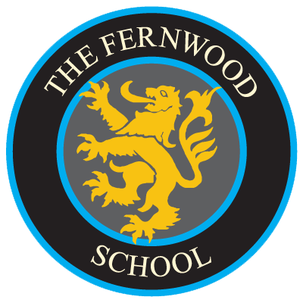

Ethos: What are we trying to achieve?

Our aims, values, expectations and aspirations are clearly set out below. It is our intention to realise these every day for the benefit of all who learn and work in our school. High Achievement with Care and Discipline for All is both our moto and our challenge. It is our intention to achieve “The Fernwood Way”, by adopting, practising and galvanising the positive personal and collective attitudes as outlined.
At the heart of “The Fernwood Way” lies equality of opportunity and shared understanding, respect and tolerance for each other’s differences and needs. It is a values driven, person centred, philosophy.

School Aims
- To challenge every pupil to raise their aspirations and excel in academic achievements
- To instil in pupils the values and characteristics necessary to become successful, confident and responsible members of society
- To teach pupils the value of self-discipline, resilience and endeavour in order to become life-long learners
- To prepare pupils to participate in and contribute to a society with ever changing scientific, technical and international needs
These aims are underpinned by:
- Very effective teaching leading to a stimulating and enjoyable educational experience for all
- A broad and balanced curriculum, which offers real choice and opportunity in an ever changing technological world
- A well ordered and disciplined environment where pupils feel safe and happy
- An extensive programme of enrichment where pupils can develop their talents and interests
- Strong bonds between home, school and the community that reinforce the school’s success
“High Achievement with Care & Discipline for all”
These are embodied in our school motto of
High Achievement with Care and Discipline for All which permeates all aspects of school life.

Achieving Excellence, Shaping Futures
The Fernwood School is a richly diverse multi-cultural community based on the principles of mutual respect for all. These principles allow everyone to contribute to an environment which is both supportive and challenging. Pupils learn to develop a positive self-image alongside respecting the rights, feelings and beliefs of others. At Fernwood everyone’s uniqueness is valued and celebrated. Pupils are encouraged to share their own cultural experiences and to explore, understand and value the diversity of cultures within our community.
At Fernwood our priority is to deliver high quality teaching and learning. We believe that all pupils have the right to a stimulating learning environment where they are motivated to learn through the provision of a varied and engaging curriculum. Our teachers and support staff work tirelessly to guarantee that our pupils have the very best education possible. Everything we do as a school is to ensure that all pupils can achieve their very best.
Our high expectations are evident both in lessons and around school. We promote and achieve excellent standards of behaviour; we expect pupils to behave in a way that supports their own learning and that of others. We want every pupil to be successful; to strive for success from the very first day they join us and throughout their school lives.
Fernwood pupils are ambitious and understand the value of hard work. They have a strong sense of responsibility, are caring and compassionate to others and are engaged and enthusiastic learners. We expect visitors to Fernwood to notice, enjoy, and often comment on, the politeness, manners and warmth they see from the moment they enter the school.
At Fernwood we are always aspiring to be the best we can be and inspiring others to do the same. We take pride in what we do and strive to be better each day.
Our ambitions for the Fernwood pupil are to;
- be ambitious and understand the importance of hard work
- have good relationships with adults and peers
- be caring and compassionate
- be prepared for the challenges of society
- have a strong sense of responsibility and discipline
- be socially, morally and spiritually aware
- be able to operate as part of a team and have leadership skills

Curriculum: What are we trying to achieve?
In very simple terms we want our students to be good people and make the most academic progress they possibly can; gaining good and meaningful qualifications with the highest examination results possible. However, our curriculum is far from simple. It is our vehicle to do much more than focus on examination results. Our curriculum is about the development of the “whole person”. It’s about encouraging and enriching learning, recognising positive achievement in all its forms and nurturing the motivation, character and personal development of every individual.
There are five fundamental components to what we are trying to achieve with our curriculum. We call these the five pillars of the curriculum.

The 5 Pillars of the Curriculum
- Principled Design – A curriculum which is based on a clear philosophy, rooted in “The Fernwood Way”. It is aspirant and its shared aims remain central to all decisions, leading to “High achievement with Care & Discipline for all” in a climate which develops a strong cultural capital.
- Holistic Threads – Intertwined throughout the whole curriculum are our holistic learning outcomes. These embody the personal learning and thinking skills required for successful learning and the attitudes and dispositions required to nurture character, care and self-discipline.
- Praise & Reward (The Fernwood Award) - Recognising and valuing wider achievement and progress in all its forms. Giving students motivation, a strong feeling of success and providing a platform to gauge, measure and recognise their progress.
- Depth, Breadth & Balance – The curriculum is knowledge driven. It is designed to broaden and deepen knowledge and use this as a vehicle for the development of skills and understanding. It is wide reaching, embracing the national curriculum and character curriculum, providing a rich learning experience in its own right, whilst preparing young people for life beyond Fernwood.
- Quality, Choice & Diversity – The curriculum seeks to offer quality provision. Standards are high in all areas affording young people an element of choice and diversity. They are empowered to make decisions in a climate of clear advice and effective guidance. Curriculum pathways and progression routes forward are designed to meet the needs of all learners.

Our terminology used when referring to the curriculum
Wider curriculum | The total experience which young people enjoy at Fernwood School.
Taught curriculum | Traditional timetabled lesson time. This may include imersion days or alternative timetabled lessons.
Pastoral curriculum | This includes assemblies, tutor periods / tutorial time. It may include mentoring or additional support activities to meet the needs of individuals e.g.EBD intervention
Extra-curricular | These are additional activities outside the normal timetable. They are often associated with clubs, societies and teams. Trips, visits and residential learning may be involved. Participation in extra-curriculur activitiy is useually voluntary.

Principled Design: Curriculum Aims
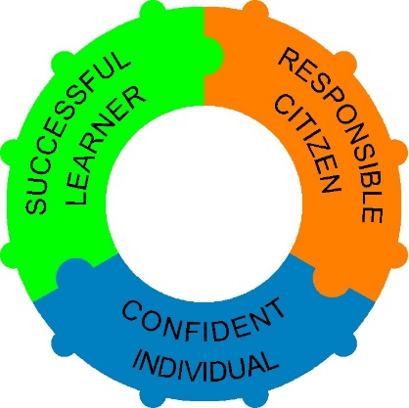
The Fernwood School wider curriculum includes the entire planned learning experience for pupils. It is based on shared aims and offers coherent approaches to learning. At its heart lies the individual learner. Meeting learner’s needs, embracing statutory programmes of study, preparing learners for life-long learning and becoming active citizens are important elements of the wider curriculum; they represent the core entitlement for all pupils. Our curriculum aims focus on the qualities and skills learners need to succeed in school and beyond. These aims inform all aspects of curriculum planning, teaching and learning at whole-school and subject levels.
The curriculum should enable all young people to become:

- successful learners who enjoy learning, make progress and achieve
- confident individuals who are able to live safe, healthy and fulfilling lives
- responsible citizens who make a positive contribution to society.

Successful learners who: | Confident individuals who: | Responsible citizens who:
- have the essential learning skills of literacy, numeracy and information and communication technology  - are creative, resourceful and able to identify and solve problems  - have enquiring minds and think for themselves to process information, reason, question and evaluate  - communicate well in a range of ways  - understand how they learn and learn from their mistakes  - are able to learn independently and with others  - know about big ideas and events that shape our world  - enjoy learning and are motivated to achieve the best they can now and in the future  - adopt a growth mindset. | - have a sense of self-worth and personal identity  - relate well to others and form good relationships  - are self-aware and deal well with their emotions  - have secure values and beliefs, and have principles to distinguish right from wrong  - become increasingly independent, are able to take the initiative and organise themselves  - make healthy lifestyle choices  - are physically competent and confident  - take managed risks and stay safe  - recognise their talents and have ambitions  - are willing to try new things and make the most of opportunities  - are open to the excitement and inspiration offered by the natural world and human achievements. | - are well prepared for life and work  - are enterprising  - are able to work cooperatively with others  - respect others and act with integrity  - understand their own and others’ cultures and traditions, within the context of British heritage, and have a strong sense of their own place in the world  - appreciate the benefits of diversity  - challenge injustice, are committed to human rights and strive to live peaceably with others  - sustain and improve the environment, locally and globally  - take account of the needs of present and future generations in the choices they make  - can change things for the better.
While these aims are separated into three distinct categories, each aim complements and reinforces the others.
Our diagrammatic representation of these connections as pieces of a jigsaw is deliberate. We use the jigsaw analogy to show how the various elements “fit together” to support the development of the whole child (who remains at the centre). Further layers are added to this jigsaw below. | 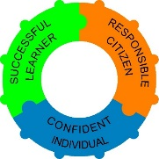
Values underpinning the curriculum
Our curriculum reflects the enduring values that contribute to personal development and equality of opportunity for all.
These include values relating to:
- the self, recognising that we are unique human beings capable of spiritual, moral, intellectual and physical growth and development
- relationships, as fundamental to the development and fulfilment of ourselves and others, and to the good of the community and society. We value others for themselves, not only for what they have or what they can do for us
- our society, where truth, freedom, justice, human rights, the rule of law and collective effort are valued for the common good. We value families, including families of different kinds, as sources of love and support for all their members, and as the basis of a society in which people care for others. We also value the contributions made to our society by a diverse range of people, cultures and heritages
- the environment, both natural and shaped by humanity, as the basis of life and a source of wonder and inspiration that needs to be protected.
At the same time learners must be enabled to respond positively to the opportunities and challenges of the rapidly changing world in which we live and work. In particular, we need to be prepared to engage as individuals, workers and citizens with economic, social and cultural change, including the continued globalisation of the economy and society, with new work and leisure patterns and with the rapid expansion of communications technologies.
Holistic Threads: Holistic learning outcomes
In order to prepare and equip our learners for life in an uncertain future world, we have identified a set of holistic learning outcomes to be embraced across the wider curriculum. These are as follows and relate to the core aims as shown.
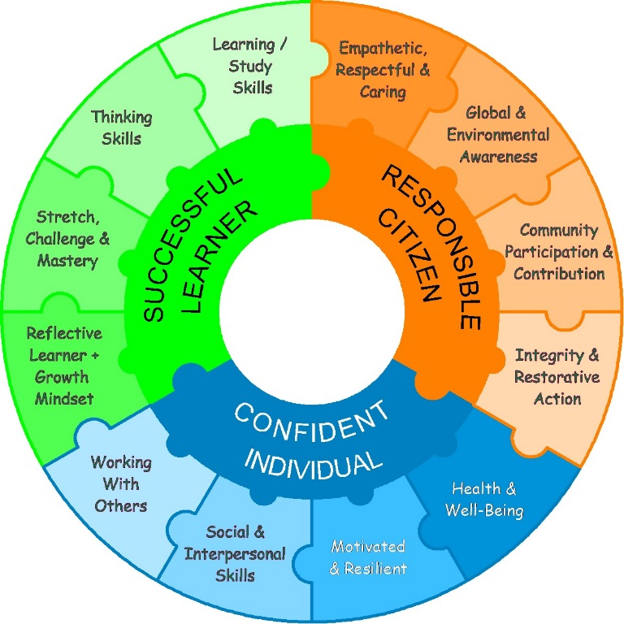
The successful learner uses tools and develops techniques to enhance and improve:
“My Learning” through:
- Learning skills
  - memory techniques
  - study skills
  - wider & home learning
- Thinking Skills
  - Independent enquiry
  - Critical thinking
  - Creativity
“My Progress” through
- Stretch, Challenge & Mastery
  - Securing learning objectives
  - Deep understanding
- Reflective Learner with a Growth Mindset
  - Assess oneself
  - act on feedback
  - adopt a growth mindset

The confident individual enjoys strong personal and social skills and seeks to improve:
Personal – “My well-Being”
- Motivation and resilience
  - Confidence
  - self-awareness/ esteem
  - resourceful
- Health & Well-Being
  - Healthy lifestyle
  - Fitness & Safety
  - Emotional & mental health
Social – “Teamwork”
- Interpersonal skills
- Working with others
  - Group work
  - Leadership
The responsible citizen displays positive attitudes and acts to improve:
“Citizenship” through:
- Empathy, Respect & Care
  - Respectful & helpful
  - Caring for others
  - Social conscience
- Global & environmental awareness
My “Getting Involved” through:
- Participation
  - Wider school contribution
  - Community participation
- Integrity & restorative action
  - Dignity, sense of justice
  - Honesty & trustworthiness
  - De-escalation & conflict resolution
  - Responsible action

All words emboldened and in italics reflect our direct link between our holistic threads and The Fernwood Award see p10.

Holistic Threads: Learning Outcomes
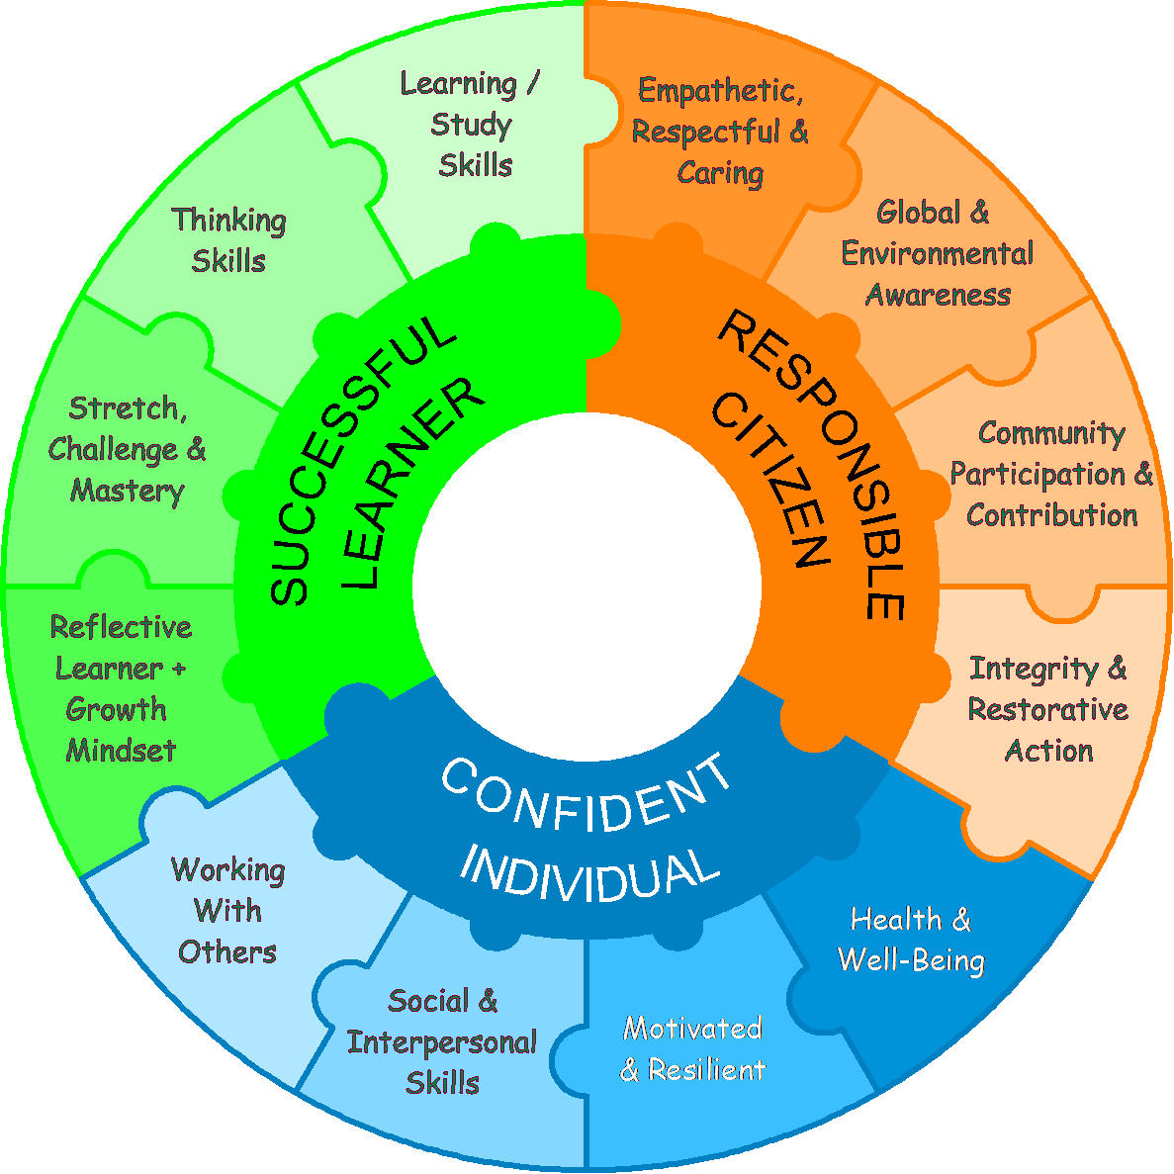
Motivated & Resilient
Young people are enthusiastic and motivated; they enjoy and engage with their learning, having positive determination and perseverance. They organise themselves, showing personal responsibility, initiative and enterprise. They actively embrace change, responding positively to new priorities, coping with challenges and looking for opportunities.

Social & Interpersonal Skills
Young people develop a range of social and interpersonal skills. They understand their rights and responsibilities as individuals who belong to many social groups. They communicate effectively and listen well. They take others’ feelings into account, use a range of strategies to manage relationships, and have the tools to repair relationships which have been damaged.
Learning & Study Skills
Young people use brain exercises to aid studying and improve memory. They apply strategies for knowledge retrieval and recollection, using cues, stimuli and associations. Through a wide range of techniques they organise learning and information e.g. mind mapping, chunking, note taking and graphic organisers. They apply revision strategies, use games, tips and resources.
Thinking Skills
Young people use a variety of thinking tools/ techniques. They have enquiring minds, solve problems and think critically; contextualising, analysing and evaluating information, judging its relevance and value. They think creatively by generating and exploring ideas and making connections. They question and challenge assumptions, demonstrating inventive and innovative reasoning.
Stretch, Challenge & Mastery
Young people push themselves to reach the most advanced knowledge, skills and understanding possible. Their progress is evidenced by meeting increasingly complex learning objectives and challenges. As well as moving forward they deepen their knowledge and understanding, applying their learning to new and unfamiliar contexts, leading to mastery and fluency.
Reflective Learner with a Growth Mindset
Young people evaluate their strengths and limitations, setting themselves realistic goals with criteria for success. They monitor their own performance and progress, welcoming feedback from others and making changes to further their learning. They adopt a growth mindset, think positively about how to learn, their learning preferences / journey and maintain motivation.
Working with Others
Young people work confidently with others, adapting to different contexts and taking responsibility for their own part. They listen to and take account of different views. They form collaborative relationships, resolving issues to reach agreed outcomes. They work well in familiar and unfamiliar teams, playing different roles. They demonstrate very effective leadership skills.
Health & Well-Being
Young people know themselves and manage their emotions. They actively promote healthy lifestyles for themselves and others. They are physically and mentally health and safety conscious. They learn from their own mistakes and successfully manage barriers to learning; including stress. They positively look after themselves both physically and emotionally, and manage risk well.
Global & Environmental Awareness
Young people are globally and environmentally aware; they are conversant with the impact of identity and cultural diversity, technology, media and communications. They appreciate and act positively to secure the environment and its resources for present and future generations. They consider issues at school, community, national and global levels.

Community Participation & Contribution
Young people act as informed and thoughtful citizens, demonstrating an awareness and appreciation of issues of concern. They are actively involved in the community, maintaining responsible influence and participation. This includes working with members of the wider community, engaging positively in projects and/or contributing to the care and welfare of others.
Empathetic Respectful & Caring
Young people respect, understand, value and support the thoughts and feelings of others. They listen to and empathise with others and respond with positive effect. They show respect for themselves, others, the community and environment, valuing and celebrating difference. They demonstrate a caring disposition.
Integrity & Restorative Action
Young people have moral purpose; they understand the difference between right and wrong. They act with honesty, integrity and trustworthiness, valuing different opinions and having a strong sense of justice. They exercise responsibility for themselves, others and the community, working to de-escalate and resolve conflict, taking restorative action when appropriate.

Praise & Reward: The Fernwood Award
One of the pillars of our wider curriculum is provision to encourage, recognise, value and capture achievement in all its forms. We call this The Fernwood Award. Here, we articulate what we are trying to achieve with The Fernwood Award. Its importance in pulling together, and bringing to life, all the pillars of our curriculum, in a student friendly format, cannot be overstated. There is a deliberate connection between our curriculum aims, holistic threads and The Fernwood Award.
The Fernwood Award is a voluntary, non-competitive programme designed to encourage students to develop their wider skills and participate in diverse activities. There are three progressive levels of the programme which when successfully completed lead to a Bronze, Silver or Gold Award. Students are credited through the normal school rewards system and enhance this through their involvement in opportunities & challenges provided in school and beyond. They are able to plan and create their own programme.
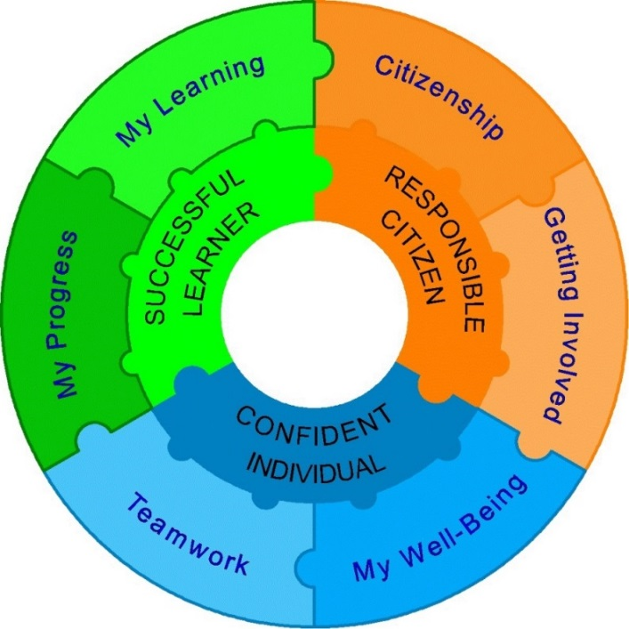
Students are awarded in recognition of their active engagement and endeavour to promote their personal development, learning and contribution to the care of others and the world around them. Participants in the award develop new skills, broader life experiences and a wide range of personal attributes which will stand them in good stead for the rest of their lives. The award demonstrates to future employers and educational institutions that the awardee has a balanced all-round skills-set and competencies to complement formal academic qualifications.
The award shows a willingness for individuals to go "the extra mile" to become Successful Learners, Confident Individuals and Responsible Citizens.
The Award is divided into 6 categories as shown.

The diagrams below illustrates an example of how the separate skills, competencies and aptitudes across the curriculum feed into our holistic outcomes. Progress towards these outcomes is directly recognised within The Fernwood Award.

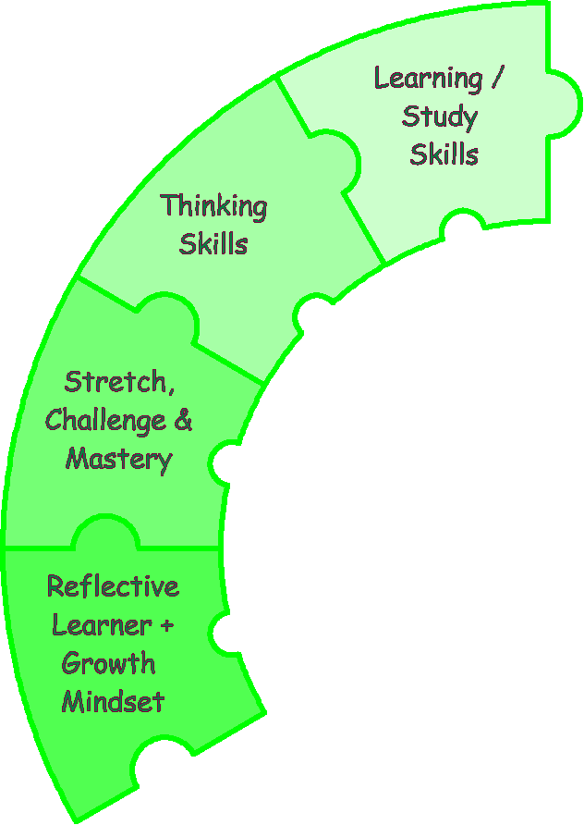
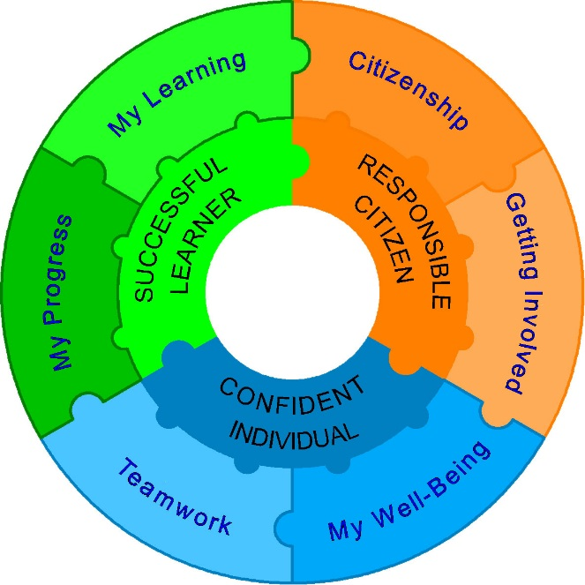
Linking attributes, skills and competencies to our Holistic Threads and The Fernwood Award.
Securing Learning Objectives
Deep Understanding
Learning Gains
Self-Assessment & Evaluation
Commitment to Self -Improvement
Accepting & Acting on Feedback
Wider / Home Learning
Study Skills
Memory Techniques
Problem Solving Skills & Creativity
Critical Thinking
Independent Enquiry

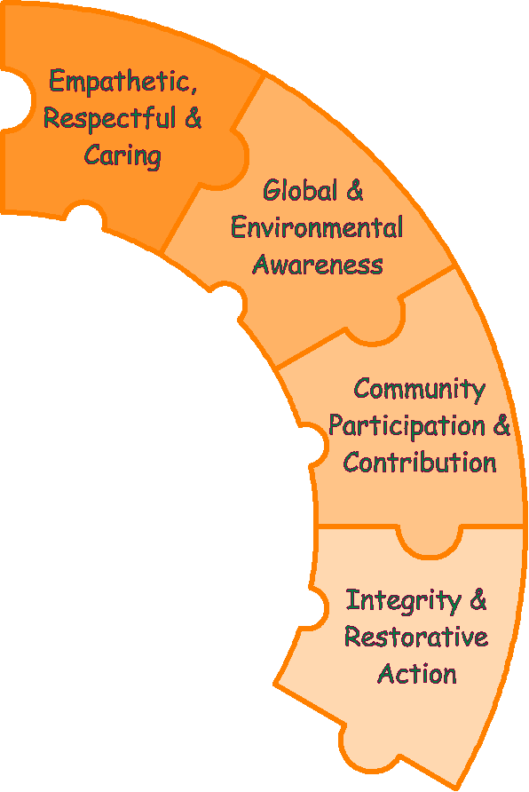
Responsible Action
De-escalation & Conflict Resolution
Honesty & Trustworthy
Dignity, Sense of Justice
Community Involvement & Volunteering
Clubs, Teams & Societies
Wider School Contribution
Environmental Ambassador Local/Global
Investing in Community Cohesion
Conservation Action
(Life & Resources)
Tolerant & Open-Minded
Considerate & Supportive of Others
Social Conscience
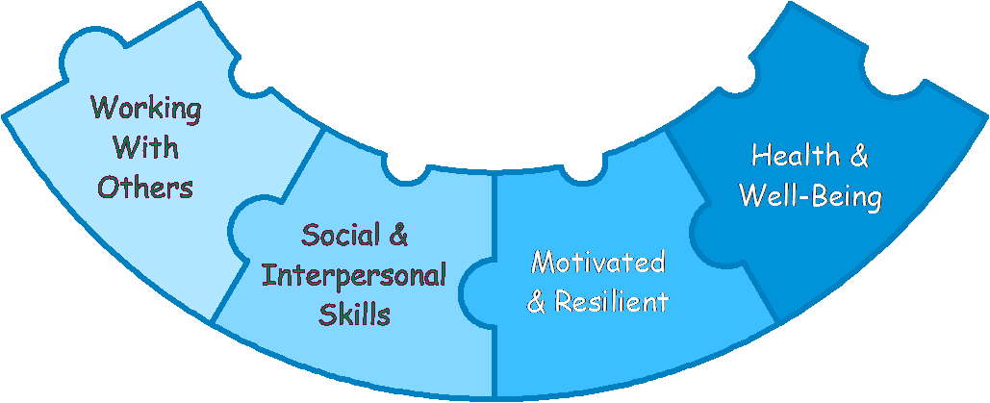
Forming positive Relationships
Co-operation & Negotiation Skills

Listening & Communication Skills
Resilient &
Determined
Self-Aware / Self-Esteem
Enthusiastic & Confident
Emotional Health & Happiness
Physical Health & Fitness
Lifestyle Choices
Leadership
Adaptable, Play Different Roles
Strong Team: Member/ Builder

Depth, Breadth & Balance
The Fernwood taught curriculum is rooted in a traditional approach to subjects and the acquisition of knowledge, skills and understanding. Interwoven throughout the curriculum are competencies and experienced designed to promote each child’s personal development and wider learning.
We provide a broad and balanced curriculum relevant to young people in the 21st century. We set high expectations and challenge all pupils to become independent learners who can take responsibility for their own work.
Our taught curriculum is intended to be:
- balanced in its breadth of subjects and topics
- rigorous to the disciplines taught
- coherent within and across subjects
- engaging through compelling learning experiences
- designed to promote progress over time
- ambitious in its expectations of pupils and the standards they achieve
- appropriate for the stage of students’ learning
- focused in its choice of content, and
- relevant to our young people.
Our curriculum design ensures that all pupils are exposed to depth and breadth of experience in a wide range of fields including:
- Aesthetic and creative
- Ethical
- Linguistic
- Mathematical
- Scientific and technological
- Social & political
- Spiritual
- Physical
Young people learn about how to be an effective learner, how to use thinking skills and how to learn with others. In Personal Development they focus on interpersonal skills, teamwork and self-awareness. These plus the key skills of Literacy, Numeracy, ICT and Problem Solving are developed across all subjects as each individual improves as a creative, reflective and critical learner.
The KS3 curriculum includes English, Mathematics, Science, French & German, Art, Computer Science, Drama, Design & Technology, Geography, History, Music, RE, PE and Personal Development.
Subjects, individually and collectively, identify hierarchical learning objectives. These objectives fulfil and go beyond the requirements of the national curriculum. They are progressive and tailored to meet pupil need. Pupil progress through these objectives is assessed and monitored. Personalised feedback is provided with next steps to learning.

Quality, Choice & Diversity
In KS4 all pupils follow a core curriculum. Some Faculties introduce an element of choice within the core. In addition pupils also choose from a broad range of courses according to their own preferences and chosen pathway. These options include:
- Academic courses – a broad selection of GCSE subjects
- Vocational / Applied courses – e.g. leading to Technical Awards
- Foundation Learning – this pathway provides a route forward for less academic learners, focusing on Functional Skills, Personal development and vocational learning.
The core curriculum at KS4 includes English, mathematics and science at GCSE level plus non examination courses in PE and Personal Development. Most students also work towards a GCSE in religious education as part of their core curriculum.
It is our intention to inform pupils and parents about the EBACC as well as perspectives on school accountability measures. However, there is no intention to make specific combinations of subjects compulsory. Our options offer is intended to provide as much choice and diversity as possible, in addition to the core curriculum.
Information, advice and guidance, sex and relations education and careers education all form part of the personal development programme. Preparation for working life, including work experience are also built into KS4.

Characteristics of “The Fernwood Way”

What do we mean by “The Fernwood way”?

The Fernwood way describes a positive mindset. It is an attitudinal way of being, which we encourage students and adults to embrace, both in school and beyond.

The Fernwood way is typified by a set of characteristics.
It is not oue intention to set Fernwood above anyone else, but to value these characteristics in ourselves and others.

The Fernwood Way

- Developing a well-rounded whole child, not just about academic ability.
- Culture of modelled behaviour.
- High expectations culturally.
- Meaningful social interactions - +ve and supportive.
- Family feel/school community (include wider community).
- High social aspirations.
- Independent learners.
- Dignity and respect for all – demonstrated by staff and pupil actions.
- Self-belief.
- Valuing all, tolerance.
- Togetherness.
- Courteous, doors opened, ‘hello’, welcoming.
- Confident in social interactions.
- Kindness.
- Respect for all – for their education and the education of others.
- Embodies ‘High achievement with care and discipline for all’
- Tangible relationships that make up a community.
- Praise - Fernwood Award.
- Beyond ‘the Fernwood Way’
  - Global
  - Skills for life
- Celebrating success – own and others.
- Opportunities for all – enrichment, inside and outside the classroom.
- Mutual respect.
- Celebrating effort and endeavour.

