Queen Elizabeth’s High School

An Outstanding 11-18 Grammar. Original Charter 1589.

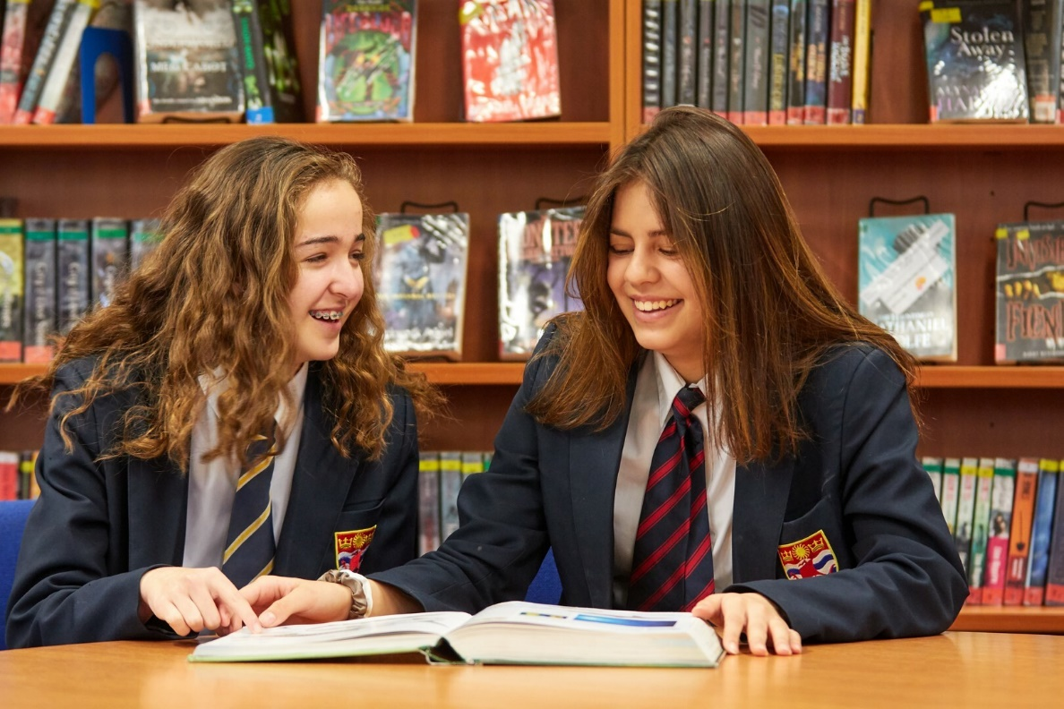

Vacancy Information Booklet
Teacher of English
Full time, permanent
MPS / UPS

Queen Elizabeth’s High School is entirely committed to safeguarding and promoting the well-being of all of its students. Each student’s welfare is of paramount importance. Successful candidates are therefore required to reveal information concerning all convictions and offers of employment will be subject to an enhanced background check by the Disclosure and Barring Service (DBS)

Closing Date: Midday on Monday 1 March 2021
Interviews: To be provisionally held week commencing 8 March 2021

School Vision
Queen Elizabeth’s High School is a school where children can grow and develop into successful young adults who are equipped with the knowledge, skills and qualifications to follow their dreams and aspirations. Qualifications are a key element of that success and our past results at both GCSE and A Level speak for themselves; we are regularly listed in The Times top 200 schools list. However, education is more than that, and here at QEHS we provide a safe environment in which young people can grow and learn who they are, what interests them and who they would like to be in the future.
School Motto and Values
Tradition Achievement Opportunity
At Queen Elizabeth's High School we aim for high standards in all we do.
♦ We strive to fulfil the potential of each student.
♦ We aim to achieve this through a carefully planned, broad education in which enthusiastic teachers use a variety of teaching styles in activities inside and outside the classroom.
♦ We aim to maintain a friendly and caring atmosphere in which students and staff share a mutual respect.
♦ When they leave Queen Elizabeth's High School we want students to be well-balanced adults, inspired to continue their learning and able to contribute positively to society.
♦ Queen Elizabeth’s High School is committed to the highest possible standards of child protection.
The selection criteria for student admission to QEHS in Years 7-11 benefits children of staff who have worked at our school for more than two years, or who are recruited to fill certain key posts. See the full Admissions Policy on our school website (www.qehs.lincs.sch.uk).
The English Faculty
The QEHS English Faculty is a high performing faculty and very popular with students.
The English Faculty is led by a Faculty Head and two Second in Department Leads with responsibility for KS3 and A-Level English. We have 7 teachers in all.
This is a forward-thinking faculty, with the unique ability to offer specialist teaching to our students. The faculty is friendly and supportive. We have staff with a wealth of experience, as well as staff early in their career.
There are 6 English classrooms as well as a very well stocked school library. Computer rooms and a Drama studio are also bookable resources available. We are very well resourced for classroom lessons and have a good range of digital resources to support our students.
The faculty is well lead and managed. As such we are able to plan strategically to best support the students in our care, as well as each other. Teachers new to the faculty are well supported by a mentor and/or their Head of Department. Reviews and observations consistently show teaching and learning to be good, or better. Faculty planning and policy is open to review and feedback from all stakeholders, and also takes into consideration work life balance.
Results 2019 (last external examinations)
GCSE - English Language 9-4 97%, 9-7 28%, 9-8 11%; English Literature 9-4 93%, 9-7 28%, 9-8 12%
A Level - Language and Literature A*-E 100%, A*-B 86%; Literature A*-E 100%, A*-B 82%

The English Curriculum
It is the intention that our curriculum challenges and enriches our young people, exposing them, as far as possible, to a wealth of human knowledge, experience and understanding. We therefore plan our curriculum carefully to ensure a broad education for all students throughout the whole of their career at school.

Through delivering our English curriculum our intent is to inspire students to appreciate and create literature and to understand and use language to thrive in the world beyond school. Our curriculum is rich, varied and challenging. We study a broad variety of fiction and non-fiction texts across all key stages, including Shakespeare in every key stage. In terms of breadth and challenge, we deliver over and above the National Curriculum subjects. Enjoying a love of learning and a passion for reading in particular are key focuses and we have a close relationship with our librarians. We have superb borrowing rates which reflect this. In and beyond the classroom, we expect that students should develop not just knowledge, but also skills, aesthetic appreciation and an understanding of concepts and the community they live in at local, national and global levels, as well as appropriate attitudes and values.
Years 7 - 9
Students follow schemes of work that have been developed and resourced in house to meet the aims and objectives of the National KS3 PoS as well as to prepare them for GCSE. Students are taught in mixed ability groups. All Year 7 and 8 classes have a weekly timetabled Library lesson and use the Accelerated Reader programme. Year 9 have a fortnightly Library lesson and use the Bedrock vocabulary programme. All classes have a fortnightly SPAG lesson.

Years 10-11
Students follow the AQA Language and Literature GCSE courses. Schemes of work have been developed in house to meet the individual needs of our learners. We have two top sets per year group and six parallel mixed ability classes. They are all taught by specialist teachers.

Sixth Form
We offer AQA Language and Literature combined course and AQA Literature Specification A at A Level. English is a popular A Level choice and we have thriving groups in both subject areas. Classes are shared between two specialist teachers.
Extracurricular
The English Faculty enjoys providing a wide range of extra- curricular activities to enrich our curriculum and take our love of learning beyond the classroom. A sample of what we offer is below:
Competitions | Visits/Other Activities
English Speaking Union | Annual visit to the First World War Battlefields
Rotary Youth Speaks – regional winners and national finalists | Year 8 Guardian Newspaper Visits
Regular entries to external poetry competitions e.g. Foyle Young Poets, Carol Ann Duffy Remembrance Competition | Year 8 Annual Newspaper Day Event
Young Writers Competition | Regular theatre visits for GCSE and A Level especially
In house creative writing competitions | Carnegie Award Reading Group
‘Send My Friend to School’- regional ambassadors | Year 7 Annual Readerthon Sponsored Read
World Book Day Competitions | Writers’ visits and workshops
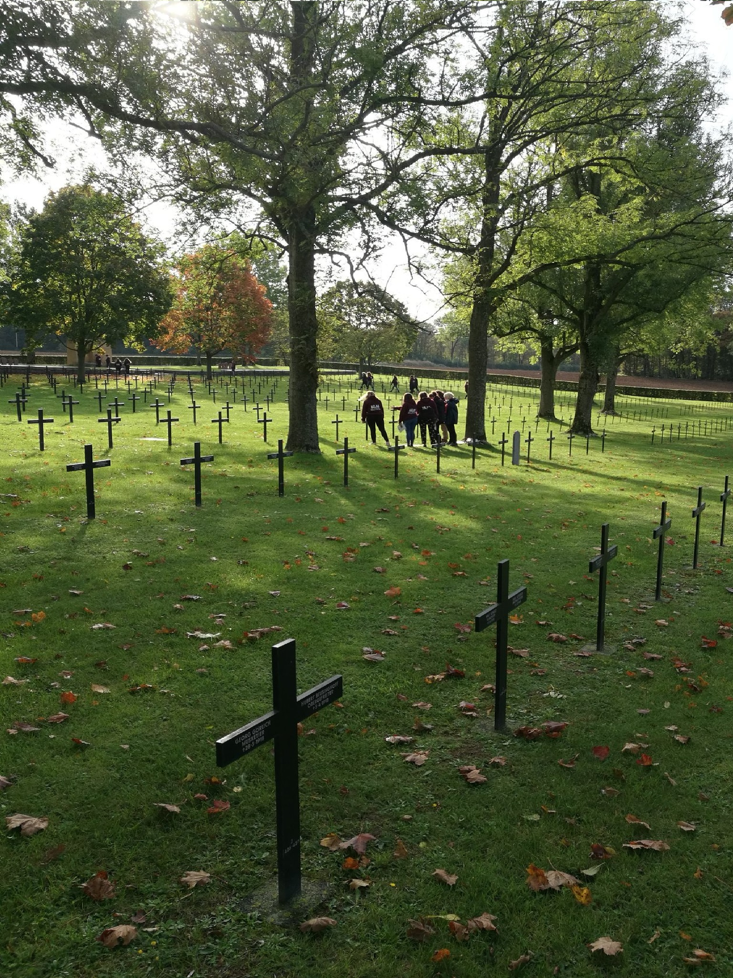

HOW TO APPLY
We believe that QEHS is a great place to work. Please read the information in this booklet, the subject teacher job description and have a look at our website. Should you wish to apply, application details are available on our school website (www.qehs.lincs.sch.uk) or by emailing a request to recruitment@qehs.lincs.sch.uk.

A letter of application is required to accompany the formal application form. This must be limited to one side of A4 paper and is an opportunity for you to explain how you believe your own experience equips you for the post and for you to outline how you would approach this role at QEHS.

You are also welcome to telephone 01427 612354 ext. 267/264 if you have any questions about the post.

Completed applications should be submitted by email to recruitment@qehs.lincs.sch.uk by midday on Monday 1 March.

We will contact your referees for a reference before the interviews and, for shortlisted candidates, the references will be taken into account in deliberations at the conclusion of the final panel interviews. Interviews will provisionally be held week commencing 8 March 2021.

Candidates are required to bring to interview evidence of all relevant qualifications listed on their application as well as certificates for A Level, degree, teaching and other qualifications acquired. Please also bring proof of identity, including at least one item of photographic evidence (current passport or new style UK driving license with associated counterpart licence). A list will be provided detailing which documents can support your application. Please be aware that at least one document should include your National Insurance number. Candidates will also be provided with a self-disclosure form. This will allow them the opportunity to disclose and fully explain any information with regard to disciplinary sanctions, anything they are concerned might appear on their DBS, etc.

Queen Elizabeth’s High School is committed to safeguarding and promoting the welfare of children and young people and expects all staff and volunteers to share this commitment. The successful candidate will be subject to an enhanced DBS check.

Queen Elizabeth’s High School is committed to equal opportunities and staff development. Our policy is to ensure that no job applicant or employee receives less favourable treatment because of race, colour or nationality, gender, marital status, religion, disablement or criminal record (QEHS policy 17a). Members of staff are expected to set a good example in their appearance and smart office dress is a good guide for all staff.

QEHS and Lincolnshire Children Services are committed to
the highest standards of child protection and staff development.

Queen Elizabeth’s High School

Original Charter 1589

Morton Terrace ∙ Gainsborough ∙ Lincs DN21 2ST ∙ Tel (01427) 612354
Website: www.qehs.lincs.sch.uk Email: office@qehs.lincs.sch.uk
CO-HEADTEACHERS: Mr Peter Russell & Mr Neil Allan

Original Charter 1589

