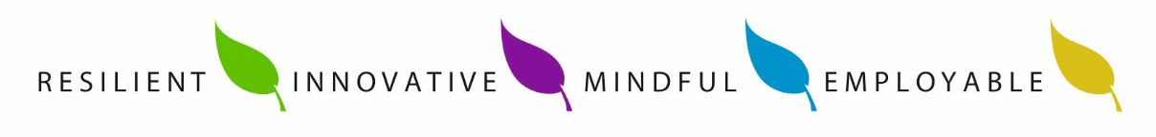

Kingsmead School

Science Department

## Staffing and Accommodation

The Science department at Kingsmead are enthusiastic, motivated and dedicated to ensuring all pupils receive the highest standard of education in Science. We are committed to embracing new teaching ideas and methodologies to further enhance the education our pupils receive. The department has 10 full-time teaching members of staff and 1 part time teaching member of staff including 5 Biologists, 3 Physicists, 3 Chemists and 2 Computer Science staff. There are also four members of SLT within the department.

Science is housed in 10 laboratories served by two preparation rooms. All labs have data-projectors or touch screen display boards. The Curriculum Leader has overall responsibility for Science and Computer Science. In addition, there are further post-holders in the department with curriculum responsibility and two full time Laboratory technicians.

Staff are responsible for the delivery of their own lessons, but a collaborative approach is used in the design of new schemes of work and resources. This has been mirrored in the development of resources for the blended learning platform, which is used across the school and contains a wide range of resources from lessons, quizzes, content support, stretch and challenge exercises and current media coverage involving each subject. This has given students the opportunity to take a more independent and active approach to their learning with use of IT both inside and outside of school and allow staff to use a ‘flipped learning’ approach to lessons.

## Curriculum

The intent of the science curriculum is to develop learners who know not just what science is, but how science has culminated in who and where they are now, who they will become, and what will become of their surroundings.

The curriculum is carefully designed so that key concepts are revisited regularly and build upon the prior learning of the pupils. Regular assessments accurately nform the teacher, pupils and parents of the progress of the students.

## Key Stage 3

At Kingsmead, pupils follow the 5 year AQA curriculum plan starting with the KS3 AQA science specification. In Year 7 and 8 students are taught in mixed ability groups by one or two teachers in all areas of Science.

The department also has an integrated exam and assessment system to closely monitor the progress of students across the Key Stage. Formal assessments and key question tests form the basis for assessment at KS3 along with staff input.

## Key Stage 4

Pupils at Kingsmead follow the GCSE AQA specifications with two sets of students completing triple science and the rest of the pupils following the Combined Science; trilogy specification. A selection method is put in place to decide on the pupils following the triple science route. Results within the department have continuously improved over the last three years and expectations remain high for further improvement to 7-9 grades. Student progress is closely monitored on 6-week cycles to assist in progression and to enable effective intervention at all key stages.

At KS4 students are taught Biology, Chemistry and Physics by staff in their chosen specialism and this further enhances and promotes progress amongst pupils.

## Post 16

The sciences have a very high profile in the school; we offer the opportunity to study Physics, Chemistry and Biology at A level in sixth form. These courses have become increasingly popular over the last few years resulting in continuously expanding class sizes. Learners have gone on to further their education with places at universities such as Oxford, Bath and Nottingham and progressed in to careers such as biomedical sciences, medicine and pharmacology.

A-Level Biology follows the OCR specification, Physics follows the EDEXCEL specification, and chemistry follows the AQA specification.