
JOB DESCRIPTION

JOB TITLE: IT Technician

REPORTS TO: ICT Services Team Leader

AREA: ICT Services

GRADE/SALARY: Support Staff Scale 4/5, points 20 to 26, £22,137 to £26,322 per annum (Dependent on skills and experience)

POST NO: SS064

CLOSING DATE: Monday 23rd October 2023

DBS: Enhanced DBS check with children’s barred list check
_______________________________________________________________________

Please note: IT Technicians appointed at Scale 4 need to be aware that in order to progress through to point 22 (Scale 5) they must have satisfied the following conditions:

- An IT Technician must have successfully achieved at least one Microsoft or equivalent recognised technical qualification
- An IT Technician must be able to demonstrate that they have proven experience in this or a similar post
- An IT Technician must have contributed to the productivity of the ICT Services team by successfully completing at least 5 service desk tickets per day (this is calculated on a weekly average and including ‘zero return days’ such as holidays, time-in-lieu, staff development and days off due to sickness)

PURPOSE:

To support the provision of IT and telecommunications throughout the College. To provide technical support for the planning and development of these services and ensure the effective operation and maintenance of related hardware and software.

PRINCIPAL DUTIES:

- To help implement an integrated College IT strategy both within and outside the College.

- To offer technical support and maintenance for any problems which may arise in the use of College IT, audio-visual and telecoms facilities. To ensure that requests for assistance are dealt with quickly and effectively and to assist staff and students as necessary.

- To provide first line technical support to users on network issues, helping staff and students connect to the College network and corporate systems. To provide initial troubleshooting and diagnosis of networking or connectivity issues and to pass this information on and liaise with the team to resolve the issue.

- To work with a team to ensure the effective installation and configuration of College IT and audio-visual equipment and services. This involves some lifting and carrying and includes the set up of presentation and display equipment.

- To provide technical support, advice and research where necessary and assist in the provision of up-to-date information for the many and various IT applications and developments within the College.

- To accurately update service software to ensure tasks undertaken are tracked and asset movements are auditable.

- To ensure the security and safety of IT and audio-visual equipment and systems at the College and to update appropriate stock records and databases of hardware and software.

- To work on a rota which includes evening and weekends. To work at any of the College’s campuses as required, including any current or future satellite centres plus off-site conference/meeting venues. The set up of audio-visual/presentation equipment sometimes necessitates an early start or a late finish outside normal working hours.

- To adhere to policies, procedures and values of Solihull College & University Centre.

- To actively promote equality, diversity & inclusion and to champion anti-racist practice.

- To support the college to become a Sustainable Net Zero organisation by 2030 and support the delivery of it’s Sustainability Strategy

- To undertake all mandatory training in a timely manner as required e.g. Safeguarding, Prevent.

- To undertake necessary Health and Safety responsibilities, duties and training as required by this post.

- To undertake any necessary Data Protection responsibilities, duties and training as required by the post.

- Such other duties as required which are broadly consistent with the general functions and grading of this position.

NATURE AND SCOPE:

This post provides front-line support for College IT, audio-visual and telecommunications equipment, systems and networks. This involves working closely with College staff and students as well as with other members of the ICT Services team. It is important that the post holder is able to work as part of a team as well as on their own initiative and has excellent customer service skills.

EQUAL OPPORTUNITIES:

Solihull College & University Centre is committed to a comprehensive policy of Equal Opportunities. All employees are required to abide by this policy and ensure its compliance throughout the College.

SAFEGUARDING:

Solihull College & University Centre is committed to ensuring a safe environment for all students and expects all staff to engage fully with this commitment.

CORE VALUES:
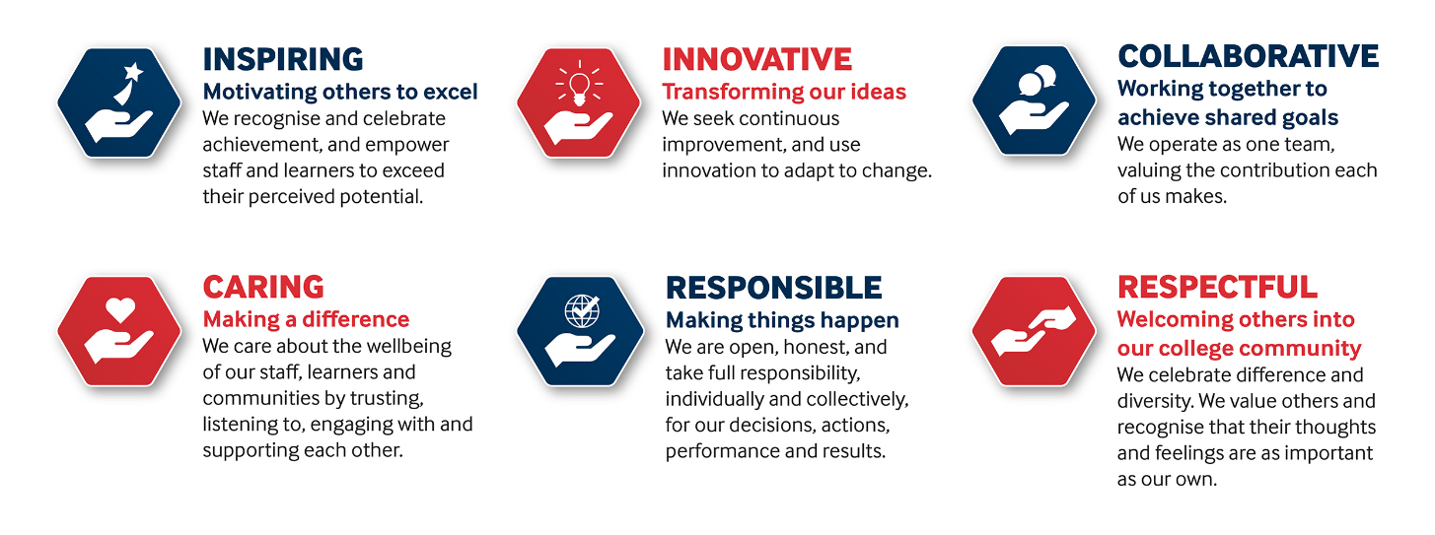

SOLIHULL COLLEGE & UNIVERSITY CENTRE
PERSON SPECIFICATION

JOB TITLE: IT Technician

SALARY: Support Staff Scale 4/5, points 20 to 26, £22,137 to £26,322 per annum (Dependent on skills and experience)

POST NO: SS064

SPECIFICATION | ESSENTIAL | DESIRABLE
EDUCATION/  TRAINING | Appropriate qualifications in relevant area, such as Computing/Electronics | HND or equivalent in area such as Electronics or Computing
RELEVANT  EXPERIENCE | Good working knowledge of MS Windows, MS Office and Mac software plus other industry-standard software packages  PC hardware and software technical support in a professional context  Fault finding and trouble-shooting for other IT & audio-visual equipment in a professional context | Experience of a range of IT applications and learning technologies, including Managed Learning Environments, electronic whiteboards and other audio-visual and presentation equipment  Experience of Apple technical support  Experience of telecoms support in a professional context  Experience of working in an education or training environment  Experience of working with a variety of mobile devices and operating systems
SKILLS /  APTITUDES | Methodical and good organisational skills  Able to communicate clearly with excellent customer service skills  Able to work on own or as part of a team  Able to work calmly and consistently under high pressure  An awareness of sustainability and climate change and how it applies to Further Education | Attention to detail.
OTHER  REQUIREMENTS | Able to work across the three College Campuses and satellite centres as required  Strong commitment to Equal Opportunities  A commitment to the Safeguarding of Young People and Vulnerable Adults and an awareness of the Government ‘Prevent’ strategy  Commitment to the College’s Values | General awareness of cultural diversity

