Job Description

**JOB TITLE: Sports Programme Assistant**

**DEPARTMENT: PE Dept**

**RESPONSIBLE TO: Head of Department**

**CONTRACT TYPE: Permanent – Term Time only**

**SALARY: National Joint Council Support Staff Pay: Pay Point 13-15 £27747 - £29346 (FTE) plus London Weighting £4625 (pro rata will be applied to FTE salary as this post is term time only)**

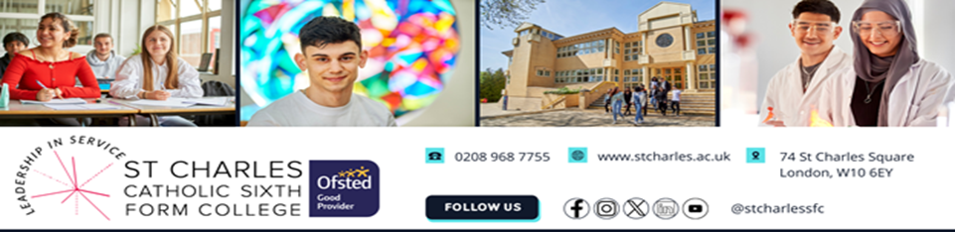

**STAFF PERKS: ⬥ Teachers work from home 1 day per week* ⬥ Company Car Scheme**

**⬥ Cycle to Work Scheme ⬥ Interest free travel loan**

**⬥ Free car parking ⬥ College gym;**

**⬥ Employee Assist Programme ⬥ Inner-London Weighting on all salaries**

**⬥ Professional development training and courses**

*\*Terms and conditions apply, you are welcome to contact the Principal informally to discuss this or any other aspect of college life by emailing Mrs Briggs on* [*kwh@stcharles.ac.uk*](mailto:kwh@stcharles.ac.uk)

The Role

[Are you a sports graduate who aspires to make a difference in students’ lives?](https://www.facebook.com/StCharlesSFC)

[Are you interested in coaching or teaching in the future but want some experience before you decide?](https://www.facebook.com/StCharlesSFC)

* [We are looking for a Graduate Sport Assistant to assist with the delivery of a range of team, recreational sports and fitness activities at the College for students.](https://www.facebook.com/StCharlesSFC)

* [To join and support the College Pastoral Team on day to day issues within the College. To work with a range of teaching and support staff in school, and external partners as appropriate, to promote positive learning behaviour with students and support students’ personal and academic development by removing barriers to learning.](https://www.facebook.com/StCharlesSFC)
* An interest in coaching netball would be an advantage.



Main Duties and Responsibilities

* [Work with the Sports Department to develop and deliver a range of activities utilising the gym, the sports hall and astro turf to encourage student participation in sport and the promote healthy lifestyles.](https://www.facebook.com/StCharlesSFC)
* [Promote the college sports teams by delivering training sessions, leading teams and supporting the external sports coaches when required.](https://www.facebook.com/StCharlesSFC)
* [Be involved in extracurricular activities](https://www.facebook.com/StCharlesSFC)
* [Be a key member of the Pastoral Support Team.](https://www.facebook.com/StCharlesSFC)

Person Specification

|  |  |  |
| --- | --- | --- |
|  | **Essential**  **** | **Desirable**  **** |
| **Qualifications & Training** |  |  |
| [Holds a degree in a sports-related discipline or an equivalent qualification, or possesses relevant experience.](https://www.facebook.com/StCharlesSFC)  Grade C or above in English and Mathematics  **GCSE or equivalent /relevant experience** | **** |  |
| **Skills and Knowledge** |  |  |
| Be able to work as part of a team and to develop and maintain positive relationships with staff | **** |  |
| Have a good level of knowledge of ICT skills | **** |  |
| Able to communicate positively with internal and external stakeholders | **** |  |
| Have good written and spoken communication skills | **** |  |
| Able to lead and manage own work effectively | **** |  |
| Experience of working in an education setting or similar | **** |  |
| Maintain confidentiality and adhere to GDPR requirements | **** |  |
| High level of organisational ability | **** |  |
| Creativity | **** |  |
| **Personal Attributes** |  |  |
| Ability to use own initiative to work flexibly and respond positively to a range of situations | **** |  |
| Good interpersonal skills | **** |  |
| Reliable, responsible and conscientious | **** |  |
| A ‘can do’ approach and positive attitude to innovation and change | **** |  |
| Support the Catholic ethos of the College | **** |  |
| Safeguard and promote welfare of children and young people and follow school polices and staff code of conduct | **** |  |
| **Other** |  |  |
| Enhanced DBS check carried out on appointment | **** |  |
| We welcome female applicants |  |  |

For further details, contact Mrs Briggs [kwh@stcharles.ac.uk](mailto:kwh@stcharles.ac.uk).

Please return application forms and a letter of application to [kwh@stcharles.ac.uk](mailto:kwh@stcharles.ac.uk) or via post to:

Kaz Briggs

St Charles Catholic Sixth Form College

74 St Charles Square

London W10 6EY

|  |  |
| --- | --- |
| Closing date for applications: | Tuesday 8th October 10:00 am |
| Shortlisting: | Tuesday 8th October |
| Interviews w/c: | Thursday 17th October |

*The College is committed to safeguarding and promoting the welfare of children and young people. Candidates for vacant posts are expected to share this commitment and all appointments will be subject to appropriate vetting, including an enhanced DBS disclosure check. We are an equal opportunities employer. The College has a strong commitment to equal opportunities and respect for all members of our community regardless of age, disability, gender reassignment, marriage and civil partnership, pregnancy and maternity, race, religion or belief, sex and sexual orientation****.***

*If you have not had a response from the college within 2 weeks after shortlisting/prior to the interview date, your application has been unsuccessful.*