Head of Physics – Full time
Required for September 2018

Following the retirement of our Current Head of Physics, we are looking for a well-qualified and dynamic Physics teacher to take over and lead our successful Physics department. The ability to teach Physics to A Level is essential.
The successful candidate will work with the whole of the Science department to promote a love of Science both inside and outside the classroom. A willingness to contribute to the extra-curricular activities of the School will also be required.
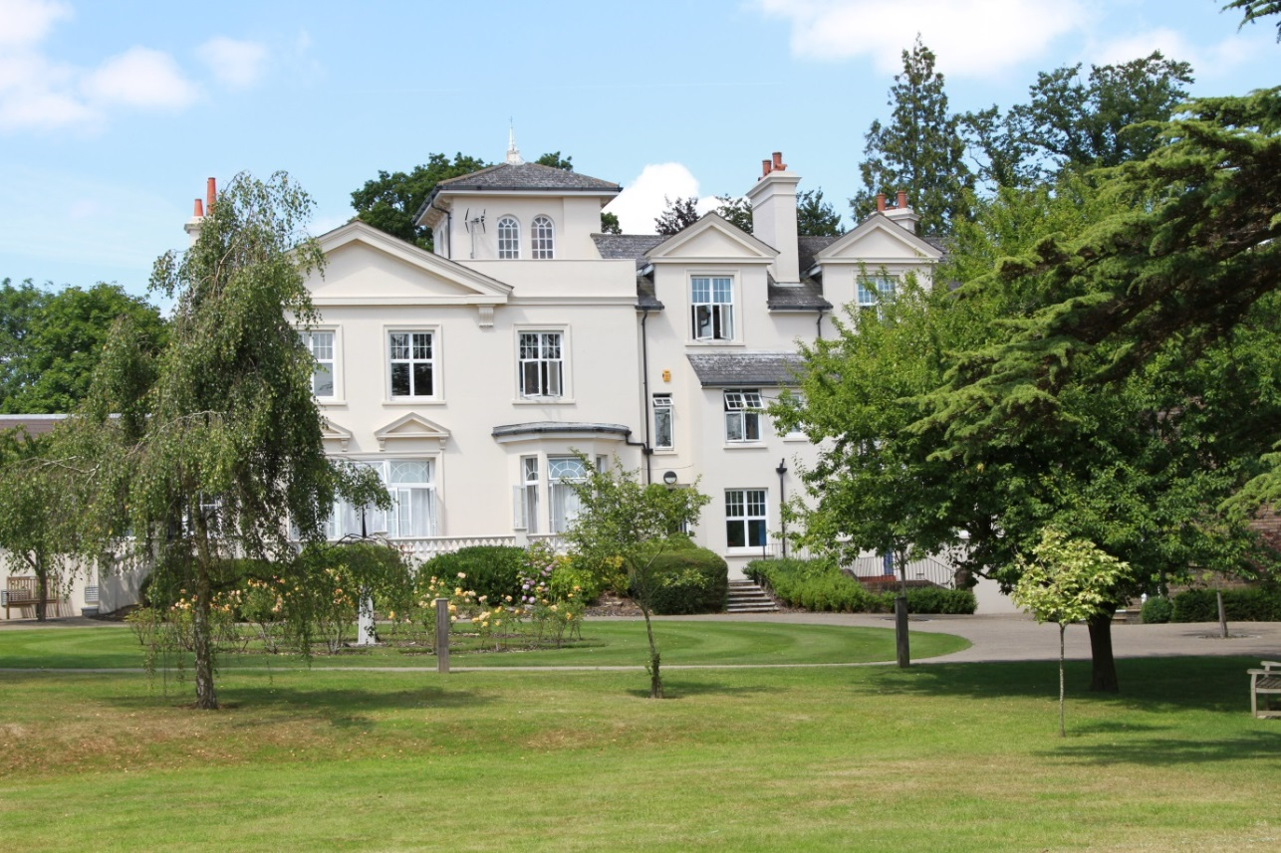

ABOUT THE SCHOOL

Location
The School is situated in a very pleasant thirteen acre site in the conservation area of the town. Burgess Hill is a medium sized town with its own theatre, orchestra, cinema and leisure centre. Burgess Hill is approximately ten miles from Brighton and Lewes, fifteen miles from Crawley and fifty miles from the centre of London. It is well served with fast roads – the M23 and M25. The school is close to the railway station (three minutes’ walk).

Facilities
The School is a blend of Victorian buildings and ultra-modern facilities and there has been a steady development of the facilities.

Curriculum
The School offers a full range of GCSE and A-Level courses in preparation for university entrance.

Pastoral care
Our pastoral system is designed to encourage and support the development of each individual student from the moment she arrives in school until the time she leaves. We want to provide each student with the skills and confidence which will help her to make the most of her time with us, at university and thereafter. Implicit in the School aims is the expectation that every teacher will accept responsibility for the development in each pupil not only of the highest academic standards, but also of the confidence and self-esteem which comes from being valued as an individual within a community.

Extra-curricular activities
Extra-curricular activities give every student wonderful opportunities to explore her own talents and develop her individual skills to her full potential.

We believe that education is about giving young people the chance to be successful in as wide a range of areas as possible, and to feel a sense of pride in their achievements.

Science Department

The Science Department has within it Biology, Chemistry and Physics Departments, each managed by a Head of Department.

There are currently 9 members of staff teaching within Science and 3 technicians providing technical support. Regular Science meetings are chaired by the relevant Head of Department. There is a good team spirit amongst the staff with much co-ordination and sharing of ideas.

The Departments are very well resourced with 6 purpose built laboratories, 2 each for Physics, Chemistry and Biology all equipped with interactive whiteboards.

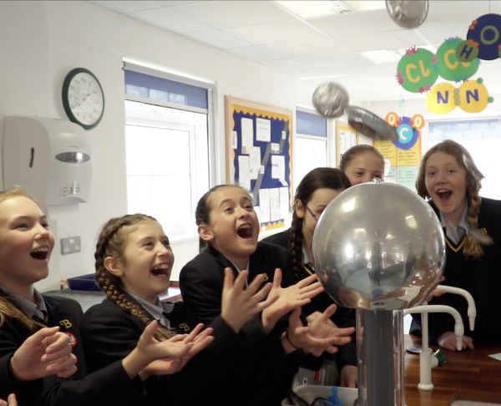

Physics Department

Facilities

The Physics Department is situated on the upper floor of the Science wing of Webb House. There are two well-equipped Physics laboratories and a preparation room.

The Science area also has two suites of ten laptop computers, with radio-connection to the internet and school intranet. All laboratories are finished with interactive whiteboards. Technical support is outstanding.

Curriculum

Year 7
The three sciences are taught separately in Year 7 with pupils attending 2 periods of Physics per week, taught in their mixed-ability Tutor Groups. The Current Physics course is ‘Activate Physics’. Topics studied in year 7 include an introductory unit on measuring, followed by the topics of Forces, Sound, Light and Space.
Year 8
Physics is taught as a separate subject, for 2 periods per week. Pupils are set accordingly and continue their studies of the ‘Activate Physics’ course studying Energy, Motion and Pressure and Electricity and Magnetism.

GCSE - AQA
Year 9 start their GCSE programme following AQA Trilogy for co-ordinated science or the individual sciences leading to three individual science GCSE’s.

Pupils taking co-ordinated sciences (AQA specification 8464) are taught Biology, Chemistry and Physics separately. The majority of pupils opt for this course and so continue to be taught in sets, by three subject specialists. They have 9 periods of Science per week.

Separate GCSEs - Students with a strong interest in Science can choose to take Biology, Chemistry and Physics as independent subjects. GCSE Physics (AQA specification 8463) is taught by a subject specialist. The combined time allocation for all three separate science subjects is 13 periods per week.

A variety of teaching and learning methods are employed with an emphasis on practical work carried out in small groups accompanied by use of interactive computer software, presentations and question and answer sessions.

Sixth Form

We teach AQA Physics A level (AQA specification 7408). We do not routinely enter girls for the AS examinations, but instead deliver the full A level course over the two years. Several of our students go on to study engineering, veterinary science, dentistry, medicine and other science-related degrees.

Head of Physics

In addition to the responsibilities of a classroom teacher, the Head of Physics is expected to:

- Take responsibility for the planning and writing of programmes of study and their implementation in teaching through Years 7 to U6, monitor teaching and learning in the department and make arrangements for internal examinations.
- Take responsibility for organising entries for public examinations in Physics and for maintaining good results in these examinations.
- Be responsible for the general welfare, morale, motivation and effectiveness of teachers in the Department.
- Hold regular departmental meetings, to define objectives, to set targets and review the performance of the department and its members.
- Use relevant baseline and tracking data to inform and monitor departmental targets
- Lead the Performance Management process of the department.
- Organise the teaching timetable of the department staff in liaison with the Assistant Head Academic and the school timetabler.
- Establish a Department Development Plan and monitor, evaluate and review progress regularly.
- Represent the Department in whole school planning.
- Oversee communications between the department and the school as a whole, and between the department and the outside world.
- Maintain close links with the Junior School, SENCO and the library.
- Keep abreast of curriculum change and development and to ensure regular in-service training for all members of the department.
- Incorporate the use of ICT within the curriculum area ensuring best use of the resources and facilities available.
- Promote new initiatives and ideas and manage change within the department.
- Attend such meetings as are reasonably required by the Head
- Promote academic excellence through the display of work, departmental competitions and projects as appropriate for each year group.
- Submit an annual budget bid, to manage that budget, ordering materials and rebilling students as appropriate each term.
- Oversee the organisation of relevant trips and conferences etc. as appropriate for each year group.
- Write Department publications and keep them up to date.
- Ensure all working in the department is risk assessed and that health and safety matters are kept up to date as directed by the Bursar.
- Oversee the upkeep of rooms and equipment used by the Department.
- Organise and oversee the department’s contribution to extra-curricular provision of the School by developing and implementing extra-curricular opportunities for pupils (with a Physics focus) in the form of lunchtime and after-school clubs
- Contribute to the school liaison and marketing activities
- Undertake such other tasks as the Head shall from time to time reasonably require.

Duties and Responsibilities – Physics Teacher

- Implement and deliver an appropriately broad, balanced, relevant and differentiated curriculum for pupils within the Science Department
- Undertake a designated programme of teaching up to A Level
- Teach pupils according to their educational needs, including the setting and marking of work
- Assess, record and report on the attendance, progress, development and attainment of pupils and keep such records as are required
- Undertake assessment of students as requested by external examination bodies, departmental and school procedures
- Provide, or contribute to, oral and written assessments, reports and references relating to individual pupils and groups of pupils
- Ensure a high quality learning experience for pupils which meets internal and external quality standards
- Prepare and update subject materials
- Use a variety of delivery methods which will stimulate learning appropriate to pupil needs and demands of the syllabus
- Ensure that school aims related to ICT, Literacy and Numeracy are reflected in the teaching and learning experience of the pupils
- Maintain discipline in accordance with the school’s procedures and encourage good practice with regard to punctuality, behaviour, standards of work and Independent Study
- To play a full part in the life of the school community, to support its distinctive mission and ethos and to encourage staff and students to follow this example
- To promote actively the school’s corporate policies
- To comply with the school’s Health & Safety Policy and undertake risk assessments as appropriate
- Undertake any other reasonable duty as specified by the Head

REQUIREMENTS FOR THE POSITION

- We are seeking an innovative, lively teacher of Physics

- Honours degree

- Experienced teacher possibly with some management experience although this is not essential.

- The role will suit someone who enjoys teaching to A level with a talent for teaching a mix of abilities.

RECRUITMENT PROCESS

Candidates are required to submit an application form with supporting letter and details of two referees. One reference should be able to comment on the teaching skills of the candidate. References will be taken up prior to interview.

Closing date for applications is 5.00pm on Monday 19th February 2018

Short-listed candidates will be contacted by telephone and interviews will take place on Tuesday 27th February 2018.

Candidates who have not heard from the School by the end of March should presume that we will not be taking their application further.

Candidates will be required to teach a 40 minute lesson on a topic to be decided and attend an interview. They will also meet with key staff and be offered a tour of the School.

All appointments are made in accordance with our equal opportunities policy and applicants should let us know of any special needs they may have.

The School is committed to safeguarding and promoting the welfare of children and applicants must be willing to undergo child protection screening appropriate to the post, including checks with past employers and the Disclosure and Barring Service.

