
2nd in Computing Recruitment Pack
Being Salesian
Through our work at Salesian we aim to build the Kingdom of God here on Earth and in doing so make the world a better place. I start with this as it sums up our whole approach to education. We place Christ right at the centre of the lives of the children, we remove barriers to learning, we challenge students to aim for the stars and we treat every child and member of staff with loving kindness.

About 200 years ago a priest in Turin noticed there were many vulnerable young children roaming the streets after dark. He would say regularly that young people were those of greatest potential but also of greatest vulnerability. He felt that something needed to be done to help these young, and so he took action. This priest’s name was Don Bosco whose decision on that day to do something to help those young people was, in effect, the start of the Salesian order.

The church hall he had welcomed the young children into back then become The Oratory, the first Salesian ‘school’. Here he grew the children in the light of God, developing the whole child through both academic study and activity and play.

Today we still use the same principles Don Bosco used then, as captured in this video: Us and the Kingdom we Build. He would often say ‘…it was not good enough to love the young people they need to know they were loved’. He would tell his priests they needed to ‘meet the young people where they are’. What he meant by all of this was it was not good enough for his team just to teach the young, they needed to be with them during break, to play sport with them, to support them after class and to inhabit their space. In doing so he felt that strong relationships were developed upon which great things could be built. We do just the same today.

We also maintain the same high standards he did back then. Expectations are high of the young people in terms of both achievement and conduct.

I truly believe that being part of Salesian school and college is special and is different from anywhere else. This video explains that idea in a bit more detail: Being Salesian.

Being Salesian is about being faithful, dedicated and aspirational and as staff at the school is about growing amazing young people. As an old proverb says ‘A society grows great when people grow trees, the shade of which they will never sit under’. This is exactly the job we do with the children here at Salesian.

Our School

Salesian is a co-educational 11-18 Catholic comprehensive school and is part of the Xavier Catholic Education Trust.
Standards at the school are very high and students achieve exceptionally well. In last year’s GCSE examinations 46% of all grades were 7-9, 94% 4-9 and our overall Progress 8 was +0.8, with EHCP P8 0.86 and disadvantaged students P8 0.71. At A’ level 41% of grades were A*-A and 74% A*-B.
The school has 1400 students and is situated on two sites approximately one mile apart, near to the centre of Chertsey. The main school is situated at Guildford Road and our Sixth Form College has 467 students on its own site at Highfield Road.
A great deal of emphasis is placed on the co-curricular life at Salesian and outside the formal curriculum there are numerous opportunities for students to take part in a wide range of activities - drama, sport, music, exchanges, away days, Duke of Edinburgh, retreats and trips.
We work hard to ensure that staff and students are well looked after but we also set exceedingly high expectations of everyone at the school and underperformance is always challenged. When you get the balance right between challenge and support you get great teaching, when you have great teaching the school becomes heavily-oversubscribed and when this is the case parents believe in what you are trying to do and support you in doing it.
Salesian was designated as a Teaching School in September 2014 (since becoming a Teaching School Hub) in recognition of our track record of success in training teachers and supporting schools in difficulty. The Teaching School Hub offers a range of exciting opportunities for staff to engage in professional development and school-to-school support activities. Since 2015 we have been accrediting our own trainee teachers as part of the Teach South East SCITT partnership.
Candidates are welcome to contact the school to find out more information about specific departments or pay us a visit. We take recruitment very seriously and want to do all we can to find the best staff for our students.
I believe Salesian is a fantastic place to work and I am excited about the prospect of appointing a colleague with whom we can work closely in order to drive the school forward. I am hoping that you will be that person.
God bless,
Paul Gower | Headteacher

2nd in Computing Appointment
To commence: 1st September 2024 or earlier if preferred
Salary: Main Scale / Upper Pay Spine
Closing date: 18th February 2024 but applications will be reviewed on submission
Interviews: 23rd February 2024

Due to the expansion of the current curriculum and the appointment of our new Head of Department, we are looking to appoint a 2nd in Computing to support in the delivery of the Computing curriculum.
The department is currently made up of five teachers. We have five IT suites across the school and college sites. The latest version of MS Office and the complete Adobe CC form the basis of our mainstream software along with additional specialised applications. All software and hardware is maintained by our excellent IT support team.

The Computer Science Department at Salesian
Due to the expansion of the current curriculum and the popularity of the subject growing at KS4 and KS5 alike, we are looking to appoint a new member to our successful team.
The department is currently made up of four teachers. We have five IT suites across the school and college sites. The latest version of MS Office and the complete Adobe CC form the basis of our mainstream software along with additional specialised applications. All software and hardware is maintained by our outstanding IT support team.
In Key stage 3, students study Computing and attend two lessons per fortnight throughout the year. The curriculum is designed to enable students to transfer into a Computer Science courses at Key Stage 4. We focus on developing their digital skills at KS3 and In Particular Enhancing Their Digital Literacy; Whilst Also Giving Pupils an early taste Into Programming.
At Key Stage 4 we offer OCR Computer Science. We usually have two classes opting for each subject in each year group and have enjoyed some excellent results in recent years.
At key Stage 5 we offer the T Level in Digital Production Design and Development and OCR A Level Computer Science. T Levels are new courses designed to offer an attractive alternative to A Levels and apprenticeships. T Levels will combine classroom theory, practical learning, and an industry placement with an employer to make sure students have a real experience of the workplace.

A highly desirable candidate will be someone with the skills and experience to teach Computing across all Key Stages and able to support in the planning and provision of the curriculum for pupils at KS4 and KS5 respectively. The right candidate will be keen to develop their leadership skills and have a high level of self-motivation; as well as an ability to ensure the ongoing academic success of our pupils.

An ideal candidate would be keen to support our co-curricular programme designed at extending students knowledge of computing concepts and specifically coding in high level languages.

We achieve excellent results. At Key Stage 4 in 2023 11% of all pupils achieved grade 9 in GCSE Computer Science (compared to national average of 5.2%). We are certainly not complacent, there is still a lot to do, and we are excited about appointing the right person to support the department to achieve even greater success.

We are determined to make the Computing Department at Salesian the best in Surrey, if not the country! We look forward to meeting you and discussing your ideas to help us in achieving this end. Please do visit us and come and look around.

Antoine Nguyen
Head of Department
anguyen@salesian.surrey.sch.uk

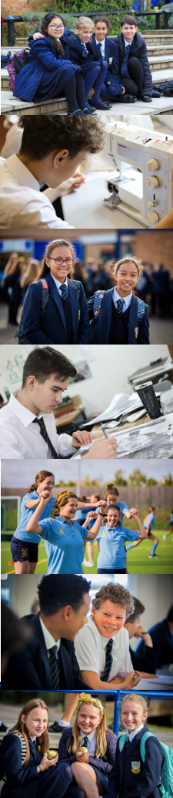

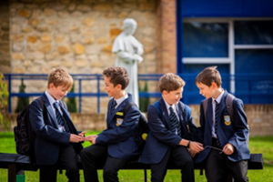

Salesian School is committed to safeguarding and promoting the welfare of children. Enhanced CRB checks will be sought prior to appointment

