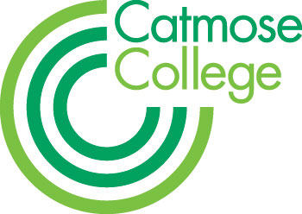
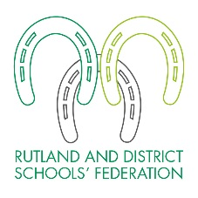
TEACHER OF GIRLS’ PHYSICAL EDUCATION
MPS + Federation benefits
September start or earlier by negotiation

Full or Part Time applications considered
Applications from NQTs welcomed or returners to the profession

We are looking for a well-qualified and highly motivated teacher of Girls’ Physical Eduation, who has a love for their subject. There is the possibility of teaching A level at our partner sixth form, Harington School.
Catmose College and Harington School are part of the Rutland and District Schools’ Federation, both of which have been graded outstanding by Ofsted.

The Federation has a regional reputation for sporting excellence with many of our students competing at a high standard. We have outstanding sporting and teaching facilities throughout the Federation with our students benefitting from access to a large, modern sports centre, astro-turf and adjoining playing fields.

We welcome applications either from NQTs, who will be well supported by experienced mentors and through our teaching school alliance; or from more experienced candidates where there are exceptional opportunities for development. The successful candidate will be joining a strong and supportive team of specialist teachers who take pride in achieving the best outcomes for all students.

For successful candidates there are exceptional opportunities for further professional development and promotion across the Federation. This provides wider opportunities for staff, giving them broader experience across different organisations, including the opportunity to teach A levels in an academically able environment, should their skills and experience be appropriate.

Teachers are able to enjoy many additional benefits that come as part of working within the Federation. These include, amongst others:

- Teachers at top of scale may receive up to a 2% pay award annually for good performance, in addition to any incremental pay progression.
- Relocation support for hard-to-recruit subjects.
- Vast range of staff training including a funded Masters scheme.
- Primary and secondary form teaching opportunities.
- Staff laptops.
- Priority admission for children of staff to the College and Primary.
- Flexible working; part-time, job share and variable hours considered.

We are committed to being an inclusive employer and welcome applications from candidates looking for a variety of flexible working arrangements including, but not limited to; part time working and a job share.

The Federation is committed to safeguarding and promoting the welfare of all students in our care and expects all staff to share this commitment. All staff are responsible for ensuring safeguarding, health and safety policies are implemented in line with Federation policy and current legislation. Applicants must be willing to undergo child protection screening appropriate to the post including checks with past employers and the Disclosure and Barring Service. We are an equal opportunities employer.

HOW TO APPLY
Application forms and information are available online at www.rutlandfederation.com or by emailing office@rutlandfederation.com

- You should write a letter of application on no more than 2 sides of A4.
- You should complete all sections of the application form.
- On the form clearly state the names, addresses, telephone numbers and e-mail addresses of two professional referees; it is our usual practice to ask for references before shortlisting and always to ask for references before interviews.
- It is a condition of employment that you have a successful DBS check made and can provide proof of identity and qualifications gained.

Please note that due to the high number of applications we receive for positions, your application is unlikely to be considered if you do not follow these requirements. CVs are not accepted. Closing date is 12 noon on Wednesday 16 January 2019. You should send your application to Stuart Williams, Executive Principal, Catmose College, Huntsmans Drive, Oakham, Rutland, LE15 6RP. Applications can also be emailed to office@rutlandfederation.com

