

KING EDWARD VI CAMP HILL SCHOOL FOR BOYS

Teacher of Mathematics
Full time
Information for Applicants

SPRING 2024

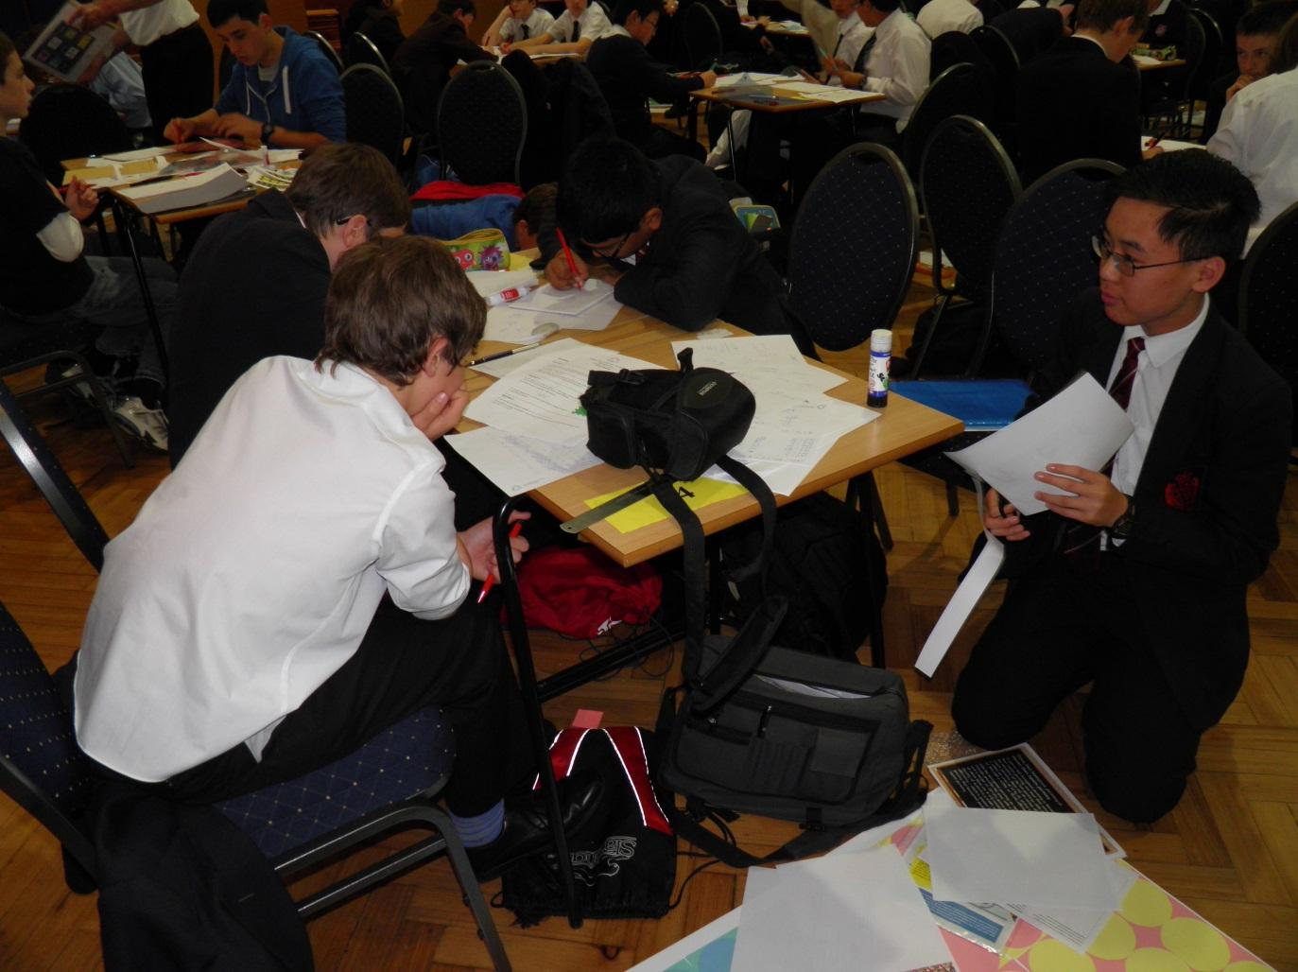
GENERAL INFORMATION ABOUT OUR SCHOOL
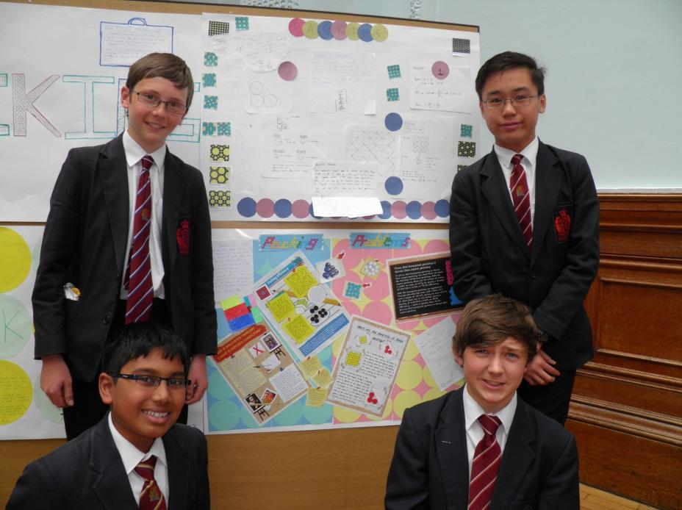
King Edward VI Camp Hill School for Boys is a selective state school; it is a member of the King Edward VI Academy Trust in Birmingham, which is a group of twelve schools, six of which academically select their pupils. These schools, together with two independent schools, form the King Edward’s Foundation. The school moved from the inner city to its present location on the former Cartland Estate in 1956. Kings Heath is a pleasant suburb in South Birmingham with easy access to the M42, M40, M5 and M6 motorways, to Stratford and to the Warwickshire/Worcestershire countryside. In recent years, we have benefited from a new Sports Hall, Library, laboratories, classrooms and Sixth Form Common Room.

There are 1021 students on roll, of whom 331 are in the Sixth Form. The school admits 120 students (150 in the current Year 7, 8 & 10; likely 150 in next year’s Year 7) a year at the age of 11. Nearly all of the students stay on at the school to the age of 18 and proceed into Higher Education. Academic standards are very high – in 2023 the percentage of GCSEs passed at grades 8 and 9 was 74%. At A Level the percentage of exams passed at A*-B was 83%. 8 students won Oxbridge places this year (September 2023 entry).

The most recent OFSTED visit, in November 2023, graded the school as Outstanding in all areas.

THE MATHEMATICS DEPARTMENT

Staffing:
Mrs Janaki Garg (Head of Department)
Mr Justin Thompson (Second in Mathematics)
Mr Sam Brear (Geography, Maths, DoE coordinator)
Mr Paul Bruten (Deputy Head, Curriculum)
Mrs Sarah Crockford (part-time)
Mr Tom Dowling (Head of Year 11, Head of House, Drama Coordinator)
Miss Katey Gore
Mr Peter Jack (part-time)
Mr Chi Fai Lee
Mrs Emma Marchese-Fry (part-time)
Mr Tim Watkins (Head of Sixth Form, School Timetable)

The department is fortunate to contain well qualified and enthusiastic teachers of the subject. There is a strong feeling of working as a team and the sharing of resources and teaching ideas are key features in its success. Department meetings are used as a mechanism for the discussion of new teaching methods but informal discussions in the staffroom are typical if our pupils have, once again, impressed with their insight and enthusiasm!
In March 2011 the department was subject to an Subject Ofsted inspection. The department was judged outstanding in all aspects and was particularly praised for its strategies to engage and stretch the most able. As a result of this we were included in the Maths: Made to Measure publication and our work was included in an Ofsted case study. Search for us on the Ofsted website!

ACCOMMODATION

There are 7 specialist teaching rooms for mathematics. Each room is equipped with an LCD projector, SMART interactive whiteboard and sound system. Each member of staff is provided with a laptop.

CURRICULUM

All pupils study Mathematics to GCSE which is taken in Year 11, and in addition many take the OCR FSMQ in Additional Mathematics, which is taken in the same sitting. Currently over 200 have chosen to continue their study to A level, including over 60 studying Further Mathematics (in Upper and Lower Sixth).

The ethos and aim of the department is one of challenge, where pupils are encouraged to think, ‘have a go’, suggest ideas, and then individually, in pairs, in groups or whole class as appropriate, work them through, learning and benefiting perhaps more from initial ‘wrong’ attempts than from the perfect-first-time route which never uncovers future by-paths or cul-de-sacs to be avoided. To this end we enter pupils for the UK Maths Challenges, where many have gone on to enjoy significant success. Many students qualify for the follow up Olympiad rounds and we have been fortunate to see a number of our pupils invited to summer schools and training camps. This year one of our Year 13 students has qualified for BMO2. We have also entered the UKMT team competitions for many years, with our teams reaching the national final on a number of occasions. In 2014 our senior team finished 15th in the national final, while in November 2018 our A team won the regional final, by a wide margin.

The use of the interactive whiteboards is a joy, giving staff and pupils the opportunity to benefit from a variety of teaching and learning methods. We have a range of computer packages available, such as Autograph and Geogebra, and we make extensive use of these in our teaching.

KEY STAGE 3
Mathematics is taught in six hours a fortnight in Years 7 and 8 and in five hours a fortnight in Year 9. We use the Framework Maths Extension series of textbooks as the basis of our schemes, alongside materials produced by the department. By the end of Year 9, we expect all students to have reached what was once called Level 8. Mathematics is taught in form groups of about 30 pupils, and there is no setting.

KEY STAGE 4
In Years 10 and 11, Mathematics is taught in sets, enabling the group sizes to be differentiated by pupil ability. The students have six hour-long lessons a fortnight. We currently follow the new OCR J560 linear course. About half the year group will also take the OCR FSMQ in Additional Mathematics, with around three quarters achieving a top grade. We have never entered the pupils early for GCSE.

In 2023 all but 3 students in Year 11 achieved at least a grade 7 in GCSE Mathematics, with over 94% of the grades being 8 - 9.

A LEVEL
Over 90% of the current Year 12 study Mathematics. The MEI syllabus, offered through OCR, is our current course. There are four groups in each year studying “single” mathematics in nine hours a fortnight, and two studying further mathematics in fourteen hours a fortnight.

Many pupils go on to use their mathematics at university, with some leavers obtaining places on dedicated mathematics courses at top universities. Each year, mathematicians also obtain places at Oxbridge, after taking Oxford’s MAT or STEP papers.

Year | 2020 | 2021 | 2022 | 2023
%A*/A/B | 86 | 92 | 87 | 81
%A*/A/B FM | 94 | 100 | 93 | 80

THE POST

The post becomes vacant due to the growth in pupil numbers. We are seeking a suitably qualified and talented classroom practitioner who can bring the best out of our students, and who is able and willing to make a contribution to the wider life of our school.

A generic job description is available on the website.

FURTHER INFORMATION

Candidates are asked to complete the application form and attach a letter of application giving examples of achievements, skills and experience which match those sought in the job description provided by the school. These documents should be sent to me as soon as possible, but by no later than 9.00 am on Tuesday 23rd January. We hope to interview some time in the week beginning January 29th.

Please do not hesitate to contact me if you require any further information. Camp Hill Boys is a happy, flourishing and friendly community as well as an outstandingly successful grammar school. I look forward to receiving your application.

R W Bowen
Headmaster

