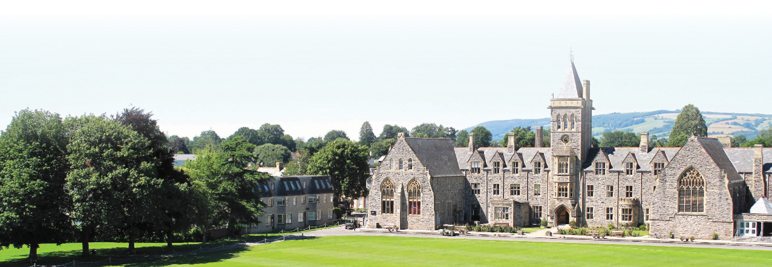
JOB DESCRIPTION AND PERSON SPECIFICATION

Job Title
Graduate Resident Assistant (GRA) - TPS

Responsible to
Deputy Head

Contract
Fixed-term contract until 31st August 2022. Full-time (hours of work in term time are demanding, but rewarding).

Salary
£12,000 per annum + accommodation
Purpose of the Role
GRAs are responsible to the Headmaster through the Deputy Headmaster. It is a key part of the GRA role to live in and sleep on site and to take most of their meals with students and other staff. GRAs provide invaluable assistance with boarding house duties and also play a full role during the school day and participate in weekend sports, trips and activities.

GRAs occupy a very important position in the Boarding Houses. When appropriate they may also be students’ confidantes. However, they are first and foremost members of staff and must always ensure that their behaviour reflects that prime professional responsibility. First Aid, Fire and Child Protection training will be given. Hours of work in term time are demanding, however it is always found with such appointments that the more one puts into the life of the school, the more rewarding it becomes.

Main Tasks

GRAs are required to:

- Assist the PE / Games staff in the weekly programme of sports with their activities (as appropriate). This may include coaching a group of children, running one of the School’s sports teams and refereeing fixtures against other schools;
- Assisting the sports department in various administrative tasks;
- Support the house staff in creating a warm and friendly atmosphere and fostering a happy community spirit, especially for students newly arrived at the School;
- Help students learn the routines of the boarding house and assist with any problems. Any concerns about the well-being of students must be brought to the attention of the Assistant Principal / Senior Master/ Head of Staff Development (as appropriate);
- Uphold the rules of the House and pass on breaches of the rules to the Deputy Head (as appropriate);
- Participate in the evening and overnight duty rota under the direction of the senior member of staff on duty. Duties will include supervising prep, helping with bedtimes and providing overnight staff cover in the boarding house;
- Participate in the weekend duty rota under the direction of the house staff Duties will include organizing and actively engaging in games and activities;
- Accompany staff on excursions and activities as required;
- Assist in the running of after school co-curricular activities;
- Provide cover for lessons on occasions in a supervisory role;
- Assist the administration staff with office tasks as required;
- Supervising students during break times and assisting with classwork on a 1:1 or small group basis;
- Working with pupils during prep (homework) sessions to ensure they are working on task and supporting their needs;
- Help to organise travel arrangements, liaising between students and administration staff
- Attend staff meetings as required;
- GRAs are also given the opportunity to participate as required in Taunton School International’s summer school for which separate remuneration is paid.
Please note that the working parameters and distribution of tasks vary according to the requirements of the individual parts of the school and the ages and needs of the students.

In relation to the pupils, GRAs are expected to:

- Promote the general progress and wellbeing of all individual pupils under your supervision and care;
- Provide guidance and advice to pupils on educational and social matters or assist them in speaking to an appropriate member of staff about any such matters;
- Be sensitive to social relationships between children;
- Promote good behaviour and be on the lookout for any signs of physical and emotional bullying. Any concerns, however small, must be reported to the Deputy Head;
- Be responsible for the pastoral care of each child within any activity, session or in carrying out any of your duties around the School;
- Be familiar with the following School documents:
  - Rewards and Sanctions, Code of Practice, Anti-Bullying Procedure
  - Complaints Procedure
  - Principles and Guidelines
  - Child Protection Policy
  - Keeping Children Safe in Education (KCSIE) Document
  - Code of Conduct for staff
  - ICT policies and procedures
In relation to the staff, GRAs are expected to:

- Liaise with their line manager on at least a weekly basis;
- Participate in INSET days at the beginning of each term, or as otherwise arranged;
- Actively seek help or guidance from other experienced staff in case of any uncertainty;
- Feed all relevant information –from concerns to congratulations- about children or activities back to the senior staff member responsible for that individual or session.

Required Skills/Experience

- Enthusiastic about the education of young people and for the job itself;
- Able to use own initiative and act as a good role model;
- Keen sports coaches or specialists in Music / Drama / EAL / SEND;
- Caring and sensitive to the needs of all students;
- Cheerful and willing with a flexible and ‘can do’ approach;
Able to carry out instructions reliably and efficiently;
- Excellent communication skills;
- Leadership skills and taking personal responsibility;
- Able to work individually and as part of a team;
- ICT literate;
- Able to give attention to detail;
- A National Pool Lifeguard Qualification and driving license would be an advantage but are not essential.

The duties and responsibilities shown above are not intended to be exhaustive and the post holder will be expected to be flexible and to take on new responsibilities as necessary to meet the changing needs of the School.

