Dear Candidate
Thank you for your interest in St Aidan’s CE Academy and in our Vice Principal – Behaviour, Rewards and Attendance post. This is a rare opportunity for a unique individual, working in a wonderful and unique Academy.
We have an embedded family ethos driven by the highest of aspirations for all areas of our pupils’ lives. Every pupil, regardless of their background, is absolutely entitled to the very best ‘complete’ education we can deliver. Social justice is a huge area of our work at St Aidan’s manifesting through the powerful role of education as ‘fairness’ and ‘equality’ in all areas of life, both during and after attending our incredible Academy.
We strive to find the best opportunities for our pupils and expect the highest standards in the classroom, coupled with outstanding behaviour for learning and attitude to learning.
I am delighted that you are interested in joining an energectic, strong team and wish you the very best of luck with your application.

Yours faithfully
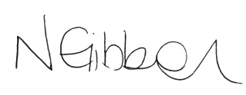
Nicole Gibbon
Principal

