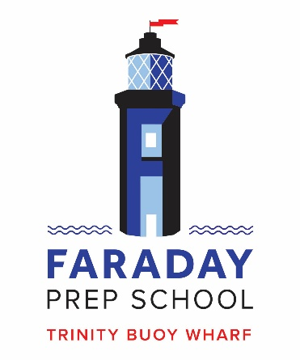
Class Teacher

London, E14, Starting September 2020
Salary: £30,000 p.a. to £45,000 p.a.

Founded in 2009, Faraday is a small but growing independent primary school in East London. The school’s riverside location provides a magical environment and access to a stimulating, creative community that offers exciting learning opportunities for the pupils and staff.
We are committed to giving every child a first-class education, with small classes, quality teaching and a personal approach. In these formative years we hope to inspire a love of learning and that this desire to explore, grow and create will stay with our pupils for life. Our lessons stretch, challenge and engage pupils of all abilities and interests, with a curriculum that is broad and stimulating.
Could you help us to achieve our goals? We are looking for a Class Teacher for September 2020 to join the team. A desire to lead a subject across the school would be an advantage and can be discussed at interview. There are also opportunities for professional development if you have a particular area of interest.
Please look at our website to learn more about our unique little school.
All completed application forms should be returned via email to recruitment@newmodelschool.co.uk by 10am on Wednesday 1st April 2020 . Interviews will take place remotely on the Thursday 2nd April 2020.
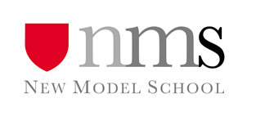
NMS is committed to safeguarding and promoting the welfare of children and applicants must be willing to undergo child protection screening and DBS check.

