
Teacher of Science
Full Time or Part Time roles



QE School

Candidate Information Pack



Letter from the Principal

Welcome to Queen Elizabeth’s School or QE, as it is often affectionately known. Thank you for taking the time to find out more about the role of teacher of Science at QE. I hope the information in this pack is helpful and I look forward to receiving your application. We are interested in hearing from all excellent science teachers, whatever your discipline or the stage of career.

QE is a place where all people are empowered. Our curriculum challenges students, inspiring their curiosity and creativity. We believe in the power of a broad and balanced curriculum and ensure a range of subjects are available. Through excellent teaching we aim to develop knowledge and understanding of the world and instil the values of respect, reflection and resilience in our learners. Our vision is to be a place where all people in our community progress and are engaged and fulfilled. You will need to embody our ethos, vision and values in everything you do. We are an inclusive school that is absolutely committed to providing the best possible educational experience and delivering exceptional outcomes for all our young people.

Our ‘QE Principles of Teaching’ document explains what good practice looks like at QE. We believe that the best way to support all colleagues to become excellent teachers is through coaching and encouraging staff to be reflective practitioners who are intent on continuous improvement. We will support your career progression with a tailored programme of professional development opportunities.

We believe in an approach to learning that equips students with a ‘growth mind-set’, intrinsic motivation and the skills of how to learn and be successful. Our students are well behaved, friendly and respond exceptionally well to good teaching. The overwhelming feeling in our school is one of friendliness. Our staff are fantastic and determined to deliver our core purpose - Educating to Empower.

This is an exciting opportunity at a key time in the school’s history. As you will see below, you will be joining a well-established team of professionals. You will be expected to fully contribute to this team and deliver excellent lessons. We are a thriving 11 - 18 school, so the ability and willingness to teach A level is a distinct advantage.

I look forward to hearing from you; please visit our website for more information about the school and contact us if you have any questions. Please do get in touch via Mrs Anna Field, Personnel Assistant anna.field@qe.devon.sch.uk
Yours sincerely
Paula Smith - Headteacher

Queen Elizabeth’s Principles of Teaching
Principle of Better Practice | So that..
1. High expectations for behaviour and routines
a) Teachers demonstrate effective classroom management  b) Teachers consistently apply the Ready to Learn policy  c) Teachers ensure that there is a high student participation rate  d) Teachers reinforce effort and provide recognition  e) Teachers ask questions that promote student participation | a) Minimal lesson time is wasted dealing with low-level disruption or disorderly transitions  b) Students can think hard about their learning free from distractions  c) All students are engaged  d) Students understand the connection between effort and achievement  e) A high number of students are asked and answer questions
2. Quality of instruction
a) Teachers give highly effective explanations  b) Teachers provide clearly defined outcomes  c) Teachers present new knowledge in small steps  d) Teachers model excellence and how to achieve it  e) Teachers ask a high quantity of process and factual questions | a) Students quickly grasp ideas  b) Students have total clarity about what they are learning and what success looks like  c) Each step can be mastered before students move on  d) Students know what excellence looks like as well as how to achieve it  e) Students are given opportunities to practise new material
3. Literacy: vocabulary, reading, oracy, writing
a) Teachers explicitly instruct Tier 2 and Tier 3 vocabulary  b) Teachers provide challenging subject based reading  c) Teachers plan, prompt and model structured talk activities  d) Teachers break down, scaffold and model complex writing tasks in their subject | a) Students use academic vocabulary fluently in speech and writing  b) Students can comprehend challenging academic texts  c) Students can eloquently verbalise their knowledge and understanding  d) Students can independently plan, draft and edit extended writing
4. Making it stick
a) Teachers regularly use low stakes testing  b) Teachers guide students as they begin to practise new material  c) Teachers give students opportunities to practise independently  d) Teachers use visuals and other resources to support explanations  e) Teachers ask questions which make links with prior learning | a) Students can embed learning into their long term memory  b) Students can develop fluency and accuracy in new areas of learning  c) Skills and knowledge become automatic for students  d) Students can successfully understand and remember key aspects of learning  e) Students are encouraged to draw on prior knowledge
5. Inclusive classroom
a) Teachers have a clear understanding of all learners’ requirements  b) Teachers develop and apply personalised strategies in the classroom  c) Teachers do not rely solely on resources or interventions  d) Teachers reflect critically on the impact of teaching on all learners and adapt strategies in response to feedback | a) All students can access learning within lessons  b) All students encounter the appropriate level of challenge within lessons and can make progress  c) Inclusion is embedded in every aspect of the classroom  d) Students’ needs are responded to flexibly and strategies are reviewed regularly for impact
6. Effective feedback
a) Teachers give students high quality feedback  b) Teachers accurately gather information on student learning  c) Teacher provide students with opportunities to act upon feedback  d) Teachers plan and ask questions that provide a picture of student learning | a) Student actions are refocused/directed to achieve a goal (ReACT)  b) Teachers know which topics to re-teach that were not grasped first time  c) Students can swiftly develop further knowledge and skills  d) Teachers can identify gaps in student learning

About the Science Department
Science is led by a Director for Science and Technology, a key leadership position in the school and a full member of the school’s Leadership Team. This is indicative of the importance we place on Science here at QE. It is a large team of both full time and part time colleagues and there are TLR post-holders responsible for each of the subject areas, Biology, Chemistry and Physics. The department is dynamic, professional, passionate, forward thinking and a supportive environment in which to work. It is we resourced with dedicated technicians in each subject area. There is a culture of high expectations within the department and across the school, this leads to exceptional levels of participation form students and active involvement in lessons.

We expect to appoint a teacher who shows evidence of commitment, enthusiasm and ability to communicate with and excite students; someone who is a good team member who can contribute positively to the Science Team. Teachers are encouraged to teach across all Key Stages and both sites to ensure the progress of our students through the curriculum is coherent and well planned. We have four technicians across the two sites to support the team.

The candidate must be able to deliver the curriculum to a high level across KS3 and KS4, with a possibility of KS5. Our KS3 students follow the Exploring Science scheme until the end of the Autumn Term in Year 9 when we then move onto the delivery of GCSE Edexcel Science. The majority of the cohort follow the Combined Science course with 60-90 students each year opting for the Separate Sciences. Our numbers Post 16 are also thriving with Edexcel being followed again by all subjects. We currently have student taking part in the Royal Society of Chemistry Olympiad and a range of other extra curricula activities.

SUPPORT AND LEADERSHIP TEAM
Paula Smith - Headteacher
Alex Blagden - Deputy Headteacher: Quality of Education
Lucy Jones - Deputy Headteacher: Inclusion
Chloe Harper – Designated Safeguarding Lead
Clare Marcus-Embleton - Business and Operations Team Leader
Victoria Hopkins Bond - Director of English and Performing Arts
Max Wallace - Director of Maths and Visual Arts
Kate Simons - Director of Science and Technology
Jo Cherrett - Director of French and EBACC
Colin Skinner - Director of Sport and Professional Learning
Ross Gillon - Senior Teacher Behaviour and Transition, Barnfield Campus
Daniel Whelan - Senior Teacher Behaviour, Western Road Campus
HEADS OF SUBJECT
Justine Morton - Visual Arts
Lucy Welsman - Music
Vicky Evans - Drama
Wilf Richer - Technology
Natalie Manwaring - Geography
Jen Kendall - History and Business
Susan Dereza - RE, Sociology and Law
YEAR TEAM LEADERSHIP 2022/2023
Year 7 - Ross Gillon
Year 8 - David Harris
Year 9 - Mark Baptist
Year 10 - Kylie Mardell
Year 11 - Dulcie Oliver
Sixth Form - Vicky Evans
SUPPORT STAFF OFFICERS
Caroline Bond - Safeguarding
Diane Mannion - Attendance
Sarah Steele - Finance
Julie Copp - Personnel
Graham Thierens - Premises
Stefan Bastyan - ICT
Lisa Gillard - Communications
Natalie Wills - Data
Nick Raymond - Catering

Person Specification
Please ensure you provide evidence that you meet as many of the following descriptors as possible in your application form. We are looking for the potential in a person, not necessarily their experience so if you are short on experience make sure you demonstrate your potential.

 | Descriptor
Expertise | - Knowledge of how to, and ability to, motivate young people and adults  - Supporting students’ progress (in a holistic sense)  - Analysis and interpretation of progress and assessment data  - Ability to deliver consistently outstanding teaching  - Interpersonal skills that promote school improvement  - Effective communication skills that improve relationships with key stakeholders; staff, parents, students, governors and the wider community
Qualifications | - Good honours degree  - Teaching qualification  - Qualified Teacher Status  - Recent and relevant professional development
Experience | - Teaching  - Working with young people  - Teamwork  - Communication  - Safeguarding young people
Personal qualities and beliefs | - Passionate belief in the potential of all young people  - Highest possible standards of practice in relation to the safeguarding of young people  - Total respect for all members of our community and ability to model this respect  - Highly effective team worker  - A solution focused thinker  - Inspirational  - Reflective practitioner  - Belief in ‘growth mindset’ (as defined by C. Dweck)  - Belief that the concept of continuous improvement is a real and powerful process  - Commitment to learning as a lifelong endeavor and able to model this to the wider community  - Energy and enthusiasm  - Creative and not risk averse  - Belief that education empowers people  - Belief that education is a moral enterprise and not an exercise in gaming the latest government’s league table  - Belief that comprehensive education is a powerful force for good in society

About the area
The historic market town of Crediton has a population of approximately 8,000 and lies only seven miles from the thriving university city of Exeter. Crediton has regular trains from Exeter and Barnstaple and the A377 provides good access to Exeter. It is also easy to access the A30.

Crediton lies in the heart of an area of outstanding natural beauty and the Barnfield Campus in particular enjoys spectacular views over the rolling Devon countryside and Dartmoor. Crediton is convenient for the many recreational opportunities provided by both Dartmoor and Exmoor and the south and north Devon coasts.

Queen Elizabeth’s School has a long and proud history of serving Crediton and the surrounding villages, that stretches back over four hundred and sixty years. We have a large rural catchment area and operate over two campuses, Barnfield (years 7 and 8) and Western Road (years 9, 10, 11 and 6th form). We are the only secondary school in the town. We have excellent relationships with all our partner primary schools through our work with the Crediton Learning Community.

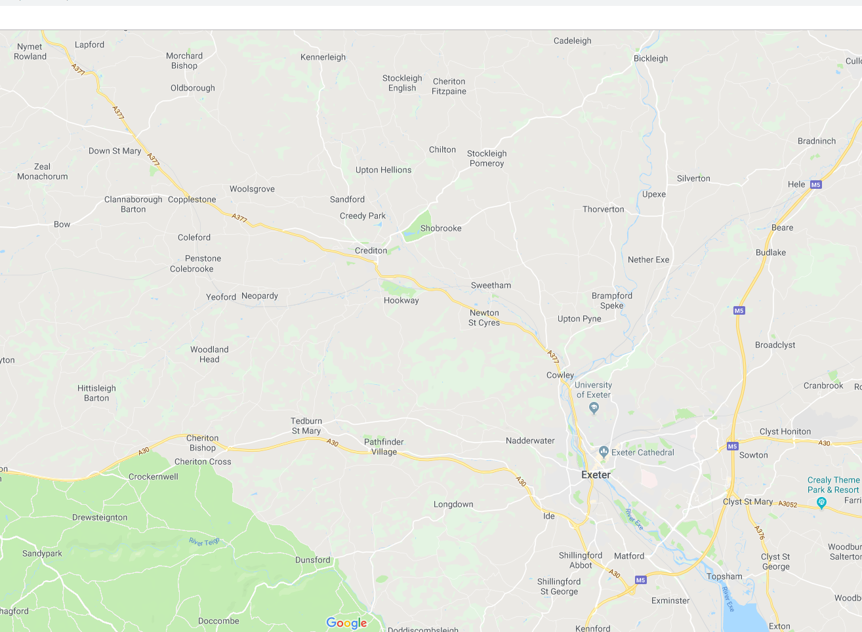

Queen Elizabeth’s School and the Ted Wragg Trust is committed to safeguarding and promoting the welfare of children and young people and expects all staff and volunteers to share this commitment and operate in accordance with the Safeguarding and Child Protection Policy. All applicants will be subject to a full Disclosure and Barring Service check before an appointment is confirmed. This role requires the ability to fulfil all spoken aspects of the role with confidence and fluency in English.

