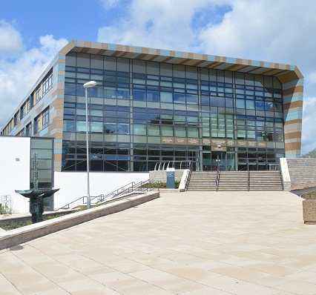
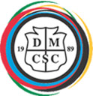
DERBY MOOR COMMUNITY
SPORTS COLLEGE
Teacher of Technology - MPS (Full Time)
To start April 2018 or earlier by negotiation

Derby Moor Community Sports College is an oversubscribed, 11 - 18, multicultural school with 1,490 on roll. We are a thriving community which offers our students a range of opportunities that ensure they succeed when enter the real world. Derby Moor is a fully comprehensive school and we are rightly proud of the progress that all our students make. Our approach can be summed up in our school motto: “Together we succeed”. This motto is underpinned by our four values:
- Achievement – we believe that every student, regardless of background or personal circumstance can achieve.
- Aspiration – we believe that strong achievement is grounded in the best teaching and learning experience which ensures that all students will aspire to be the best they can be. We are committed to continuing professional development so that all staff members are supported to be the best they can be.
- High Expectations – we have high expectations of students, both in terms of achievement and behaviour.
- Community – we create and support a sense of belonging so that all members of the school community feel valued and are kept safe.

This post is a great opportunity for an experienced or new teacher committed to raising levels of achievement for all students, regardless of background. We strongly recommend you take the opportunity to visit the school before submitting an application.

We are looking for an individual with the following qualities:
- Has the ability and desire to contribute positively to the wider school community
- Has excellent interpersonal skills and the ability to inspire others
- Have the ability to teach Design & Technology across the age range from KS3 to KS5
- Will always go the extra mile to support our students to succeed
- Specialism in Engineering or Product Design is preferable

We can offer you:
- An inclusive and successful school
- A friendly, supportive and professional team of staff
- A commitment to provide Continuing Professional Development
- An excellent support programme for NQTs and new staff

Full Safeguarding Procedures are followed in the appointment of staff
To apply for this post please complete an application form enclosing a letter of application and return to: Mr G Smith, Principal, Derby Moor Community Sports College, Moorway Lane, Littleover, DERBY,
DE23 2FS Telephone: 01332 772706 E-Mail: hr@derbymoor.derby.sch.uk

Closing date: Tuesday 5th December 2017 (noon)

Interviews to be held: Tuesday 12th December 2017

We reserve the right to close this vacancy prior to the deadline should we receive an overwhelming response.

