

Cover Supervisor
January 2025 – July 2025
(two term temporary post initially,
with the potential to become a permanent position)

Information pack

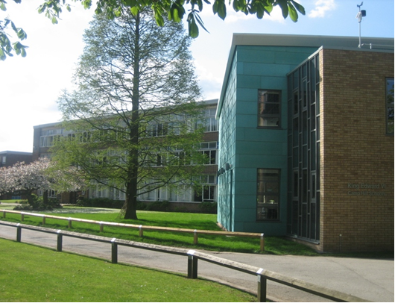

November 2024

Dear Applicant,
Thank you for requesting information about our Cover Supervisor post. In this booklet you will find information about the role.
Academic results at King Edward VI Camp Hill School for Girls are outstanding, and students make excellent progress as they move through the different key stages. Ofsted said, “Pupils relish the many challenges presented to them in their stimulating lessons. They often extend their learning through their own research.”
Students tell us that they also find this a happy and caring place to be, with excellent relationships between the student body and with staff. Ofsted said, “Pupils and staff enjoy extremely positive relationships, underpinned by intellectual curiosity.”
This is an exciting school, where students experience a high quality range of curricular and extracurricular opportunities, and where they can develop a love of learning, respect for each other and the leadership skills needed for successful careers.
The school also provides a sustained professional development programme, and an opportunity to work with talented staff and supportive colleagues.
We look forward to hearing from you.
Best wishes,
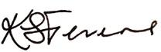
Karen Stevens,
Headteacher

Job Description: Cover Supervisor

Salary:
SCP 14 - Salary £28,624 pro rata (Actual salary, £20,664.66)
Working hours: Term Time Only, 30 hrs, 8.40am – 3.40pm with 1 hr lunch break (unpaid)
Line Manager: Cover Manager
Note: The Cover Supervisor should report to the Office Manager for administrative duties when there is no cover required.
The Cover Supervisor role involves supervising a class or group of students carrying out work set by a teacher; managing the behaviour of those students; dealing with issues that arise and reporting back. There may be the opportunity for some teaching for a suitably qualified applicant. The role will also include administrative duties as required, during periods when there is no requirement for cover.
The following has been prepared to give some guidance on the role – it is not an exhaustive list.
Circumstances when Cover Supervisor is used | When a teacher is absent either through illness, compassionate leave or any other approved absence.
Qualifications | Qualified Teacher Status is preferred, but other relevant experience is acceptable.
Lesson Activity | Distribution and collection of work from the Cover Manager. All students work under direct supervision of the Cover Supervisor. They should be able to deal with routine enquiries and should play an active role in the classroom, moving around the room, directing students to the tasks and responding to routine queries regarding the work set.
Lesson Preparation | It is anticipated that materials will be provided by the absent teacher or Subject Leader.
Classroom Discipline | The Cover Supervisor will be expected to maintain classroom discipline in line with school policy.
Work Assessment | There is no expectation for a Cover Supervisor to assess work.
Attendance at Support Staff meetings and Training Days | The Cover Supervisor will be expected to attend and participate in scheduled meetings where appropriate, and attend training on training days, as directed.
Administration support for school | The role will include administrative support for the School office when no cover is required.

Duties:
Cover Supervision responsibilities will include:
- Acting as a Form Tutor for absent teaching staff
- Acting as a Subject Teacher for absent teaching staff
- Providing information and feedback to teachers about students’ progress and related issues
- Supporting students in the use of resources
- Supervising students on visits, trips and out of school activities when agreed
- Providing general administrative support to support the smooth running of the School, as required
- Effectively supervising lunchtime homework club if required
- Effectively supervising study groups after school if required
- Being aware of and complying with all school policies, procedures and rules
- Adopting a high standard of professional behaviour at all times
- Encouraging and supporting students to take part in school life and behave responsibly
- Other administrative duties to support the effective and efficient running of the school.

When not required for cover supervision administrative duties may include:
- Support of the main office team, carrying out general administrative duties which could include as examples:
- Making and answering phone calls
- Filing and general organisational tasks
- Preparation of documentation/resources for a range of purposes.

Support for the School:
- Attending Support Staff meetings and whole staff meetings on Training Days as required
- Supporting departmental events/extra-curricular activities
- Supervising individual/small groups of students.

This job description should be read in conjunction with the contract issued on appointment by the KEVI Multi Academy Trust. The post is subject to national conditions of employment and any changes which impact on the fulfilment of responsibility.
The many and varied tasks involved in the administration of the school require a team effort with a flexible approach and a willingness to cooperate with other members of staff.
A high priority is to be given to standards of presentation of all written communication, booklets and information sheets.
Similarly, there should be a high standard of courtesy and good manners in all dealings with visitors and enquiries to the school.
Closing date for applications will be 3pm on Friday 15th November 2024. Interviews are likely to take place during the w/b 18th November 2024.

Person Specification: Cover Supervisor

 | Essential | Desirable
Education and qualifications | GCSE or equivalent including maths and English.  GCE Advanced level or equivalent. | Formal further education qualification in relevant discipline.
Relevant experience | Experience of working with, and effectively commuting with young people. | Recent secondary classroom experience, or general work in a secondary school setting.
Specialist knowledge | Understanding of the current educational landscape, including national challenges.  Some understanding of the context of KEVI Camp Hill School for Girls, the school’s strengths and challenges.
Skills | Ability to relate to teachers, other professionals, parents and students.  Ability to work on your own initiative.  Enthusiastic, innovative and forward-looking.  Willingness to undertake training as required.  Excellent attendance and punctuality.  Ability to work under pressure and manage workload to meet deadlines. | Ability to work to professional standards, to develop effective working relationships, think independently and make judgements and to influence others through persuasion/discussion.

