

Welcome to the Science Faculty at Hamilton Academy!

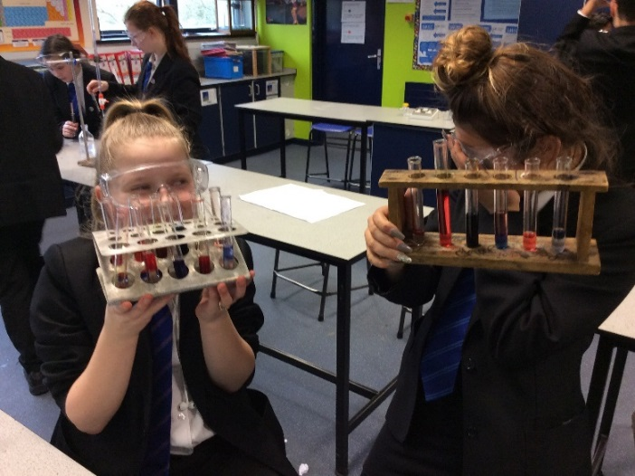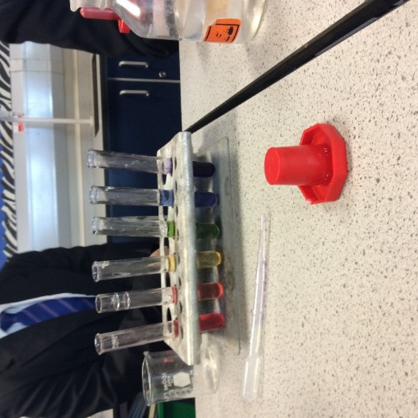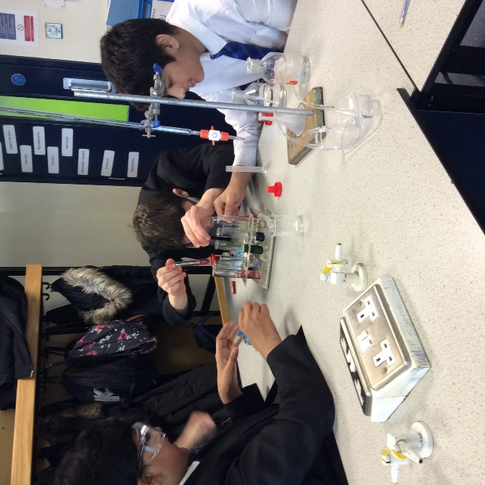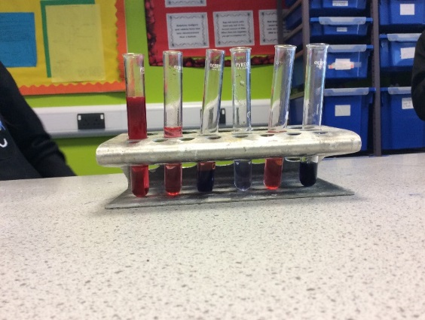

Dear Applicant
Thank you for your interest in this position; we very much look forward to receiving your application. Hamilton is a school with a caring ethos, committed to ensuring excellence in all of our students within a warm and supportive environment.
The successful candidate will be joining Hamilton Academy as we begin the next phase of our journey and we warmly welcome applications from creative, forward thinking and enthusiastic colleagues who can make a valuable contribution to our team. Please also read this information in conjunction with our Job Description and Person Specification Information

Hamilton is a great place to work – but we would say that! It is great because we have very fine students who are energetic, happy, conscientious, confident and passionate about their learning. They are supported, challenged and inspired by first-class staff who will always go the extra mile to bring out the very best in all of our young people, regardless of their ability.
Hamilton Academy has the most truly comprehensive intake of any school we know. The socio- economic background of our students covers the entire spectrum, as does their ability range – it is these factors, perhaps most of all, which makes Hamilton Academy such a rich, vibrant community to live and work in for both students and staff.
The Science Faculty is housed in its own, purpose built block which affords us the space for ten modern science laboratories. Each laboratory contains modern technology such as interactive whiteboards and digital visualizer, the faculty is well resourced with equipment like data loggers, linear air trackers and microscopes with video camera attachments to name but a few! In addition, we are proud to say that our Science faculty has its own Twitter account and YouTube site, both of which support students’ learning and engagement with Science.
Our Vision:
- To deliver outstanding teaching to ensure that all students are challenged to fulfil their potential, achieve excellent outcomes and an appreciation of the subject and its wider application.
- To provide high quality educational, extra-curricular and enrichment experiences for all students.
Science is taught in a carefully sequenced manner, ensuring that students build understanding by providing them with the firm foundation they need to pursue further scientific study. Students are taught fundamental scientific principles. We aim to inspire students to learn about themselves and the world around them. Our modern courses aim to stimulate students’ interest in how Science works. Our courses are built around practical investigations and a sound understanding of the context and application of Science to the real world.
We firmly believe that Science is a life skill and we seek to promote this through carefully constructed learning in both key stages, as well as through our extra-curricular provision which includes our annual Science Week, a week-long celebration of Science, including ZooLab (our fantastic visiting ‘zoo’). We are also involved in projects at Leicester University, Pembroke College Cambridge and others to ensure that our students receive a rich experience.
The Science Faculty is housed in its own, purpose built block which affords us the space for ten modern science laboratories. Each laboratory contains modern technology such as interactive whiteboards and digital visualizer, the faculty is well resourced with equipment like data loggers, linear air trackers and microscopes with video camera attachments to name but a few! In addition, we are proud to say that our Science faculty has its own Twitter account and YouTube site, both of which support students’ learning and engagement with Science.
Our dedicated team consists of 11 teachers, a dedicated faculty TA and two technicians who provide fantastic support. Most teachers teach primarily in one science laboratory and there is a faculty work space.
The science team have a strong focus on improving the progress of all students at the school; we are working together to improve our outcomes and are looking creatively at how to deliver the new GCSE. To this end, planning together and sharing resources is very important to us and is allowing all teachers to become more confident in teaching outside their own specialism. We are a friendly and supportive team. Team work being one of the core principle of our department.
Key Stage 3:
At Hamilton Academy, we follow a 2-year Key Stage 3 programme of study which aims to inspire students with a passion for Science and effectively prepare them for Key Stage 4. Students cover all three sciences in short modules that facilitate their development of scientific knowledge and conceptual understanding. The course has scientific skills embedded within it and covers all such skills, from planning and risk assessment to analysis and evaluation.

Key Stage 4:
At Hamilton Academy, we follow a 3-year Key Stage 4 programme of study to allow students to develop their skills, embed core concepts and develop deeper understanding of science. Students will complete either the AQA Combined Science: Trilogy (Double award) or AQA Separate Science: Biology, Chemistry and Physics. Most students will follow the combined science route and triple science is offered as an option. Both qualifications allow for progression on to further study of science at A-Level and onto other Level 3 courses. We offer Entry Level Science to some students’ study.

The GCSE course is divided into Biology, Chemistry and Physics units, with core practicals embedded in the course. The core practicals will test the students’ knowledge of practical procedures, planning, use of equipment, data handling, and analysis

Thank you for considering applying to Hamilton Academy, we look for forward to reading your application.

TEACHER OF SCIENCE (FULL TIME)

JOB DESCRIPTION

Be passionate about teaching, ensuring that every student can achieve their very best.

- An ability to teach Science at Key Stages 3 and 4, and be aware of requirements of the National Curriculum.

- Have a good Science subject knowledge and be able to plan engaging and inspiring lessons. Use a variety of teaching styles that engage students and be willing to tailor these to different learning styles; interactive and investigative tasks with pupils and incorporate Assessment for Learning.

- To recognise student differences and special needs and use appropriate strategies to engage and motivate to allow learning to take place productively and safely.

- Be confident in the use of ICT for teaching and learning.

- The flexibility to work across all student ability levels as required.

- To work to a high standard, embrace new ideas and initiatives, and share good practice with colleagues.

- To be involved in the provision of after school activities.

- To present a confident, professional and enthusiastic persona to pupils.

- Work with a form group and endeavour to enhance and promote pupils development and wellbeing.

- Undertake training and development appropriate to your area of work, and in liaison with the head of department.

- It is desired that the successful candidate has knowledge and understanding in using an interactive whiteboard, although full training will be provided.

- Follow local authority and college procedures, and uphold the teacher professional standards

- Any other duties commensurate with the post as instructed by the Principal.

Teacher of Science

Person Specification

Attributes | Essential | Desirable | How Identified
Relevant  Experience | - Teaching science to students of all abilities at KS3 and KS4, to GCSE standard (this could be on teaching practice)  - Excellent attendance and punctuality record  - Evidence of students achieving improved results, and good teaching practice  - Good assessment procedures in place  - Willingly organises extra-curricular activities | - Creative use of resources to improve standards | Letter of Application  Application Form
Education and Training | - QTS with a science based degree  - Evidence of INSET within the areas of good practice in Science  - Be able to plan and prepare three part lessons with a variety of teaching styles that engages students | - Evidence of further study | As above plus:  Interview
Other Skills and Knowledge | - Devotion to building a subject area with a high quality of teaching and learning, which constantly improves  - An enthusiastic and creative person to create and maintain a culture of success; manage change and growth and develop staff  - An ambitious teacher who would be willing to develop this post as a foundation to further promotion | - Evidence of challenging all students.  - Engender enthusiasm Science in all students  - Knowledge of new innovations in STEM teaching  - Be confident and competent using ICT and use of ICT within STEM to raise standards and enhance teaching styles | As above

