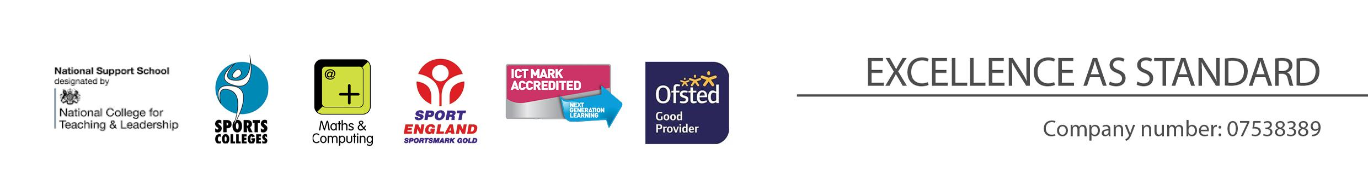
Lead Science Technician
Person Specification

REQUIREMENT | ESSENTIAL | DESIRABLE
LEGAL REQUIREMENTS | Enhanced DBS Clearance including Children’s Barred list checks
QUALIFICATIONS  Principally assessed through letter and application form |  | Health and Safety qualification  Radiation Protection Officer  PAT testing
EXPERIENCE and PROFESSIONAL COMPETENCE  Principally assessed through letter, application form | Working with people, machinery and chemicals  Health and Safety
KNOWLEDGE  Principally assessed through letter and interview process | Health and Safety  General knowledge of GCSE and A Level Science practicals. | Assembling, making, and repairing equipment.  Physics specialism
COMMUNICATIONS  Principally assessed through letter and interview process | Have good written and verbal communication skills  Ability to use IT technology to communicate professionally
PERSONAL ATTRIBUTES  Principally assessed through references, letter and interview process | Enthusiasm, energy, vigour, reliability and integrity  To be committed to safeguarding and promoting the welfare of children and young people.  Interpersonal skills that equip the appointee to relate effectively to members of staff, students, parents, external partners and suppliers.  Ability to work under pressure, accurately and meet deadlines.  Ability to manage a range of priorities and prioritise responses.  Flexibility and willingness to be involved in the school.  Committed to continuing to learn through professional development.  Work effectively as a member of a team  Be an effective role model through presentation and personal conduct

