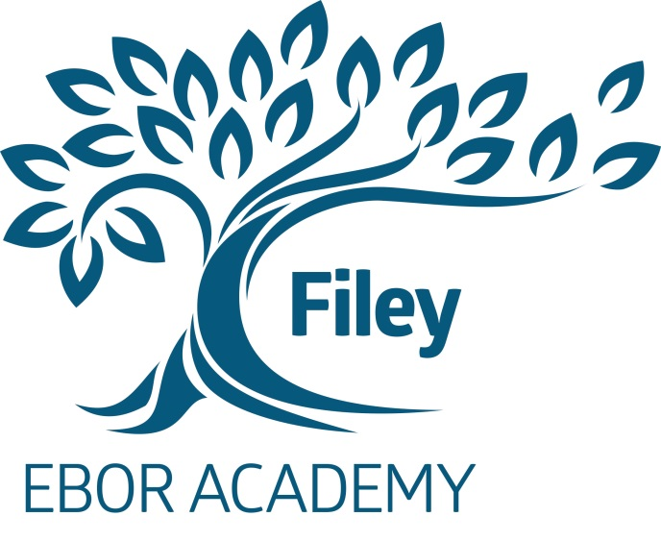

EBOR ACADEMY FILEY
MUSTON ROAD
FILEY
NORTH YORKSHIRE
YO14 0HG
TEL: 01723 512354
FAX: 01723 512165
e-mail: admin@fs.ebor.academy

MIXED COMPREHENSIVE 11-16
NUMBER ON ROLL: 363

HEADTEACHER: MR. T CARTMAIL

ENGLISH TEACHER
SALARY RANGE - TEACHERS pay scale MPS 1 to UPS3
CURRENTLY BEING £23720 to £39406

Required for the summer term as a fixed term post until 31.08.19 -
in the first instance

At Ebor Academy Filey we are seeking to appoint an “Outstanding”; talented and enthusiastic teacher for our English department.

At Ebor Academy Filey we offer an exciting career choice and a real opportunity for giving ambitious teachers and leaders the chance to influence our school and its community for the better.

Every member of our school community will focus on fulfilling our Academy Vision. We will insist all members of our school community will live by our values of Kindness, Respect, Integrity and Team work.

We are part of the North Yorkshire Opportunity Area that is prioritising improvements to education and numeracy and literacy outcomes, alongside a drive to recruit and retain high-quality, motivated teachers to the area. Teachers on the North Yorkshire Coast will have unique opportunities to engage in additional professional and leadership development through this programme, as well as access to fully-funded national professional qualifications.
The successful applicant must:
• be passionate and committed to improving teaching and learning
• have excellent interpersonal and presentational skills
• be receptive to change and have the ability to work under pressure
• be able to maximise the potential of students of all abilities

Ebor Academy Filey is located on the beautiful North Yorkshire coast with easy access to areas of outstanding natural beauty as well as fantastic culture and arts.

We are looking for a colleague who shares our commitment to high standards of academic achievement for every one of our students and who will go the extra mile to help them achieve excellence. If you are an outstanding practitioner with a commitment to high standards and a passion for enhancing the life chances of young people we would be delighted to hear from you and look forward to receiving an application.

The successful candidate can be assured of our full support in their professional development and career aspirations.

The job description, person specification and application form are available as downloads from the school website address namely filey.ebor.academy.

Please return your application to the Headteacher, Mr T Cartmail, by post to the school address or log on http://www.eboracademytrust-careers.co.uk/vacancies where you can apply direct.

Ebor Academy Filey is committed to the safeguarding and promoting the welfare of children and young people and expects all staff and volunteers to share this commitment.

Applicants should be aware that this post is subject to compliance with a fully Enhanced DBS
Disclosure.

Closing date for applications: Monday 18 February 2019

Interviews to be held: Thursday 21 February 2019

