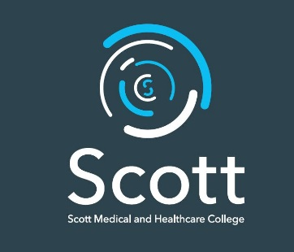

Scott Medical and Healthcare College

JOB DESCRIPTION

Job Title: Receptionist

Grade: B9 FTE £15,375

Hours Per Week: 35

Weeks Per Year: 40

Responsible to: Headteacher and Deputy Headteacher

About Scott Medical and Healthcare College
Scott Medical and Healthcare College is a new studio school for Plymouth, Specialising in Medicine, Social and Health Care. Opening in September 2017, we will be a small school (375 capacity) for young people of all abilities. Scott College is a state-funded schools which specialise in medicine and health care and which combines academic study with a focus on employability skills and regular work experience. A proportion of learning will delivered using a project based approach, and we will work closely with local hospitals, health care provider and businesses to ensure that our projects are relevant, engaging and ‘real’ to young people. On graduating from Scott College, our students will have the skills and resilience to secure purposeful jobs, apprenticeships with many going on to further study at University.
We will open is September 2017 with ten teaching staff and five support staff including this post and one receptionist. We will have a small team and this needs a flexible can do approach. In the two year after opening further support staff will be recruited to Scott College.

The Post

The following outlines the main duties required for this post. It is not a comprehensive or exclusive list and duties may be varied from time to time which do not change the general character of the job or the level of responsibility held.

- Reception:

- To be the first point of contact at reception
- To deal with parents, students, staff and visitor enquiries
- Operate the main telephone switch board
- To call parents or work placement providers where students have not arrived at school or the work placement
- To deal with deliveries to the college
- Process incoming and outgoing mail
- Be responsible for the safe custody of keys

- First Aid:

- To provide First Aid cover to staff and students who are injured or become unwell.
- Contacting parents or next of kin and the appropriate teaching staff
- To maintain relevant records and proforma
- Where necessary to contact the emergency medical services.

- Staff Development:

- To participate in a programme of support staff development.

