Job Description

Job Title: Rowing Coach

Job Purpose: The role will involve a range of coaching duties throughout the week and will play an important part in the continued development of the Boat Club. Weekend working will be required as well as attending rowing events and training camps
Reporting Line: Head of Rowing
Start Date: October 2023
Tenure: Casual
Up to 30 hours per week, Monday to Saturday
You may also be required to work additional for events and training camps as well as Sundays on occasion

Coaching Responsibilities
- To work across all squads from WJ13 to WJ18, with an emphasis on Wj13, 14 and 15
- To coach and lead a training session, focusing on every individual
- To record and monitor rower’s records of assessment and report on individual rower progress, which will include racing and training data, ergo scores, water results and registers
- To work with the Head of Rowing and colleagues to improve the rowing performance
- To coach and develop sculling and sweep rowing within the Surbiton technical model
- To follow set training plans created by a lead coach or Head of Rowing and work within the team to create training plans
- To provide training session feedback to a lead coach or Head of Rowing
- To supervise pupils during each session and outing, and monitor the correct usage of the equipment
- To assist with the running of land training sessions; ergos, strength and conditioning etc
- To attend rowing races and events
- To manage rowing squads at events
- To assist in trailer loading/unloading, to attend regattas and head races and to assist in transport, rigging and all other organisation related to such events
- To prepare rowing sessions; getting launches ready, and boats on and off the water
- To attend training camps and holiday training

Boats, Equipment and Launches
- To supervise the racking and removal of equipment from the boathouse to minimise damage
- To assist in maintaining the quality of boats and equipment
- To assist with the rigging of boats

Administration
- To ensure attendance registers are completed
- To actively monitor SOCS and the rowing calendar and edit if required

Transport
- To drive a minibus and tow a trailer
- To assist in the transport of boats to from events; helping with the loading and unloading of boats and all associated equipment as well as rigging and de-rigging boats
- To assist with pupils travelling to and from training

Other Responsibilities
- To assist with general day to day running of the boathouse, its fleet of boats and associated equipment
- To keep the boathouse and training venues in a neat and orderly condition as determined by the Head of Rowing
- To support the Head of Rowing in the internal and external vision of Surbiton Rowing
- To raise the profile of rowing within SHS and in the community
- To carry out any further duties which the Head of Rowing sees fit providing that such duties are appropriate to this role and sport at Surbiton

Person Specification

The successful candidate will be likely to fit the following profile:

Qualifications
- British Rowing Level 2 Coaching would be beneficial, or a willingness to undertake a Level 2 Coaching Course
- RYA Level 2 Powerboat would be beneficial
- First Aid would be beneficial

Skills
- Have a good knowledge of rowing/sculling technique and be able to communicate this to athletes
- Have a vision for and the ability to translate the Surbiton High School strategy into reality
- The ability to work as part of a team in a successful and dynamic School and rowing programme
- Good communication, organisational, administrative and ICT skills
- Excellent planning skills and the ability to manage multiple tasks and prioritise effectively

Experience
- Experience of rowing coaching in an educational setting would be preferable
- A proven track record of demonstrable training and race success with young people
- Proven record of coaching both rowing both sculling and sweep to a range of age groups
- Experience of coaching junior rowers would be advantageous
- Experience of operating professionally and safely within a Rowing environment
- Possess good judgment and sound knowledge of the river Thames
- Experience of collaborating with colleagues and working as part of a team
- Confidence and creativity in working with large squads of varying abilities in changeable conditions
- Rowing boat rigging

Personal Qualities and Attitudes
- A passion for rowing
- Personal warmth to gain the confidence of pupils, staff and parents
- High standards of personal presence and presentation and attention to detail
- Ability to communicate concisely and sensitively, both orally and in writing, to a variety of audiences
- A strong work ethic, flexibility and a healthy sense of humour
- Positive, enthusiastic and energetic approach to life, with a can-do attitude
- Committed to the Surbiton High School’s ethos
- Committed to representing the strategic vision for the School
- Ambitious and aspirational for oneself and for the School and the boat club
- Committed to professional development and show a willingness to undertake appropriate training for this role

To Apply

Please apply online via the link on the TES or our School website

Closing date for Applications: 8:00am, Wednesday 6 September 2023
Interviews to be held week commencing: 11 September 2023

Please note that the School reserves the right to appoint at any stage during the recruitment process.
For any queries relating to the role or your application, please email recruitment@surbitonhigh.com

The Benefits of Working for Surbiton High School

- Competitive Salary
- Extensive CPD Opportunities
- Flexible Working
- Complimentary School Lunches
- Fee reduction for children attending the School for permanent staff
- Contributory Pension Scheme
- Sabbaticals for long service
- Generous Rewards Programme
- Excellent transport links
- Working as part of a motivated and committed team

About Surbiton High School

We aim to inspire, encourage and empower our staff and pupils to be the very best they can be.

Surbiton High School is a friendly and vibrant community where people matter, results count and where a passion for excellence drives everything we do. We are a School with a real heart and soul, where we look beyond the A* to offer a breadth of opportunity which allows every pupil to flourish and every staff member to develop and succeed.

Our inspirational Teachers are committed to delivering a rich curriculum and programme of co-curricular activities which challenge our pupils to explore ideas for themselves. We feed our pupils’ minds, but we also care passionately about their character development and happiness. Our approach to education means that Surbiton High School pupils achieve the very best exam results and are also compassionate, authentic young people with strong values, keen to make a positive difference in the world. Our Educational Support Staff are the backbone of the School, and are dedicated to supporting our aim of creating an intellectually rigorous and challenging academic environment which runs smoothly and efficiently.

Surbiton High School has approximately 1,600 pupils aged between 4 and 18. Our Junior Schools are divided into the Girls’ Preparatory School and Boys’ Preparatory School, and the Senior School is girls only from age 11 upwards.

We are looking for applicants who are passionate about inspiring those around them, bringing out ‘The Best in Everyone’ and working with us to become the number one School of choice in South West London.

Read more on our website: www.surbitonhigh.com

Additional Information

Equal Opportunities
Surbiton High School is a member of the United Church Schools Trust, Charity Number 1016538 and is an equal opportunity employer. We expect all employees to act in a manner which is consistent with the Trust’s principal objective: to provide education based on Christian principles. While we recognise that employees may come from other faith groups (as indeed do many of our pupils), we expect everyone in our community to conduct themselves appropriately in the light of this objective. As a School we, in turn, respect the different faiths of our colleagues and pupils, and welcome them and their contribution.

In Surbiton High School, male colleagues and those from ethnic minorities are under-represented among our staff; we would therefore wish to encourage them to apply. However, the aim of the selection process is to appoint the best possible candidate, and gender and ethnicity are not criteria for selection.

Eligibility for Employment
Surbiton High School is committed to safeguarding and promoting the welfare of children and young people and expects all who work at the School to share this commitment. Successful applicants will be subject to an Enhanced Disclosure from the Disclosure and Barring Service (DBS). Any offer of employment is thus conditional on clearance from the above, on the receipt of: two satisfactory references, a satisfactory medical questionnaire, proof of qualifications, overseas checks where applicable, and on proof of right to reside and work in the UK.

Choice of Referees
We wish to have someone who can write knowledgeably about your abilities to perform professionally in a position similar to this one. We also need to have the most recent possible references. Your referees should therefore normally include your current – or most recent – employer. If you are unable to supply referees who fit into the above categories, please explain this in your application. We shall carry out such further reference checks as are necessary to ensure the safety and welfare of children. Please provide professional, rather than home addresses for your referees, and supply email addresses in all cases.

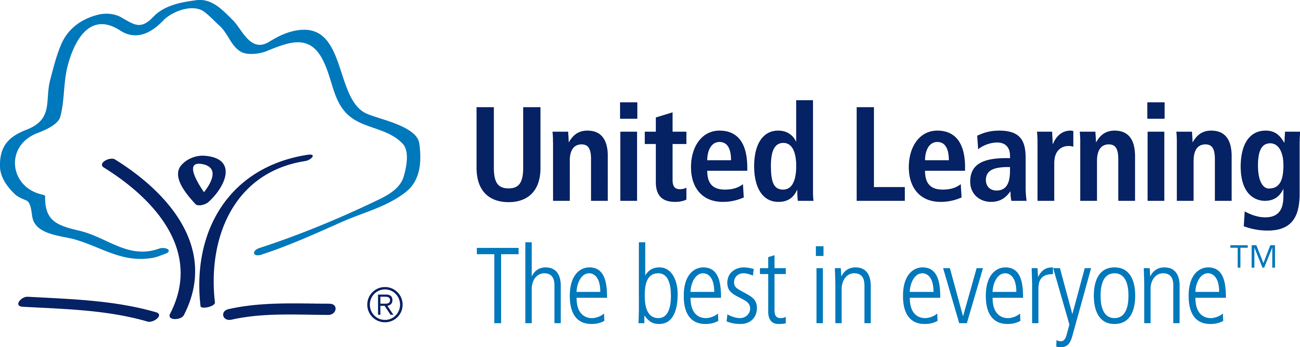

United Learning
United Learning is a unique group of independent and state schools working together to achieve the best in everyone. Our vision is to provide excellent education so that all young people are able to make a success of their lives and, if we are to realise this vision, we need to make sure we attract, develop and reward the key ingredient – you.

