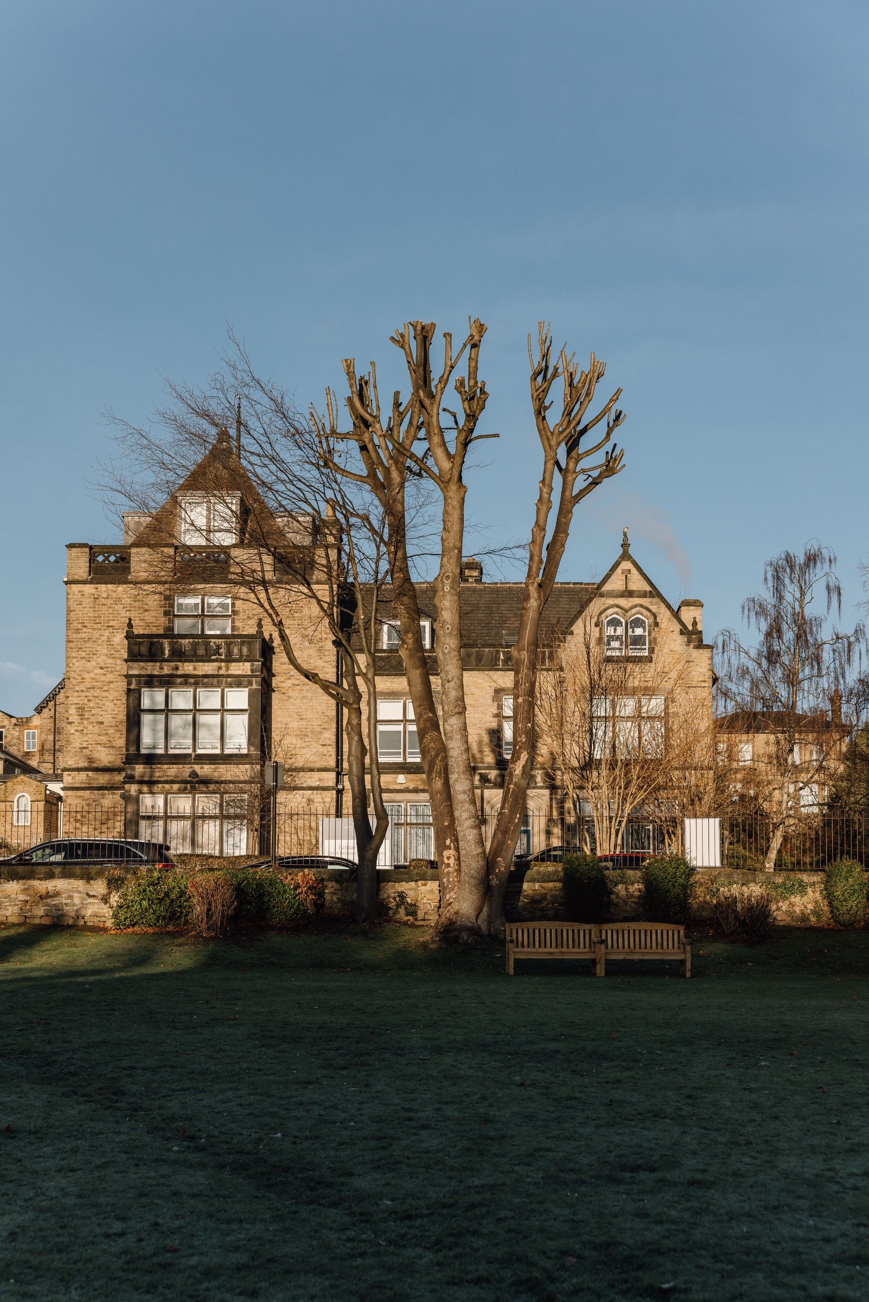

Appointment of Minibus Driver

Our School
Our aims
At Sheffield Girls' we aim to nurture a love of learning and curiosity in our girls that encourages them to explore, question and challenge.
We want our girls to be confident, to flourish and be ready to take their place, and make a difference, in an ever-changing world.
We want our girls to be proud! Proud of themselves, proud of each other, proud to be forged at Sheffield Girls'.

“Teaching her everything so she can be anything”
Our values
We have three school values: Positivity, Kindness and Courage.
We want our girls to be positive. Positive in the way they approach their learning, positive in the outlook on life, positive in their aspiration for the future.
We want our girls to be kind. Kind to others, kind to themselves, kind to the world they live in.
We want our girls to have courage. Courage to stand out from the crowd, courage to speak up for what is right, courage to push herself that little bit further.

Girls only by design
Schools like ours can offer a learning environment dedicated to girls' learning needs and preferences, an environment where girls can establish their own identities attitudes and self-worth free from gender stereotypes during those crucial formative years.
We firmly believe that girls' education has never been more important, because it has a purpose and a unique position in a world that can only benefit from the contribution these girls will make to a better future for us all.

An exceptional education from 4-18
Founded in 1878, Sheffield Girls’ is situated in Broomhill, a very pleasant area of the city between the University and the Botanical Gardens.
The school serves a wide geographical area attracting girls from the neighbouring towns of Barnsley, Doncaster and Rotherham as well as Derbyshire and North Nottinghamshire.
The school is spread across several buildings within close proximity of each other, and we have specialist facilities to support learning across all ages.
At Sheffield Girls’, our pupils are immersed in a purposeful environment, free from disruptive behaviour, where it is cool to work hard and do your best, which means the girls are enthusiastic and motivated in their learning.
The learning is rigorous, but it is fun. Lessons are fast-paced with students engaged as active learners and they are delivered by inspirational teachers who bring a wealth of experience and are innovative in their approach. Learning takes place in a supportive environment where mistakes are encouraged. We aim to develop the girls’ resilience and confidence and instil a ‘can-do’ attitude.

There are currently 710 girls on roll which includes approximately 150 girls in the Junior School and a Sixth Form of around 150 students.
We have a commitment to innovation, sustainability, skills development, and equality, diversity, and inclusion (EDI). Our strategic actions over the last three years have seen us achieve Unicef Rights Respecting Schools Silver Award status; become the national hub for World Education Robotics (WER); introduce and embed a competency based curriculum across our all phases; appear in 18th position in the School Sports Magazine’s ‘Top 200 sporting schools’; achieve the highest judgements in our ISI Educational Quality Inspection in September 2021; be named the Sunday Times Top Independent Secondary School in the North of England 2023 and, most recently, achieve the title of Prep School of the Year at the Independent School of the Year Awards 2023.
Part of the GDST
Sheffield High School for Girls is one of 25 schools administered by the Girls’ Day School Trust (GDST).The GDST is the leading network of independent girls’ schools in the UK, with nearly 20,000 pupils and over 3,700 staff in its 23 fee-paying schools and two academies. The GDST is the UK’s largest educational charity with an annual turnover of more than £200m. The GDST is fully committed to its current and future students, parents and staff and any surplus is reinvested in its schools, for the benefit of its pupils.
For further information on the school or the GDST, please visit www.sheffieldhighschool.org.uk or www.gdst.net

VACANCY FOR THE ROLE OF
MINIBUS DRIVER
The Role
We are looking to appoint an experienced Minibus Driver to join our existing support team. Primarily, the successful candidate will transport students to and from the school campus to the Fulwood area in time for the start of the school day and after the end of the school day.

As a Minibus Driver you will be responsible for working unsupervised with small groups of students. You will need to be reliable, flexible and be available to work the designated hours each day during term-time.

The successful candidate must have a full clean UK driving licence which includes the D1 category.

The contracted working hours for this role will be 7am to 9am and 3pm to 5pm Monday to Friday, term time only to cover the school run. Additional hours are routinely available to transport pupils and staff to a variety of school events and activities.

To apply please go to the GDST website and complete the online application. Please ensure that you enclose a cover letter with your application. The deadline for applications is 4:00pm Sunday 16 March 2025 and the interviews will take place shortly after this date.

We are committed to the safeguarding of children and child protection screening will apply to this post. For further details of our Safeguarding Policies and Procedures, please follow this link:
https://www.sheffieldhighschool.org.uk/school-policies/safeguarding-policy/

Job Description
Role | Minibus Driver
Job purpose | To act as a driver transporting staff/pupils on home-to-school journeys and to local events/matches.
Accountable to: | Site Manager
Accountabilities: | Driving Duties  - Drive school vehicles (people carrier and minibus) for a daily school run at the start and end of the school day.  - Drive school vehicles (people carrier and minibus) to take children and staff to school events/matches within normal working hours.  Administration  - Ensure compliance with Health and Safety regulations and codes of practice in the provision of safe and healthy working environment for all site users.  - Collect goods as required for the efficient completion of any caretaking or maintenance job.  - Certification, completion of necessary time sheets, sickness/absence records/holiday records.  Maintenance  - Conduct daily and weekly vehicle checks  - Maintain the cleanliness of the vehicles and identify and report any repairs, maintenance of replacement issues that require rectification.
General requirements | All school staff are expected to:  - Work towards and support the school vision and the current school objectives outlined in the School Development Plan.  - Contribute to the school’s programme of extra-curricular activities.  - Support and contribute to the school’s responsibility for safeguarding students.  - Work within the school’s health and safety policy to ensure a safe working environment for staff, students and visitors  - Work within the GDST’s Diversity Policy to promote equality of opportunity for all students and staff, both current and prospective.  - Maintain high professional standards of attendance, punctuality, appearance, conduct and positive, courteous relations with students, parents and colleagues.  - Engage actively in the performance review process.  - Adhere to policies as set out in the GDST Council Regulations, ORACLE and GDST circulars.  - Undertake other reasonable duties related to the job purpose required from time to time.
Review and amendment | This job description should be seen as enabling rather than restrictive and will be subject to regular review, in consultation with the recognised trade union.

Person Specification
Skills required
Ability to work effectively both in collaboration with other professionals/teams and also on own initiative | Essential
Ability to understand oral and written instructions | Essential
Excellent interpersonal skills, particularly the ability to relate to young people, parents, colleagues and external agencies | Essential
Excellent organisational skills / Time management / Ability to prioritise and organise own workload / able to work to deadlines | Essential

Knowledge Base & Experience
Knowledge of relevant health and safety requirements | Desirable
Understanding of child protection issues | Desirable
Knowledge of routine preventive maintenance | Desirable

Qualifications/Attainment
Clean Driving Licence | Essential
D1 driver category | Essential
Midas certification | Desirable

Personal Attributes
Honesty and integrity | Essential
Professional and approachable attitude | Essential
Willingness to learn new skills | Essential
Self-motivated with a positive ‘can do’ approach to work | Essential
Reliable | Essential
Well Presented | Essential
Flexible over working hours according to the needs of the school | Essential

