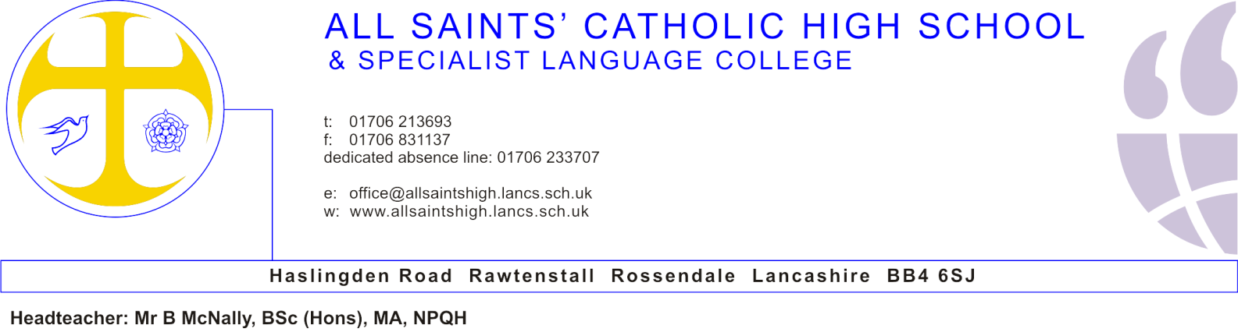

BMcN/TT

14th December 2018

Dear Candidate,

Teacher of Maths
I am delighted to provide further details about the post of Teacher of Maths, as advertised.
The school is at a very exciting stage in its development and continues to move forward at a considerable pace. Ofsted recognised that we are ‘welcoming and wholly committed to the well-being of the youngsters in its care’. It is a community in which students are happy and where every child is known and valued.
We are looking for a teacher who will be energetic in working with pupils, staff, governors and senior leaders, who will make a significant contribution to raising attainment, improving learning and teaching, and supporting the whole-school Catholic ethos. We would like the successful candidate to start on 1st September 2019 or earlier if possible by agreement.
Professional development has a high priority, and staff have regularly been promoted internally and to other schools. Our support and induction programmes are very good.
Following your examination of the enclosed information, I hope you will feel able to apply for this post.
Applications should be forwarded to Mrs Tracey Torr, School Business Manager, t.torr@allsaintshigh.lancs.sch.uk. The closing date for applications is Wednesday 23rd January 2019 at 12 noon and interviews will be held shortly after.

Yours sincerely,

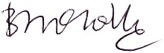

Mr. B. McNally
Headteacher

Enc.

