ILFORD SEVEN KINGS STUDY CENTRE
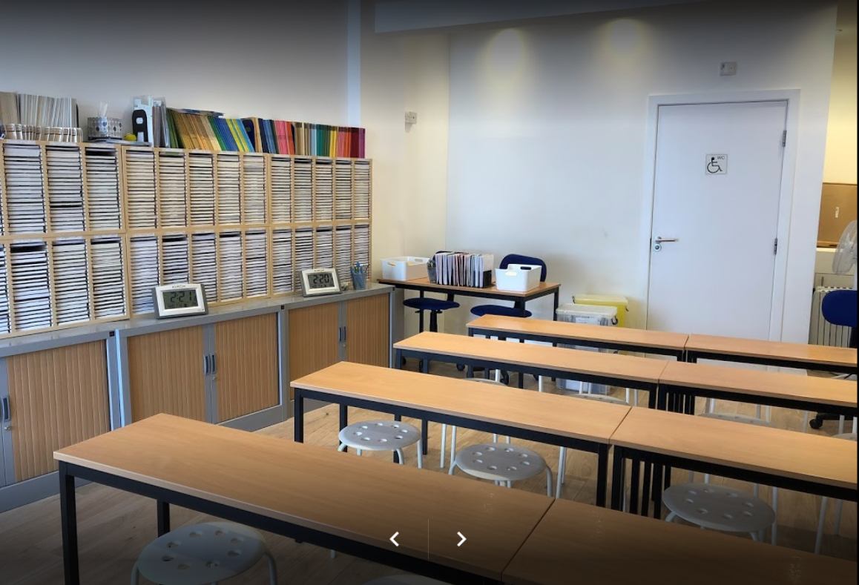

http://www.kumon.co.uk/

ABOUT KUMON
- World’s largest supplementary education provider offering individualised maths and English study programmes
- Established for over 60 years
- 4.3 million students worldwide
- Over 600 study centres and over 73,000 students in the UK
- Please visit www.kumon.co.uk for more information
Ilford Seven Kings
- Ilford Seven Kings Study Centre is the longest serving Kumon centre in Ilford having been open for over 25 years.
- This centre has grown by over 30% in the last year (throughout the pandemic), building strong ties with the local community.
- It is expected that this centre could grow further.
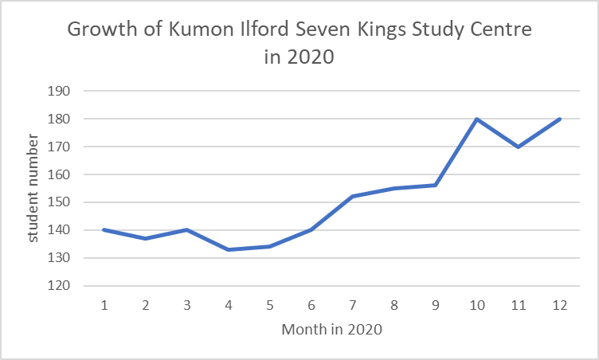

POTENTIAL FOR FURTHER GROWTH
- Schools nearby (and quality)
  - There are many outstanding secondary schools in the area. This encourages families with younger children to seek for extra tuition to aid with their development to access such schools.
  - There is a high population of pre-schoolers in the area with Kumon being their only option for extracurricular education.
- Housing nearby
  - Over 13,000 homes to be built by 2027 to allow for the 20% expected population growth by 2030.
- This centre operates out of a retail unit with lease for renewal in 2022.

CURRENT VALUE
Photos of centre

Ilford Seven Kings Kumon Study Centre
249 Aldborough Road S,
Ilford,
IG3 8JA

- The Kumon Forest Green study centre runs from a warm, bright and airy downstairs room inside Forest Green Leisure Centre.

- Dedicated entrance.
- Aldborough Road South is on the main high street which has a number of shops and is less than a ten-minute walk to Newbury Park station. There are a several bus routes that run along this road.
- Students often travel from further afield to attend the Saturday session which is not offered by other Kumon centres in the area.
- There is free on-street parking around the centre.

OPERATION
OPENING HOURS: Monday 4:30pm – 7:30pm
Tuesday 3:00pm – 5:00pm
Thursday 4:30pm – 7:30pm
Saturday 10:00am – 2:00pm

WORKING HOURS: Class preparation and admin (flexible) = 12 hours
Class time = 12 hours
+ 8 additional assistant hours (outside class time) = 40 hours*

*The purchaser may decide to delegate more/less hours to an assistant

HOLIDAYS
The centre can be closed for up to 8 weeks per year as determined by the purchaser.

TRAINING
- Kumon provides full training in the Kumon method
- This begins with an initial orientation meeting and a maths and English proficiency assessment
- This is then followed by an interview and, if successful, two weeks of training spread over 6 weeks
- To get more information please request a call back from a Kumon Area Manager on 0800 854 714

OTHER INFORMATION ABOUT THE CENTRE
- The centre is Ofsted registered, offering the highest safeguarding standards to all families:
  - This enables the centre to accept payment via childcare vouchers, tax free childcare and working tax credits. An added benefit for many families.
  - Ofsted registration can be applied for by the buyer and this is the favourable option to continue to offer the benefits and high levels of safeguarding to current customers.
- 4 members of staff (assistants)
- All staff over 16 are DBS checked
- The class is fully time-slotted helping to manage the needs of all types and ages of student without over-staffing
- 95% of families have a regular payment date via direct debit or standing order
- There is a payroll system in place

REVENUES AND PROFITABILITY

- INCOMING FEES: £65 per month per subject (maths or English)
£50 registration fee

- EXPENSES: Royalties to Kumon Europe and Africa - £24.75 per month*

Venue rental £1250 per month

Assistants 3-4 per session (currently 12 individuals working on different days)

Assistant wages
18-20 year olds (currently x3) - £6-7 per hour
21+ year olds (currently x2) - £8.40 per hour

Other Expenses** On average £250 per month

*For a fully qualified instructor this would be £22
**Including prizes, stationery, staff uniforms, communication with customers etc.

MONTHLY PROFITABILITY
- Revenue for month of February 2021 is £11,400
- Pre-tax profit for February 2021 is £4,000
- Forecast pre-tax profit for 2019 is £35,000 (£40,000 for a fully qualified Instructor)
- Forecast pre-tax profit for 2020 is £45,000 (£49,000 for a fully qualified Instructor)

REVENUE CONTINUITY

HIGH STUDENT RETENTION RATE: 100% stay for 3 months +
76% stay for 6 months +
66% stay for 9 months +
55% stay for 12 months +
22% stay for 24 months +

PLEASE CONTACT KUMON FOR MORE INFORMATION ON THE SALES PRICE
Full financial details can be provided upon request

INTENDED TAKEOVER DATE: ASAP or SEPT 2021

**You must hold a current UK or EU driving license
** You must have a university degree or equivalent qualification
**You must have the right to live and work in the UK

