

Careers at
SHARE Multi-
Academy Trust
Application Pack
Valuing People, Supporting Personal Best

Northern Cluster of Schools (Heaton Avenue and Millbridge SHARE Primary Academies)




Teaching Assistant


John McNally
Chief Executive Officer
SHARE Multi-Academy Trust
Quality is our driving force

Welcome to SHARE Multi-Academy Trust, a supportive and close-knit family partnership of eight academies across West Yorkshire,
and a Teaching School Hub.

We are proud to be an employer of choice.
I believe our role as educators is to help children and young adults to instil a desire to learn, to overcome barriers to success, and to encourage an ambition to achieve. To reach this standard, we must first deliver for our people and ensure they feel valued, listened to and have a strong sense of belonging. In turn, our colleagues, pupils, and society all benefit enormously.

Two of our guiding principles are that ‘quality is our driving force’, and ‘teams drive success’. We know that recruiting and retaining an outstanding workforce is fundamental to achieving our aims. We therefore make it our mission to ensure every colleague within the trust has access to exceptional training and personal development opportunities, alongside a positive teaching environment, clear and ambitious progression pathways, and highly competitive packages.

We are also committed to sharing best practice across our trust, creating networks for colleagues to learn from one another, and fostering a learning environment and workplace where everyone feels supported and inspired, and can truly thrive. As a result, we are proud to be an employer of choice.

Thank you for your interest in our academies and trust. I hope you will consider joining us as we continue to deliver the very best education for our pupils. Whether you are an education practitioner looking to start your journey, or an established professional wanting to bolster your career – we look forward to working together soon.
We must
first deliver
for our people and ensure they feel valued.
At SHARE, we are committed to delivering strong educational standards within our
academies and providing our people with excellent careers. This is all underpinned by an unwavering commitment to our vision of Valuing People, and Supporting Personal Best.

Teams drive success






ABOUT US
TESTIMONIALS
JOB DETAILS


About
our Trust

SHARE Multi-Academy Trust was first established in
2014, and since then, we have built a solid reputation
for high standards and strong achievements.

We operate four successful primary academies and
four high-performing secondary academies across
the region. Our outstanding provision is supported
by our Calderdale and Kirklees Teaching School Hub
and national training accreditations, which enable us
to deliver exemplary training and development opportunities for education practitioners at every stage of their career, from initial training to executive leadership.

Our academies achieve excellent outcomes across the board. This includes academic attainment and school improvement, as well as maintaining exceptionally high standards in all aspects of school life including behaviour and attendance.

As a result of the trust’s supportive and inclusive approach, senior leaders invest significant time in supporting positive pupil behaviour and attendance. Our pupils attend well and are positive about learning. In turn, this creates a positive and respectful teaching and learning environment for staff, with teachers able to focus on delivering an excellent education to students without distraction, and with a manageable workload.

Behaviour is excellent, and there are high levels of mutual respect and tolerance amongst pupils and staff.

Ofsted, 2023*

Whilst being close-knit, we are ambitious for the future.


We are always looking for additional ways to expand our positive impact, be that by working with new schools
on exciting initiatives, or by collaborating with our
talented team of staff.

Our aim has long been to be the best trust, not
the biggest. Our priority for the future is to keep
improving standards, building on our successes,
and raising aspirations so we can support even
more pupils to achieve even better outcomes.


*2023 Ofsted report for Thornhill
Community Academy, A SHARE Academy
ABOUT US
TESTIMONIALS
JOB DETAILS


Jack Wyatt
Associate Principal
Shelley College
often exceed them. We continue to contribute to the generous Teachers and Local Government Pension

School Teachers’ Pay and Review Body. We use the flexibilities available to us as an academy to enhance our offers where we can.

Schemes and at least match pay awards agreed or recommended by the Local Government Association and

Your Career
at SHARE
Our vision of ‘Valuing People, Supporting Personal Best’ underpins everything we do. Central to our work and ability to deliver a transformational education, is our dedication to developing our greatest asset, our staff.
That is why we have an outstanding pledge to teachers and support staff to provide professional development and training opportunities, particularly through our Teaching School Hub. We are committed to investing in our staff, ensuring that they have fulfilling careers and enjoy their jobs every day. This is fundamental to our ability to turn academies around and
deliver the very best education to pupils.
We offer a competitive package
to all our colleagues.
We work as a collective group of professionals to achieve common goals. Watching new teachers and leaders become established in their roles gives me an immense sense of professional pride, as they help our pupils to achieve excellent outcomes.
As well as two generous pension schemes, we also offer

employee assistance and wellbeing packages; and flexible

and family-friendly policies, such as flexible working, shared parental leave and enhanced maternity,
paternity, and adoption entitlement, giving colleagues

the control and freedom to work in a way that suits their needs. We offer incremental progression and cost-of-living pay increases, subscribe to local
and national discount schemes, and provide exceptional onsite catering facilities.
We have committed to offering our colleagues pay and conditions that are at least as good as those available to colleagues in maintained schools. In practice, we
ABOUT US
TESTIMONIALS
JOB DETAILS
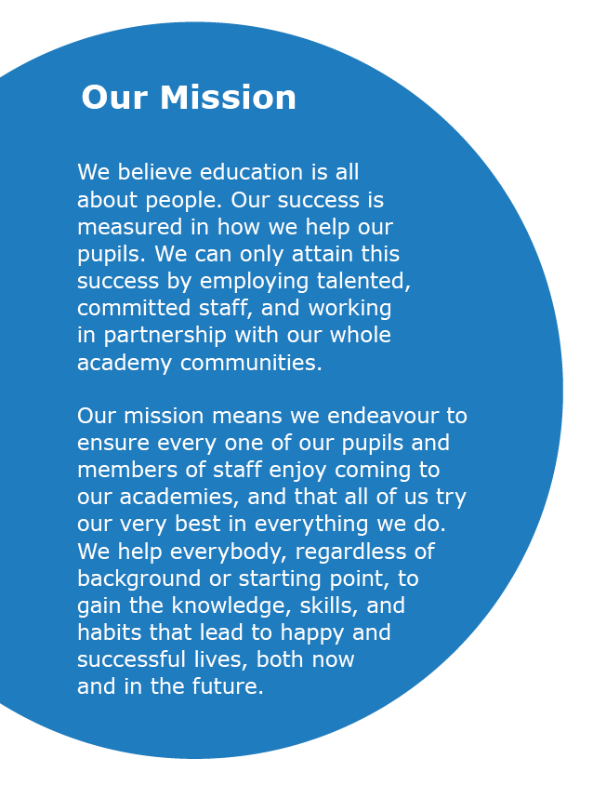



ABOUT US
TESTIMONIALS
JOB DETAILS
Our Shared Vision and Mission




ABOUT US
TESTIMONIALS
JOB DETAILS
Build positive communities that achieve outstanding outcomes, together
Overcome disadvantage, so all pupils achieve outstanding outcomes
Deliver an outstanding curriculum and pedagogy
Recruit and retain an outstanding workforce
Provide outstanding leadership, management and trust infrastructure
People thrive in communities
Teams drive success
Quality is our driving force
Everyone can achieve
We have a clear and ambitious strategy as a trust, so that we can ensure we collectively fulfil our overarching vision and mission. This is built upon our guiding principles, with distinct goals and objectives linked to accountability and performance measures.

Our Guiding Principles













ABOUT US
TESTIMONIALS
JOB DETAILS
*Most recent Ofsted prior to academisation in 2022
Click below to select the location of the vacancy you are interested in to find out more.
Our primary academies
Our secondary academies
Academies

ABOUT US
TESTIMONIALS
JOB DETAILS
Alongside our successful Teaching School Hub and
training accreditations, we take great pride in one
another’s individual successes. Many of our most
senior leaders have progressed through the routes.
That includes the countless colleagues who have enjoyed varied, rewarding, and long careers with our academies and trust, as well as those who are just starting on their journey and are glowing with potential.

We remain committed to developing our staff, who are our greatest asset in achieving our mission.

Through our broad curriculum, first-class careers
education and guidance, and our wide-ranging enrichment offer, we successfully prepare our young people for life beyond the classroom. We ensure no child is left behind, and do so by fostering a safe, inclusive, and nurturing environment where all barriers can be overcome.
enrichment offer, we successfully prepare our young people for life beyond the classroom. We ensure no child is left behind, and do so by fostering a safe, inclusive, and nurturing environment where all barriers can be overcome.
At SHARE, we are proud of the high standards and expectations we set and uphold, across the board. Consequently, we consistently surpass both national and regional school results. Our academies consistently secure excellent academic outcomes, with achievement levels being amongst the highest in our region.
Supported by robust, well-resourced, and accountable improvement plans, we have a proven track record of significantly improving our academies, as reflected in national performance measures and our strong Ofsted outcomes.

Our Outcomes


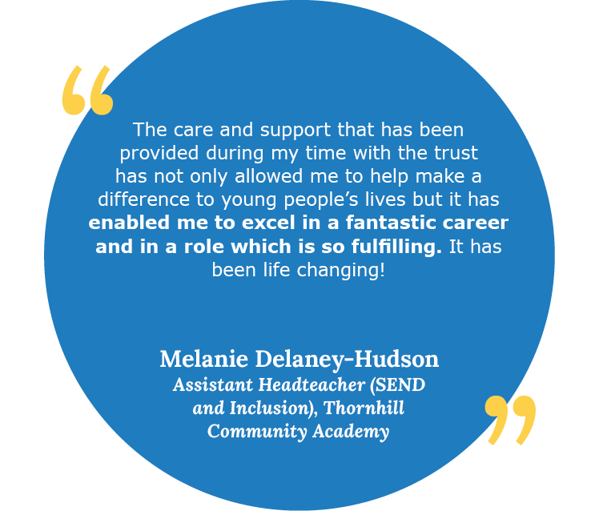
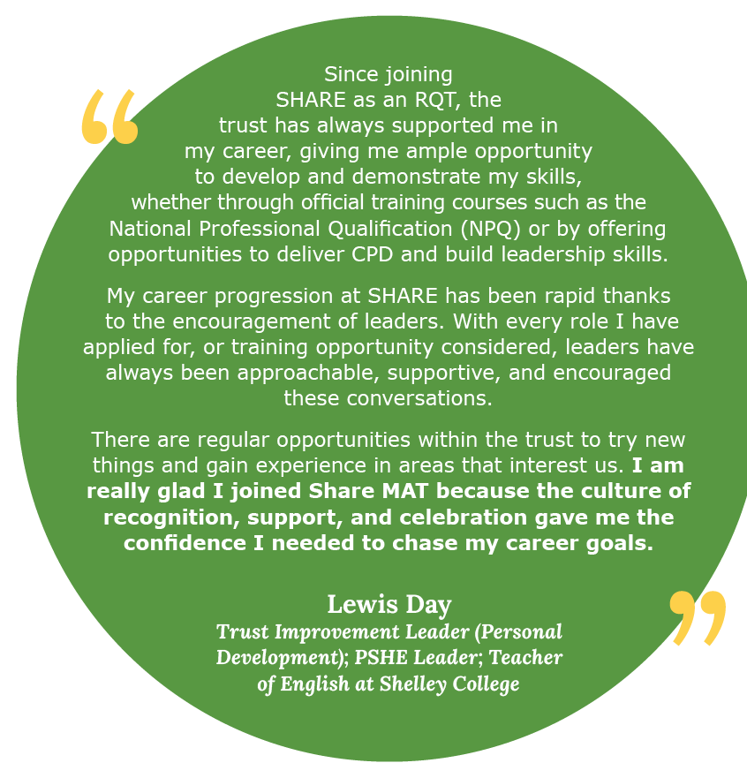
ABOUT US
TESTIMONIALS
JOB DETAILS

What our colleagues say




ABOUT US
TESTIMONIALS
JOB DETAILS
What our colleagues say



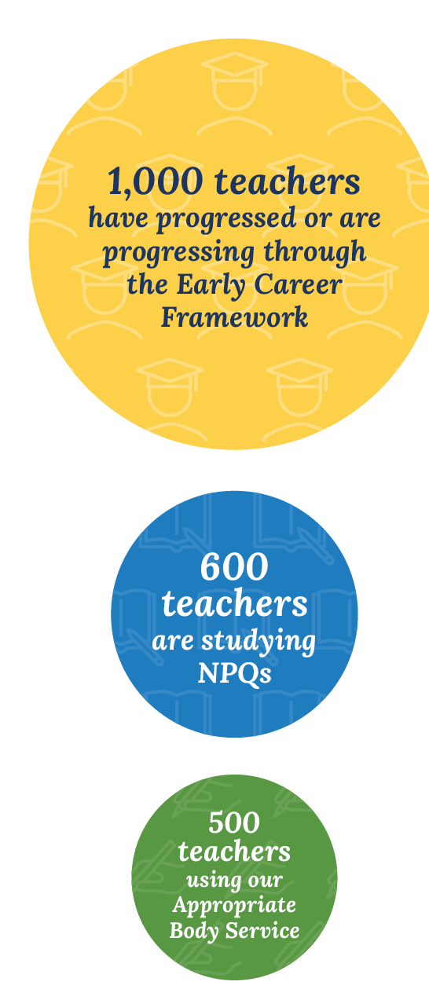
ABOUT US
TESTIMONIALS
JOB DETAILS
specialist and leadership National Professional Qualifications (NPQs), offer Lead Practitioner positions for those with classroom-based preferences, alongside middle and senior leadership training programmes for new and aspiring leaders. With additional development opportunities for staff including research projects, subject enhancement training, and access to The National College online development platform, we are dedicated to supporting our staff to develop and grow as educators.

Our success as a trust depends entirely on our colleagues who are the bedrock of all we do. That’s why we’re determined to recruit and retain the best staff by offering first-class training and support, alongside highly competitive packages.
First-class careers, through
bespoke training and support
Across the trust, we pledge to deliver outstanding professional development and training opportunities that are bespoke for our teaching and support staff. We support colleagues through ongoing training, coaching, and mentoring using the latest evidence-based research, to strengthen their expertise.

Alongside career pathways carved out for our support staff, we similarly offer a variety of progression and promotion routes for teachers. In addition to the traditional progression journey, we deliver a full suite of specialist and leadership National Professional Qualifications (NPQs), offer Lead Practitioner positions for those with classroom-based preferences, alongside middle and senior leadership training programmes for new and aspiring leaders. With additional development opportunities for staff including research projects, subject enhancement training, and access to The National College online development platform, we are dedicated to supporting our staff to develop and grow as educators.

We also champion cross-trust collaboration and best practice sharing, maximising the opportunities and expertise available across our schools. All colleagues are encouraged to meet regularly, including through various forums where they can discuss ideas, and share experiences and resources.

We also champion cross-trust collaboration and best practice sharing, maximising the opportunities and expertise available across our schools. All colleagues are encouraged to meet regularly, including through various forums where they can discuss ideas, and share experiences and resources.

Alongside career pathways carved out for our support staff, we similarly offer a variety of progression and promotion routes for teachers. In addition to the traditional progression journey, we deliver a full suite of
We are committed to protecting our staff’s wellbeing by providing the support, guidance, and training needed to achieve the highest standards they are capable of.

Just as we encourage our pupils to achieve their personal best, we want the same for our staff, with colleagues having their own personal development plans.

ABOUT US
TESTIMONIALS
JOB DETAILS
Since its launch, we are delighted that 1,000 new teachers have progressed or are progressing through our Early Careers Framework Course, with over 600 studying NPQs. We also continue to provide the Appropriate Body Service for nearly 500 new teachers.
Having the Hub as a central part of our trust family means it continually informs our approach to staff development and how we can enhance our training based on learnings and insights. It has also shaped our approach in recognising that development is a long-term, meaningful investment in our colleagues and therefore our pupils.

Endless opportunities through our Teaching School Hub and Training Accreditations
Our commitment to professional development and raising opportunities and aspirations in the communities we serve and beyond, is best reflected through our Teaching School Hub and Training Accreditations.

We are immensely proud to be the Teaching School Hub for Calderdale and Kirklees, enabling us to connect with, shape, and inspire teachers and practitioners of the future.
Through our Teaching School Hub and training platforms, we induct Early Career Teachers (ECTs) into the profession through an outstanding Initial Teacher Training programme. All our academies similarly play an important role in supporting trainee teacher placements through the Hub and with other local trainee teacher providers. We also offer a full suite of specialist and leadership NPQs through the Hub, including for staff themselves to facilitate Early Career and NPQ frameworks.

JOB ADVERT

Job title:
Teaching Assistant |  |  |  | 
Academy:
Northern Cluster of Schools (Millbridge and Heaton Avenue SHARE Primary Academies.
Headteacher:
Rhona Pleasant, Head of School (Millbridge)
Sarah Quinn, Head of School (Heaton Avenue)
Section: |  |  |  | 
Support Staff
Reporting to:
Assistant Headteacher
Contract type:
Permanent | Fixed Term

Time commitment:
32.5 or 37 hour a week contracts available.
Temporary Fixed Term - 12 months fixed term starting September 2024, with a view to becoming permanent
Band/Range:
Band D, SCP 7-11, Term Time + 5 days
Further salary information:
32.5 hour post actual salary £18,589 to £19,879
37 hour post actual salary £21,163 - £22,631
Academy information:
Our Northern Cluster of schools incorporates Heaton Avenue and Millbridge Primary Academies.

- Millbridge Academy, a SHARE Primary Academy, continually strives to provide its pupils with the very best education possible. It does this by having high expectations, and children always giving their best.

- Heaton Avenue, A SHARE Primary Academy, is a family-centred academy that nurtures and motivates pupils to become shining citizens of the future. It is one of eight academies within the well-regarded and high-performing SHARE Multi-Academy Trust.

Located in a close-knit, diverse community, the academy is within good commuting distance from Leeds, Huddersfield, and Wakefield, the Northern cluster of schools is proud to offer:

- A supportive and ambitious environment where all pupils are encouraged to go beyond what they think they can achieve and to enjoy learning, helping them to lead successful, healthy and happy lives.

- A vibrant place to work which equips staff to deliver their best every day, under the strong belief that Valuing People, Supporting Personal Best is the key.

- A commitment that staff are happy, engaged, and well supported at work, taking pride in pupils’ attendance, behaviour, progress and development as well as their own.

- Excellent training and guidance relevant to individual job roles, so expectations are understood and staff are motivated.

- Great benefits, as an employer of choice, including outstanding CPD, supportive line management, and meaningful networking opportunities across the trust to aid personal development.

- Supportive leadership, encouraging a healthy work-life balance.

- A high-quality teaching and learning environment, alongside good facilities.

- A culture where children are happy, settled and confident, accessing a broad and balanced curriculum which provides a memorable educational experience for pupils and staff.
We are looking to recruit:
We are looking to recruit enthusiastic and excellent individuals to join our team of Teaching Assistants. The ideal candidates will support the class teacher with the overall delivery of the Curriculum by undertaking work/care/support programmes in order to enable access to learning for all pupils.

They will be involved in delivering engaging learning experiences that encourage pupils to think for themselves, whilst ensuring they see a purpose to their work. A wide range of learning styles are used to ensure personalised learning is at the heart of what we do.

We have vacancies for Teaching Assistants at both Millbridge, A SHARE Primary Academy in Liversedge and Heaton Avenue, A SHARE Primary Academy in Cleckheaton (known as our Northern Cluster of Schools). Successful applicants will be offered a post at the school best suited to their experience and skills. We have vacancies for 32.5 hour and 37 hour a week posts. Please state your preference on your application.

The ideal candidate will:
- Have Maths and English to GCSE Grade C or equivalent;
- Have previous experience of working with children/young people;
- Love encouraging, motivating and inspiring young children through the support they give in order to encourage their learning;
- Be committed to our ethos that all pupils can achieve at our SHARE Primary Academies;
- Have experience of working with children who have SEN/EAL;
- Have an understanding of behaviour management;
- Have great references demonstrating they are a suitable candidate, safe to work with children.
For more information, get in touch with:
Kirstie Humphreys, Admin Manager – kirstie.humphreys@sharemat.co.uk

JOB DESCRIPTION
Overall purpose of the role:
Assisting the teacher in the overall delivery of the Curriculum, undertaking work/care/ support programmes in order to enable access to learning for all pupils and the teacher in the management of pupils in the classroom.

Safeguarding requirements:
This post requires the post holder to work in settings with children and young adults.

Any employment offer is therefore subject to the results of an Enhanced Disclosure from the Disclosure and Barring Service (DBS). People who may have contact with younger children (i.e. primary school age) are also required to complete a declaration about family or other members of their household.

Applicants MUST complete the MAT’s standard application form to be considered, will be required to provide evidence of identity and qualifications and offers of employment will be subject to satisfactory references. For applicants who work or have recently worked in a school, one of the references must be from the Headteacher.
Key Outputs:
1. To undertake duties in accordance with school practices and procedures, ensuring the post holder actively upholds and promotes the philosophies of the school.

2. Under the guidance of the teacher, supervise activities and assist with the general management and control of pupils across all key stages as required and during the school day including lunchtime.

3. Under the guidance of the teacher, support within a key stage, to deliver either one to one work or to small groups, preparing resources and feeding back to teaching personnel.

4. To participate in and assist in supervision of educational visits, in conjunction with the teacher/line manager.

5. To promote good pupil behaviour, dealing promptly with conduct and incidents in line with established policy and encourage pupils to take responsibility of their own behaviour.

6. To undertake relevant training and development as required from time to time by the Headteacher or Governors, and be involved in ongoing development reviews of skills and competencies.

7. To attend and contribute towards the daily departmental briefing and other meetings as required.

8. To actively encourage the inclusion of all pupils to participate in the life and activities of the school and access the national curriculum to the best of their ability.

9. To provide individual assistance or assistance within groups through Pastoral Support, EHC plans, SEN support and teaching strategies etc, to maximise their achievements.

10. To provide information via CPOM’s of incidents or occurrences to teachers & senior staff.

11. To work flexibly across key stages as required alongside the teacher to monitor and assess pupil progress towards achievement of SEN targets as identified in MSP or ANP.

12. To act as a key person with an overview of the care needs of specific pupils. This would include acting under the direction of the SENDCo to coordinate the medical and personal care needs of the pupil.

13. Under the direction of the teacher, assist in the delivery of the structured and agreed learning activities/teaching programmes.

14. Carry out your duties with due regard to current and future school policies, procedures and relevant legislation.

15. Have an understanding of the importance of lesson planning, contribute to lesson planning and learning objectives to develop learning.

16. Contribute to and uphold the vision and ethos of the academy.

17. Recognise own strengths and areas of expertise and use these to advise and support others.

18. Promote team work within the team, working in partnership to ensure effective working relations.

19. Treat all users of the academy with courtesy and consideration.

20. Be aware and comply with all academy policies at all times. As part of your wider duties and responsibilities you are required to promote and actively support the schools responsibilities towards safeguarding.
Dimensions:
Heaton Avenue -
Range of staff approximately 45 across the whole school.
Range of pupils approximately 400.

Millbridge –
Range of staff approximately 35 across the whole school.
Range of pupils approximately 300.
- Work/Business contacts:
Internal: All teachers and support staff including liaising with other MAT staff as required;

External: Parents/Carers, Agencies.
Expertise in role required (At selection – Level 1):
ESSENTIAL
- Maths and English to GCSE Grade C or equivalent.

- Experience of working with children/young people in a school.

- Experience of working with children who have SEN.

- Ability to engage and influence others.

- Excellent interpersonal skills and the ability to foster good relationships with parents/carers and other outside agencies.

- Excellent behaviour management skills.

- Commitment to the safeguarding of young people.

- Ability to deal with the personal care and comfort, and necessary treatments with pupils, i.e. toileting and intimate care issues.

- Ability to assist the teacher in planning class activities.

- Ability to prepare differentiated materials and teaching aids suitable for learning activities.

- Ability to use ICT to support learning.

- DESIRABLE
- NVQ 3 for Teaching Assistants or equivalent qualifications or experience.

- Experience of working across departments and with external organisations.

- Ability to monitor and evaluate impact of interventions and strategies.

- Is willing to work flexibly within scope of overall hours.
Expertise in role – After initial and advanced development:
- Ability to deal with students who require physical restraint and interventions, using such methods as Team Teach, under the direction of the Head of School.
- Ability to assess individual students core skills and maintain appropriate records.
- Working knowledge or understanding of relevant policies and codes of practice.
- Trained in the relevant learning strategies e.g. literacy.
- Achieved NVQ 3 for Teaching Assistants or equivalent qualifications or experience.
Structure/Department Information:
Assistant Headteacher

Teaching Assistants

HOW TO APPLY
Please note that CVs will not be accepted. To apply, please complete an application form on the Every Candidate Portal using the application link below.
Application link:
https://candidates.every.education/Vacancies/Details?advertKey=28125186-28a8-457c-acc7-2cedfb5b5093
Closing date:
Wednesday 26th June 2024
Interview date:
Monday 1st July 2024

Share MAT is committed to the Equalities Act 2010 and also to promoting the welfare and safeguarding of children and young people, by adhering to the “Keeping Children Safe in Education” guidance. All staff and volunteers are regularly trained regarding our expectations in keeping our students safe. An enhanced DBS is required for every post. An online search will be undertaken for all shortlisted candidates.


www.sharemat.org
millbridge.org.uk (Millbridge website) and
heatonavenue.org.uk (Heaton Avenue website)

Ready to start your career with Share MAT?
Get in touch:
Visit

Email
millbridge.office@sharemat.co.uk or
heatonavenue.office@sharemat.co.uk

Call
01924 668836 (Millbridge) or
01274 028613 (Heaton Avenue)
Addresses
Millbridge, A SHARE Primary Academy
Vernon Road, Liversedge, West Yorkshire
WF15 6HU
Heaton Avenue, A SHARE Primary Academy
South Parade, Cleckheaton, West Yorkshire, BD19 3AE
Visit the trust website
Valuing People,
Supporting Personal Best

