Dear Colleague,
Thank you for considering the post of Head of Chemistry at Cove School. From viewing our website and reading our Ofsted report you will be aware that Cove is a great school to work in, but has also been through some challenging times. At Cove we are passionate about learning and about expanding the life chances of all students in its community. Therefore, standing still is never and option and we continue to evolve and adapt to meet the needs of this changing world and local community.
One of these significant changes is the structure of our science department. Chemistry has a long tradition of success at Cove and has a prominent place in both double award science, separate sciences and science studied at Key stage 3.
The science department is well resourced with a suite of specialist rooms and a fantastic technical support team. In 2017, our results in science dropped, but there is a strong history of excellent outcomes of 80%+ and every year we see a significant number of students taking ‘A’ level sciences at the local sixth form colleges.
Due to changes in leadership and curriculum structures at Cove, we now need someone that is passionate about their subject and take Chemistry to the next stage of its journey. Naturally, we are seeking an outstanding individual, or an individual with outstanding potential. Due to the importance of the role, we seek an imaginative, creative and dynamic individual to inspire young people and be a supportive member of the science leadership team. With these high levels of expectations come high levels of support and the opportunity to develop both your management and leadership skills. We run a personalised middle leadership CPD programme, alongside our whole school iTeach CPD. This is all underpinned by our teaching and Learning communities (Coaching groups) who regularly use IRIS video technology to reflect and discuss their professional practice.
The school has ample parking, all science laboratories have digital projects and interactive whiteboards, two dedicated prep. Rooms. All science rooms have a dedicated windows PC and staff are able to request their own laptop or iPad whichever is more suitable.
Applications to myself must be received by Friday 12th January 2018, we are planning to hold interviews the following week. Your application must include a completed application form with suitable references. As you would expect, we would like you to articulate, in your application letter, why you believe you have the knowledge, understanding, skills and confidence to fulfil the advertised role. The letter must also identify how you would (i) Promote and develop Chemistry (ii) further enhance the quality of teaching, learning and assessment within our Science team.

Yours sincerely
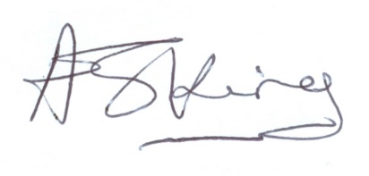
Dr Andrew King
Headteacher

