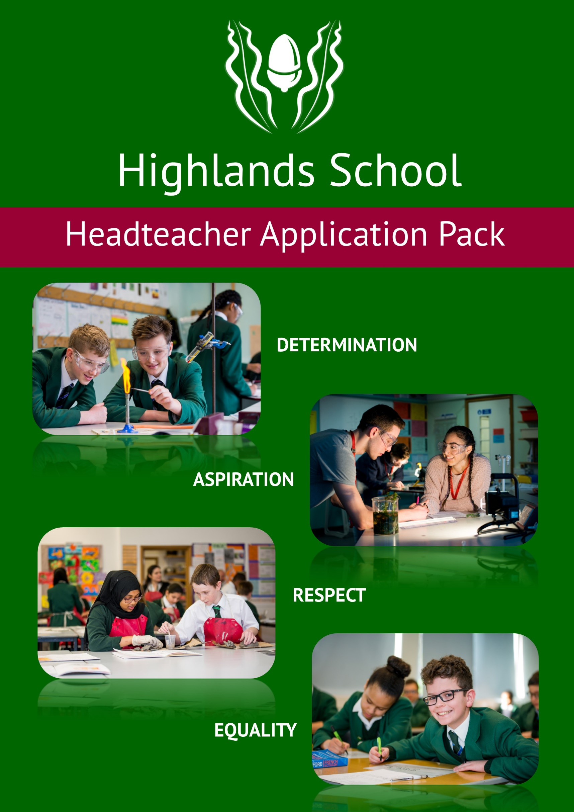

TABLE OF CONTENTS
INTRODUCTION FROM THE CHAIR OF GOVERNORS | 2
HEADTEACHER JOB DESCRIPTION  Overview  Main Tasks  - Strategic direction and development of the school  - Teaching and learning  - Leading and managing staff  - Efficient and effective deployment of staff and resources  - Accountability  - Safeguarding Children and Safer Recruitment | 3  3  3  4  4  4  5  5  5  5
PERSON SPECIFICATION FOR HEADTEACHER APPOINTMENT | 6

INTRODUCTION FROM THE CHAIR OF GOVERNORS

Dear prospective candidate,
Highlands School has been on an incredible journey since it first opened its doors to students in September 2000. Attracting national attention as the first PFI school to be built in England, expectations have been set very high for students and staff alike.
Whilst we are proud to be judged as an ‘outstanding’ school, there are many other features of Highlands which make us unique. Our ‘student first’ culture inspires inclusion and engagement as we prepare our young people for the challenges and opportunities that await them in later life. At the heart of our success is strong and dynamic leadership, which reflects our collective pledge to look out for the best interests of all who teach and learn; in every classroom.
Understandably, we place a high premium on academic excellence but more than that, we look to build success stories for those students whose skills and aspirations may lie elsewhere. As a Governing Body, we place immense value on the wonderfully talented staff body, who regularly go above and beyond in their quest to always give of their best so that the students can achieve their best.
We are also very proud of our reach within the wider community as the lead school within Pan Enfield Alliance (PEA), a flourishing collaboration of special, primary and secondary schools.
The successful candidate will be only the third headteacher to have served at Highlands and the appointment will come at a time when the education landscape presents greater challenges than ever before. We will therefore, be hoping to recruit a visionary leader who is able to demonstrate a creative approach in overcoming the obstacles which stand in the way of our desire to raise the bar further still.
Along with my colleagues on the Governing Body, I look forward to welcoming you to Highlands School so that you may see first-hand what an exciting and vibrant school we are. If you would like to have a tour of Highlands School, we would be happy to organise this.
I hope this opportunity will be of interest to you.


Matt Miller MBE
Chair of Governors
Highlands School December 2017

HIGHLANDS SCHOOL
HEAD TEACHER JOB DESCRIPTION

OVERVIEW
Position: Headteacher
Reporting to: The Governing Body
Main Purpose: As the lead professional of a richly diverse organisation, harness the wealth of talents within the school community so that all may reach their true potential.
As a role model, open the eyes and minds of the young people so that they may respond to life’s challenges with confidence and purpose.
The Headteacher will aspire to excellence in the four domains of The National Standards for Excellence for Head Teachers (DFE 2015).

The Headteacher will:
- Champion the fundamental entitlement of all students to be provided with the very best educational experience possible.
- Promote a learning environment where safeguarding is of paramount importance across all aspects of school life.
- Be visionary in the pursuit of academic excellence across each year group and in every classroom.
- Set strategic goals which are both aspirational and achievable and reflective of a highly ambitious culture which challenges the status quo.
- Act as the lead role model in a learning environment where respect and value are at the heart of all relationships.
- Shine the light on poor practice and confront those who do not embrace change.
- Embed equality and inclusion as the cornerstone of a broad and balanced curriculum where student achievement and opportunities to excel are celebrated.
- Promote the social and cultural development of all students, reflecting the school’s core values and British values.
- Create an inspiring learning environment which is engaging and fulfilling for all students, and where ‘risk’ is encouraged within sensible boundaries.
- Ensure sustained and rigorous evaluation of the school’s performance identifying key areas for improvement with strategies to address any weaknesses.
- Have a proven track record of leading school improvement through ‘School to School’ support.
- Value the importance of working collaboratively with local schools, educational partners and stakeholders.
- Build strong and enduring relationship with the Highlands Governing Body and understand the importance of their role in strengthening school leadership.
- STRATEGIC DIRECTION AND DEVELOPMENT OF THE SCHOOL

  - Provide inspiring and purposeful leadership for the staff and students

  - To work closely with the Governing Body, staff and parents, in promoting the ethos and values of the school

  - To create, implement, monitor and review the School Improvement Plan which will secure continuous school improvement

  - To monitor and evaluate the performance of the school and respond and report to the Governing Body as required

  - To ensure that management, finances, organisation and administration of the school is aligned and supportive of the vision and aims.

  - To ensure that school policies and practices are compliant of national, local and school requirements.

  - To monitor, evaluate and review the impact of school policies, priorities and targets and recommending improvement or amendment where appropriate

  - To provide leadership and support for the Teaching School Alliance (PEA)

- TEACHING AND LEARNING

2.1 Through high quality performance management and CPD, promote high quality teaching, learning and assessment across the school.

2.2 Monitor and evaluate the quality of teaching, learning and assessment through robust internal data tracking systems, self-evaluation and external moderation.

2.3 Ensure that the school has a rich, broad and balanced curriculum which meets national curriculum standards and provides high quality and stimulating extracurricular activity.

2.4 Ensure that students develop personalised study skills in order to broaden their independent learning strategies.

2.5 Ensure high standards of care through pastoral provision and high quality PSHE curriculum.

2.6 Ensure there are positive strategies and programmes which encourage the highest standards of student behaviour and discipline with appropriate rewards and sanctions.

2.7 Continue to maintain an effective partnership with parents and the wider community to support and improve students’ achievement and personal development.

- LEADING AND MANAGING STAFF
3.1 Provide a model of clear, open and transparent leadership at every level across the school.
3.2 Promote a culture which encourages staff development through high quality CPD and effective performance management.
3.3 Lead a culture where equality and inclusion are central to all school functions.
3.4 Ensure that professional duties are fulfilled, as specified in the Teaching Standards, including those of the head teacher.
3.5 Ensure that a Deputy Headteacher or suitable person, assumes responsibility for the discharge of the Headteacher’s function, at any time when absent from school
3.6 Embrace the principle of positive challenge from the Governing Body.
- EFFICIENT AND EFFECTIVE DEPLOYMENT OF STAFF AND RESOURCES
4.1 Work with Governors and senior colleagues to recruit and retain staff of the highest quality.
4.2 In partnership with the Facilities Management provider, ensure the security and effective supervision of the school buildings, their contents and the grounds.
4.3 Set appropriate priorities for expenditure, allocation of funds and effective administration and control.
4.4 Manage, monitor and review the range, quality and use of all available resources in order to improve the quality of education, improve students’ achievements, ensure efficiency and secure value for money.
4.5 Manage a balanced financial budget.
- ACCOUNTABILITY
5.1 Ensure there is effective accountability across the school, for the educational outcomes and personal development, behaviour and welfare of all students.
5.2 Ensure a rigorous approach to financial oversight and accountability.
5.3 Ensure that parents/carers and students are well informed about the curriculum, attainment and progress and about the vital contribution they should be making in supporting their child’s learning.
5.4 Provide information, advice and support to the Governing Body to enable it to meet its statutory responsibilities in line with the ‘three core functions’.
- SAFEGUARDING CHILDREN AND SAFER RECRUITMENT
  - Highlands School is committed to safeguarding and promoting the welfare of children and young people, as required under the law, and expects all staff and volunteers to share this commitment.

The detailed job description will be reviewed with the successful candidate.
PERSON SPECIFICATION FOR HEADTEACHER APPOINTMENT
The governors anticipate that the successful candidate will aspire to the four ‘Excellence as Standard’ domains outlined in National Standards of Excellence for Head teachers, published by the DFE in January 2015. The governors also anticipate that the successful candidate will be an intelligent, qualified, graduate teacher and have appropriate senior management experience (but does not necessarily need to be a current Head Teacher).
This person will:
- be a strong leader who sets high expectations for all pupils and staff

- have excellent management and organisational skills

- drive change through consultation and collaboration

- be someone who values Governance

- have the ability to inspire, motivate and lead others

- have highly developed interpersonal and communication skills

- have experience in a variety of schools and have a proven track record of achievement

- be professional and at ease with all stakeholders in the school community

- understand the challenges facing all young people and their parents in the rapidly changing society of today.

- have a range of professional experience and competencies showing evidence of recent professional development

- have commitment to performance management and CPD at all levels

- be able to manage the school on a daily basis

- be able to build and manage teams of people in a variety of contexts and for different tasks

- be competent and ensure that the requirements of the law, the DfE, and where applicable, the local authority, are met in full

