

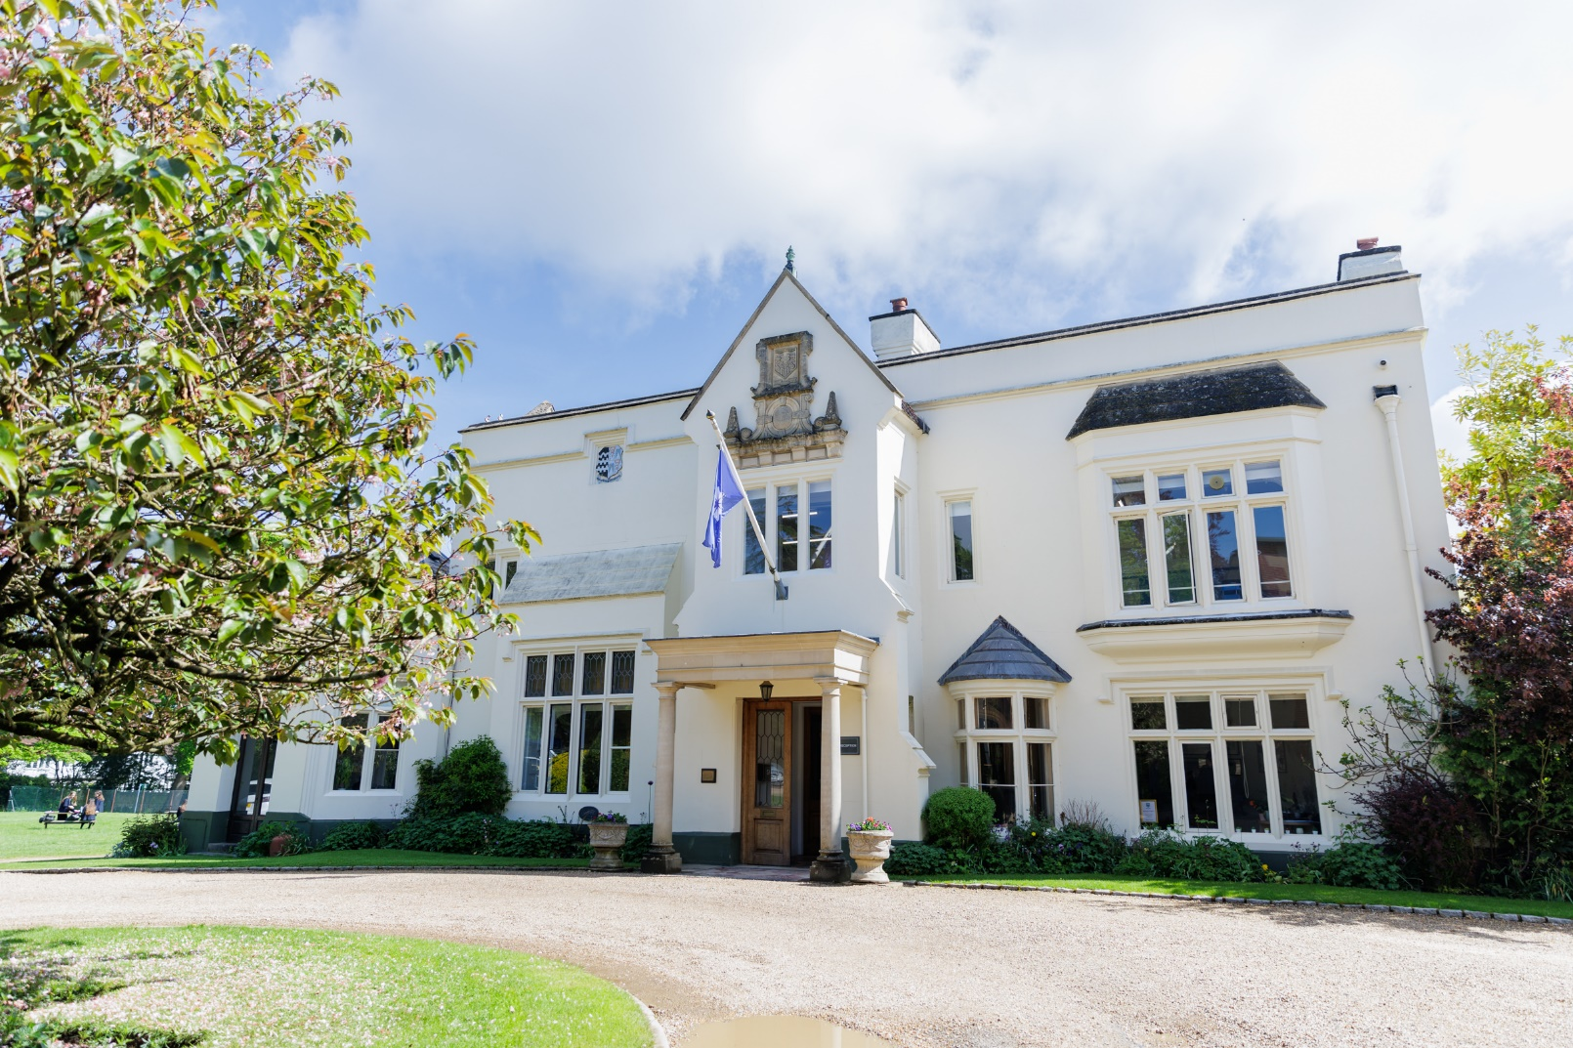
Application Pack
Job Role: Head of Psychology & Sociology
Start Date: September 2025 (or April 2025)
Closing Date: 9.00 am on Monday 10th February 2025
Interview Date: W/C Monday 24th February 2025
Welcome from Headmistress

St Mary’s is quite simply a wonderful school. The experience of each individual student is at the heart of all that we do. Our warm and inspiring environment encompasses a supportive framework where our students, whether in Pre-Prep, Prep, Senior House or Sixth Form, are encouraged to take risks, be creative, think for themselves, learn to make good choices and to embrace a challenge.
All of our students are encouraged to aim for excellence in all of their pursuits, to be kind to each other and look for opportunities to make a difference in the wider world. Students here ‘dream big’ we prepare our students for their future lives and careers to be compassionate, caring and confident young women.
The opportunities at St Mary’s, including those for leadership and co-curricular activities, are wide ranging, the academic and pastoral focus unsurpassed and the ability to tailor your daughter’s education unrivalled.
Please visit our website to give you a brief insight into our wonderful school, I do hope you will come and meet us to discuss this teaching role.

Mrs Patricia Adams, Headmistress


About St Mary’s School

St Mary’s is an independent day school for girls aged 3-18 in the heart of Gerrards Cross, Buckinghamshire.
Founded in Paddington in 1872, the school moved to its present site in 1942. Class sizes average 16-18 and academic outcomes are excellent.
St Mary’s School is warm friendly community where parents, staff, students, and governors work together to ensure that every student exceeds her potential whilst having the time of her life, making memories, and building skills to equip her to be successful through her future years.
Our students leave with the resilience to take on the next challenge, the ambition to follow their dreams and the confidence in themselves to go from success to success in their future careers. Through the pastoral and classroom support she has received at St Mary’s, she knows her worth, who she is as an individual, and what she wants to go on to do.
Well-being and happiness of staff and students alike is at the heart of our success – a happy school is a successful school!
Joining St Mary’s staff community, you would be welcomed into a supportive, close- knit community who can regularly be found spending lunch times in the Senior or Prep staff room, enjoying social time outside of school, competing in the teacher’s relay, performing in the school orchestra or at an open mic event, and can even be caught on a space hopper on the lawn on the last day of term!

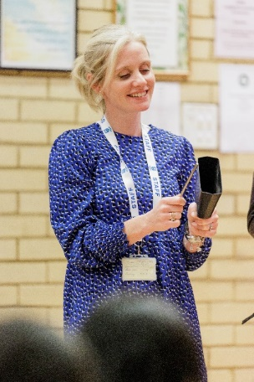

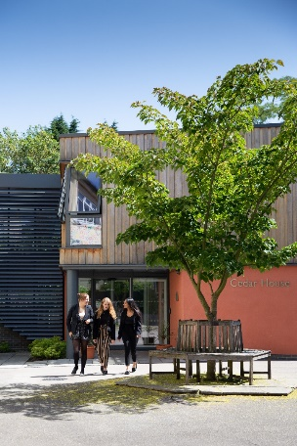

St Mary’s School Values
St Mary’s is committed to providing an excellent education in a caring, happy environment, where each girl develops self-confidence and exceeds her potential.
Staff and students, alike, are encouraged to find their own SMS Spirit by exploring our huge range of Co-Curricular activities to try new skills and meet new people, explore different learning or teaching techniques in small classes and make friends from Nursery right through to Sixth Form through our House System and whole school opportunities that brings.
Staff are supported in their roles through Department Heads, and SLT links, with wellbeing at the heart of staff satisfaction and the positive morale which we pride ourselves on. A comprehensive CPD programme allows for staff members to grow personally and professionally and broaden their skills in their specialist areas finding their very own SMS Spirit in their own individual ways.
Our whole school community operates under our Take Care acronym which ensures each individual reaches his or her potential in a supportive and challenging environment.
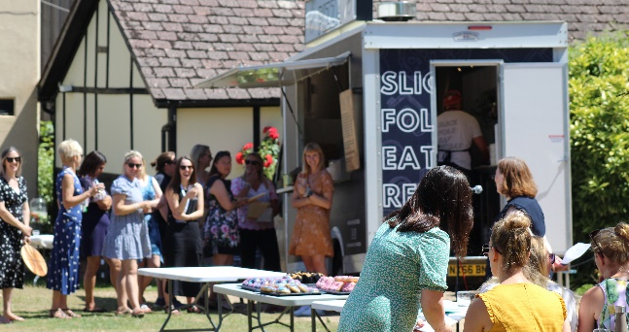
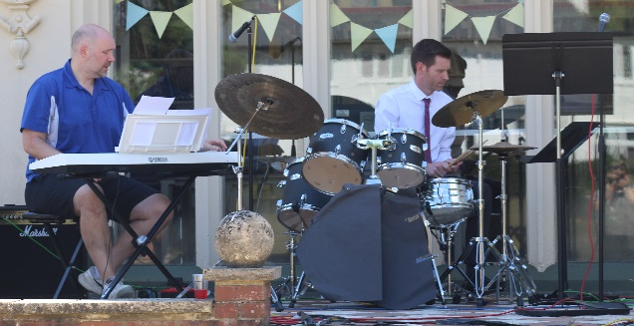

T – Team Work – we work together to ensure we achieve the best outcomes for our students, pastorally and academically, and that as a staff community we work in a supportive, collaborative caring team who have each other’s backs.
A – Ambition – we go above and beyond in everything we do. We look for the WOW factor at every opportunity.
K – Kindness – through our ethos runs the theme of kindness. Everything our staff and students do should consider kindness first.
E – Enthusiasm – staff and students alike bring the energy and desire to succeed.
C – Curiosity – we always ask why.
A – Adventure – work should be exciting, satisfying and thrilling – we are spending time doing what we feel passionately about.
R – Resilience – we carry on in the face of challenge, and come out stronger and wiser.
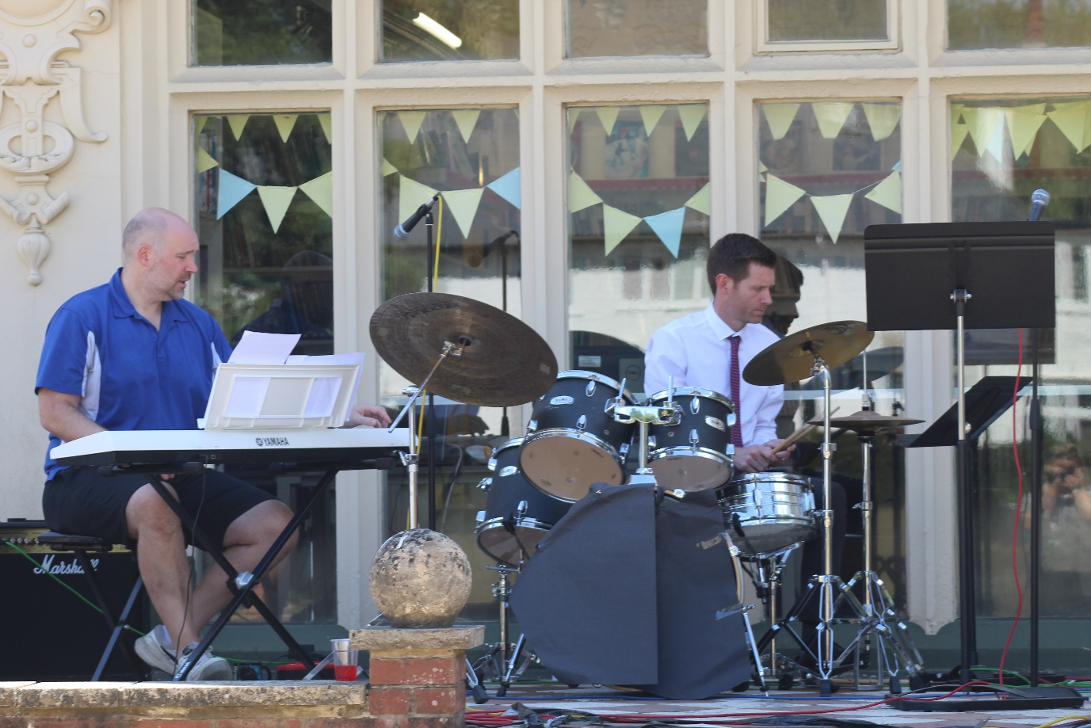
E – Excellence – aim for the highest quality in all that we do.

Why Work at St Mary’s?
- Competitive Salary
- Pension Scheme
(TPS or TPT for support staff)
- 30% fee Remission at St Mary’s
- 25% fee Remission at Thorpe House
- Subsidized staff socials
- Annual pay review

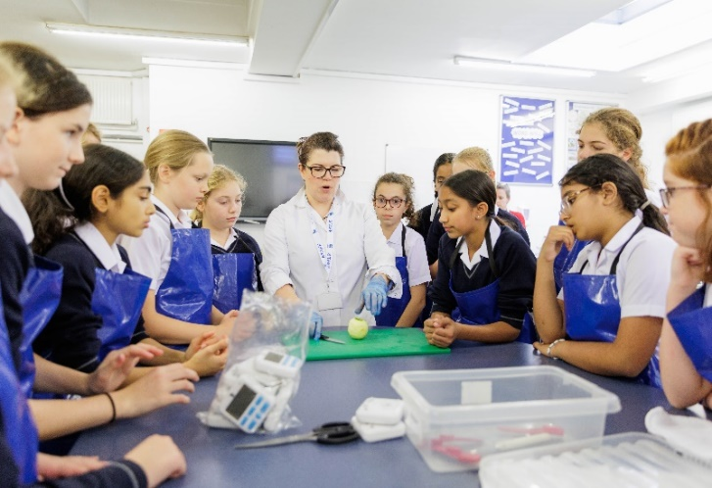


- Hot daily meal
- Use of fitness suite
- On-site parking if available
- Free annual flu vaccine
- Electric Car purchase Scheme
- Cycle to work Scheme

- Full staff induction in Term 1
- Staff buddy system
- Full training and development program
- Equal opportunities for all
- Well-being committee to share ideas
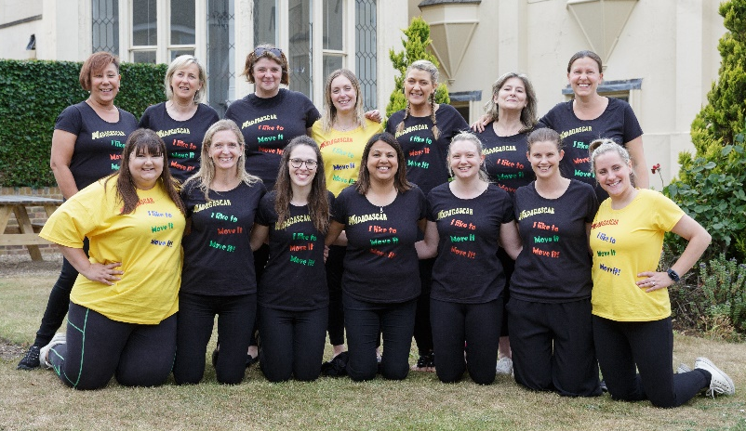

All staff share responsibility for promoting and safeguarding the welfare of our pupils and must adhere to, and comply with, the School’s safeguarding and Child Protection Policy at all times.

Teaching and Learning at St Mary’s
Professional trust and teacher autonomy are important to us. There is some flexibility when it comes to how and what you teach, and you will have more occasions to invest in creative planning and teaching, taking opportunities to follow the passions of the class whist delivering an effective curriculum. We do not expect you to adhere to explicit and directed lesson formats, writing lesson objectives on the board or following a prescribed lesson order. When our students change class, they move in an orderly fashion to their next lesson, taking responsibility for their own behaviour. Our students are taught in an environment where engagement and quality work is expected of everyone. In addition, there are pedagogical benefits to smaller class sizes. You will get to know the unique attributes of each student, giving them increased levels of attention and building productive classroom relationships that enable your students to excel.




Staff professional development is given a high priority at St Mary’s. The professional development process is aimed at cultivating great teachers who can flourish in our environment and meet our pedagogical standards. You will have the opportunity to contribute to working parties, a Teaching and Learning forum, speak at the regular ‘Gold Nugget’ best practice slot, write for the T&L newsletter and enjoy the buzz around our Open Classroom events. CPD is encouraged and generously funded. We want our teachers to be the best they can be and recognise that a culture of continuously learning is a crucial component of supporting and developing our staff.

The Role – Head of Psychology & Sociology

We are seeking an enthusiastic and experienced Head of Head of Psychology & Sociology to lead and inspire this thriving department, two very popular subjects. The successful candidate will teach A-Level Psychology and Sociology and play a pivotal role in shaping the strategic direction of the Department.
You will be expected to play a full part in the life of the department, including the planning of the curriculum, the creation of schemes of work and monitoring of students’ achievement. You will be expected to stretch and challenge students throughout the full age and ability range in order to secure excellent progress at all levels. You will be required to take the lead in overseeing the programmes of study in both Psychology and Sociology for Years 12-13. You will be expected to foster an environment where students enjoy their learning and are able to develop a love for their subjects; this includes using appropriate technology to augment the learning experience, developing well-sequenced schemes of work and ensuring the students are supported through well planned lessons and timely formative and summative feedback. You will liaise with other teachers and support staff as required. A level Sociology examines social behaviour from a variety of perspectives: how it originates and then develops, and the ways people are organised into groups according to distinctions such as class, gender and race. Sociology also looks at the institutions and forces which shape and are shaped by groups within a society, such as the media, religion and education.
Currently our students study Psychology and Sociology at A Level following the AQA specifications. While the school does not offer Psychology and Sociology at GCSE, applicants with the ability to also teach History at GCSE would be advantageous. This is a well-equipped department with a generous budget, housed in a modern sixth form building. Our small class sizes enable teachers and students to work closely together. Students are highly motivated to succeed in their A Level studies, and the department offers enrichment activities such as support entering national essay competitions, hosting a Brain Day, organising a research day at Whipsnade Zoo, and subject-specific revision conferences for A Level students.
The school has an extensive lunch-time and after school co-curricular programme to which you will be expected to contribute. Department clubs include Soc Soc and Psychology Club, available to students in Years 8-10.
If you are a passionate, forward-thinking Teacher who is eager to lead a dynamic department or a current Head of Department seeking a new environment then we would like to hear from you. St Mary’s School values academic excellence whilst fostering a supportive and inclusive learning environment. We are committed to continuous improvement and innovative teaching practices, ensuring students thrive in all aspects of their lives. We offer a friendly school community working environment on a beautiful site where staff are encouraged to develop their careers and progress.

Main Duties
Leadership and Management | To continually review methods of teaching, schemes of work and participate willingly and pro-actively in arrangements for further training and professional development.
Leadership and Management | The creation of a department improvement plan with clear aims and objectives, success criteria and plans for implementation, review cycle and spending plans lines to the budgetary cycle.
Leadership and Management | To ensure that the department has in place a rigorous system of assessment, recording and reporting and that colleagues are consistently using this data to inform both setting and curriculum planning.
Leadership and Management | To support the aims of the school and to contribute to its strategic direction.
Leadership and Management | To ensure the views and particular needs of the department are fully understood and represented at relevant meetings at all levels.
Leadership and Management | To rigorously evaluate the work of the department, ensuring the highest professional standards at all times and to work towards continuous improvement.

Teaching and Learning | To plan and prepare courses, schemes of work and individual lessons, appropriate to the needs, interests, experience and existing knowledge of students.
Teaching and Learning | To set homework and mark written work regularly according to the Marking Policy and ensure that the correct procedures are followed if work is missing, incomplete or late.
Teaching and Learning | To set, supervise and mark school examinations and coursework for public examinations.
Teaching and Learning | To assess, record and report on the development, progress and attainment of pupils and to communicate this information to parents via written reports and parents’ evenings.
Teaching and Learning | To provide written information for UCAS and other similar forms when required.
Teaching and Learning | To consult with SLT Link about any problems occurring over academic matters, such as aspects of the curriculum or the syllabus for A level.
Teaching and Learning | To keep records of attendance at lessons as required.
Teaching and Learning | To maintain good order and discipline among pupils and safeguard their health and safety.
Teaching and Learning | To build and maintain co-operative relationships with parents and to communicate with them on students’ learning and progress, drawing attention to skills and talents as well as areas for improvement and difficulties.
Teaching and Learning | To liaise with Form Tutors or Heads of Department and SLT links about serious discipline matters or any other difficulties pupils may cause, or appear to be having.

Teaching and Learning | To ensure the views and particular needs of the department are fully understood and represented at relevant meetings at all levels.
Teaching and Learning | To attend Departmental, Staff, Parents and INSET meetings as required.
Teaching and Learning | To ensure a high level of communication at all times, to include formal communication such as schemes of work, department handbook, policies, systems and procedures and information communication such as liaison with other members of the school community at events such as parents’ evenings and open days.
Teaching and Learning | To work collaboratively with other staff as members of teams, departments and/or other cross curricular groups and contribute your own particular talents and skills to these groups to aid the production of new initiatives, policies, resources or schemes of work.
Teaching and Learning | To liaise with parents and external bodies within the community as appropriate, representing and reflecting the aims and ethos of the school.
Teaching and Learning | Teachers are expected to uphold all aspects of the Teaching Standards.
Teaching and Learning | Teachers are encouraged to assist in the development of any aspects of the school to which they would wish to become involved.
Teaching and Learning | To ensure highly effective provision for all students across all abilities.
Teaching and Learning | To provide cover for absent staff.
Teaching and Learning | To attend assemblies.
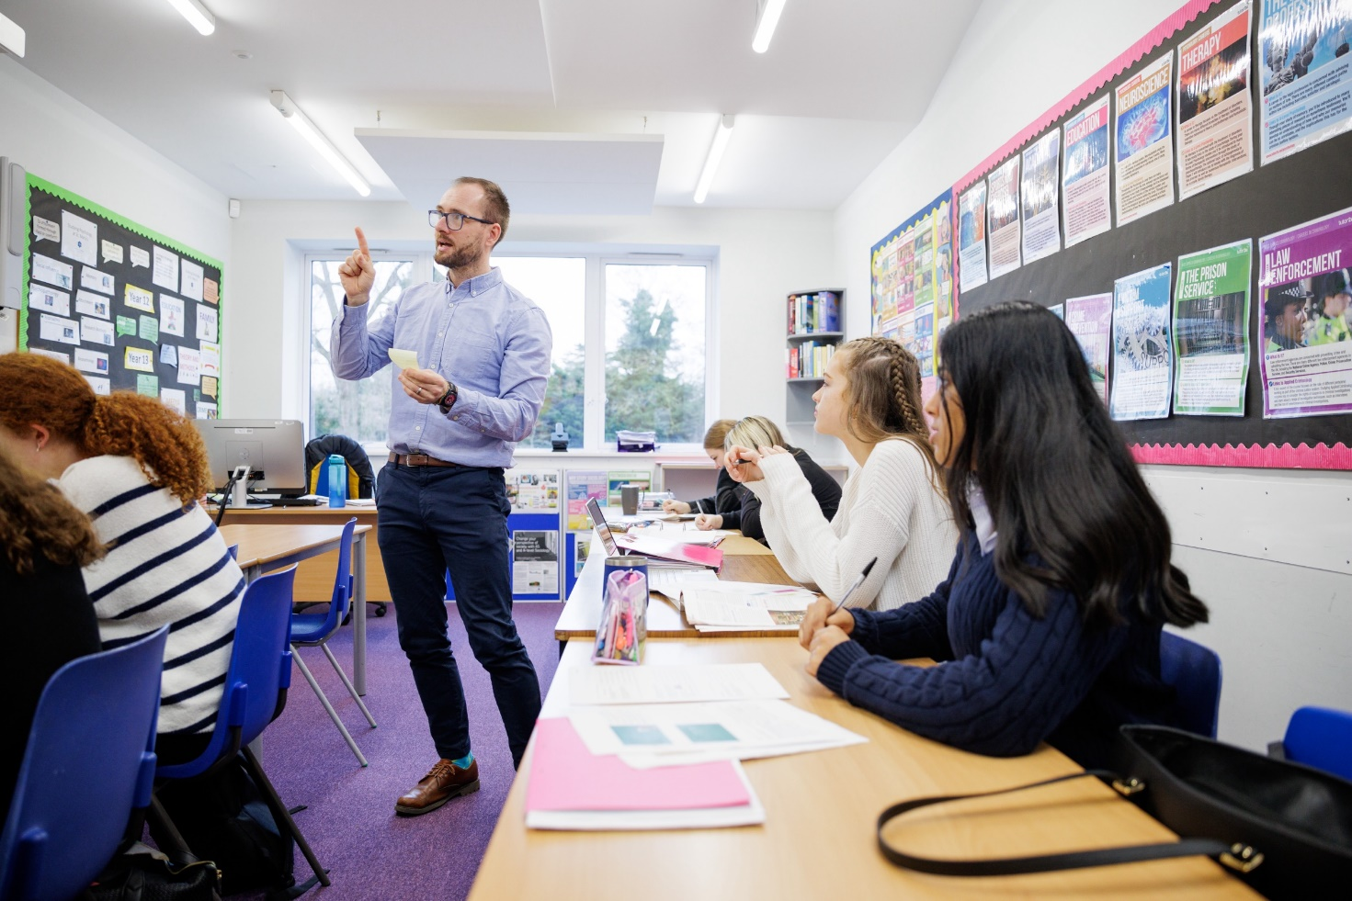

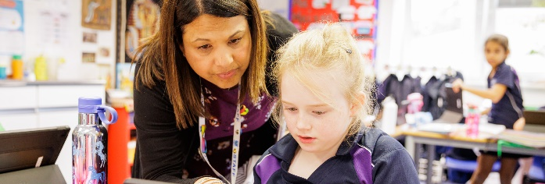

Candidate Specification

Pastoral | Prepared to act as a Form Tutor and to support the school’s emphasis on pastoral care.
Pastoral | A commitment to the philosophy of personalised learning.
Pastoral | An awareness of the factors that contextualise each child’s ability to learn.
Pastoral | Be committed to equality of opportunity, community cohesion and student social mobility.
Attributes | Good organisational skills.
Attributes | A high level of professionalism in all aspects of work.
Attributes | Demonstrate enthusiasm for the subjects and is committed to raising standards.
Attributes | Demonstrate commitment to the co-curricular achievement of all students.
Attributes | Flexible and Proactive.
Attributes | Willing to support the School’s Christian ethos.
Attributes | Supportive and sensitive to the needs of others.
Attributes | Enjoy working in collaboration with others and be a team player.
Attributes | Display moral, intellectual and personal integrity and authority.
Education | Good honours degree in a related discipline.
Education | Qualified Teacher status.
Education | Evidence of continued Professional Development and a commitment to personal lifelong learning.
Education | Proven willingness to embrace new ideas and methodology.
Teaching | Be able to teach across the ability range.
Teaching | Ability to teach Sociology A Level.
Teaching | Ability to teach Psychology A Level.
Teaching | Ability to teach History at GCSE would be advantageous.
Teaching | Awareness of children’s varied learning styles.
Teaching | Secure and competent ICT skills.
St Mary’s School is committed to safeguarding and promoting the welfare of children and young people in its recruitment and selection of job applicants. The school expects all staff and volunteers to share this commitment and be willing to undergo checks with the Disclosure and Barring Service.
Safeguarding
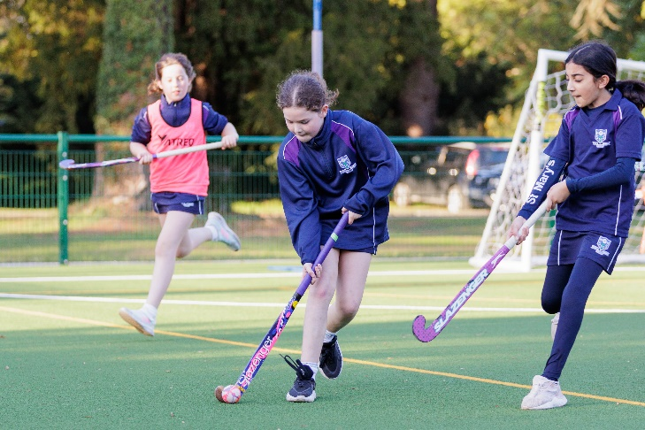

How to Apply

Please complete an application form which can be obtained from the HR Administrator at hradmin@st-marys.bucks.sch.uk or from our website www.stmarysschool.co.uk
Early applications are advised as the school reserves the right to appoint at any stage during the application process. Completed application forms and cover letters must be emailed to hradmin@st-marys.bucks.sch.uk
Interviews will take approximately three hours and will be held at the school. As part of the process you will be given a tour of the school and attend a panel interview. You will also be asked to provide documentation confirming your identity and qualifications and a search of an online social media presence may also be conducted as part of due diligence checks.
There is no need to visit St Mary’s before applying, as the school website contains plenty of information, photos and all the school’s policies. However, if you’d like to see the school in person, you are most welcome to arrange a visit. Interviews will, of course, include a tour. All applications will be acknowledged and interview dates are provided below. References will be requested for all those invited to interview.
Closing date for applications: 9:00am on Monday 10th February 2025
Interview date: W/C 24th February 2025
Hours: Full-Time
Salary: Competitive

