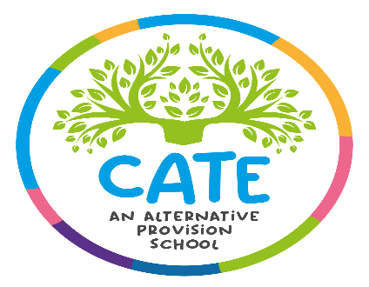
Woodbridge Park Education Service
St Georges House
60 Green Dragon Lane
Brentford TW8 ORS
Headteacher: Mrs L Grimley
Teaching Assistants Required
32.5 hours per week term time only – Permanent Contract
Salary Scale 6 Point 16 - 20 (£26,178 gross pa - £27,769 gross pa)
Please note that the starting Salary will be Scale 6 Point 16

Woodbridge Park is on a journey to outstanding and we need outstanding people to join us. We are a multi-site Alternative Provision for children and young people with complex needs and we provide a vital service to the families and schools of Hounslow.

As our service provision continues to expand to meet emerging needs, we are now looking to grow our team of experienced Teaching Assistants to add value across our various centres. We need kind-hearted, compassionate people who want to commit to changing lives for the better. The posts are term time (39 weeks per year) on a permanent contract – full time – 5 days per week.

We can offer a varied professional experience, thanks to our many diverse sites – no two days are the same. We can also offer outstanding professional development with a dedicated training programme and planned investment in staff development. We place a high regard and focus on staff wellbeing, having been awarded the NEU Workload Charter Status and we offer all staff six early finish days per school year to support their wellbeing.

We are seeking to appoint further Teaching Assistants to work alongside our friendly and close-knit team to support students with medical conditions within our CATE Department, based in Brentford TW8. Candidates will be able to inspire and motivate our students to get the very best meaningful outcomes and show a commitment to raising the achievement levels and self-esteem of disaffected young people

OFSTED November 2023 judged WPES as a GOOD school.
Closing Date Friday, 20th June 2025 at 3 pm
Shortlisting week of Monday, 23rd June 2025
Interviews week of Monday, 30th June 2025

Please note that we do not accept CVs. We also do not accept applications direct from Agencies. Previous applicants need not apply again.

Woodbridge Park Education Service is committed to safeguarding and promoting the welfare and wellbeing of all children and expect all staff and volunteers to share this commitment. Please note that shortlisted candidates will be subject to an online search. Successful candidates will be subject to an enhanced DBS disclosure.

