respect resilience responsibility

DEPUTY HEAD TEACHER INFORMATION PACK

28th January 2019

Dear Applicant,

I am delighted that you have shown in interest in applying for the post of Deputy Head Teacher at Woodlands. I was appointed as Head Teacher of the school in April 2018, having previously been Deputy Head Teacher at Regents Park Community College in Southampton. Woodlands is an amazing school and a wonderful place to work. My vision for staff and students at the school is clear - we must expect the best to achieve the best!

We have recently received an Ofsted Section 5 Inspection and have been considered requires improvement. In that report it is clear that there are significant changes happening to ensure that Woodlands starts to achieve the best results that our students deserve. My plea to you is have a careful read of that report, because it will be basis of my School Development work for the next 2 years as I move the school to Good. I was really pleased that Ofsted recognised the significant work that has taken place at the school over the last two terms, but please be sure that this is just the start of a journey; a journey where, whoever is appointed in this role, will play a crucial leading part.
Woodlands is a school of great diversity, energy and creativity but above all it is typified by a caring and supportive ethos. Every teacher and member of staff at Woodlands is determined to provide the highest standards for all students. In turn we expect and demand the highest standards from our students. We expect learners to work hard, attend well, behave impeccably and show the resilience and determination needed to succeed.
So if you feel you have the determination, passion and enthusiasm to work in a school like Woodlands, I really would like to hear from you.

“Respect, Responsibility, Resilience”

Yours sincerely

Jim Henderson
Head Teacher

DEPUTY HEAD TEACHER
(Curriculum and Teaching)

L17 – L21

Woodlands is an exciting and welcoming school in which to work. We have high expectations of our students and we want to recruit teachers who are passionate about their subjects and dedicated to providing high quality teaching and learning. Our school is on a journey to become truly outstanding and we welcome applicants who wish to join us on that journey.

To further develop the leadership capacity in the school, we are seeking to appoint a new Deputy Head Teacher from September 2019. We are looking for an innovative teacher who shares our passion for raising the standards of progress and attainment of all our students. This is an important appointment for the leadership of Woodlands as we aim to become an outstanding school and the first choice school for our community.

The successful candidate will have

- A proven track record of raising attainment and standards at senior leader level
- A commitment to raising standards for all our students
- A passion for teaching and learning
- The ability to lead and motivate a team of staff
- The ability to inspire our students
- An innovative approach to problem solving
- A strategic and collaborative approach to school improvement

The post offers an exciting career opportunity for the right candidate. This role has significant whole school leadership responsibilities in an innovative environment which will provide excellent preparation for those aspiring to become a Head Teacher in the future.

If you would like to visit the school or talk with the Head Teacher about the post please contact Nikki Purse on 02380475966.

Download an application form and further details from
www.woodlands.southampton.sch.uk

Please email your application to nicola.purse@woodlands.southampton.sch.uk

Closing date for applications is 12 noon on 25th February 2019

Woodlands Community College is committed to safeguarding and promoting the welfare of children and young people and expect all staff to share this commitment. The successful candidate will be subject to Disclosing and Barring Service checks along with other relevant employment checks.

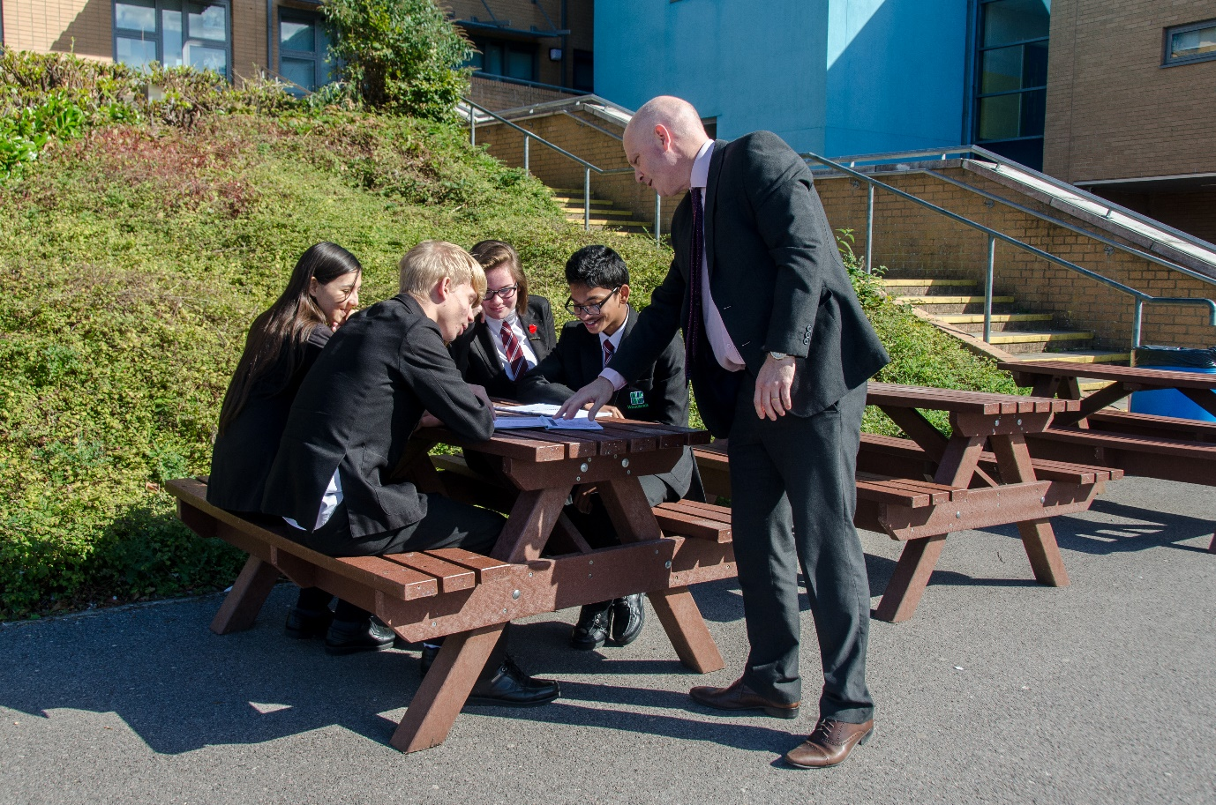

‘The new Head Teacher has a clear aspirational vision for the school. Since his appointment in April 2018 he has taken rapid action to improve pupils’ progress and behaviour.’

Ofsted January 2019

Job Description

Post Title: | Deputy Head Teacher
The Deputy Head Teacher should support and assist the Head Teacher in developing a shared vision, which inspires and motivates students, staff and all other members of the school community. This vision should include core educational values, moral purpose and be inclusive of all stakeholders’ beliefs and values.
Accountable to: | The Head Teacher
Responsible for: | - Undertaking the professional duties of the Head Teacher in the event of their absence  - Leading teaching and learning including embedding the Woodlands Way  - Leading the raising of standards of progress and attainment for all students  - Leading curriculum development  - Carry out the professional duties of a teacher as required  Supporting the Head Teacher in:  - Leading the strategic direction and development of the school  - Leading and managing staff  - Managing the efficient and effective deployment of staff and resources  - Securing accountability  - Strengthening the community
Liaising with: | The Head Teacher and other members of the Senior Leadership Team, Middle Leaders and relevant staff with cross curricular responsibilities, relevant partnership staff, governors, LA staff, parents, students and the community.
Salary: | L 17
Disclosure level: | Enhanced
MAIN DUTIES
The strategic direction and development of the school | To support the Head Teacher in their work with the governing body, to develop a strategic view for the school in its community and analyse and plan for the future needs and further development of the school within the local, national and international context:  - In partnership with Head Teacher and Governing Body establish and implement an ambitious vision and ethos for the future of the school, ensuring the highest standards are provided for the students  - Motivate others to create a shared learning culture and positive climate  - Support the overall aims and objectives for the school and the policies for their implementation  - Support the Head Teacher’s educational vision and direction in securing effective teaching, successful learning, progress and achievement by students and sustained improvement in their spiritual, moral, cultural, mental and physical development and prepare them both for the opportunities, responsibilities and experiences of adult life  - Support the Head Teacher in securing the commitment of parents and the wider community to the vision and direction of the school to create and implement a strategic plan, underpinned by sound financial planning, which identifies priorities and targets for ensuring that students achieve high standards and make progress, increasing teachers’ effectiveness and securing school improvement  - Ensure that all those involved in the school are committed to its aims, motivated to achieve them and involved in meeting long, medium and short term objectives and targets which secure which ensure the educational success of the school  - Ensure that policies and practices take account of national, local and school data and inspection research findings  - Monitor, evaluate and review the effects of policies, priorities and targets of the school in practice and take action if necessary
Learning and teaching | - Support the Head Teacher in securing and sustaining effective teaching and learning throughout the school and in monitoring and evaluating the quality of teaching and standards of students’ achievement, using benchmarks and setting targets for improvement.  - Support the Head Teacher in ensuring that all students receive a good quality education through a programme designed to promote a stimulating style of learning in a safe and healthy school environment  - Support the Head Teacher in securing a consistent and continuous school-wide focus on students’ achievement and progress, using data and benchmarks to monitor progress in every child’s learning  - Support the Head Teacher in ensuring that learning is at the centre of strategic planning and resource management  - Support the Head Teacher in establishing creative, responsive and effective approaches to learning and teaching  - Ensure a culture and ethos of challenge and support where all students can achieve success and become engaged in their own learning  - To be able to demonstrate and articulate high expectations  - Support the Head Teacher in implementing strategies which secure high standards of behaviour and attendance  - Support the Head Teacher in determining, organising and implementing a diverse, flexible curriculum and in the implementation of an effective assessment framework  - Support the Head Teacher in taking a strategic role in the development of the new and emerging technologies to enhance and extend the learning experience of students  - Support the Head Teacher to monitor evaluate and review classroom practice and promote improvement strategies to ensure that underperformance is challenged at all levels and ensure effective corrective action and follow up is undertaken in line with safeguarding procedures  - Ensure that high standards of professionalism by staff are established and maintained  - Motivate staff to achieve the highest possible standards
Leading and managing staff: | To support the Head Teacher in leading, motivating, supporting, challenging and developing staff to secure improvement:  - Be an excellent role model, exemplifying a high standard of teaching and promoting high expectations for all members of the school community  - Support the Head Teacher in maximising the contribution of staff to improve the quality of education provided and standards achieved and ensure that constructive working relationships are formed between staff and students  - Plan, allocate, support and evaluate work undertaken by groups, teams and individuals, ensuring clear delegation of tasks and devolution of responsibilities in a manner consistent with their conditions of service, ensuring a reasonable balance for teacher and other members of staff, in work carried out in school and work carried out elsewhere  - Support the Head Teacher in implementing and sustaining effective systems for the management of staff performance, incorporating appraisal and targets for teachers, including targets relating to students’ achievement  - Participate in arrangements for own performance management
Efficient and effective deployment of staff and resources | To support the Head Teacher in deploying people and resources efficiently and effectively to meet specific objectives in line with the school’s strategic plan and financial context:  - Work with governors and senior colleagues to recruit staff of the highest quality available  - Work with senior colleagues to deploy and develop all staff effectively in order to improve the quality of education provided  - Advise the Head Teacher and implement decisions in relation to staffing  - Advise the Head Teacher on the adoption of effective procedures to deal with the competence and capacity of staff  - Support the Head Teacher in managing and organising accommodation efficiently and effectively, to ensure that it meets the needs of the curriculum and health and safety regulations  - Support the Head Teacher in managing, monitoring and reviewing the range, quality, quantity and use of all available resources in order to improve the quality of education, improve students’ achievements, ensure efficiency and secure value for money
Accountability | - Support the Head Teacher in providing information, objective advice and support to the governing body to enable it to meet its responsibilities for securing effective teaching and learning and improved standards of achievement and for achieving efficiency and value for money  - Report to the governing body as requested by the Head Teacher  - Support the Head Teacher in creating and developing an organisation in which all governors and staff recognise that they are accountable for the success of the school  - Support the Head Teacher in presenting a coherent and accurate account of the school’s performance in a form appropriate to a range of audiences, including parents, governors, the LA, the local community, OfSTED and others, to enable them to play their part effectively  - Support the Head Teacher in ensuring that parents and students are well-informed about the curriculum, attainment and progress and about the contribution that they can make to achieving the school’s targets for improvement  - Support the Head Teacher in reporting to the governors annually on the performance management of teachers at the school in relation to the School Teachers Pay and Conditions Document  - Support the Head Teacher in providing information about the work and performance of staff where it is relevant to their future employment  - Take responsibility for promoting and safeguarding the welfare of students within the school
Strengthening the community | - Develop and strengthen effective relationships with parents, the local community and external agencies  - Promote the positive involvement of parents/carers in school life  - Support the Head Teacher in building a school culture and curriculum which takes account of the richness and diversity of the school’s communities  - Support the Head Teacher in creating and promoting positive strategies for challenging racial and other prejudice and dealing with racial harassment  - Support the Head Teacher in ensuring learning experiences for students are linked into and integrated with the wider community  - Work in partnership with other agencies in providing for academic, spiritual, moral, social, emotional and cultural well being of students and their families  - Seek opportunities to invite parents and carers, community figures, business or other organisations into the school to enhance and enrich the school and its value to the wider community  - To be able to contribute to the development of the education system by, for example, sharing effective practice, working in partnership with other schools and promoting innovative initiatives  - Co-operate and work with relevant agencies to protect children  - Support the Head Teacher in ensuring that the school promotes effective links with the local community and continues the development of close liaison with other local primary and secondary schools.  - Support the Head Teacher in ensuring that the school offers appropriate extended services.
Additional Duties: | - Support and deputise for the Head Teacher  - Take responsibility for, and demonstrate commitment to, own professional development.  - Engage actively in the performance management review process.  - To undertake any other duty as specified by STPCB not mentioned in the above.
SLT specific responsibilities | - Line management to be agreed on appointment  - Standards and achievement for all  - Teaching and learning  - Developing the curriculum
Whilst every effort has been made to explain the main duties and responsibilities of the post, each individual task undertaken may not be identified.

Employees will be expected to comply with any reasonable request from the Head Teacher to undertake work of a similar level that is not specified in this job description.

The school is committed to safeguarding our students. Employees are expected to have read the contents of the Safeguarding Policy and follow the procedures at all times.

Employees are expected to be courteous to colleagues and provide a welcoming environment to visitors and telephone callers.

The school will endeavour to make any necessary reasonable adjustments to the job and the working environment to enable access to employment opportunities for disabled job applicants or continued employment for any employee who develops a disabling condition.
This job description is current at the date shown, but, in consultation with you, may be changed by the Head Teacher to reflect or anticipate changes in the job commensurate with the grade and job title.

Person Specification

Qualifications | Meets criteria
Qualified Teacher Status | A
Evidence of recent and continuing professional development appropriate to this role | A
Experience and Knowledge
Recent experience of successful secondary school leadership as an Assistant Head or a member of an Extended Leadership Team | A
Successful and varied experience, preferably in more than one school, including 11 – 16 year educational setting | A/I/R
Sound knowledge and understanding of national policy/legislation, statutory requirements, current issues and best/outstanding practice in education | A /I
Excellent teaching experience in a secondary school setting | A/I/R
Ability to use assessment data effectively to set targets and raise achievement | A/I/R
Experience and understanding of school planning, monitoring review and evaluation | A/I/R
Embedded knowledge and understanding of the most current Ofsted process and statutory requirements | I
Skills and Attributes
Able to further develop a culture of high expectations with all students | I/R
Ability to recognise and develop individual staff skills and abilities to their full potential for the benefit of the whole school | I/R
Demonstrate a commitment to inclusion, equality and diversity | A/I
Knowledge of all aspects of safeguarding including guidelines and legislation | I
Is passionate about learning and seeks to further create an inspirational learning and teaching environment | A/I
Professional and personal integrity and be a positive role model for students and staff | R
Proven ability to tolerate pressure and work to demanding deadlines while maintaining a work life balance | I/R
Has strong interpersonal skills and self-awareness, adapting to situations and carefully managing professional relationships | I/R
Ability to think and plan strategically to promote the college’s vision, ethos and values | I
Has presence and visibility as a leader, demonstrating optimism, resilience with a well-developed sense of proportion | I/R
Ability to manage challenging situations and make difficult decisions | I/R
Ability to develop skills in performance management, recognising high performance and tackling underperformance through to resolution | I

Key
A: application
I: interview
R: reference

