October 2017

Dear Applicant

Thank you very much for your interest in the part-time, fixed term post of Teacher of Philosophy and Religious Studies at Headington School.

I hope that the enclosed information pack provides you with all the details you need to know about the role and the School. However, please do not hesitate to get in touch with me if you have any other questions.

I look forward to receiving your application.

Best wishes



Caroline Jordan

Headmistress

President - Girls' Schools Association



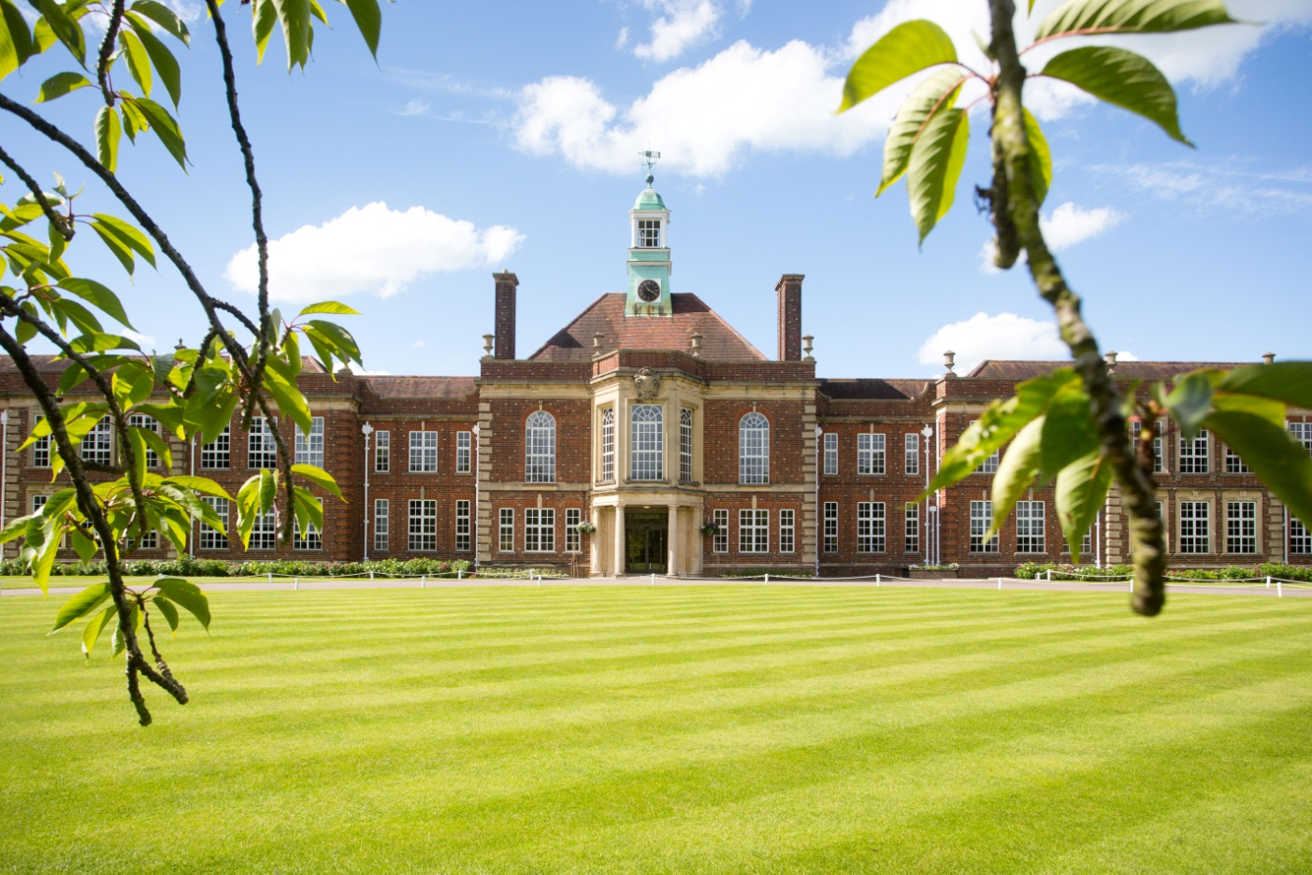

**Applications are invited for the post of**

**Teacher of Philosophy and Religious Studies, part-time (approx 0.7 fte), fixed term**

**for January 2018**

**Information Pack**

The School

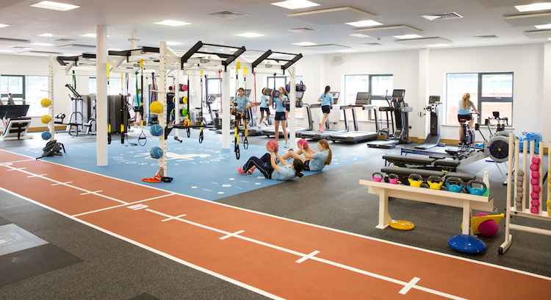Headington is a highly successful day and boarding school in Oxford that offers more than 1,000 girls from Nursery to Sixth Form an unrivalled opportunity to pursue academic, sporting and artistic excellence in a caring and nurturing environment. Founded in 1915, the School’s Church of England foundation underpins an ethos where every individual is encouraged and valued.

Set in 23 acres of playing fields and gardens, our superb facilities provide the perfect backdrop for teaching and learning that extends way beyond the classroom and curriculum. We encourage participation in all aspects of sport and culture, teamwork and leadership, challenging girls to discover and explore their own potential and achieve more than they thought possible.

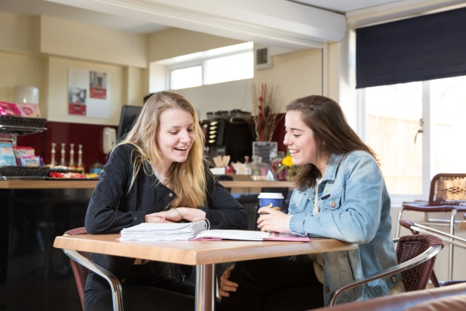Consistently in the premier league of academic schools in the UK, life at Headington is about much more than exam results. Through the sheer breadth of subjects and activities at Headington – and the option to study for the International Baccalaureate – we aim to educate the complete individual, giving girls the confidence and self-awareness to compete, contribute and succeed at school, university and in their adult lives.

At Headington School we are committed to providing a stimulating, enriching and empowering education for all pupils, whatever their background. We want each girl to develop an enquiring mind and the confidence to tackle new things, achieving beyond her expectations and becoming independent in her thinking and learning.

**Philosophy and Religious Studies at Headington**

[](http://www.google.co.uk/url?sa=i&rct=j&q=&esrc=s&source=images&cd=&cad=rja&uact=8&ved=0ahUKEwjesr330ZDMAhVJrRoKHZofDtYQjRwIBw&url=http://www.drury.edu/history-philosophy-and-religion/philosophy-major/&psig=AFQjCNE1R2K0nH2eKCgcwmFlnd8shyS-0Q&ust=1460809586871537)Philosophy and Religious Studies is a well respected and rapidly growing subject at Headington. We are fortunate to have excellent resources, which include various artefacts, textbooks, magazine subscriptions and a well stocked section in the library.

The subject is compulsory at Key Stage Three. In the Upper Three (Year Seven), girls begin with an introduction to various religious conceptions of ‘God’. Subsequent work includes a consideration of Jewish biblical history, a study of the life of Christ and a unit on ‘Prejudice’.

Pupils in the Lower Four (Year Eight) are introduced to some of the Eastern religions, particularly the Hindu, Buddhist, Islamic and Sikh traditions, where they are encouraged to reflect upon their learning and make connections with aspects of their own lives.

Upper Four (Year Nine) pupils begin with a study of ‘Suffering’, where much time is devoted to issues concerning the Holocaust. A GCSE-style topic on ‘Crime and Punishment’ follows before the year draws to a close with a consideration of the philosophical question ‘What does it mean to be a human being?’

Philosophy and Religious Studies is an optional subject at Key Stage Four and is a popular choice among the girls. Ordinarily, numbers are sufficiently robust to require three or four teaching sets in each of the GCSE years (with roughly 15 students per set). We follow Edexcel’s Specification B, and have opted to study component 1 through Buddhism and component 3 through Christianity.

Sixth Form numbers are similarly healthy; we currently have two sets in the Lower Sixth and one in the Upper Sixth. Again, we follow Edexcel’s specification and have chosen the following options: Philosophy, Ethics and New Testament. We have good track records of university entrance, which last year included a successful Oxford applicant.

IB Philosophy is also increasingly popular, with 13 Lower Sixth girls and 6 Upper Sixth studying at both Higher and Standard level from September. Our IB students are normally very strong academically; indeed, this year the cohort is predicted mostly to achieve 7s.

The department is accommodated in a suite of three classrooms and a store room. All teaching rooms are equipped with a teacher’s PC and the latest smart board technology. One room has a class set of twenty four retractable PCs for students to work on. Staff workspace exists in an office area that is shared with colleagues from the Geography and Law departments. 6th formers are expected to bring their own laptops to lessons while the younger year groups are issued with iPads.

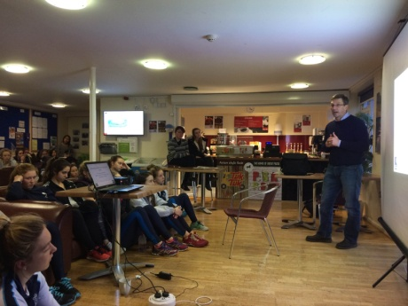

Enrichment opportunities exist in the form of a variety of trips and conferences: for example, sixth formers have visited Peter Vardy’s annual Philosophy and Ethics conferences in Oxford, whilst a very successful trip to Nepal ran in October 2014. A high profile academic club is the ‘Philosophy Cafe’ on Thursdays after school, which has attracted speakers such as Peter Singer, AC Grayling, Baroness Warnock, Julian Baggini, Julian Savulescu, John Cottingham, Nigel Warburton, Stephen Law, Sir Roger Scruton and Alister McGrath.

Professor Julian Savulescu speaks at the Philosophy Café

**The Role**

This is a part-time, fixed term position starting in January 2018.

The successful candidate will be a well-qualified graduate who may have a PGCE. They will be expected to be able to teach throughout the school. They need to be happy to work with a team and willing to try new ideas.

The successful candidate will be accountable through the Head of Department and the Second Deputy Head (Staff, Admissions and Marketing) for the academic performance, organisation and administration of the teaching of P & RS to pupils according to a set timetable and curriculum.

Key responsibilities of the role:

Teaching responsibilities

* To teach (or be available for emergency cover) lessons in accordance with the school’s requirement for a full time teacher’s timetable as appropriate;
* Plan, prepare and deliver lessons that follow the Department’s schemes of work. Ensure the lessons are suitably differentiated and appropriate to all members of the class;
* Support the specific targets of the School and Department development plans;
* Mark pupil work on a regular basis in accordance with Department and school marking policies;
* Accurately record-keep for your classes including registering, assessments marks, merits and penalty points;
* Feedback to pupils and parents through completion of ‘Learner Profiles’, writing appropriate academic reports and attending Parents’ Evenings;
* Monitor national and international curriculum developments;
* Draw up Schemes of Work as directed by the Head of Department, including opportunities for stretching the most able, supporting pupils on the Learning Development register and the setting of Prep and regular testing;
* Ensure that department areas provide a stimulating and attractive learning environment;
* Assist in the development, delivery and supervision of academic enrichment activities such as extra-curricular projects and subject-related societies;
* Attend morning staff briefings where possible;
* Attend whole school staff meetings;
* Cover lessons both within and outside the Department, and be available for exam invigilation as directed by the Examinations Officer or the Assistant Head Staff;
* Assist the Head of Department with the marking of scholarship and other entrance examinations as required;
* Actively participate in the promotion of the School e.g. on open days;
* Be aware of and ensure compliance with all Health and Safety regulations;
* To contribute to the wider co-curricular life of the school, through involvement in co-curricular clubs and activities;
* Carry out any other duties that are within the employee's skills and abilities whenever reasonably instructed.

**Professional Development**

* Show evidence of and a continuing interest in professional and personal development;
* Participate in the School’s Performance Management process when appropriate;
* Ensure that lessons are covered and work is set when absent, in conjunction with the Head of Department;
* Share resources and ‘best practice’ with the rest of the department

**Pastoral responsibilities**

* All members of staff are expected to perform the role of a tutor. This includes registering the tutor group; monitoring their attendance and initial stages of pastoral and academic welfare; delivering PSHE ;
* Attend year group meetings;
* Attend assemblies with your tutor group;
* Organise tutor group assemblies in conjunction with the School Chaplain.

These duties are illustrative. Headington School reserves the right to alter the contents of this job description, after consultation and consistent with the level of responsibility of this role, to reflect any changing demands of the School. Person Specification

The successful candidate will possess a strong track record of achievement in:

* their subject area, with excellent subject knowledge of P & RS and good classroom management skills;
* being able to design every lesson individually, to a high standard, in accordance to the scheme of work set out by the Head of Department;
* communicating concepts articulately, positively and sensitively to pupils of different abilities;
* nurturing and supporting pupils’ wellbeing with well-developed pastoral instincts.

Qualifications

ESSENTIAL

* a good honours degree relevant to the teaching aspects of the role.

DESIRABLE

* a recognised teaching qualification e.g. a PGCE, QTS.

PERSONAL ATTRIBUTES/SKILLS

* high levels of literacy;
* an ability to inspire and motivate others through verbal and written communications;
* good time management and organisational skills;
* ability to use initiative;
* patience and a sense of humour; an ability to demonstrate good IT skills and constructive use of other technology;
* show an awareness of different pupils’ educational needs and be able to direct teaching and learning appropriately;
* a genuine desire to contribute to the wider life of the School, with the ability, skills and experience to contribute to the School’s Co-curricular programme.
* a sympathy with the ethos of the School within a Christian foundation.

Employment benefits and conditions

**Benefits**:

Teacher’s pension: As per current legislation. Eligibility is based on the School’s terms and conditions of eligibility for the teacher’s pension scheme.

Fee Remission: In accordance with the School’s policy, which may be subject to change from time to time, up to 50% fee remission for girls attending Headington School and up to 20% fees remission for boys attending Magdalen College (under a reciprocal agreement) and subject to the terms of their policy. Fee remission is calculated on the number of weeks and hours worked and is pro rata for part time staff who work at least 50% of a normal working week.

**The remuneration package**

Headington offers an enhanced teaching scale with points that equate to teaching experience and a leadership scale for responsibility. The salary offered will reflect the experience of the successful candidate and be commensurate with the post.

**The application process**

* All applicants can download information regarding this post from the Headington School website
* Applications will only be accepted from candidates completing the Application Form in full. CVs will not be accepted in substitution for completed Application Forms. However, they may be sent in addition to the Application Form
* We will seek references on shortlisted candidates and will approach previous employers for information to verify particular experience or qualifications, before interview. References will ask about your suitability to work with children
* If you are invited to interview you will receive notification outlining the interview process and guidance regarding the documentation you are required to provide.

Headington School is committed to safeguarding and promoting the welfare of children and young people. Applicants must undergo child protection screening, including checks with past employers and DBS and barred lists checks. The School expects all staff and volunteers to share this commitment. Headington School is an equal opportunities employer.

[www.headington.org](http://www.headington.org)