


Lady Margaret School
Candidate Application Pack
Teacher of Design & Technology (Food Technology)

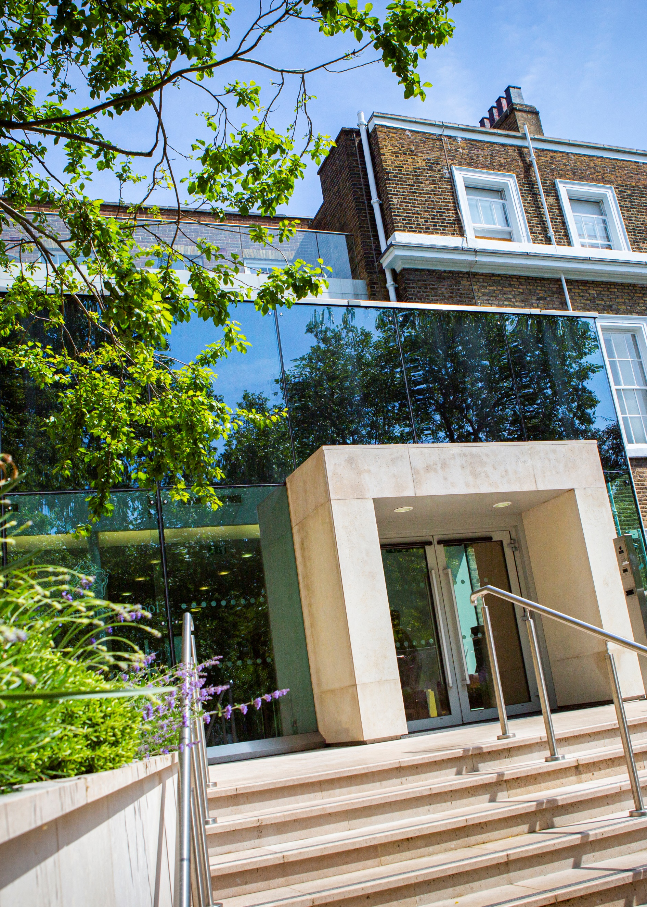
Letter from Headteacher


Dear Candidate,
Thank you for showing interest in the post of Teacher of Design and Technology at Lady Margaret School.
Founded in 1917, Lady Margaret School has a proud and successful heritage in educating girls. We wish to appoint a Teacher of Design and Technology to build on the great strengths of the school, maintaining the highest academic and behavioural standards, whilst adapting to the fast-changing educational landscape.
Lady Margaret School is a high performing school, as testified by its most recent ‘Outstanding’ Ofsted and SIAMS ratings. Our SIAMS Inspection in October 2023 noted the ‘transformational’ impact the school has and the School was graded ‘Outstanding’ in all categories in our Ofsted Inspection in November 2023. LMS was awarded ‘London Comprehensive School of the Year’ by The Sunday Times ‘Parent Power’ poll in 2023. Recent results at GCSE and A Level results are excellent and show extremely high levels of attainment and achievement for all students. We continue to offer a rich curriculum for all our students.
This post offers the chance to work with a committed and experienced staff as part of a talented learning community, supporting each other to develop an innovative and exciting curriculum. This is a unique opportunity to work in a school with a strong and proud heritage.
Thank you again for your interest in joining us.

Yours faithfully
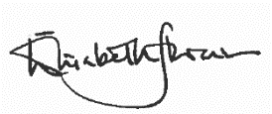

Elisabeth Stevenson
Headteacher

Teacher of Teacher of Design & Technology (Food Technology)
September 2025 start — Permanent and 0.7FTE Position
Inner London Pay Range

We are delighted that you have taken an interest in our teaching vacancy: This is an exciting opportunity to join a successful school with a friendly and supportive staff.

About Lady Margaret School
Lady Margaret School is a Church of England academy for girls aged 11-18 situated on Parsons Green in South West London. Established in September 1917, there are currently 780 girls on roll, of whom 182 are in the Sixth Form. It is an outstandingly successful school in welcoming girls of all academic abilities and ensuring that they achieve their full potential. Its success is based on a culture of high expectations and aspirations, excellent standards of teaching and a strong commitment to its Christian ethos. However, it remains an inclusive school and girls from other faiths or those who have no religious beliefs at all are welcomed.
Our exam results reflect the hard work of our students and staff. In 2024, 93% of our girls attained GCSE English and Mathematics at grades 9-4. At A Level, our results are consistently outstanding, with high numbers of girls progressing to a wide range of Higher Education courses. In 2024 73% of grades were A*-B. Students at LMS have an excellent record of securing places at top universities.

About the Role
We are looking for an inspirational, committed and enthusiastic professional to join our Design and Technology Department in September 2025 on a part-time, permanent basis. The successful candidate will teach Design and Technology across the full age and ability range, including and delivering GCSE Food Preparation and Nutrition.

What you can expect from us
- A supportive school that has staff well-being at its core
- Enthusiastic and engaged students and a culture of high aspirations
- Excellent career progression opportunities in addition to the high quality CPD which is part of our established systems for staff support and development
- A comprehensive benefits package including pension, employee assistance programme and Cyclescheme
- A convenient location served by excellent transport links, close to local amenities and green spaces.

Closing date for applications: Tuesday 17th June 2025 at 8am.
Interviews will be held on: Friday 20th June 2025

Early applications are encouraged. Suitable candidates may be interviewed before the closing date and Lady Margaret School reserves the right to withdraw the position if an early appointment is made.
How to apply: Please click on the ‘Quick Apply’ button on our TES listing to fill out an online application form. Alternatively, visit our website to complete our own application form: https://ladymargaret.lbhf.sch.uk/our-school/vacancies

Design & Technology at Lady Margaret School
The Design & Technology department at Lady Margaret School is a vibrant and innovative space where creativity, collaboration, and high standards are at the heart of everything we do. We provide a broad and exciting curriculum from Key Stage 3 through to A Level, encouraging students to explore a wide range of materials and design principles.
Our Key Stage 3 programme includes Food Technology, Textiles, Systems & Control, Resistant Materials, Graphics, and Product Design. Students work in rotation and benefit from double lessons in classes of 24, allowing them to fully engage in practical, hands-on learning.
At Key Stage 4, D&T is a very popular option. We offer GCSEs in Design & Technology (AQA) and Food Preparation & Nutrition (Eduqas), and consistently attract strong cohorts. At A Level, we offer Fashion and Textiles (AQA), preparing students for further education and careers in design through a combination of practical skills and theoretical knowledge.
The department is exceptionally well-equipped, with a main workshop housing a laser cutter, 3D printer, and brazing hearth, a specialist textiles and graphics room, and a fully fitted food technology suite. Students also have access to bookable IT suites and laptops with CAD software to support digital design.
We foster a strong culture of collaboration and professional development among staff. The team currently includes two full-time teachers, one part-time teacher, and a part-time technician who is a skilled and experienced furniture designer. Our open-door policy encourages students to use the department during free periods, and the space is always busy with lunchtime and after-school clubs, project work, and national competition entries such as Design Ventura and Wool4School.
We also value real-world learning experiences, offering regular enrichment trips to venues such as the V&A Museum, Design Museum, Graduate Fashion Week, and university degree shows.
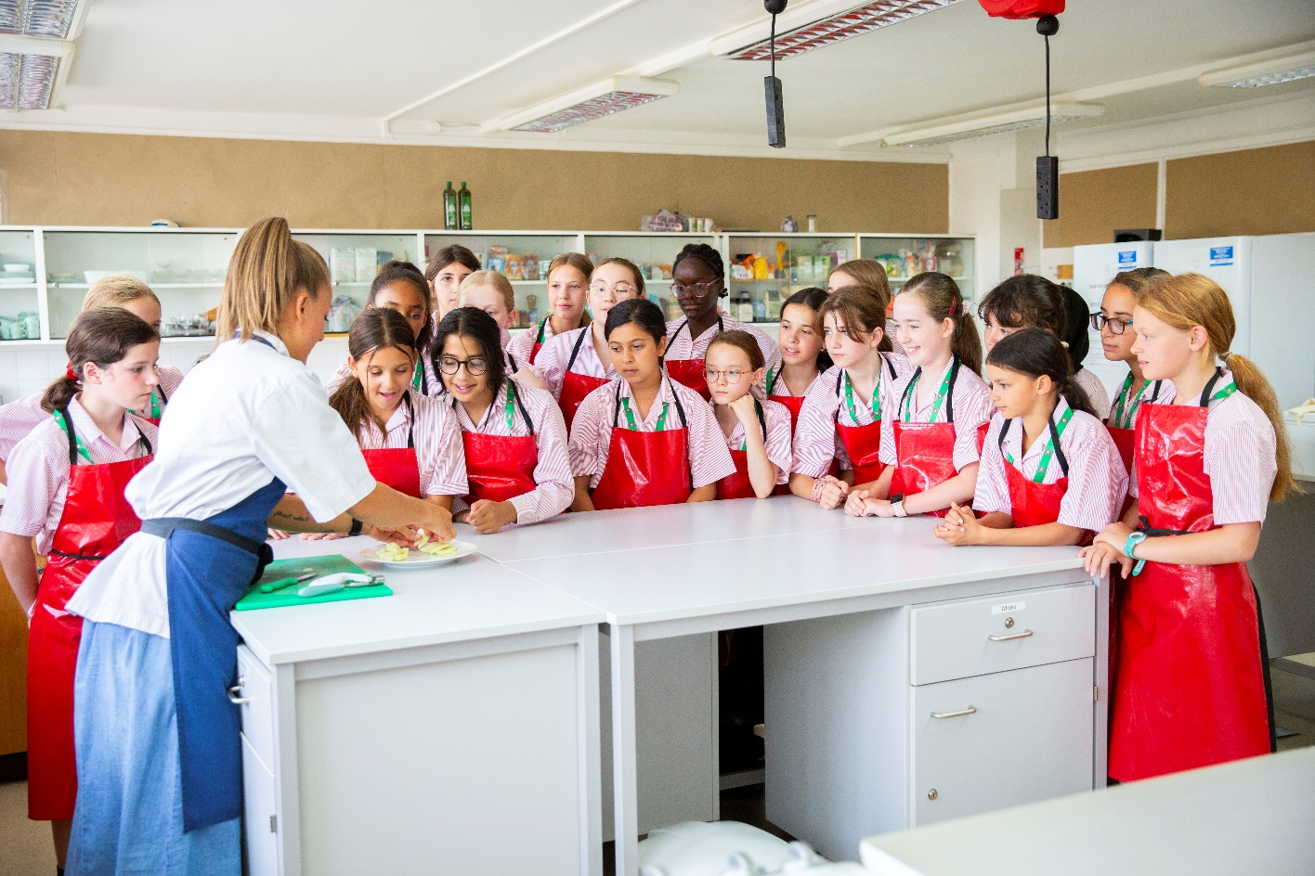

Job Description
Teacher of Design and Technology (Food Technology)
Job Title: Teacher of Design and Technology (Food Technology)
Reports to: Head of Design and Technology
Overall Responsibility: Delivering the highest quality learning experiences to students learning Design and Technology
Start date: September 2025
Salary: Inner London Teachers’ Scale
Disclosure level: Enhanced
Roles included: Classroom Teacher, Form Tutor

Safeguarding
- Lady Margaret School is committed to safeguarding and promoting the welfare of children and young people and expects all staff to share this commitment
- Appointment to this post is subject to an enhanced criminal record and background check

Job purpose:
To support the outstanding outcomes of the Design and Technology Department by teaching an exciting and challenging Design and Technology curriculum, teaching consistently high-quality lessons, and promoting exceptional levels of academic development, attainment and wellbeing for LMS students.

Overview:
To deliver consistently high-quality lessons to students to enable them to make outstanding progress.
- To support the development of an engaging, challenging and accessible Design and Technology curriculum for each year group that supports students to make outstanding progress.
- To make a valued contribution to the school’s pastoral and extra-curricular programmes, including trips and school visits.
- To be a committed Form Tutor, supporting the personal development and well-being of the students in your tutor group.

Classroom Teacher:
- Plan and deliver high-quality, challenging lessons.
- Prepare students for any internal or public examinations, to enable each student to achieve her potential.
- Maintain high expectations of students and set them challenging but achievable targets.
- Understand your responsibilities for students with particular educational needs. These will include identifying students with special educational needs, adapting your teaching accordingly, seeking advice from colleagues including the SENCO when appropriate.
- Follow all relevant school and departmental policies in the planning and delivery of lessons.
- Where a member of staff is under allocation to do cover lessons where necessary.

Assessment, reporting and communication
- Implement the school approach to assessment and feedback to inform planning, develop learning and evaluate students’ progress.
- Provide formative oral and written feedback to help students reflect upon and improve their work.
- Make effective and regular use of the school’s assessment criteria and reporting procedure to inform learning.
- Maintain regular records of students’ attainment and progress.
- Attend parents’ evenings and open evenings as required.

Job Description
Teacher of Design and Technology (Food Technology)

Professional development
- Demonstrate a commitment to continuous professional development by participating in opportunities to build your capabilities as a teacher.
- Maintain an up-to-date expert knowledge of your subject area, relevant aspects of the curriculum and exam board requirements.
- Ensure you understand your professional responsibilities in relation to school policies and practices.
- Evaluate your own teaching critically and use this to improve your professional development.

Form Tutor Responsibilities
- Maintain a holistic overview of the academic and pastoral progress of your tutees, including monitoring their wellbeing, and academic progress.
- Develop strong relationships with tutees based on trust and respect.
- Deliver the PSHE curriculum to tutees in the weekly PSHE lesson.
- Implement attendance, rewards, sanctions, behaviour and monitoring policies.
- Work with the Head of Year to identify the need for intervention planning where necessary.
- Monitor the safeguarding and welfare of students in your tutor group.
- Make Heads of Year, SENCO and senior staff aware of any issues with students as necessary.
- Proactively engage parents to build positive home-school relationships. Act as the primary point of contact for parents of your tutees.
- Model the ethos of the school.
- Keep the form register and monitor patterns of student attendance and absence.

Notes
- All the responsibilities outlined in this job description are subject to the general duties and responsibilities contained in the statement on conditions of employment under the Teachers’ Pay and Conditions Act 1987.
- This job description allocates duties and responsibilities but does not direct a particular amount of time to be spent carrying them out and no part of it may be so construed. In allocating time to the performance of duties and responsibilities, the post holder must use directed time in accordance with the schools published time budget policy and have regard to Clause 4 (1F) of the teacher's conditions of employment.
- This job description is not necessarily a comprehensive definition of the post it will be reviewed at least once each year and may be subject to modification or amendment at any time after consultation with the holder of the post.
- Staff are required to wear business dress and to be professionally presented.
- Candidates must be in sympathy with the aims and objectives of a Church of England school and its ethos. (See school website for guidelines). Members of staff must support the church ethos of the school, including taking part in religious education and acts of worship.

Person Specification
Teacher of Design and Technology (Food Technology)

 | Essential | Desirable
Qualifications | - Qualified to at least degree level.  - Qualified to teach in the UK.  - Qualified to work in the UK.  - QTS or equivalent. | - Further professional qualifications
Experience | - Ability to deliver consistently outstanding lessons in this subject to students of all ages and abilities.  - Proven record of significantly raising achievement with all groups of students across the age and ability range and of helping them achieve impressive examination outcomes.  - Proven commitment to continued professional development and a readiness to reflect and self-evaluate to change, improve and develop.  - Experience of having designed, implemented and evaluated effective, imaginative and stimulating schemes of work. | - Successful experience of working particularly with high ability and SEND students.  - Experience of teaching A level
Knowledge | - Thorough knowledge of the requirements of the subject.  - An understanding of the ways children learn and how individual needs may be assessed and met.  - Good knowledge of current educational developments and initiatives relating to the subject and their implications.  - An understanding of the strategies needed to establish consistently high aspirations and academic / behavioural standards in an urban school setting, and a commitment to relentlessly implementing these strategies. | - Actively informed of developments in your subject area, and of broader pedagogic developments at local, national and international levels.
Skills | - Excellent interpersonal and listening skills; a high degree of emotional intelligence; and an effective oral and written communicator with students, staff and parents.  - The ability to develop positive relationships with all young people.  - Well-developed planning & organising skills including time management, prioritisation, delegation and administration.  - Ability to plan, monitor, evaluate, review and lead by example.  - Sound judgement and problem solving skills. | - Ability to plan and lead fieldwork.  - An ability to use data confidently to inform planning.  - Competent user of ICT

Skills | - Excellent interpersonal and listening skills; a high degree of emotional intelligence; and an effective oral and written communicator with students, staff and parents.  - The ability to develop positive relationships with all young people.  - Well-developed planning & organising skills including time management, prioritisation, delegation and administration.  - Ability to plan, monitor, evaluate, review and lead by example.  - Sound judgement and problem-solving skills. | • Ability to plan and lead fieldwork.  • An ability to use data confidently to inform planning.  • Competent user of ICT
Motivation | - Willing to support LMS school ethos a s a Church of England school.  - Willing to be fully engaged in the whole life of the school including extra-curricular activities.  - Willing to be a form tutor.  - Committed to working collaboratively with colleagues.  - A commitment to the safeguarding and welfare of all students. | - Experience of leading successful extra-curricular activities which inspire and motivate learners.
Person Specification
Teacher of Design and Technology (Food Technology)

Safeguarding
Lady Margaret School is committed to safeguarding and promoting the welfare of children and young people and expects all staff and volunteers to share this commitment.
- Successful candidates are required to undertake an enhanced Disclosure and Barring Service check.
- This post is exempt from the Rehabilitation of Offenders Act 1974 and therefore shortlisted candidates will be required to declare any convictions, cautions, reprimands and final warnings that are not ‘protected’ (ie filtered out) as defined by the Rehabilitation of Offenders Act 1974 (Exceptions) order 1975 (Amendment) (England and Wales) Order 2020. Having a criminal record will not necessarily prevent you from taking up appointment; it will depend on the nature of the offences and their relevance to the post you are applying for. However, should a shortlisted candidate NOT declare an offence that is subsequently revealed, e.g. through the DBS check, this may place their appointment in jeopardy.
- It is a criminal offence for barred individuals to seek or undertake work with children.
- In compliance with Safer Recruitment guidelines, CVs cannot be accepted.

Referees
Two references will be sought for candidates invited to interview. It is our policy to obtain references prior to interview, therefore if you have any concerns regarding this please contact us.
- The first reference must be from your present or most recent employer.
- If any of your references relate to your employment at a school or college, your referee must be the Headteacher or Principal.
- If you are currently working with children, your present employer will be asked about any disciplinary offences relating to children, current and/or time expired, and whether you have been the subject of any child protection concerns and if so, the outcome of these investigations. If you are not currently working with children, but have done so previously these issues will be raised with your former employer.
- If you are not currently working with children but have done so previously the second reference must be from that employer.
- We are unable to accept references from anyone acting solely in the capacity of a friend or relative.
- Other previous employers may also be approached for information, before interview, to verify details on your application form such as particular experience or qualifications.
- If you have worked with any of the referees you have provided for less than 24 months, please provide an additional referee.

Thank you for your application. Applications may not always be acknowledged; however, we aim to advise non-shortlisted applicants of the outcome within a reasonable period after the closing date. Where a large number of applications is received this may not be possible, and if you have not been contacted within 3 weeks of the closing date, please assume that you have been unsuccessful.

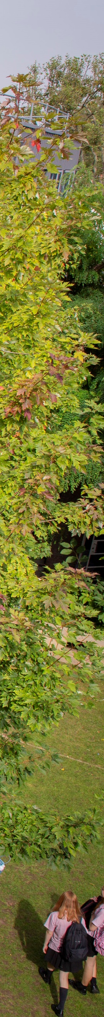

Lady Margaret School
Parsons Green
London
SW6 4UN
Tele: 020 7736 7138

recruitment@ladymargaret.lbhf.sch.uk
www.ladymargaret.lbhf.sch.uk

