Leader of Maths
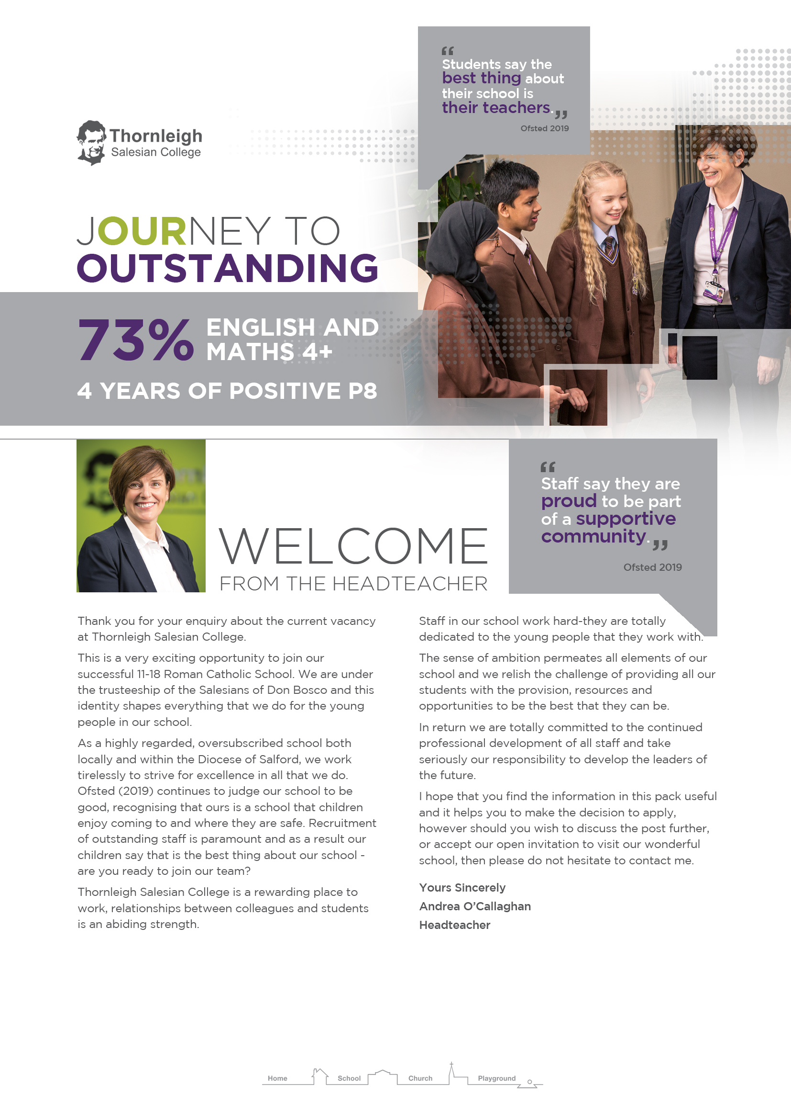

A
Leader of Maths

Full Time, Permanent Post
Salary: T1-T9 +TLR 1C (£9,929)
Required from September 2020

You will be working alongside the Director of Maths in providing leadership, innovation and direction in teaching and learning.

You will be responsible for the day to day running of the department and for raising achievement and attainment at KS4 as well as monitoring the work of other TLR holders.

If you are
- Passionate about working with young people
- Excited about developing world class teaching and learning
- Ambitious for yourself and the students that you teach
- A dynamic classroom practitioner with high expectations
- A flexible and creative teacher who can enthuse and inspire
- Committed to excellence
- Dedicated to your own professional development

In return we can offer you
- The opportunity to work alongside a dedicated team of staff in a well-resourced, innovative and supportive Mathematics department
- Excellent Professional Development and Learning opportunities
- A friendly, inclusive school where all are respected

Closing date for applications:
12noon Monday 24th February 2020
Interviews: Monday 2nd March 2020

Application packs can be downloaded from the school website. Please return completed application forms to recruitment@thornleigh.bolton.sch.uk

This school is committed to safeguarding and promoting the welfare of children and young people and expects all staff and volunteers to share this commitment. The successful applicant will be required to complete an enhanced DBS check.

Every member of staff at Thornleigh is expected to endeavour to maintain and develop the Catholic and Salesian character of the school, and to support and promote the aims and mission of the school in and through the exercise of all contractual duties and any voluntary activities.
Post Title | Leader of Mathematics
Post Holder
Salary Scale | T1-T9 + TLR 1c £9,929
Reporting to | Director of Maths/Deputy Headteacher
Responsible for | TLR postholders, teaching and associate staff within the department.
Purpose | - To ensure the provision of an appropriate broad, balanced, relevant and differentiated curriculum for students studying in the department, in accordance with the aims of the school and the curricular policies determined by the Governing Body.  - To agree and support the achievement of student progress targets ensuring thorough rigorous monitoring and evaluation and a measurable and significant contribution to whole school targets. Analyse and interpret student and staff performance data and lead and facilitate intervention strategies to maximise student achievement.  - To effectively manage and deploy teaching and associate staff, financial and physical resources within the department to support the designated curriculum area.  - To monitor, develop and enhance the teaching and working practice of others within the department.  - To review and report to the designated member of the Senior Leadership Team (currently the Deputy Headteacher) and governors on the standards of leadership, learning and teaching in all areas of Mathematics consistent with the school’s self-evaluation procedures thereby leading to a continual focus on school improvement.  - To provide regular progress checks to the SLT on all successes, issues and concerns relating to Mathematics ensuring full awareness amongst the SLT.  - To lead the implementation of the SDP/SIP as it relates to the department.  - To participate in the pastoral care of students and to support and promote the policies, ethos and values of the school.  - To contribute to the comprehensive subject handbook and annual development plan which carries forward school aims and policies and identifies resource needs. This will engage all subject staff in the creation, implementation and review of innovative schemes of learning which encapsulate the most up to date mathematical pedagogy.
Main Areas of responsibility | - To undertake the responsibility associated with the role and duties of curriculum leader/head of department (as specified in the Staff Handbook)
Other Responsibilities | - To undertake an appropriate programme of teaching in accordance with the duties of a standard scale teacher (as specified in the Staff Handbook)  - To undertake the role and responsibilities of a Form Teacher / Sixth Form Group Tutor (as specified in the Staff Handbook)  - To carry out any other duty as specified by STPCD not mentioned above  - To comply with any reasonable request from a manager to undertake work of a similar level which is not specified in this job description  - To ensure effective and equitable delegation of responsibilities and to provide regular feedback for team members in a way that recognises good practice and supports their progress against rigorous performance management targets resulting in tangible impact on our young people’s attainment in Mathematics.

The successful candidate must be able to demonstrate that he/she has the qualifications, experience, knowledge, abilities and personal qualities outlined below. References obtained about candidates will also be used in the assessment of their suitability for the post.

Essential | Desirable | Method of Assessment

Qualifications, Training, Experience
- A relevant degree and teaching qualification  - Post qualification professional development  - Successful teaching experience to at least GCSE level  - Evidence of work on the development and writing of schemes of work | - Catholic Teachers’ Certificate  - Experience of teaching to ‘A’ level standard  - Experience as a GCSE or KS3 examiner | Qualification Certificates  Application form and interview  Application form and interview  Application form and interview

Knowledge and Abilities
- Detailed knowledge of the requirements of National Curriculum Maths  - Fully conversant with the planning and delivery of KS3 and KS4 Maths courses  - The ability to accurately assess the quality of the work of students against national standards  - Proven organisational skills  - Ability to teach up to GCSE standard  - High level teaching skills  - Ability to maintain good order and discipline  - Good communication skills  - The ability to manage the work of others and monitor and evaluate the quality of their work  - The ability to use ICT to facilitate learning  - The ability to promote the spiritual, moral and cultural development of students through Maths teaching | - Fully conversant with the planning and delivery of ‘A’ level courses.  - Ability to teach to ‘A’ level standard | Application form and interview  Application form and interview  Application form and interview  Application form and interview  Application form and interview  Lesson observation and interview  Lesson observation and interview  Interview  Application form and interview  Application form and interview  Application form and interview

Personal Qualities
- Good health  - Clear dedication to teaching as a career  - Enthusiasm and a liking for work with young people  - Resilience, flexibility and an ability to respond creatively to changing circumstances  - Ability to relate well with colleagues and students  - Appropriate professional dress and appearance  - Capacity to work hard, under pressure, to meet deadlines | - Commitment to extra-curricular activities  - Sense of humour | Application form and interview  Application form and interview  Application form and interview  Application form and interview  Interview and interaction with others whilst visiting the school  Interview  Application form and interview

Date Job Description and Person Specification prepared/updated | January 2020

.

