

Re: Teacher of Technology, Engineering and Design

Start Date: Feb/Easter 2019

Thank you for your enquiry.

As one of the Academy specialisms, we are home to a well-resourced, well-budgeted Technology, Engineering and Design department that offers a varied and broad curriculum at all key stage.

At KS3 students study the subject for 2 hours per week and follow a mixed, 5 project curriculum of Graphics, Resistant Materials, Product Design and Engineering. At KS4 students opt to study GCSE Design and Technology and/or VCERT Engineering. During year 11 students study their option choice for 6 hours per fortnight and at A level study the Design and Technology curriculum for 10 hours per fortnight.

The department’s facilities include 2 workshops, a CAD suite, a sixth form work space a theory classroom, a staff break and workspace and a well organised and well stocked cutting room.

The department vision is strongly supported by leadership and our team of 4 teachers and a supportive technician work hard to deliver a curriculum which encourages students to be innovative, independent and resilient. The department is also very supportive of CPD.

We are looking to appoint a passionate, forward thinking and dynamic teacher looking to inspire the next generation of engineers and designers. The right candidate will believe in fostering an engaging and exciting classroom atmosphere that will help develop well rounded, skilled and conscientious designers and engineers.
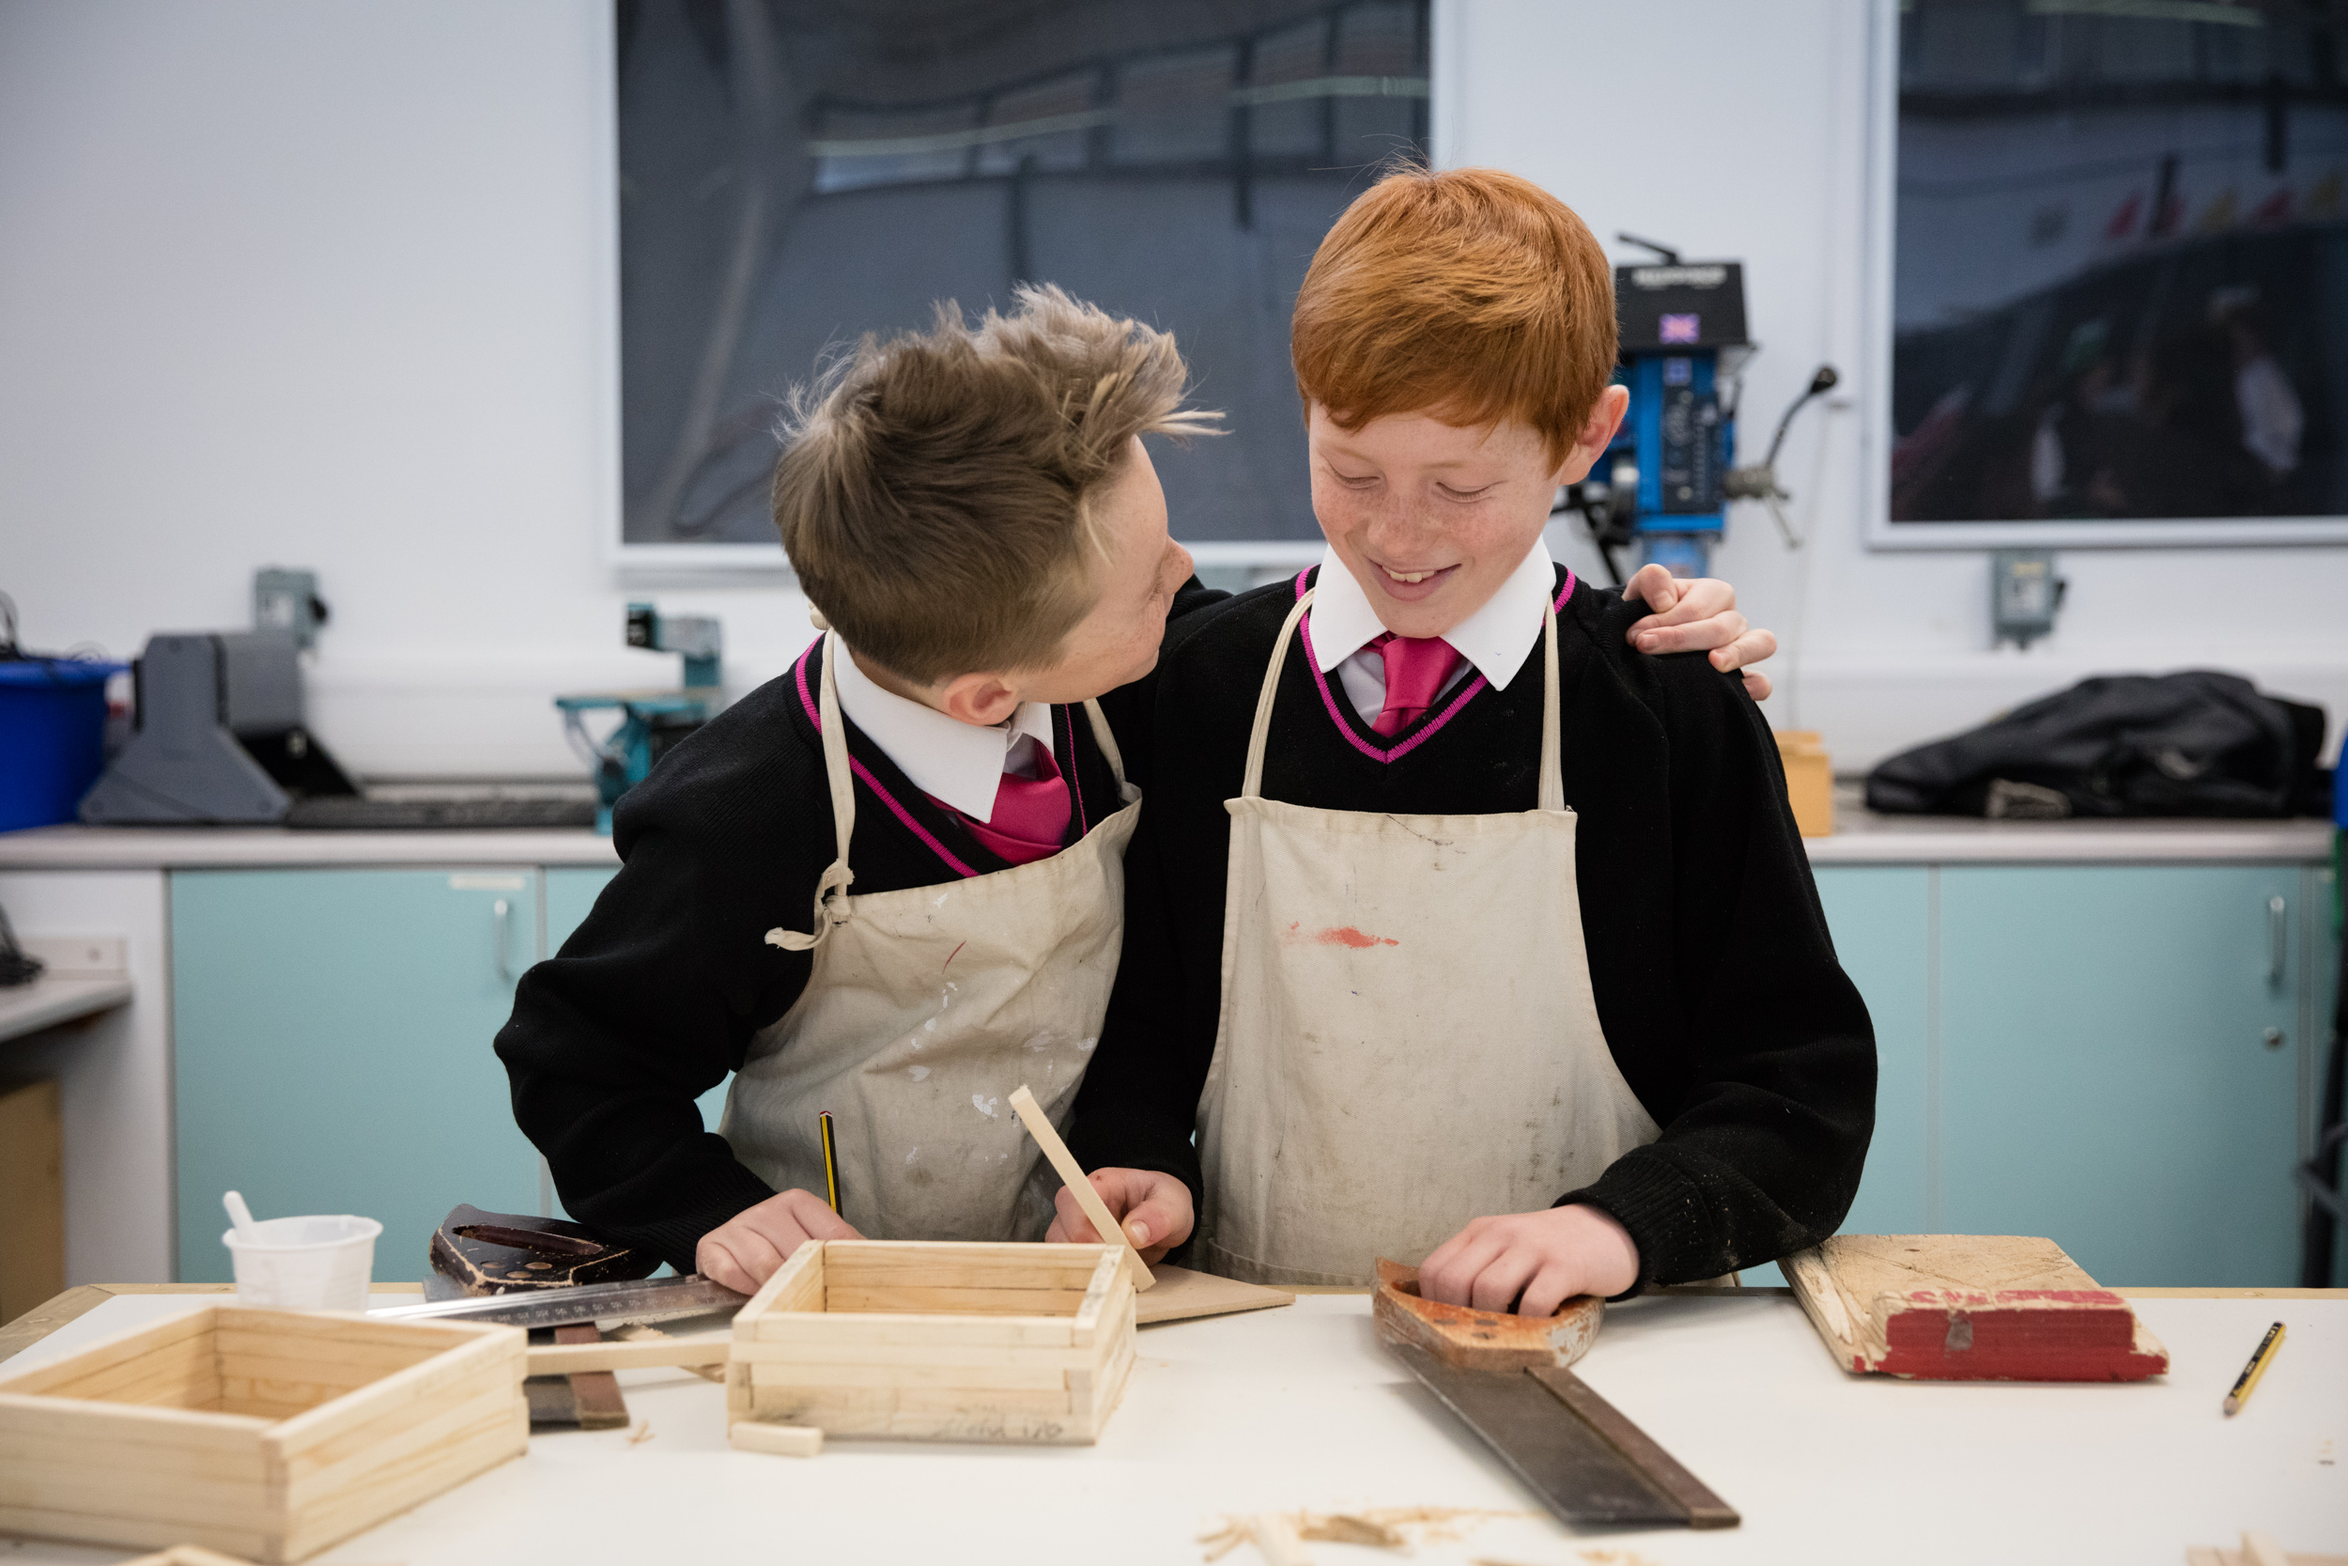

OFSTED The Academy was last inspected by OFSTED in February 2018 and concluded that The Bourne Academy was a ‘good school’. The report highlighted the following;

- ‘the Academy engages well with parents and the local community, understanding the importance of reaching out to secure support for different aspects of the school’s work. As a result, and with good reason, the school is held in high regard by parents and local employers’
- ‘Pupils are safe in school and reported to inspectors that they feel safe. This is because they do not feel intimidated by other pupils and feel that everywhere in school is a safe place’
- ‘All pupils who spoke with the lead inspector said they would be happy to speak to members of staff if they had worries. Pupils do not think that bullying is an issue at this school and, if it does occur, it is dealt with effectively’
- ‘Students in the sixth form are progressing well. They value the academic and pastoral support they receive from staff and are loyal towards the school. They benefit from positive relationships with staff’
- ‘Staff are rightly proud of the increasing number of students who have achieved places at ‘Oxbridge’ and Russell Group universities. This is, in part, because of the helpful partnership with the school’s sponsor, Canford School. It is also because of the work staff are doing to raise students’ aspirations’

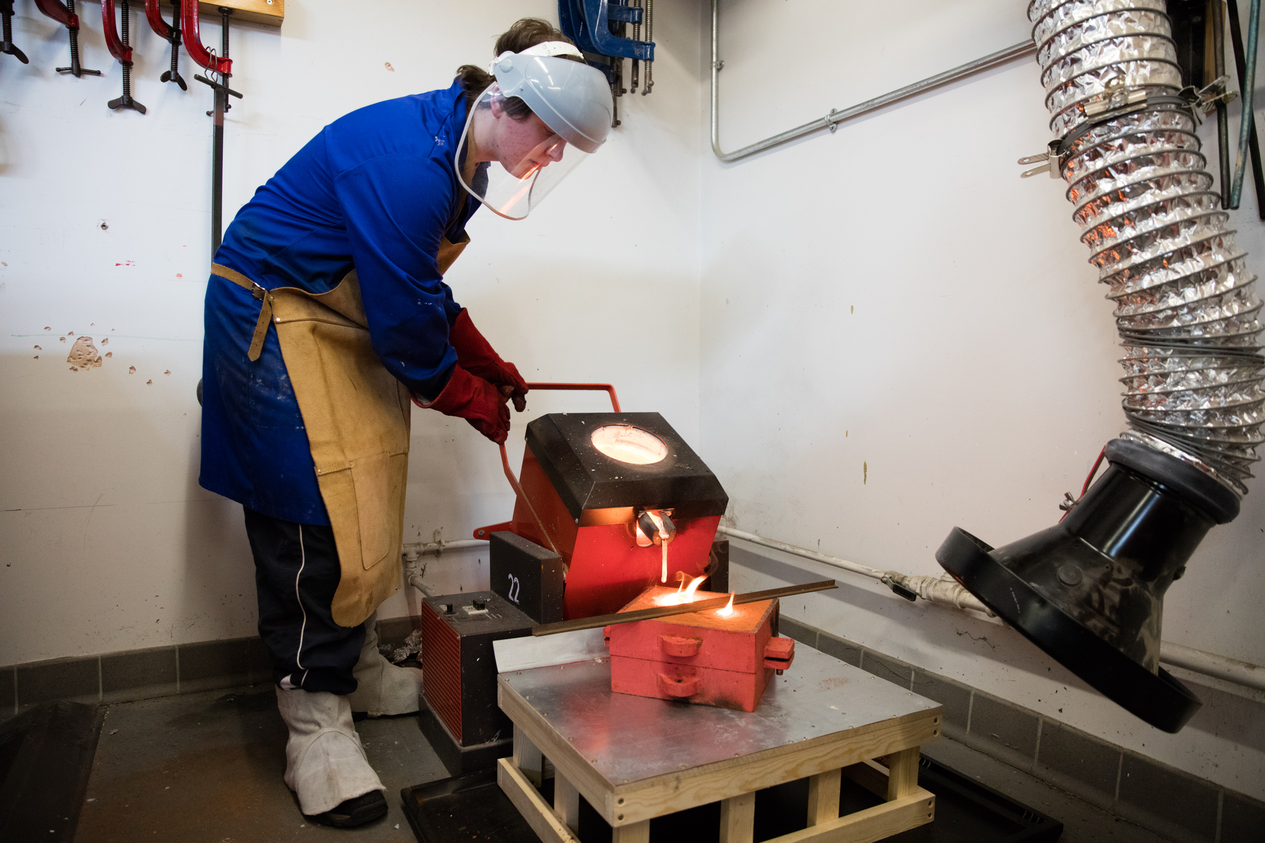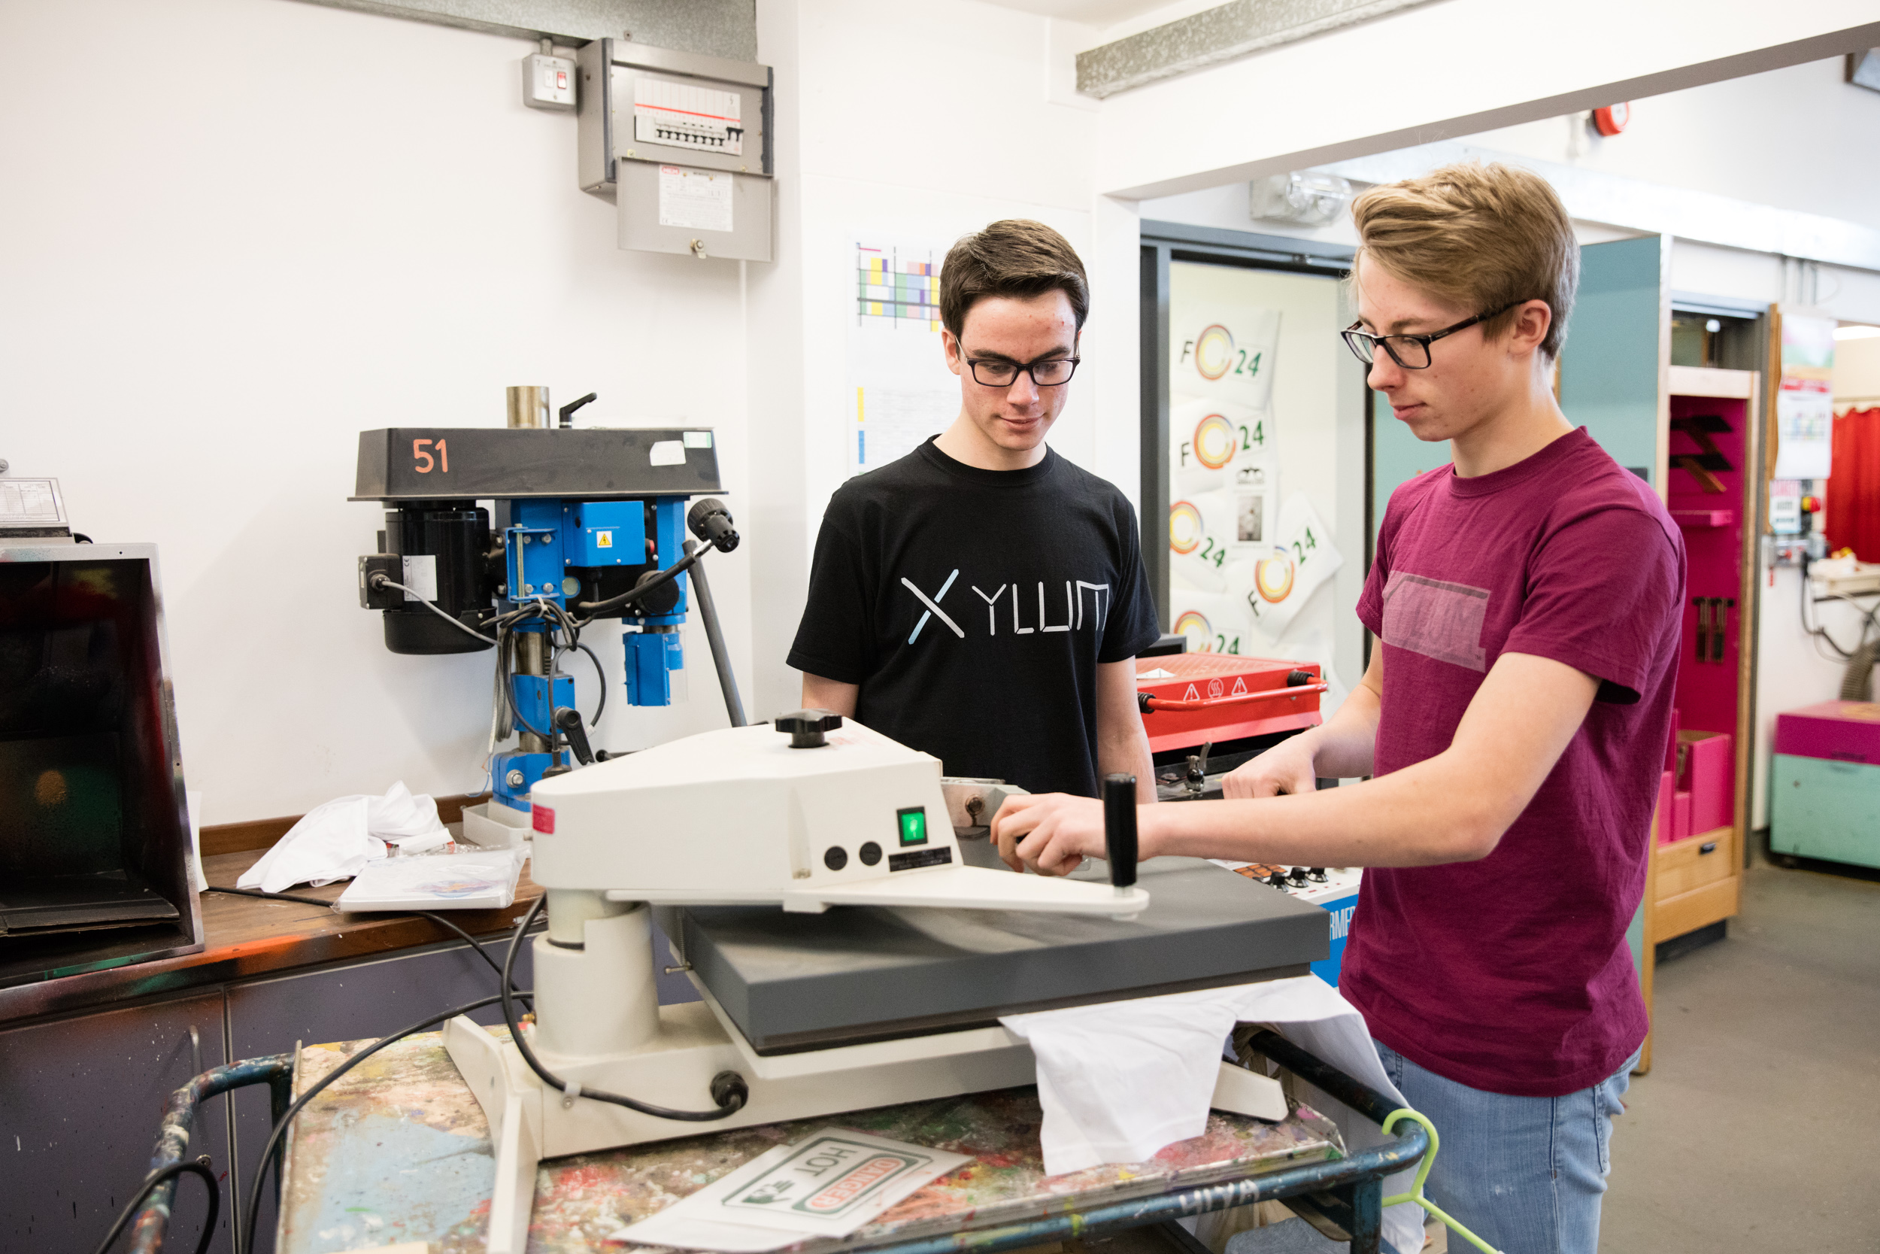

At The Bourne Academy we will develop literate, numerate global citizens who ASPIRE, ie are: Ambitious, Self-confident, Physically Literate, Independent Learners, Resilient, Emotionally Literate.

We want to help students to:
- Have belief in and a positive vision for themselves, their future and their school
- Be literate and able to communicate ideas clearly and confidently
- Think clearly and be able to question, make decisions and solve problems
- Understand and apply engineering and design principles to make life better for people
- Be well prepared to participate in the community and as a global citizen

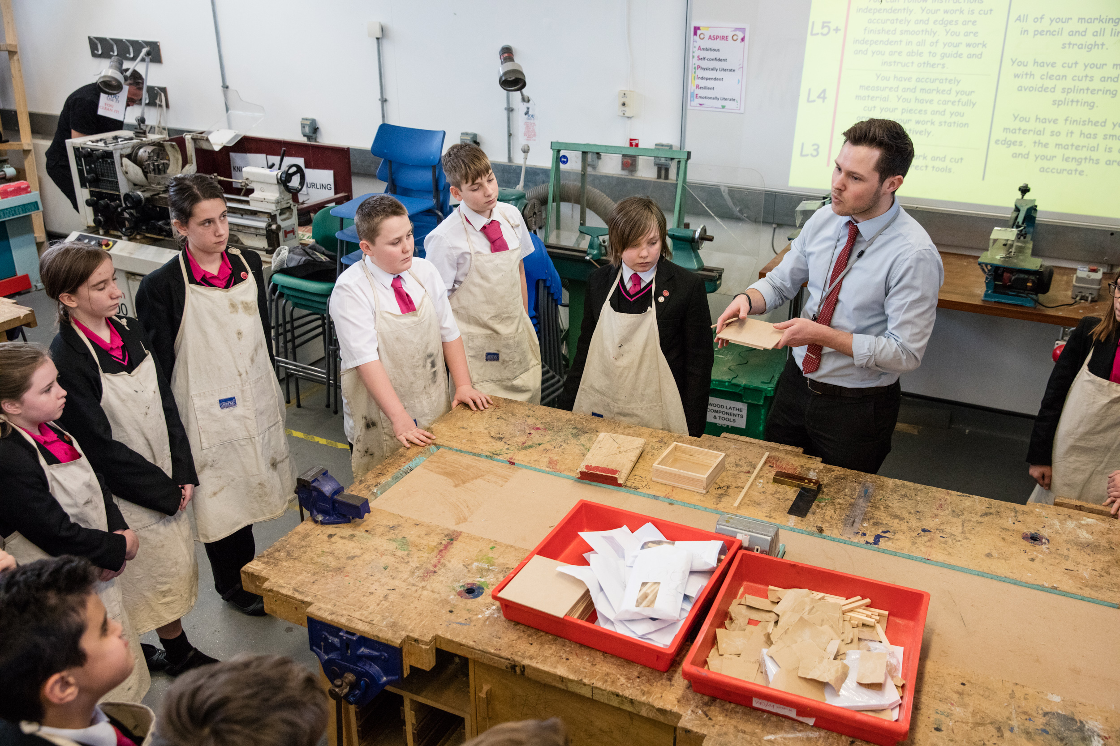

Students are assessed through subject-led ASPIRE DAYS. They spend the day working in teams on various projects, and they take part in many various activities, according to the theme.
Several schools have a House system underpinning their pastoral care, but very few have as many as eight Houses. Ours, named after lighthouses along the south coast, are small enough that the Heads of House, each of whom is only on a 50% timetable, can get to know each student and their parents/carers personally.

Relationships within the House are strengthened through regular House assemblies and internal competitions which also provide an opportunity for friendly rivalry between the Houses.

The Academy’s House system is named after the lighthouses standing at various points along the south coast, providing illumination, aide navigation and safe harbour for mariners and wayfarers. At The Bourne Academy we aspire to do likewise for all our students.

Houses Names: Anvil, Calshot, Eddystone, Hurst, Kingswear, Portland, Sovereign, Trinity

Every individual, their needs and aspirations, are important. The Academy values every child and every adult associated with it. We aim to create a culture in which every person is treated with dignity and respect. Accordingly, good behaviour is expected. The vertical House Tutor relationship is the foundation of the Academy’s care, fostered by daily contact in tutorials.

Additional staff benefits
- Free breakfast every morning for staff
- Lunch provided every Wednesday for staff
- Child care vouchers
- Bike to work scheme
- Bursaries available for professional development
- Comprehensive and highly effective CPD programme
- All teaching staff are assigned a coach

These are very exciting times for The Bourne Academy. Whilst there has been a lot of improvement in recent years, there can be no room for complacency. We are aiming for excellence. This is a wonderful opportunity to join a strong and dedicated team of professionals and to help enhance the successes in this important subject area. This post will be demanding and very rewarding. If you possess the qualities listed above and have the necessary skills and experience, we will welcome your application.

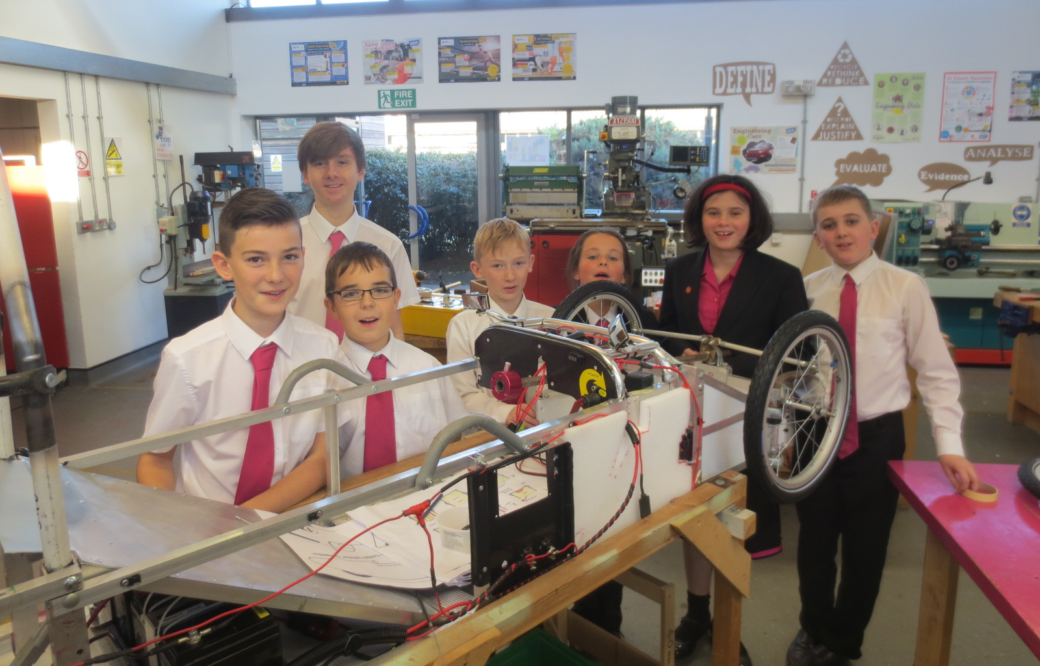

Applications

Please find enclosed an application form, job description and person specification. Further information can be obtained from the Academy’s website at www.thebourneacademy.com

If you would like to visit the Academy prior to making an application, please contact Finola Gilson on 01202 636991.

Safeguarding Children

Please note that The Bourne Academy is committed to safeguarding children. In line with our Safeguarding Policy, we adopt safe recruitment procedures and always check the suitability of applicants to work with children/young people through the appropriate authorities. Only applications submitted on the Academy’s application form will be considered and the successful applicant will be required to undertake an Enhanced Disclosure by the Disclosures & Barring Service. It is our normal procedure to request references on shortlisted candidates prior to interview.

The Interview Process

If selected, the interview process will test and assess your fulfillment of the requirements for this position. As part of this process, you will be observed teaching a lesson to a class/group of students. You will also be expected to attend a panel interview. The interview process will include consideration of your suitability to work with children and the interview panel will ask questions on safeguarding children/young people.

We look forward to your application.

Yours sincerely


Mr M Avoth
Principal

