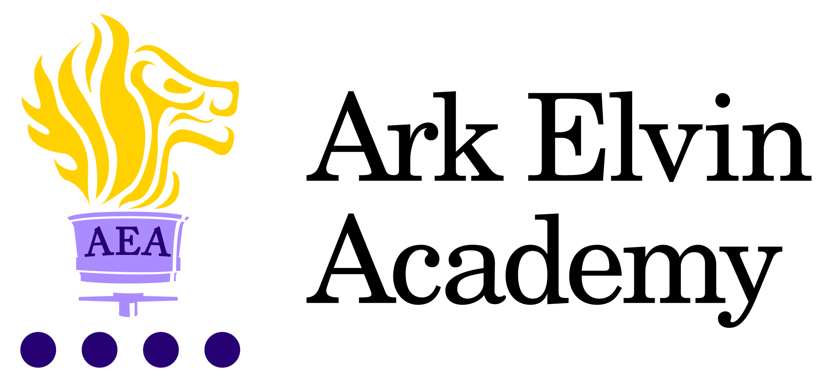

Job Description: Data Manager

Reporting to: Assistant Principal
Start date: ASAP
Salary: Ark Support Staff Scale Grade 11, point 34 to 41 - £43,266 to £50,323 per annum
Hours: 36 hours per week, all year round

The Role
Reporting to the Assistant Principal, the Data Manager is responsible for managing and developing the academy’s data systems, whilst maintaining full accuracy and confidentiality with integrity. The role involves analysing and interpreting data to inform decisions at all levels in the academy; it is vital to our school mission in ensuring that we make the right decisions for pupils and staff based on the data available. The Data Manager is also responsible for ensuring that all statutory data requirements are met.

Key responsibilities

The Data Manager has a wide-ranging remit focused on supporting Ark Elvin Academy to take the next step in our school improvement journey through the timely use and analysis of data, as well as ensuring all statutory duties are met. The specific responsibilities are subject to change.

Student Management Information System
- To take responsibility, with integrity, for all areas of data input and output within the academy through our MIS.
- To maintain relevant databases, including pupil records, using Bromcom, the Student information Management System, in order to ensure that they are up to date and fit for purpose.
- To support with the creation of the timetable.
- To work with Assistant Principal in the setting of Key Stage and Year Targets for Students as well as subject targets.

Reporting & Examinations
- Reporting to parents on pupil outcomes, Census returns and updating pupil and staff details to ensure that the information is always relevant and up to date. To distribute the relevant detail to the right people, including data relating to SEN.
- To provide reports, as requested, for the DfE, LA, Governing body, Principal, SLT, staff, students, and parents regarding assessment information, ensuring the provision of accurate and appropriate information to relevant parties.
- To assist the Examination Officer in the import, use and distribution of examination data
- To assist with the academy’s annual students reporting procedures; to ensure that pupils receive regular and timely academic feedback.
- To assist in the management of the in-year admissions and leavers procedure, ensuring that the Admissions Officer has access to the right information and follows all procedures correctly.

Other
- Actively promote the safety and welfare of our children and young people.
- Ensure compliance with Ark’s data protection rules and procedures.
- Liaise with colleagues and external contracts at all levels of seniority with confidence, tact, and diplomacy.
- Work with Ark Central and other academies in the Ark network, to establish good practice throughout the network, offering support where required.

This job description sets out the main duties of the post at the time of drafting. It cannot be read as an exhaustive list. These responsibilities will be discussed annually as part of the postholder’s annual performance review and are subject to change. However, it may be altered at any time subject to need in consultation with the postholder subject to the Principal’s approval.

Person Specification: Data Manager

Qualification criteria
- Qualified to work in the UK
- Educated to at least A-Level standard or equivalent
- Appropriate and relevant professional qualification

Experience
- Experience of working with BROMCOM is highly desirable through not essential
- Be proficient with Microsoft products – particularly Microsoft Excel
- Good understanding of the role of data in an education context

Skills and Knowledge
We are looking for these skills and attributes or at the very least, a candidate’s clear, demonstrable capacity to develop them:
- Alignment with Elvin vision
- Relentless drive to do whatever it takes to ensure all pupils succeed.
- Embody our core values – integrity, courage, community and mastery – in all aspects of work and conduct.
- The belief that with the right environment all of our pupils are able to excel at university, or in a meaningful alternative.
- The courage and conviction to make a difference

Communication Skills
- Be a confident communicator with a proven track record of building and maintaining positive working relationships.
- Empathy and the ability to understand the needs, aspirations and motivation of diverse individuals and groups
- Working with others
- Possess strong customer service skills, including an excellent phone manner.
- Model desired behaviour and values
- Have excellent interpersonal skills, with previous experience in a client facing role

Problem solving
- Identify, analyse and resolve problems and issues
- Develop plans with concrete outcomes and effective solutions.
- Show sound time management skills, and an ability to prioritise workload to meet deadlines

Resilience
- Sustain energy, optimism, and motivation in the face of pressure and setbacks.
- Stat clam in difficult situations and maintain clarity of vision.
- Be self-motivated and resilient with a “can-do” attitude and the ability to work calmly and pragmatically under pressure.

Other
- This post is subject to an enhanced DBS
- The post holder must be committed to safeguarding the welfare of children and to providing equality of opportunity.

Ark is committed to safeguarding and promoting the welfare of children and young people in our academies. In order to meet this responsibility, we follow a rigorous selection process. This process is outlined here, but can be provided in more detail if requested. All successful candidates will be subject to an enhanced Disclosure and Barring Service check.

