Recruitment Pack for
Science Teachers
Fixed term contract for one year maternity cover (with the possibility of becoming permanent)

Contents

Message from the Headteacher page 3
Ethos and Values page 4
Overview of the school page 5 Department Overview page 9
Job Description page 12
Person Specification page 16
Guidance of completing the Application Form page 19

Dear Candidate
Thank you for taking an interest in the post of a Science Teacher at Whitefield School.
‘Whitefield is a good school with outstanding personal development, behaviour and welfare’ (Ofsted 2017). We are proud to be named as the fourth best school in the country for the outstanding progress some of our key students make. Our examination results continue to rise year on year. But we still have ambitious plans for the future.
The successful candidate will be an inspiring and expert classroom practitioner, who will work alongside the Director of Learning for Science and an experienced and committed Governing Body that lead the whole school community into this next phase of the school’s journey from being a good, to being a truly great school.
I hope that you find this candidate pack useful and I urge you to look on our website to gain a flavour about the school. Applications must be completed on the TES application form (CVs will not be accepted). Completed applications can be sent as a hard copy for the attention of myself at the school address or by email to Miss Christina McGhan, our HR Officer, at Cmg@whitefield.barnet.sch.uk.

All applications will be acknowledged, so please contact Miss McGhan if you do not receive one.
The timeline for appointment is as follows -
Closing date for applications noon 03rd October 2019
Interview date w/c 07th October 2019
Commence Post As soon as possible

This is an exciting time for Whitefield School. We have talented students, caring staff, a skilled Governing body and supportive parents. If you are looking to join a school which is on a rapid trajectory of improvement, and want to develop your skills as middle class leader, then this is an exciting opportunity for you.
If you would like further information about the post, arrange a visit or an informal discussion please contact Miss Christina McGhan at the school on 0208 455 4114 ext 206 or email cmg@whitefield.barnet.sch.uk

I very much look forward to receiving your application.
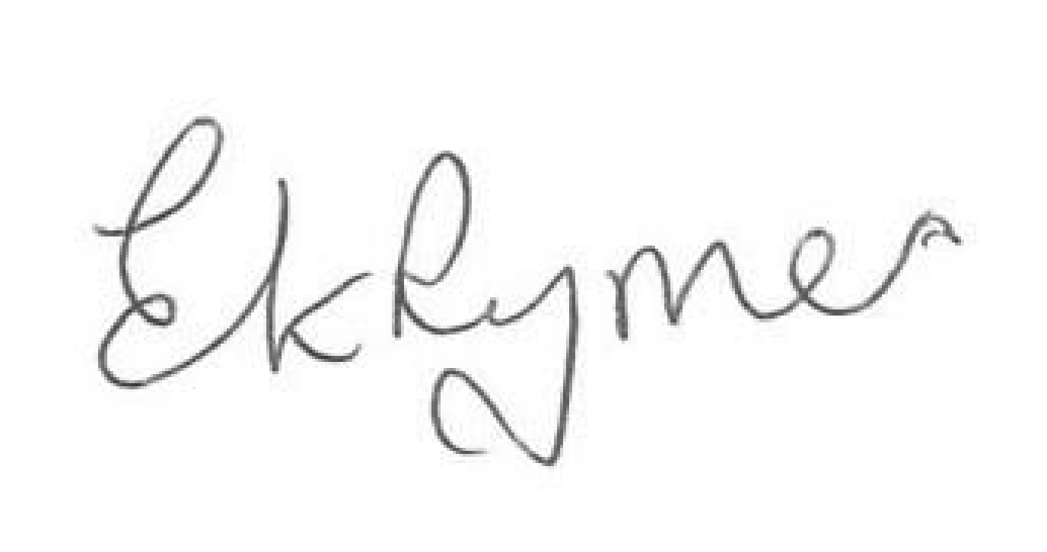
Elizabeth Rymer
Headteacher

LIVE LEARN ASPIRE ACHIEVE

Ethos and Values

Whitefield School is a unique and exciting school; one of the most improved schools in the country.

Our vision is to develop children into confident, ambitious, resilient young adults, who are ready for life in the future; a school where students have high expectations of themselves and where staff go the extra mile to realise these ambitions. Our commitment to academic excellence and personal well-being is absolute. Our success lies in the close and safe community that flourishes here at Whitefield, and the excellent relationships that exist between staff and students. We are a medium sized school and our students tell us that it feels like a ‘big family’.

At Whitefield School we know that our students have one chance of a good education; one chance of getting the qualifications and experiences that they need to succeed in life. For these reasons we are committed to our students:

- achieving all that they possibly can, even above and beyond what their prior attainment tells us is possible
- aspiring to make their dreams come true. No matter what a young person’s starting point in life, we believe that all students should have the opportunities and support to become a Doctor, a Lawyer, a top athlete or indeed whatever they aspire to be.
- having the tolerance within themselves to make a positive contribution to building a more tolerant and understanding society when they leave. Tolerance is a real strength of our school community. We have students and staff here from over 70 different countries and we celebrate the rich diversity of our global community. We believe that being part of this community where being different is normal, not helps prepare our students for the global community that they will operate in as adults.
- having the pride and the confidence in themselves to take risks and achieve. We want our students to be proud of their school and proud of their achievements and we will work tirelessly to give them the opportunities and reasons to have this pride.
- being so resilient that in a world where the pace of technological change makes it impossible to accurately predict the future, they are able to deal with whatever challenges the future throws at them.

Through the embedding of these core values we will realise our vision and in achieving this we will ensure also that Whitefield School becomes the school of choice in the locality.
‘Whitefield’s ethos of ‘live, learn, aspire, achieve’ permeates the work of the school. Pupils, irrespective of when they start at the school, are welcomed warmly and supported to make good progress from their starting points.’ (Ofsted 2017)

Overview of the school

This is just a very brief summary about our school. The website is where you will find much more detailed information
Whitefield School is located to the southern end of Barnet, very close to Brent Cross. We became an Academy on 1st September 2011 and were graded as a ‘Good’ school by Ofsted in December 2017. It is a very exciting time at Whitefield School. We continue to go from strength to strength with a talented and friendly staff whose commitment to taking the school forward is second to none and an experienced and skilled governing body that provides challenge and support.

“The school’s work to promote pupils’ personal development and welfare is outstanding.” (Ofsted 2017)

“Diversity at this harmonious school is celebrated and respected. As a result, pupils mix very well and they consistently show respect and tolerance towards each other, staff and visitors.” (Ofsted 2017)

“The behaviour of pupils is outstanding. Pupils’ conduct around the school and in lessons is of the highest standard. The atmosphere is calm and quiet across the large site. In lessons, pupils enthusiastically engage in the task at hand, working collaboratively with others and listening carefully to each other’s views.” (Ofsted 2017)

Our school has a positive atmosphere and everyone is expected to treat each other with respect in creating a positive and effective learning environment.

The current school roll is 850 students, including 150 in the Sixth Form, but this is increasing. We wish to remain a medium sized school to ensure we can provide each student with the appropriate level of personal attention and care that they need and deserve.

As an Academy (and we were the first Full Service Extended School in Barnet) we are renowned for our community links. Staff and students have spoken at national conferences about our community outreach work. We have extremely positive relationships with our local Primary schools, who send their most able students to us for timetabled masterclasses in mathematics and English, send entire year groups to our STEM festivals and use our wonderful stage and theatre facilities for their own productions.

Students

“Pupils’ conduct is of a very high standard. They attend regularly, work hard and are eager to learn. They value and enjoy the full range of extra-curricular opportunities available to them.” Ofsted 2017

The school is ethnically very diverse. Most of the students come from minority ethnic groups. The largest groups are from Somali, Afghan and Eastern European backgrounds.

The proportion of students who speak English as an additional language is very high. A larger than average proportion of students joins the school part way through their education. The proportion of disabled students and those with special educational needs supported at school action is well above average. The proportion supported at school action plus or with a statement of special educational needs is also above average. A small number of students currently attend courses off site for all or part of the week.

Parents
Our parents are very supportive of the school. They have high aspirations for their children and they work with us to ensure their children are successful. Attendance at Student Progress Evenings is now consistently very high (90 %+).
“Parents who responded to Ofsted’s online questionnaire, Parent View, were positive about the support they receive from the school and the progress their children make. As one parent said: ‘The school has done everything to ensure pupils learn and make progress so that they achieve the best results.” (Ofsted 2017)

Staff
Our staffing body is talented, dynamic and forward looking. Staff speak in excess of 40 languages.
“Teachers have secure subject knowledge and use the school’s excellent resources well. Regular opportunities for them to share good practice ensures that there is ongoing dialogue about high-quality teaching.” (Ofsted 2017).
“Teachers know pupils well and plan learning activities carefully to ensure that there will be sufficient support and challenge. The ‘Whitefield lesson’ has raised expectations.” (Ofsted 2017)

In the classroom
“The majority of pupils make strong progress from their starting points, particularly in English and Mathematics.” (Ofsted 2017)
Our expectations of students are high; they are expected to work hard. Various programmes are in place to provide a wide range of opportunities for all students whether it is additional help in the class for those who need it or additional activities for more able students. Considerable emphasis is placed upon academic achievement and students’ progress is monitored carefully to support them in meeting their targets. As a school we set challenging targets and constantly reflect upon our practice and plan effectively in order to reach our goals. Classroom teaching is supported by expert SEND, EAL and inclusion provision.

Leadership
Leadership is strong at all levels. We believe in developing the teaching and learning skills and qualifications of all our staff. Leadership development is prevalent throughout the school. Internal promotion is encouraged. A number of staff have gone on to be Heads of Department and Senior Leaders in other schools.
We want all our teachers, through their creativity, initiatives and teaching skills to ensure the delivery of high quality lessons and learning opportunities for all our students.

Partnerships
The school is a member of The Prince’s Teaching Institute. We were invited to become members of the Mayor of London’s prestigious Gold Club in recognition of the progress our students make. We have strong partnerships with many local Primary and Secondary Schools and local FE Colleges. We have very good partnerships with Universities, particular Middlesex University, and have recently become a MiSST school (one of only 14 schools in the UK) and we have links to prestigious organisations such as Access Aspiration and Laughton Scott. We also have strong and developing links to schools abroad.

“Leaders work collaboratively and effectively with the local authority and other local schools to ensure that staff are well trained, share best practice and provide the best opportunities for their pupils. For instance, they have recently become involved in the ‘Resilient Schools Programme’, which works closely with schools, pupils and their families to ensure that they have the right attitudes to learning. They are also part of the informal SNAP federation with local primary schools”.” (Ofsted 2017)

Extra – curricular activities
Our school is regularly involved in a variety of extra-curricular activities covering all areas of school life. School productions, language visits, competitive sports, music tuition, creative writing, maths clubs and revision clubs are but a few examples of what is on offer. Clubs and events in school are complimented by over 100 trips annually. We would always hope to encourage staff and students to become directly involved in these activities, or seek to develop others where their interests lie.

The Premises
Major developments are evident throughout our site. We have invested heavily in the last few years and we now have a site that is spacious, clean, bright and exceptionally well resourced. Recent refurbishments include a new Sixth Form centre, state of the art Science facilities, and impressive specialist Performing Arts facilities, two new All Weather Pitches, new PE changing rooms, two Apple Mac media/music rooms and upgraded ICT facilities across the school. Every classroom has a new 75 inch flat screen television. Our modern facilities provide staff and students alike with the latest and most effective resources to support learning. A new purpose built resource provision to support Autistic students will be built this year and an onsite nursey is planned.

The Local Community
The Brent Cross/Cricklewood regeneration is just about to begin. This is a redevelopment of the whole area surrounding the school and offers us exciting opportunities to get involved in shaping the future of our local community. The school is easily accessible by road and public transport and there is ample free parking on site.

Plans for the future
Our School Improvement Plan is succinct – everything we do must improve the quality of teaching and learning so student outcomes continue to rise. Our students have one chance of a decent education and we are determined to get it right first time.

Whitefield School Science Department
These are exciting times for the Whitefield Science department, where we are moving from a period of uncertainty (with national curriculum development at all levels, and local staffing changes) into a period of stability and improvement. We are a vibrant and energetic team, dedicated to ensuring that all of the young people in our care are equipped with the scientific knowledge and skills needed to survive in the modern world. It is our aim that consistently strong teaching, and regular opportunities for practical work will also inspire and sustain a fascination for Science that will stay with our students for the rest of their lives.

Curriculum
In line with the new National Curriculum, we broadly follow the Oxford University Press ‘Activate’ scheme of learning. Lessons focus on strengthening the scientific knowledge and skills needed to succeed in GCSE and beyond. We aim to support and challenge all levels of ability, and learners are supported in and out of school by the online platform, Kerboodle.
At GCSE students follow the AQA Science programme and all students are expected to take either combined Science (Trilogy), or separate Biology, Chemistry and Physics. All students start GCSE Science in Y9, and follow a triple Science pathway. The final decision as to whether they take Triple or Combined Science will be made in Y11, allowing every Whitefield student the opportunity to study all three Sciences in depth.

Results in Science have steadily begun to improve with some tremendous Triple Science results this year - almost half of students entered being awarded a grade 7 or above in each of the three sciences. We continue to have success at KS5. We currently run all three science A-Levels in years 12 and 13. Last year saw us obtain our best ever A-Level results, with many of our students going on to study Science related subjects at university.

Staffing & Facilities
The department is currently staffed by nine (seven full time, and two part time) Science teachers, and one Teach First student, covering all specialisms. We are also fortunate to be supported by two lab technicians. Teachers have access to trolleys of laptops and all labs are equipped with brand new interactive screens. Teachers use a range of interactive software and Science resources to provide engaging and dynamic lessons. Use of technology is always being developed to bring the best quality lessons to our students.
In recent years the Science department has undergone a total refurbishment of seven new laboratories which have provided state-of-the-art facilities to support high quality teaching and learning in Science. Our students already experience frequent and diverse practical experiments, supported by our team of technicians.

Enrichment opportunities
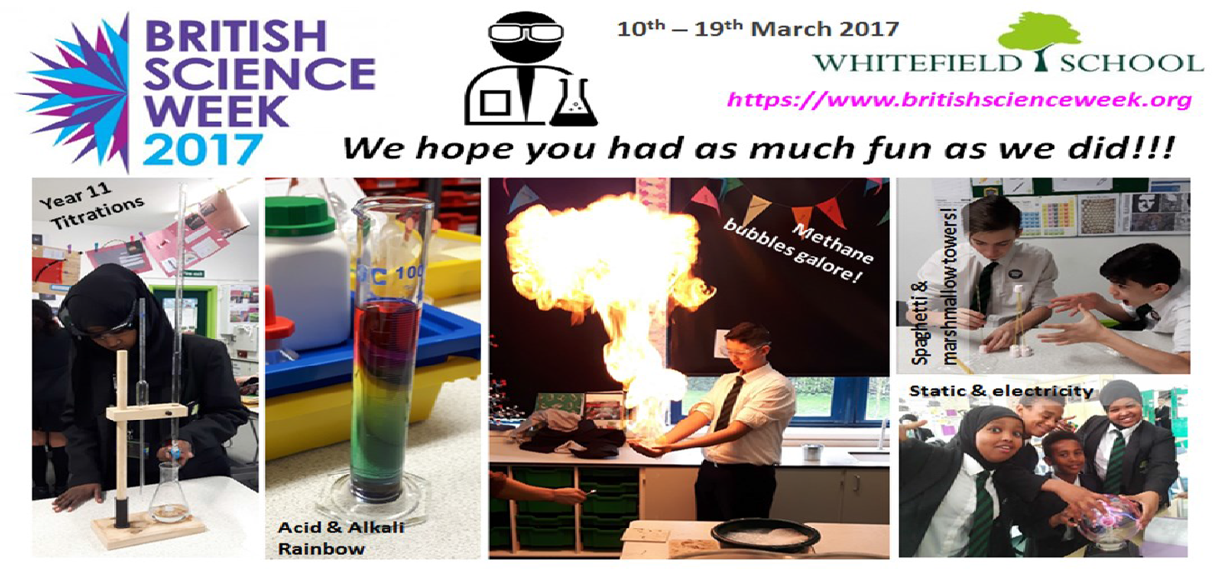

The department currently run a popular weekly KS3 Science club, where students come in their lunch breaks to conduct practical investigations.
We also plan a week of enrichment activities annually for National Science and Engineering week, including a very popular Science Fayre and demonstration day for all students, and in 2018, we had a visit from a travelling planetarium!
Sixth form students benefit from volunteering opportunities with our technical team, or working as student supporters in Science classes lower down the school. Many of our A-level students also hold subscriptions to scientific periodicals, via the department, to support their learning in Science.
For staff, we have associate membership with the Association for Science Education (ASE), and have access to all of the resources, Professional Development opportunities and other benefits of this. We have also recently joined the Stimulating Physics Network (SPN), funded by the Department for Education (DfE), and managed by the Institute of Physics (IoP), giving our staff direct access to University level Physics expertise, with a view to improving the quality of our Physics provision, and improving participation and uptake of Physics at all levels. Moreover, staff in the department enjoy a supportive environment, created by colleagues who care about their students.

We hope to see our department continue to grow and improve, filled with learners who are curious about the world around them, and ambitious in their pursuit of Science at A-level, University and beyond.

MAIN SCALE TEACHER - JOB DESCRIPTION

 | Job Title: | Science Classroom Teacher
 | Grade: | MPS/UNQ/UPS (Post is also suitable for NQT’s)
 | Reports to: | Director of Learning

Responsibilities
To meet the Professional Standards for Teachers and the Teachers statement of Conditions of Employment from the School Teachers’ Review Body (STRB)

Learning and Teaching
- To maintain good or outstanding standards of learning and teaching.
- To help develop appropriate resources and schemes of work.
- To implement school and departmental policies and procedures.
- To monitor and follow-up student progress.
- To assist in developing the use of ICT and media to enhance learning.
- To develop active learning techniques.
- To use Assessment for learning effectively.
- To plan for the delivery of highly effective lessons that challenge all students and ensure all students make progress.
- To keep up to date with national developments in the teaching of the relevant subject.

Academic Curriculum
- To contribute to the development of an appropriate and high quality curriculum, including accreditation. This may involve teaching GCSE, BTEC and GCE courses.

Assessment, Monitoring and Reporting
- To assess and mark students’ class and home learning in accordance with the whole school policy.
- To keep records of student attendance in lessons as well as monitor class and home learning, and ensure it is completed in accordance with the whole school policy.
- To report to parents through attending scheduled parent evenings and online reporting arrangements.
- To take a full part in school and department meetings.
- To set clear targets for students to enhance their achievement.

Additional Duties
- To play a full part in the life of the school community, to support its distinctive mission and ethos, and to encourage and ensure students follow this example.
- To contribute fully to the extra-curricular life of the school.
- To promote and safeguard the welfare of all Whitefield School students.
- To attend all meetings held in directed time as required
- To share in supervisory duties according to the school’s published rotas
- To keep up to date with school information e.g. the weekly bulletin, staff handbook, etc.
- Participating in any arrangements within an agreed national framework for the appraisal of your performance and that of other teachers.
- To continue personal development as agreed.

Promotion of School
- Support the Headteacher and staff in the review, implementation, development and monitoring of whole school policies which promote the school’s values, aims and objectives
- To contribute to whole School events as and when required
- To be aware of the School’s duty of care in relation to staff, students and visitors and to comply with all health and safety policies at all times
- To be aware of and comply with the codes of conduct, regulations and policies of the School and its commitment to equal opportunities

This job description is current at the date indicated below but, in consultation with the potholder, it may be changed by the Headteacher to reflect or anticipate changes in the post commensurate with the grade or job title.

September 2019

Main Scale Teacher: Person Specification
 | Job Title: | Science Classroom Teacher
 | Grade: | MPS/UNQ/UPS (Post is also suitable for NQT’s)
 | Reports to: | Director of Learning

Qualifications
Essential | Desirable
- Qualified Teacher Status  - Degree in related subject | - Higher Degree
Experience
- Teaching experience in key stage 3 and 4 (or equivalent)  - Evidence of consistently good teaching and learning  - The ability to use ICT effectively to engage students  - An understanding of how to use assessment to inform planning for good teaching and learning  - The ability to differentiate materials to meet the needs of learners  - Evidence of pastoral experience  - An interest in the wider curriculum area  - Evidence of good classroom management skills | - Successful teaching experience in multicultural context  - Teaching experience in key stage 5 or equivalent  - Experience of being a form tutor  - A commitment to offering an extra curricular activity  - Evidence of further continuing professional development e.g. attendance at relevant INSET

Knowledge/Skills (Ability to)
- A passion for education  - A willingness to learn and develop new skills  - An ability to demonstrate a good level of written and oral communication skills  - Resilience and a sense of humour | - Ambition to develop personal career and move on to leadership in the future

Personal Attributes
- Commitment to the highest standards of child protection | - Involvement in creative and innovative teaching developments

Guidance on completing the Application Form
The application form will form the basis for shortlisting. It is important, therefore, that all information relating to your application should be included on the application form. For reasons of consistency and fairness in selecting shortlisted candidates, CVs will not be considered. A brief covering letter is acceptable but this will not be considered as part of your application so it should not be used to provide further detail of your experience. Please complete all sections of the application form, ensuring that the information is clear, valid and reliable. When completing the form, please ensure that you use the above job description and person specification as your guide. The person specification describes, for example, the skills, qualities and knowledge that we require from the successful applicant and will be used as the basis for shortlisting. It is important to provide examples which demonstrate the actions you took and the impact that your leadership has made to students’ achievement.

Present and Previous Employment
As part of the school’s safer recruitment procedures, we need to see a full employment history. All relevant work experience including part-time work, temporary jobs or voluntary work should be included. Please provide a short explanation of any career breaks that you may have had. Ensure that the information is provided in chronological order with the most recent first.

Continuing Professional Development
Please give details of significant aspects of your continuing professional development over the last three years. You may wish to state how this has improved your leadership and management practice.

Information in Support of this Application
This section provides you with the opportunity to:
Identify skills, personal qualities and experience that you have that are relevant to the post of a Science Teacher at Whitefield School;

- Describe your reasons for applying for this particular post;
- Provide any further, relevant information about yourself and your achievements that you have not included elsewhere in the application.
Please note that this section is strictly limited to a maximum of 1,500 words.

References
Two references will be required before a job offer is made. The first referee should be your current or most recent employer. Referee’s will be asked to complete a school reference and will also be contacted via telephone.

Confirmation of Details
All applications should be made on the form attached and sent via email. You will be asked to sign a hard copy of your application at interview to confirm the information you have provided is correct. Please ensure that your application is received by noon on the closing date of noon Thursday 03rd October 2019

Equal Opportunities Monitoring
Whitefield School is committed to a policy of equal opportunities in employment. To ensure that our policy is effective in avoiding discrimination and promoting equal opportunities in recruitment, you are asked to complete the Recruitment Monitoring Information section. The form is confidential and kept separately from the rest of the application form. It will not be available to the shortlisting panel.

If you have any questions regarding the application process please contact HR Manager Christina McGhan on Cmg@whitefield.barnet.sch.uk

Safeguarding
Whitefield School is committed to safeguarding and promoting the welfare of children. The successful candidate will be required to complete an enhanced disclosure and barring service check.

