Saint Monica’s Roman Catholic High School

Brief Description

St Monica’s is a voluntary aided 11-16 mixed Catholic comprehensive school set in a leafy northern suburb of Manchester in the Local Authority of Bury. It is only fifteen minutes from the town centre.

The school has over 100 staff and 1134 pupil, most of whom come to St Monica’s from our five Catholic associated primary schools.

Mission Statement
St Monica’s is a Catholic community working in partnership with families, schools and parishes to teach the Catholic faith as a way of life. We provide a caring, supportive environment where everyone is of equal worth. Jesus Christ is central to our school and our main aim is that everyone can develop their God given talents and gifts to the full, while growing in faith through prayer and service.

As a Roman Catholic school, St Monica’s is conducted in accordance with the rites, practices and observances of the Roman Catholic faith. Religious Education is given according to the doctrines and practices of the Roman Catholic Church.

St Monica’s has been named as one of the best Roman Catholic comprehensives in England and in March 2013 we were awarded our fourth successive ‘Outstanding’ by Ofsted, achieving Grade 1 in all areas. In 2017, 74% of our pupils gained 5+ 9-4/A*-C including English and Maths.

In March 2014 the school achieved Teaching School status. This has meant the creation of many continued professional development opportunities for staff and the capacity for strong succession planning and talent management.

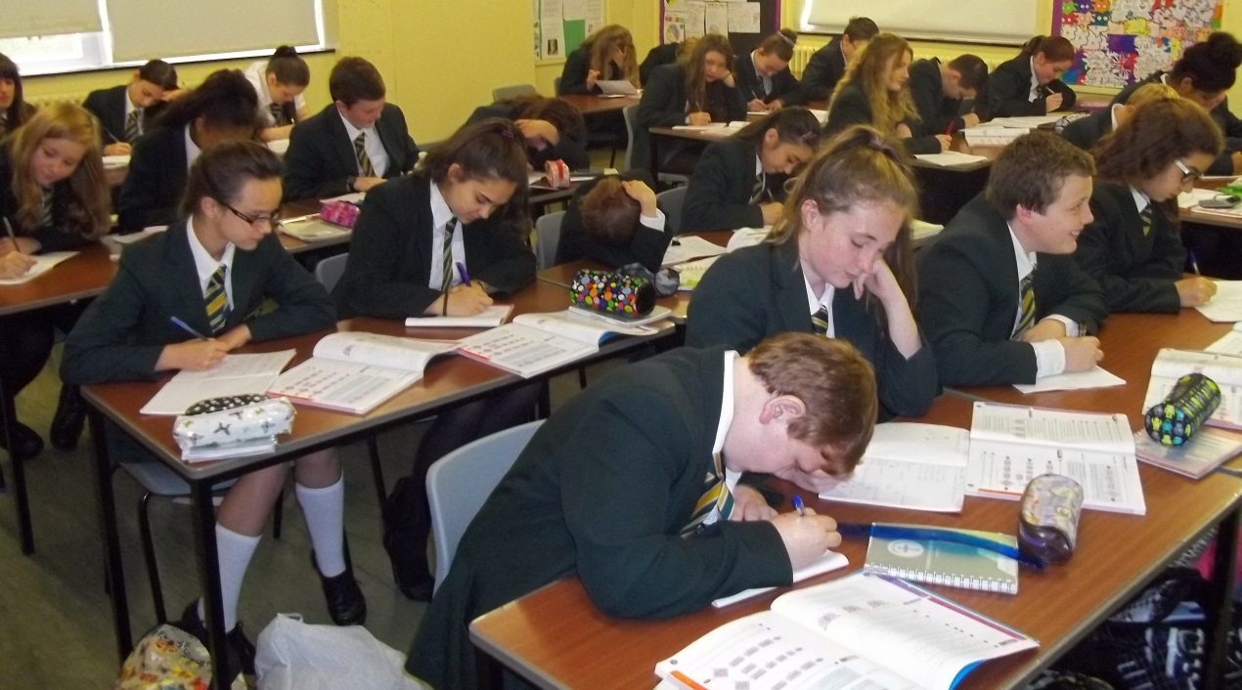
THE MATHEMATICS DEPARTMENT

The Mathematics department at St. Monica’s is committed to high standards.

The department has an examination pass rate which is above the national average. In 2017 78% of students achieved a grade 4-9 in Mathematics.

The department has seven full-time and two part-time mathematics specialists all teaching from year 7 through to year 11. Years 7 to 11 are taught in sets, across two parallel bands. The successful applicant will be expected to teach across the full ability and age range.

At Key Stage four the main source of teaching materials is currently derived from the Edexcel scheme of work provided by The Pearson Group and supplement by their textbooks (each student has a copy and it is available online). All students are entered into the Edexcel Linear examination.

At Key Stage three the main source of teaching material is derived from the Oxford University Press scheme of work. We have the MyMaths textbooks for student use as well as a copy available online.

We make extensive use of MyMaths.co.uk in all year groups and MathsWatch and Maths Box for our Key Stage 4 students.

The Mathematics department has a suite of rooms, all containing interactive whiteboards, using Promethean software, as well as a set of laptops for use within the classroom.

If you need any more information on the department please contact Miss Torkington, Head of Maths at the school, or email her on a.torkington@stmonicas.co.uk.

Applicants should make particular reference in their supporting statement to the following:

- Working in a Catholic school.
- State clearly what exam and syllabus experience you have.
- Any relevant exam results.
- Any leadership experience.
- Experience of delivering high levels of pupil progress and lessons which are consistently good and outstanding.

