THE GRANGE SCHOOL

Specialising in Business & Enterprise



TEACHER OF SCIENCE


THE GRANGE SCHOOL

The Grange School is a well established, friendly school, specialising in Enterprise.
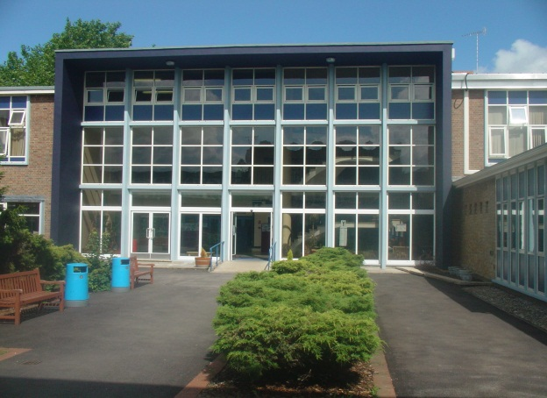
Enterprise is a driving factor throughout learning as evidenced by our Grange Enterprise and Learning Skills (GELS) which are embedded across the curriculum.



We aim to equip all students with the adaptability and flexibility to meet the demands of a rapidly changing world and to promote a sense of responsibility towards others, the school and the wider community. The support and guidance of students is based on a Year system and aims to develop co-operation, involvement and respect in all students.

A broad and balanced curriculum is provided for Years 7 to 9. In Years 10 and 11, all students will study English, Mathematics, Science, PE, RE and PSHCE (Personal, Social & Health and Citizenship Education). Students can then choose from a range of additional GCSE, BTEC and vocational courses. We offer a range of traditional and vocational courses at Key Stage 5. The curriculum in all Key Stages is further enhanced through wide ranging extra curricular experiences.

We aim to attract energetic and conscientious staff who have a commitment to the education of our students. The professional development of all staff is an important focus for the school. We strive to create a learning environment, which serves the needs of all the members of our diverse and vibrant community.

THE GRANGE SCHOOL

TEACHER OF SCIENCE

JOB DESCRIPTION

JOB PURPOSE

To be part of a team, which will have an impact on students’ levels of scientific knowledge as well as literacy and numeracy, empowering them both within the curriculum and in their lives beyond school.

DUTIES

- To teach Science to students of all abilities, such that they achieve their potential.

- To raise the level of achievement for all students.

- To contribute to the team’s development of an exciting and challenging curriculum, which will meet the needs of all students.

- To promote and support extra-curricular activities as part of the academic and cultural life of the school.

- To foster good relationships with students and with home, including attendance at parent-teacher consultations.

- To support students’ learning by the use of the school’s policies of marking, assessment, record-keeping, reporting and target-setting.

- To attend all relevant meetings.

At the Grange School, we recognise that both boys and girls can achieve well in Science. We seek to extend their scientific knowledge at every opportunity and are committed to ensuring that all students get the best from their Science education. We have high expectations of all our students, both in work and behaviour.

THE GRANGE SCHOOL

THE SCIENCE DEPARTMENT

STAFF AND STRUCTURE

The department consists of nine teachers and four technicians. They form an enthusiastic, supportive and sociable team. Science is a busy and evolving department with possibilities for career development opportunities both within the department and in pastoral care.

THE SCIENCE DEPARTMENT FACILITIES

Science is taught in nine laboratories, all of which have multimedia projectors. All the laboratories have already been refurbished to a very high standard.

At Key Stage 3, we use a combination of Activate Science, How Science Works and our own schemes of work to deliver the curriculum. At Key Stage 4, we offer Chemistry, Physics and Biology as separate science GCSE’s, as well as the 9-1 Combined Science. At Key Stage 5, we currently offer General Applied Science AQA Level 3 with Chemistry, Biology and Physics being offered at a partner school.

EXTRA CURRICULAR

Students at The Grange School are keen to progress in Science; this is reflected in the number of students who choose to attend extra after school sessions. Key Stage 4 students attend extra-curricular year-round GCSE revision lessons.

The Science Department has a successful STEMNET and BRAINIACS club which students are invited to.

Candidates are invited to visit the school prior to interview.
Please contact Mrs Jenny Bell to make an appointment.
The Grange School, Wendover Way, Aylesbury, Bucks, HP21 7NH
Tel: 01296 390900
Fax: 01296 390991
E-mail: office@grange.bucks.sch.uk
www.grange.bucks.sch.uk

