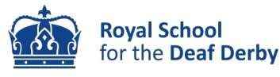

Communication Support Workers

A number of roles are available: permanent, fixed term, full and part time. All roles are term time only (38 weeks) with a full 14 weeks paid holiday leave entitlement. The salary range is from Point 3 to Point 17, £24,027 - £30,060 pa depending on qualifications and experience.

About our school
Royal School for the Deaf Derby is a unique provider of day and residential placements for deaf children and young people aged 3 – 19. We are a speaking and signing community with a qualified, competent and confident staff team. We work in collaboration to ensure all children and young people leave with the know-what and know-how to make the most of life beyond school.

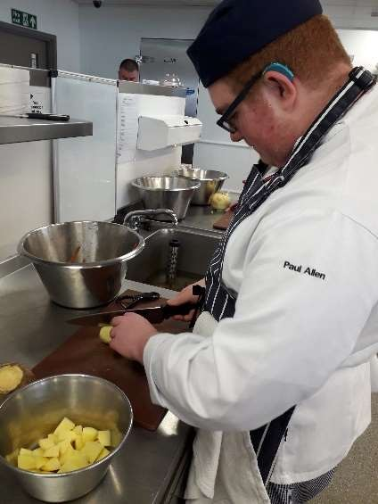


Post 16 Department
We support learners at a number of providers on a variety of courses enabling access to the same opportunities and experiences as their non-deaf peers. Courses available can range from A-Levels, motor vehicle mechanics, construction, media studies, and small animal care and are at various qualification levels.

Back at base, learners continue to build their Mathematics and English skills, learn driving theory, take part in the Duke of Edinburgh Award and enjoy bespoke careers guidance about their next steps into further education, employment or training.

Find out what we have been up to on our Facebook pages at www.facebook.com/RSDDOfficial and/or why not come and see for yourself? Contact us on 07500 878565 to visit in person or book an informal chat about the role

The role Communication Support Workers (CSWs) facilitate learning and engagement through a range of support strategies such as sign communication, note taking, language modification and lip speaking. All CSW’s can access free accredited training to improve their British Sign Language skills (up to and including Level 6) and gain professional status as a Communication Support Worker with Deaf People.

CSWs should be prepared to work at various colleges in the locality including as far away as Lichfield or Nottingham, depending on the course their learner studies.

The person Essential: proficient British Sign Language skills and the ability to build positive and constructive relationships with children and young people. A full current UK driving licence to facilitate the transporting of students to college where required.

Desirable: Level 3 British Sign Language, qualified Communication Support Worker with Deaf people, previous experience of communicating for young people in an educational setting, contributing to individual learning plans and tracking learner progress

How to apply download job details and application documents from our website at, www.rsdd.org.uk/job-opportunities.
CLOSING DATE: 15 April 2025 INTERVIEWS: 24 April 2025

This role is a Regulated Activity under the Safeguarding Vulnerable Groups Act and subject to safer recruitment checks. These include an enhanced criminal record check through the Disclosure and Barring Service. This role is exempt from the Rehabilitation of Offenders Act 1974 (Exceptions) Order 1975 (as amended) Please see our policy statement on the recruitment of ex-offenders available on our jobs pages. Following changes to Keeping Children Safe in Education (KCSIE 2022) RSD Derby will also undertake an online search as part of due diligence checks on shortlisted candidates to help identify any incidents or issues that have happened, and are publicly available.

